**My Health APP**

**Abstract**

Most people these days are very dependent on medication, and a slight delay in the intake of these medications can hamper the outcome of the result it produces. Thus, to reduce such risk, **‘My Health’** a medicine reminder application was proposed. This proposed system provides a range of features that help the user keep their health-related data and provider reminders for medicine. This is a mobile application developed in Flutter Framework.

This report includes a detailed description of the overall development of the My Health Application. This report is divided into Introduction, Background, Development, Testing and Analysis, and Conclusion. The developed application aims to provide a healthier lifestyle to the people and promote health-related applications.

**Table of Contents**

CHAPTER 1: INTRODUCTION 1

1.1. PROJECT DESCRIPTION 1

1.2. CURRENT SCENARIO 1

1.3. PROBLEM DOMAIN AND PROJECT AS A SOLUTION 2

1.3.1. Problem Scenario 2

1.3.2. Project as a solution 3

1.4. AIM AND OBJECTIVES 3

1.5. STRUCTURE OF THE REPORT 4

1.5.1. BACKGROUND 4

1.5.2. DEVELOPMENT 4

1.5.3. TESTING AND ANALYSIS 4

1.5.4. CONCLUSION 4

CHAPTER 2: BACKGROUND 5

2.1. ABOUT THE END USER 5

2.2. UNDERSTANDING THE SOLUTION 5

2.3. SIMILAR PROJECTS 7

2.3.1. Review of similar projects 7

2.3.1.1. Pill Reminder & Medicine App – MedControl 7

2.3.1.2. Medica: Medication Reminder, Pill Tracker & Refill 8

2.3.1.3. Medication Reminder 9

2.3.1.4. Pill Reminder & Medication Tracker – MyTherapy 10

2.4. COMPARISONS 11

2.4.1. Comparison Between Systems 11

2.4.2. Critical Evaluation of the solution 12

CHAPTER 3: DEVELOPMENT 13

3.1. CONSIDERED METHODOLOGIES 13

3.2. SELECTED METHODOLOGY 14

3.3. PHASE OF METHODOLOGY 14

3.4. SURVEY RESULTS 17

3.4.1. PRE-SURVEY RESULTS 17

3.4.2. POST-SURVEY RESULTS 19

3.5. REQUIREMENT ANALYSIS 24

3.5.1. Features of the application 24

3.6. DESIGN 26

3.6.1. Use Case Diagram 26

3.6.2. Activity Diagram 28

3.6.3. Collaboration Diagram 39

3.6.4. Sequence Diagram 44

3.7 IMPLEMENTATION 52

3.7.1. Core Features of the Application 52

3.7.2. System Architecture Design 80

CHAPTER 4: TESTING AND ANALYSIS 83

4.1. TEST PLAN 83

4.1.1. UNIT TESTING, TEST PLAN 83

4.1.2. SYSTEM TESTING, TEST PLAN 84

4.2. UNIT TESTING 85

4.3. SYSTEM TESTING 133

4.4. CRITICAL ANALYSIS 190

CHAPTER 5: CONCLUSION 191

5.1. LEGAL, SOCIAL AND ETHICAL ISSUES 191

5.1.1. LEGAL ISSUES 191

5.1.2. SOCIAL ISSUES 191

5.1.3. ETHICAL ISSUES 192

5.2. ADVANTAGES 193

5.3. LIMITATIONS 193

5.4. FUTURE WORK 194

CHAPTER 6: REFERENCES 195

CHAPTER 7: APPENDIX 197

7.1. APPENDIX A: BACKGROUND 197

7.2. APPENDIX B: DEVELOPMENT 198

7.2.1. CONSIDERED METHODOLOGY 198

7.3. APPENDIX C: PRE-SURVEY 200

7.3.1. PRE-SURVEY FORM 200

7.3.2. SAMPLE OF FILLED PRE-SURVEY FORMS 202

7.3.3. PRE-SURVEY RESULT 204

7.4. APPENDIX B: POST-SURVEY 210

7.4.1. POST-SURVEY FORM 210

7.4.2. SAMPLE OF FILLED POST-SURVEY FORM 214

7.4.3. POST-SURVEY RESULT 218

7.5. APPENDIX D: SAMPLE CODES 230

7.5.1. SAMPLE CODE OF THE CORE FEATURE 230

7.6. APPENDIX E: DESIGNS 277

7.6.1. GANTT CHART 277

7.6.2. WORK BREAKDOWN STRUCTURE 278

7.6.3. ALGORITHMS & FLOWCHARTS 279

7.6.4. HIGH-LEVEL USE CASE DESCRIPTION. 280

7.6.5. DATA FLOW DIAGRAMS 283

7.6.6. USE CASE 297

7.6.7. WIREFRAME 299

7.7. APPENDIX F: SCREENSHOT OF THE SYSTEM 307

7.8. APPENDIX G: TESTING 342

7.8.1. System Testing 342

7.9. APPENDIX H: USER FEEDBACK 376

7.9.1. USER FEEDBACK 376

**Table of Figures**

Figure 1 MedControl application 7

Figure 2 Medica Application 8

Figure 3 Medicine reminder application 9

Figure 4 MyTherapy Application 10

Figure 5 Kanban board for the developed system 15

Figure 6 Chart showing response to the Question 1 of the Pre-Survey 17

Figure 7 Chart showing response to the Question 2 of Pre-Survey 17

Figure 8 Chart showing response to the Question 3 of Pre-Survey 18

Figure 9 Response to the Question 4 of Pre-Survey 18

Figure 10 Chart showing response of Question 1 of Post-Survey 19

Figure 11Chart showing response of Question 2 of Post-Survey 19

Figure 12 Chart showing response of Question 3 of Post-Survey 20

Figure 13 Chart showing response of Question 4 of Post-Survey 20

Figure 14 Chart showing response of Question 5 of Post-Survey 21

Figure 15 Chart showing response of Question 6 of Post-Survey 21

Figure 16 Chart showing response of Question 7 of Post-Survey 22

Figure 17 Response of Question 8 of Post-Survey 22

Figure 18 Response of Question 8 of Post-Survey 2 23

Figure 19 Response of Question 9 of Post-Survey 23

Figure 20 Use Case Diagram for the overall system 27

Figure 21 System Activity Diagram 29

Figure 22 Login Activity Diagram 30

Figure 23 Register Activity Diagram 31

Figure 24 Medicine Activity Diagram 32

Figure 25 Measurement Activity Diagram 33

Figure 26 Doctors Activity Diagram 34

Figure 27 Notes Activity Diagram 35

Figure 28 Profile Activity Diagram 36

Figure 29 Track Me Activity Diagram 37

Figure 30 Medicine History Activity Diagram 38

Figure 31 Collaboration Diagram Login User 39

Figure 32 Collaboration Diagram Register User 40

Figure 33 Collaboration Diagram Add/Edit/Delete Medicine 40

Figure 34 Collaboration Diagram Add/Edit/Delete Measurement 41

Figure 35 Collaboration Diagram Add/Edit/Delete/Call/Email Doctor 41

Figure 36 Collaboration Diagram Add/Edit/Delete Notes 42

Figure 37 Collaboration Diagram Edit Profile 42

Figure 38 Collaboration Diagram for Tracking 43

Figure 39 Collaboration Diagram Medicine History 43

Figure 40 Sequence Diagram Login User 44

Figure 41 Sequence Diagram Register User 45

Figure 42 Sequence Diagram for Add Medicine, Edit Medicine and Delete Medicine 46

Figure 43 Sequence Diagram for Add Measurement, Edit Measurement and Delete Medicine 47

Figure 44 Sequence Diagram for Add Note, Edit Note and Delete Note 48

Figure 45 Sequence Diagram for Edit Profile 49

Figure 46 Sequence Diagram for Medicine History 49

Figure 47 Sequence Diagram for Track Me Functionality 50

Figure 48 Sequence Diagram for Add Doctor, Edit Doctor, Delete Doctor, Call Doctor and Email Doctor 51

Figure 49 Insert Medicine required Fields 53

Figure 50 Inserting the time to get a reminder 54

Figure 51 The Medicine Added being show in the Medicine UI 55

Figure 52 Medicine reminder Notification being displayed on time 56

Figure 53 Medicine Reminder being displayed in user define time 57

Figure 54 Edit Medicine UI 58

Figure 55 Edit Medicine UI 2 59

Figure 56 Medicine Stock Low Reminder Being Displayed 60

Figure 57 Medicine Reminder Being shown when the stock has finished 61

Figure 58 Adding Notes into the system 62

Figure 59 Added Notes being displayed in Notes UI 63

Figure 60 Edit Note UI 64

Figure 61 Inserting Doctors information to add doctor 65

Figure 62 Added Doctor being shown in Doctors UI 66

Figure 63 Doctor Information UI 67

Figure 64 Measurement UI 68

Figure 65 Adding Measurement Blood Pressure 69

Figure 66 Added Measurement Being displayed in the Measurement UI 70

Figure 67 Edit Measurement UI 71

Figure 68 Adding Minute Interval to Check Location 73

Figure 69 Tracking UI 74

Figure 70 Start Tracking 75

Figure 71 Status Check Dialog Being Displayed as the User location has not changed 76

Figure 72 SMS Sent If the user pressed No in Status Check 77

Figure 73 Medicine History UI 78

Figure 74 User data being stored in the firebase 79

Figure 75 Basic System Architecture 80

Figure 76 Flutter Widget Hierarchy in Hello World Application (tutorialspoint, 2021) 81

Figure 77 System Architecture of My Health 82

Figure 78 Required input to register user being entered 86

Figure 79 Required input to setup profile being entered 87

Figure 80 User being redirected to the home page 88

Figure 81 User profile being saved in the database 89

Figure 82 User being saved in the database 89

Figure 83 Medicine Containing multiple reminders 91

Figure 84 Data in database before medicine taken 92

Figure 85 Taking Medicine once 93

Figure 86 Data in database after medicine taken once 94

Figure 87 Taking Medicine for the second time 95

Figure 88 Tick color changing after taking the required medication for the day 96

Figure 89 Database data after taking the required medication for the day 97

Figure 90 Medicine With low stock being taken 99

Figure 91 Medicine Reminder being triggered when medicine stock low 100

Figure 92 Taking medicine when the stock is at the lowest 102

Figure 93 Medicine refill reminder being triggered 103

Figure 94 Entering minute field as 1 for tracking 105

Figure 95 Tracking without changing the user position 106

Figure 96 Status Check being displayed when position not changed in entered minute interval 107

Figure 97 Start tracking again with a position 107

Figure 98 Changing user position in the emulator 108

Figure 99 User position change being showed by calculating distance travelled 109

Figure 100 Status Check dialog not shown as the user position was changed 110

Figure 101 A Medicine is added in the application. 112

Figure 102 The added medicine being shown in the database 113

Figure 103 Updating some information related to the medicine 114

Figure 104 Database data being updated after editing medicine 115

Figure 105 Deleting the medicine 116

Figure 106 Medicine data being deleted form the database as well 117

Figure 107 Medicine data in database before making changes 118

Figure 108 Changing the date to yesterday’s date 119

Figure 109 Changes in database after changing the date. 119

Figure 110 Launching the application after changing the date to the previous day 120

Figure 111 Application being launched and daily changes being made 120

Figure 112 The database data being updated automatically after launching the application 121

Figure 113 Pressing Skip button 123

Figure 114 Medicine Skip reminder being triggered 124

Figure 115 Medicine data in the database before taking medicine 125

Figure 116 Pressing Take button 126

Figure 117 Medicine Taken being displayed in the application 127

Figure 118 Medicine related data being changed in the database 128

Figure 119 Pressing Call in Doctors Information UI 129

Figure 120 User being redirected to dialer with doctor’s number 130

Figure 121 Pressing Email on Doctors Information UI 131

Figure 122 User being redirected to email app with doctor’s email 132

Figure 123 Registering a new user 134

Figure 124 Setting up profile for the new user 135

Figure 125 New user being redirected to the home page 136

Figure 126 Error message being displayed when trying to register using empty fields 138

Figure 127 Invalid email message being displayed when registering using the invalid email address 139

Figure 128 Error Message being displayed when Invalid password is entered 140

Figure 129 Error dialog box being displayed when trying to register with an already registered account 141

Figure 130 Entering correct login credential 143

Figure 131 User being logged into the system 144

Figure 132 Error message being displayed when login with empty fields 146

Figure 133 Error message being displayed when login with invalid email address 147

Figure 134 Error dialog box being displayed when login in using an unregistered email 148

Figure 135 Error dialog box being displayed when logging in using incorrect password for a registered user 149

Figure 136 Medicine with a reminder in user given time 151

Figure 137 Notification for Medicine reminder being triggered in user defined time 152

Figure 138 Notification being triggered at the correct time 153

Figure 139 Adding a medicine 155

Figure 140 The medicine added being displayed 156

Figure 141 Updating/Editing a medicine information 157

Figure 142 Updated Medicine Changes being displayed 158

Figure 143 Deleting a medicine 159

Figure 144 Medicine not being shown after deleting 160

Figure 145 Error message being displayed when trying to enter empty values in Add Medication 162

Figure 146 Only Number being allowed to enter stock field of Add Medication 163

Figure 147 Only number being allowed to enter in Intake dose field of Add Medication 164

Figure 148 Medicine not being added after pressing add button when reminder time is not added 165

Figure 149 Error message on empty value being entered in Edit Medication 166

Figure 150 Only number being allowed to enter on Intake dose field of Edit medication 167

Figure 151 Edited medicine not being saved after clicking save button if reminder time is empty 168

Figure 152 Adding Body Fat Measurement 170

Figure 153 Added Body Fat Measurement being displayed 171

Figure 154 Updating/Editing Body Fat Measurement data 172

Figure 155 Updated/Edited Body Fat Data being displayed 173

Figure 156 Deleting a Body Fat Measurement 174

Figure 157 Body Fat Measurement not being displayed after deleting 175

Figure 158 Error message being displayed when entering invalid and empty data in Add Blood Pressure fields 177

Figure 159 Error message being displayed when entering invalid data both fields of Add Blood Pressure 178

Figure 160 Error message being displayed when an empty data in input field for Add Body Fat 179

Figure 161 Error message being displayed when and invalid data is entered into the input field of Add Body Fat 180

Figure 162 Error message being displayed when and invalid data is entered into the input field of Add Pulse 181

Figure 163 Error message being displayed when an empty data in input field for Add Pulse 182

Figure 164 Adding a new note 184

Figure 165 New note added being displayed in the Notes UI 185

Figure 166 Updating/Editing a Note 186

Figure 167 Updated/Edited Note data being displayed in the Notes UI 187

Figure 168 Deleting a Note 188

Figure 169 Note not being shown after being deleted 189

Figure 170 Pre-Survey Form 200

Figure 171 Pre-Survey Form 201

Figure 172 Sample of Filled Post-Survey Form 202

Figure 173 Sample of Filled Post-Survey Form 203

Figure 174 Pre-Survey Number of Response 204

Figure 175 Pre-Survey List of Names of People participated 204

Figure 176 Pre-Survey List of Names of People participated 205

Figure 177 Pre-Survey Result Question 1 206

Figure 178 Pre-Survey Result Question 2 207

Figure 179 Pre-Survey Result Question 3 208

Figure 180 Pre-Survey Result Question 4 209

Figure 181 Post-Survey Form 210

Figure 182 Post-Survey Form 211

Figure 183 Post-Survey Form 212

Figure 184 Post-Survey Form 213

Figure 185 Sample of Filled Post-Survey Form 214

Figure 186 Sample of Filled Post-Survey Form Question 1 215

Figure 187 Sample of Filled Post-Survey Form Question 2 215

Figure 188 Sample of Filled Post-Survey Form Question 3 215

Figure 189 Sample of Filled Post-Survey Form Question 4 216

Figure 190 Sample of Filled Post-Survey Form Question 5 216

Figure 191 Sample of Filled Post-Survey Form Question 6 216

Figure 192 Sample of Filled Post-Survey Form Question 7 216

Figure 193 Sample of Filled Post-Survey Form Question 8 217

Figure 194 Sample of Filled Post-Survey Form Question 9 217

Figure 195 Post- Survey Number of Response 218

Figure 196 Post-Survey Name of Participants 218

Figure 197 Post-Survey Name of Participants 219

Figure 198 Post-Survey Name of Participants 219

Figure 199 Post-Survey Email of Participants 220

Figure 200 Post-Survey Email of Participants 220

Figure 201 Post-Survey Result Question 1 221

Figure 202 Post-Survey Result Question 2 222

Figure 203 Post-Survey Result Question 3 223

Figure 204 Post-Survey Result Question 4 224

Figure 205 Post-Survey Result Question 5 224

Figure 206 Post-Survey Result Question 6 225

Figure 207 Post-Survey Result Question 7 226

Figure 208 Post-Survey Feedback Response 227

Figure 209 Post-Survey Feedback Response 228

Figure 210 Post-Survey Response for suggestion for future updates 228

Figure 211 Gantt Chart for the project developed before development was started 277

Figure 212 Work breakdown structure 278

Figure 213 System Flow Chart 279

Figure 214 Level 0 DFD of overall system 283

Figure 215 Level 0 DFD - Register 284

Figure 216 Register level 1 DFD 285

Figure 217 Login level 0 DFD 286

Figure 218 Login level 1 DFD 287

Figure 219 Add medicine level 0 DFD 288

Figure 220 Level 1 DFD - Add Medicine 289

Figure 221 Add doctor level 0 DFD 290

Figure 222 Add doctor level 1 DFD 291

Figure 223 Add notes level 0 DFD 292

Figure 224 Add notes level 1 DFD 292

Figure 225 Add measurement level 0 DFD 293

Figure 226 Add measurement level 1 DFD 294

Figure 227 Track Me Level 0 DFD 294

Figure 228 Track Me Level 1 DFD 295

Figure 229 Medicine history Level 0 DFD 295

Figure 230 Medicine History Level 1 DFD 296

Figure 231 User Use Case Diagram 297

Figure 232 System Use Case Diagram 298

Figure 233 Register page 299

Figure 234 Login page 300

Figure 235 Home page 301

Figure 236 Add Medicine pages 302

Figure 237 Add doctors pages 303

Figure 238 Add notes pages 304

Figure 239 Add measurements pages 305

Figure 240 Enable tracking page 306

Figure 241 Login Page 307

Figure 242 Register Page 308

Figure 243 Setup Profile Page 309

Figure 244 Forgot Password Page 310

Figure 245 Home Page 311

Figure 246 Medicine Page 312

Figure 247 Add Medicine Page 313

Figure 248 Add Medicine Page 314

Figure 249 Edit Medicine page 315

Figure 250 Edit Medicine Page 316

Figure 251 Measurement Page 317

Figure 252 Blood Pressure Page 318

Figure 253 Add Blood Pressure Page 319

Figure 254 Edit Blood Pressure Page 320

Figure 255 Body Fat Page 321

Figure 256 Add Body Fat Page 322

Figure 257 Edit Body Fat Page 323

Figure 258 Pulse Page 324

Figure 259 Add Pulse Page 325

Figure 260 Edit Pulse Page 326

Figure 261 Other/Menu Page 327

Figure 262 Other/ Menu Page 328

Figure 263 Notes Page 329

Figure 264 Add Notes Page 330

Figure 265 Edit Note Page 331

Figure 266 Dcotors Page 332

Figure 267 Add Doctor Page 333

Figure 268 Doctor Information Page 334

Figure 269 Edit Doctor Page 335

Figure 270 Edit Doctor Page 336

Figure 271 Profile Page 337

Figure 272 Edit Profile Page 338

Figure 273 Tracking Select Minute Page 339

Figure 274 Track Me Page 340

Figure 275 Medicine History Page 341

Figure 276 A doctor being added 343

Figure 277 Added doctor being displayed in the Doctors UI 344

Figure 278 Doctors full information being displayed when clicked on doctor 345

Figure 279 Updating/Editing a Doctors Information 346

Figure 280 Updated/Edited Doctors information being displayed 347

Figure 281 Deleting a Doctor 348

Figure 282 Doctor information not being shown after deleting 349

Figure 283 Error message being displayed when empty data is entered into fields of Add Doctor 351

Figure 284 Only Numbers being allowed to enter into Number field of Add Doctor 352

Figure 285 Invalid Email Not being allowed to enter in email field of Add Doctor 353

Figure 286 Error message being displayed when empty data is entered into fields of Edit Doctor 354

Figure 287 Only Numbers being allowed to enter into Number field of Edit Doctor 355

Figure 288 Invalid Email Not being allowed to enter in email field of Edit Doctor 356

Figure 289 Pressing Edit on Profile UI 358

Figure 290 Updating/Editing User profile 359

Figure 291 Updated/Edited Profile data being displayed 360

Figure 292 Error Message being displayed when empty data is being entered into Edit profile field 362

Figure 293 Error Message being displayed when entering empty data in date field of edit profile 363

Figure 294 Error message being displayed when entering an invalid phone number 364

Figure 295 Click Medicine History 366

Figure 296 Medicine History Being Displayed 367

Figure 297 Clicking logout button 369

Figure 298 User being logged out of the system and redirected to login page 370

Figure 299 Error message being displayed when invalid email address is entered in Forgot Password UI 372

Figure 300 Error message being displayed when empty data is entered in Forgot Password UI 373

Figure 301 Email being sent to the user to reset password 374

Figure 302 Reset password Ui provide by Firebase 375

Figure 303 Email to reset password being revived in the users email inbox 375

Figure 304 Feedbacks of the participants 376

Figure 305 Feedbacks of the participants 377

Figure 306 Suggestion for future update of the participants 377

**Table of Tables**

Table 1 Similar Systems Comparison 11

Table 2 Unit Testing Test Plan 83

Table 3 System Testing Test Plan 85

Table 4 Unit Testing Register User 85

Table 5 Unit Testing Tick Color change in multiple reminders. 90

Table 6 Unit Testing Medicine low reminder 98

Table 7 Unit Testing Medicine finished reminder 101

Table 8 Unit Testing To test Tracking Functionality 104

Table 9 Unit Testing To perform CRUD operation in Medicine related features to see changes in the database 111

Table 10 Unit Testing Medicine data being rest daily. 118

Table 11 Unit Testing Medicine Skip Notification 122

Table 12 Unit Testing Medicine Data Update 125

Table 13 Unit Testing Contact Doctor 128

Table 14 System Testing Register User 133

Table 15 System Testing Register Validation 137

Table 16 System Testing Login User 142

Table 17 System Testing Login Validation 145

Table 18 System Testing Medicine Reminder 150

Table 19 System Test To test CRUD operation for Medicine 154

Table 20 System Testing Medicine Input Validation 161

Table 21 System Testing to Test CRUD operation for Measurement 169

Table 22 System Testing Measurement Input Validation 176

Table 23 System Testing to Test CRUD operation for Notes 183

Table 24 System Testing to Test CRUD operation for Notes 342

Table 25 System Testing Doctor Input Validation 350

Table 26 System Testing Edit Profile 357

Table 27 System Testing Edit Profile 361

Table 28 System Testing View Medicine History 365

Table 29 System Testing Logout User 368

Table 30 System Testing to Test Forgot Password 371

# CHAPTER 1: INTRODUCTION

## PROJECT DESCRIPTION

This project helps the user keep track of their medication and reminds the user to take their medications on time, and keeps records of the user's various health-related information. People nowadays take medicines for different medical purposes or due to some disease they have. These medications play a vital role in keeping the person healthy. Since these medications are crucial to us, the application for this project was created with a vision to assist the people in taking their medication on time, keeping track of them, and help them by keeping their various health-related records all in a single place.

The project documented in this report is a Flutter-based android application that primarily focuses on making the user take their medicines on time by reminding them. A mobile application, also known as an app, is a type of application software designed to run on a mobile device such as a smartphone or tablet (technopedia, 2020).

For this project's development, the consideration of developing it in a mobile application platform was due to the growing popularity of mobile phones and apps. As in the current time, many people are fond of smartphones, and everyone has access to smartphones.

## CURRENT SCENARIO

In the past decade, the applications related to health care have been growing in popularity; these applications have contributed to making improvements to the users' health. With the development of technology, the uses of a mobile smartphone are common these days to almost everyone as these mobile phones are available to nearly all the people the health care industries are also creating various applications which helps people to connect better with their doctors by sending different health-related data to their doctors periodically, some application contributes to user’s fitness by assisting the people with various exercise and track their progress. Similarly, the applications like medicine reminders are also used by a significant amount of people.

In the context of Nepal, the trends and development related to technologies are a bit laid back in context to other countries; however, their use and development are progressing. Although social media applications are widely used, the concept of using apps for Health care is a bit less compared to other countries.

## PROBLEM DOMAIN AND PROJECT AS A SOLUTION

## Problem Scenario

Health is one of the most important things to us in life, and to have a good and to live a long healthy life, we continuously take care of our health by having check-ups and taking medication assigned to us by the doctor to maintain our health. Since these medications play an essential role in living a healthy life, they are vital to us. People think that not taking their medication on time is not a big deal, but they are wrong. Not taking the prescribed medication regularly is estimated by The Centers for Disease Control to kill 125,000 persons in the United States each year in the form of chronic disease treatment failures (Feltman, 2020). Many people who rely on medication forget to take their medicines on time as they are usually busy with their other tasks. The people who are dependent on medication are usually the ones who are suffering from some health conditions as well, and these people have some common issue such as:

* They forget to take prescribed medication on time.
* They have difficulty maintaining their records of health measurement.
* Have difficulty in maintaining information related to their respective doctors.
* Forget to refill their medicine supply.

## Project as a solution

This application's Development was started with the mindset to help people take their medication on time and not have to face some health issues over time due to their forgetfulness in the future. This app will help remind the users to take their medication on time by providing a reminder in the time set by the user. Along with the forgetfulness to take medicines on time, this app also offers various features considering people who take these medicines as they have some health complications. Users will be able to take notes regarding their health, store information on their various health measurements, store information related to their doctors, and the app will also have functionality for the elderly which will track their location over time and send an SMS to their loved ones if the app detects that the person has not moved for a couple of minutes.

# AIM AND OBJECTIVES

This project aims to help the people who rely on medication to take their medications on time and ease their issues related to their problems, as mentioned above. The objective of this project is as mentioned below:

* To promote a healthy lifestyle.
* To assist the people who take medication daily.
* To assist older people regarding their health and medication.
* To learn about mobile application development.

## STRUCTURE OF THE REPORT

## BACKGROUND

This chapter consists of the introduction of the project, expiation about the end-user for the developed application, understanding the solution, and discussing the similar projects and comparison between similar systems and the developed system.

## DEVELOPMENT

This chapter consists of the information related to considered mythologies, an explanation of the selected methodology, and the reasons for selecting the methodology.

## TESTING AND ANALYSIS

This chapter consists of the information related to the test plan created, various testing performed in the developed system, and critical analysis.

## CONCLUSION

This chapter consists of the discussion related to various legal, social, and ethical issues regarding the developed application, the advantages and limitations of the system, the system's future plans, and the overall experience and achievements obtained after the development of the system.

# CHAPTER 2: BACKGROUND

## 2.1. ABOUT THE END USER

The end-users of this application are mainly people who are dependent on medication daily. However, people who want to keep their health-related records or people who were prescribed medication for a certain period can also use this application. Most of the people who are dependent on medication tend to forget to take their medication on time or completely forget to take them. This application helps to minimize this factor as nowadays mobile phones are the things that a person carries with them most of the time. Furthermore, this application also allows those people to record various health-related information within the application. Also, a special tracking function is available to help people who have a unique condition like having strokes or heart problems to use if they want to notify the person close to them if they are having problems while venturing outside.

## 2.2. UNDERSTANDING THE SOLUTION

**2.2.1. My Health application**

The application developed for this project is an Android-based health application, which is known as “My Health.” The application's main objective is to make its user take their medication on time and assist them in maintaining their health profile by storing their necessary health-related information. This application aims to help people dependent on medication take their medicines on time and help keep their health-related records and information in a single place. These features provided by the application might help the person lead a healthy life, as missing to take these medications might seem like a not so big of a deal, but this might lead to various problems later on if done so frequently. By sorting the health-related records and information within the application, this application might as well be helpful for the next visit in the hospital to the user as they can easily show their various health-related records that they have stored in the application to their doctors, which might help them to get a better check-up and treatments. Applications like medicine reminders are not widely used and know in Nepal's context; thus, this application aims to make the user familiar with these types of health applications and promote their use.

The various technical terms that come up in this documentation and that were used in the development of the application are as follows:

**Dart** is an open-source, general purposed, object-oriented programming language with C-style syntax, which Google developed in 2011. This language is usually used to create front-end user interfaces for web and mobile apps. This language is under active development, as it is compiled to native machine code for building mobile apps, which was inspired by programming languages like Java, JavaScript, C#, and other strongly typed language. (javatpoint, 2021)

**Flutter** framework of the Dart programming language will be used for the development of the application. Flutter is a free and open-source mobile UI framework developed by Google. With Flutter, we can develop a native mobile application with only one codebase, which means we can use one programming language to create Android and IOS apps.

**Firebase** is a YC11 start-up project that grew up into one of the most popular app-development platforms on Google Cloud Platform. Firebase is a Backend-as-a-Service (BaaS) that allows the developer to craft a fantastic user experience as we do not need to manage servers or write our APIs. Firebase acts as our server, API, and datastore all as one (Esplin, 2016).

**pub.dev** is a website that provides a wide variety of open-source packages to use for Flutter and Dart programs.

The reasoning for developing the system and the advantage and disadvantage of the system is added in the Appendix section of the report.

## 2.3. SIMILAR PROJECTS

## 2.3.1. Review of similar projects

### 2.3.1.1. Pill Reminder & Medicine App – MedControl

This medicine reminder app helps track all the medicines the user needs and reminds us to take those medicines. It is simple to use and provides a dashboard to see how much time is left for the next intake of medication and pills.

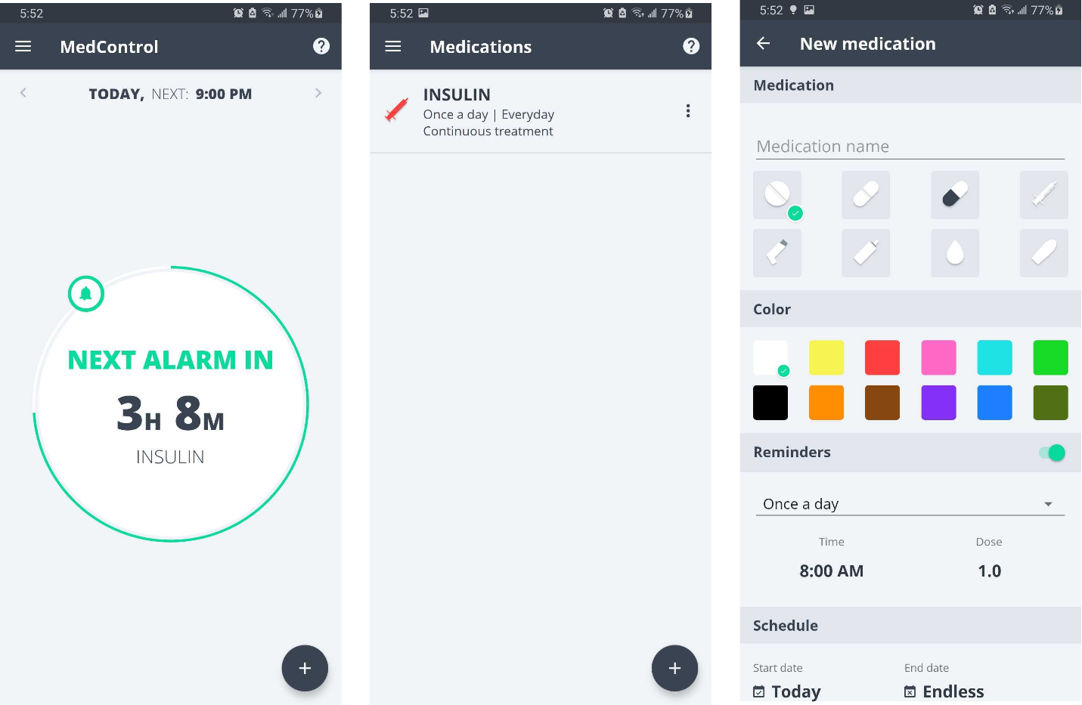

Figure MedControl application

### Medica: Medication Reminder, Pill Tracker & Refill

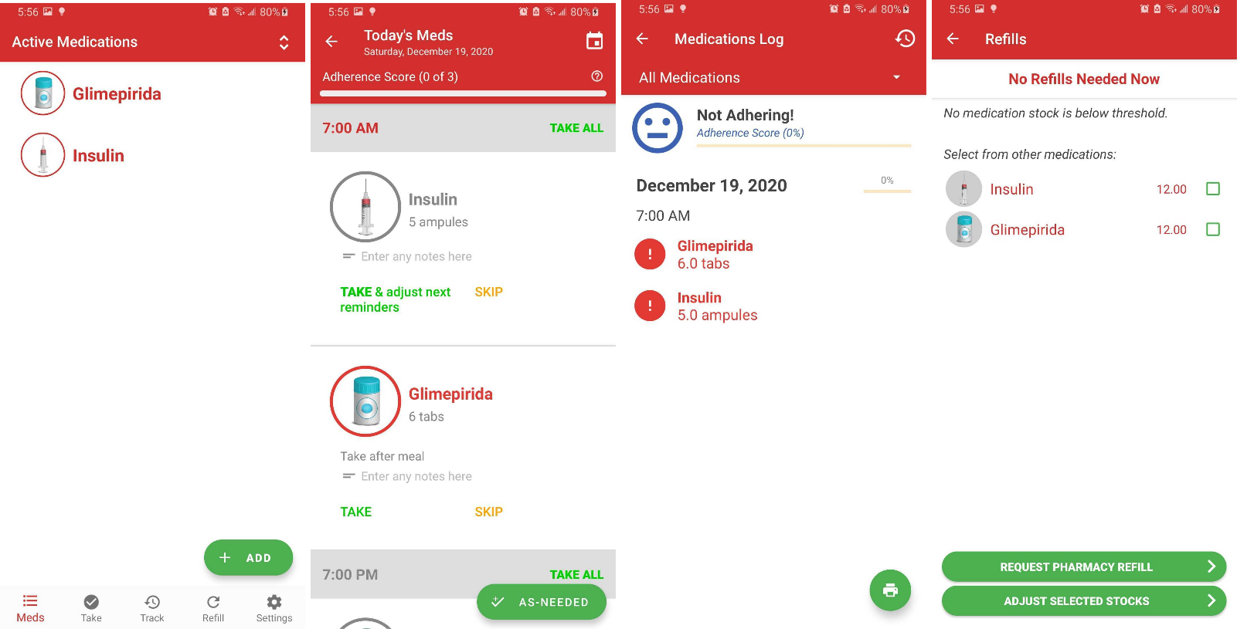This medicine reminder app has support for 17 types of medication and reminds the user to take their medication. The app also reminds the user to refill their medication when it is about to run out of it. It also tracks the user's medication and has a feature to save the report as a PDF. This app also allows the user to keep the information private by adding a passcode for the app.

Figure Medica Application

### Medication Reminder

This application is a simple medication reminder app that allows us to track our medication intake and provides a simple dashboard to show the medication to be taken daily. It also reminds the user to refill the medication and allows the user to take notes as well.

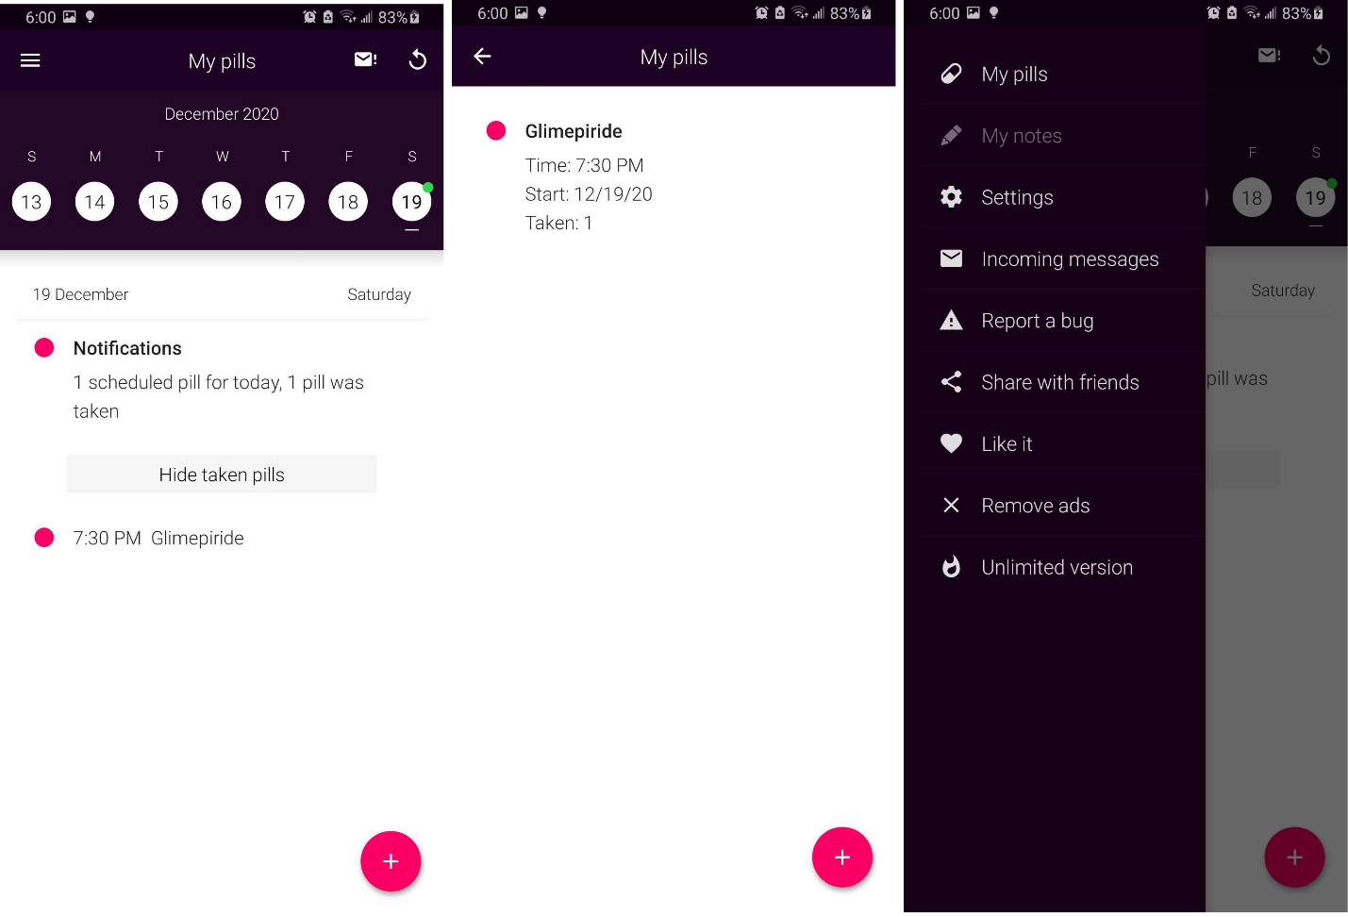

Figure Medicine reminder application

### Pill Reminder & Medication Tracker – MyTherapy

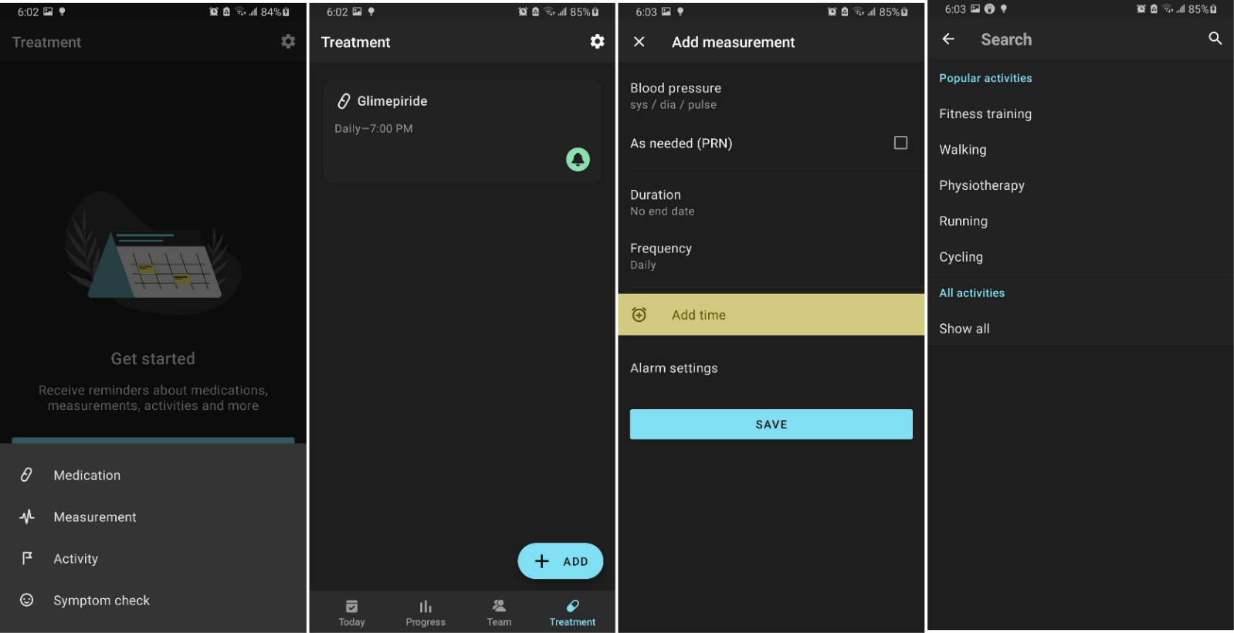This Medication Tracker allows its users to track all the user's medications and remind them to take them on time. Along with that, this app also allows the user to track various health-related measurements. This app also acts as an activity tracker, which allows tracking a wide variety of activities and has a symptom tracker. It also allows the user to add appointments and information related to their doctors, and theses information can be shared. It also can generate a report for all the user's activities.

Figure MyTherapy Application

## COMPARISONS

## Comparison Between Systems

|  |  |  |  |  |  |
| --- | --- | --- | --- | --- | --- |
| **Feature** | **My Health**  **(My Application)** | **MedControl** | **Medica** | **Medication Reminder** | **MyTherapy** |
| **Medicine Tracker / Reminder** | Available | Available | Available | Available | Available |
| **Medicine Refill Tracker** | Available | Not Available | Available | Not Available | Available |
| **Notes** | Available | Not Available | Not Available | Available | Not Available |
| **Doctors Information** | Available | Not Available | Not Available | Not Available | Available |
| **Activity Tracker** | Not Available | Not Available | Not Available | Not Available | Available |
| **Add Measurements** | Available | Not Available | Not Available | Not Available | Available |
| **Enable Tracking & Send Emergency SMS** | Available | Not Available | Not Available | Not Available | Not Available |
| **Symptom checker** | Will be available in future updates | Not Available | Not Available | Not Available | Available |
| **Medicine History** | Available | Not  Available | Available | Not  Available | Available |

Table Similar Systems Comparison

## Critical Evaluation of the solution

The similar application that was compared with the proposed application for this project has many similarities between them. The application that was reviewed all had medicine reminders as to the main features, but other features that might help the user regarding their health-related matters were lacking in some sort in all the applications, and the user experience was a bit complex in some of the applications. In my application, these problems are addressed, the user experience is simple, and the app provides other features than medicine reminders which might help the user with their health-related information. The features such as Notes, Doctors Information, Track Me, Measurements, Medicine History were all created so that the user can not just use the application to get a reminder regarding their medication but also use the application as a source to store all their health-related information. The app aims to be the single app that the user installs to have all their all-health-related matters in a single place.

# CHAPTER 3: DEVELOPMENT

## 3.1. CONSIDERED METHODOLOGIES

The methodologies that were considered for the development of the applications are as follows:

1. **Prototype Model**

The prototype modal is a software development methodology where a prototype is built, tested, and reworked until a well working and acceptable prototype of the developed system is created. This methodology works the best in cases where the project requirements are defined before the development process. This methodology is iterative and consists of many trial-and-error processes between developers and users (Lewis, 2021).

The justification and the reasons for not choosing the Prototype model are stated in the Appendix section of the report.

1. **RUP methodology**

RUP or “Rational Unified Process” is a software development process divided into four phases – Inception, Elaboration, Construction, and Transition. This methodology provides a structured way for us to create a software program. It gives a specific plan for each step of the development process, helps prevent the resources from being wasted, and reduces unexpected development costs (TechTerms, 2021).

The justification and the reasons for not choosing the RUP methodology are stated in the Appendix section of the report.

## SELECTED METHODOLOGY

**Kanban Methodology**

The Agile Kanban methodology is a popular software development methodology used for the development of software. In Kanban, the task at hand is visualized using a Kanban board where the tasks are categorized, which allows us to see the progress of the development of the project and each task's state at any time (Dan Radigan, 2021).

The reason for selecting Kanban Methodology is described in the Appendix section of the report.

## PHASE OF METHODOLOGY

The Kanban methodology has a few different implementation styles, depending on the particular need of the project or organization. For software development, most people use Kanban to visualize the process on a digital Kanban board.

Since the Kanban methodology can be used in many different areas, implementing this method may be different in various ways. But the overall process stays the same in all the projects. The steps taken to follow the Kanban process for this system are as follows:

1. **Divide the development process**

The different development stages of this project are divided into different parts like: “To DO”, “In Progress” and “Done”. After dividing the whole development process into stages, planning regarding the number of tasks to be worked on at a certain period is made. After all, the planning and dividing of these tasks were done, the Kanban Board is created.

1. **Creating the Kanban Board**

The work Kanban is a Japanese work where “Kan” means visible and “Ban” means board.

**Kanban Board** is a tool used to visualize the work and optimize the workflow among the team while developing the system in the Kanban methodology. A simple Kanban board was created to visualize the workflow of this system. This helped to realize the work that is to be done and prioritize which work was to be done in what order (Dan Radigan, 2021).

A **Kanban card** represents the task to be worked on the Kanban board. The primary purpose of describing work as a card on the Kanban board is to allow the working team to track the progress of the work through its workflow in a highly visual manner (Dan Radigan, 2021).

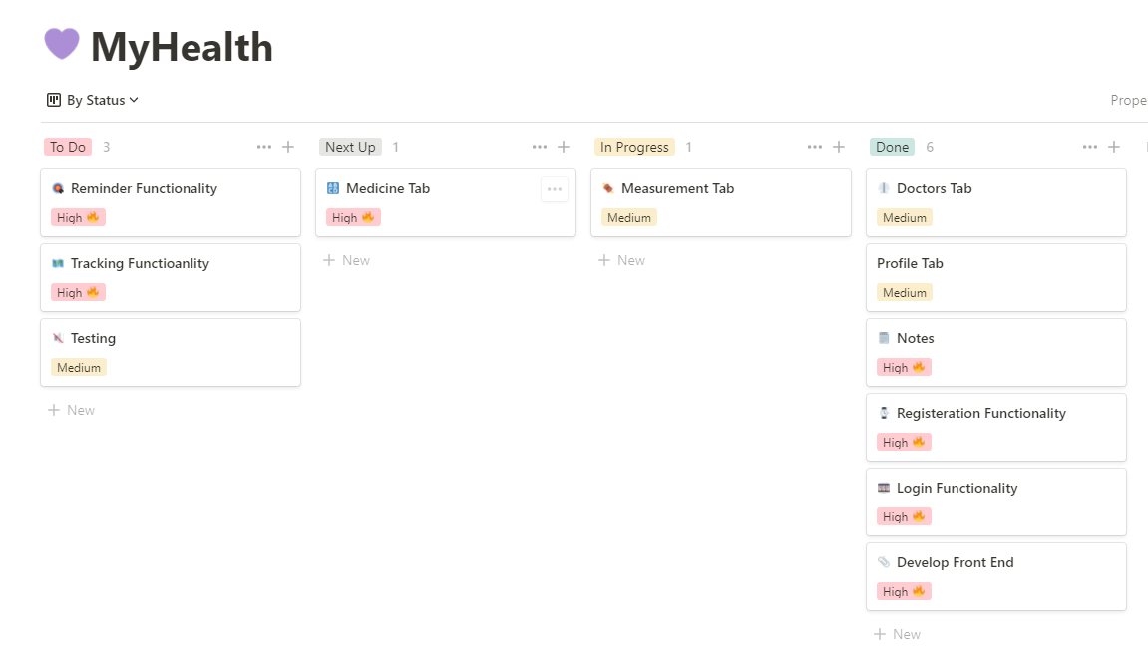

Figure Kanban board for the developed system

As shown in the above Kanban board, the board is divided into four parts:

* **To Do:** This part contains the tasks that are to be initiated.
* **Next Up:** This section of the board contains the task that is planned to be initiated after the in-progress work is done.
* **In Progress:** This section of the board contains the task that is currently being worked up upon.
* **Done:** This section contains that tasks that are completed or are developed.

As the person working on the project was me alone, the WIP (Work In Progress) was limited to one task. Thus, each task was developed one at a time.

1. **Finding the Bottlenecks**

Visualizing the work with the help of the Kanban board allowed me to find where the bottleneck of the project was. For this project, I was sure that there would be some problem in the process of sending notifications in the system; thus, this task was kept in last after completion of every task so that I can solely focus on the specific task when the time comes.

1. **Optimizing the Working Process**

The visualization of the task helped reduce the tasks being developed and assign the tasks to be done in each period. With this estimation on time to develop each task was done, by knowing which task might take more time, the order in which task was to be initiated first was then decided.

## SURVEY RESULTS

## PRE-SURVEY RESULTS

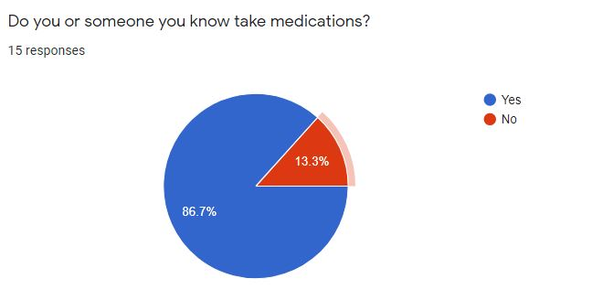**Question 1:**

Figure Chart showing response to the Question 1 of the Pre-Survey

**Question 2:**

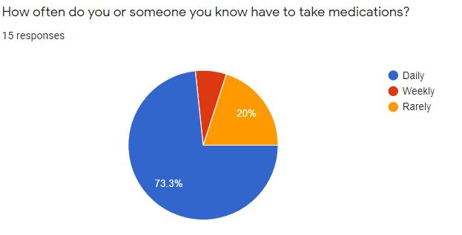

Figure Chart showing response to the Question 2 of Pre-Survey

**Question 3:**

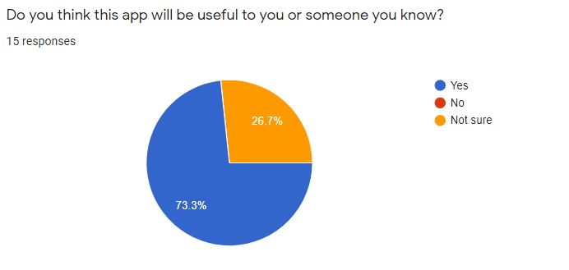

Figure Chart showing response to the Question 3 of Pre-Survey

**Question 4:**

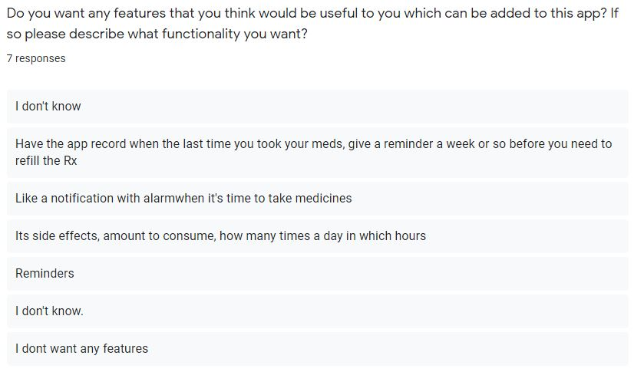

Figure Response to the Question 4 of Pre-Survey

Detailed description in Appendix.

## POST-SURVEY RESULTS

**Question 1:**

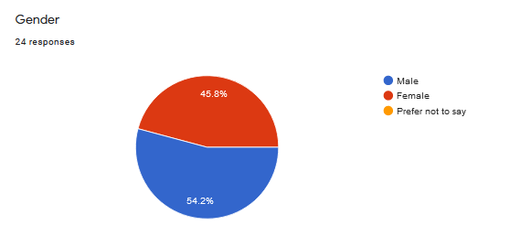

Figure Chart showing response of Question 1 of Post-Survey

**Question 2:**

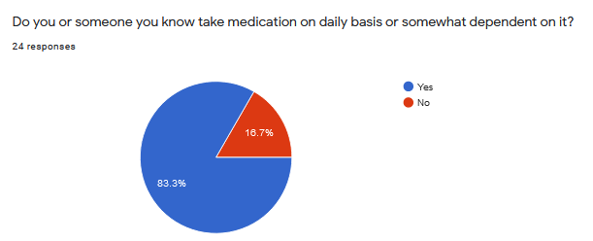

Figure Chart showing response of Question 2 of Post-Survey

**Question 3:**

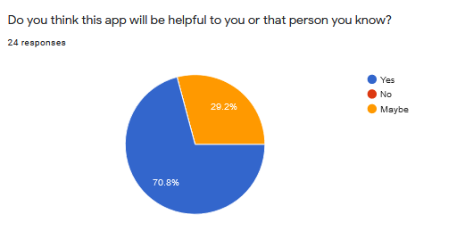

Figure Chart showing response of Question 3 of Post-Survey

**Question 4:**

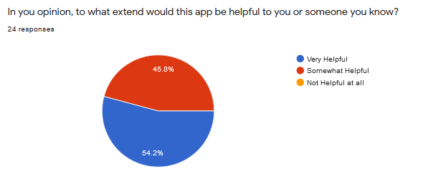

Figure Chart showing response of Question 4 of Post-Survey

**Question 5:**

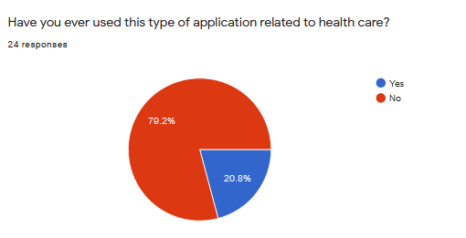

Figure Chart showing response of Question 5 of Post-Survey

**Question 6:**

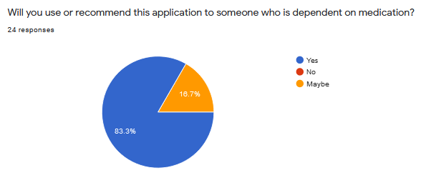

Figure Chart showing response of Question 6 of Post-Survey

**Question 7:**

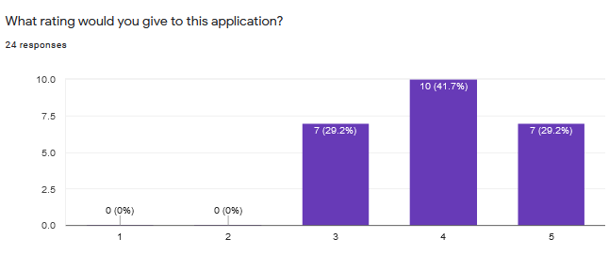

Figure Chart showing response of Question 7 of Post-Survey

**Question 8:**

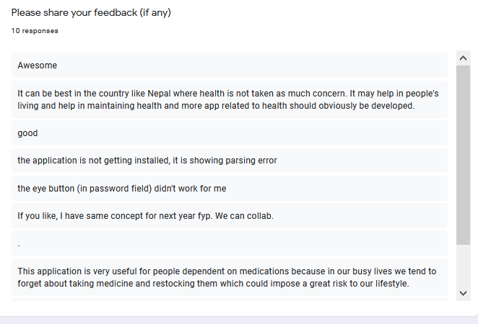

Figure Response of Question 8 of Post-Survey

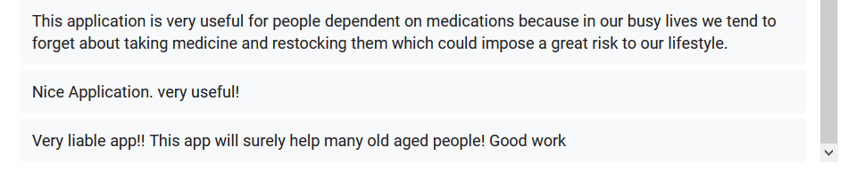

Figure Response of Question 8 of Post-Survey 2

**Question 9:**

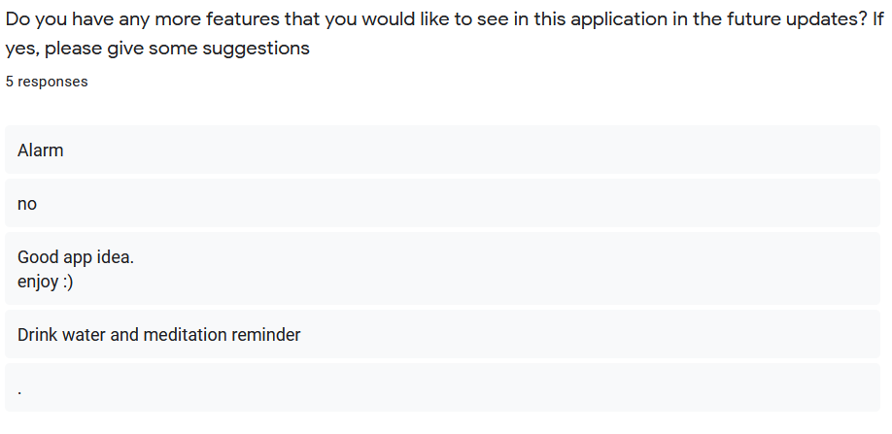

Figure Response of Question 9 of Post-Survey

Detailed description in Appendix.

## REQUIREMENT ANALYSIS

This part of the report consists of information related to the part where requirement gathering process for the development of the “My Health” application. The requirement gathering process is one of the most crucial part as this helps to clear out the goals for the project and helps to make the development process easier. It is the first step that we take while developing any project.

For the requirement gathering process for this project, at first intensive research regarding similar application was done, the user feedback of the similar application along with the features available in the similar application were taken into consideration to build out a set of features that were going to be developed for the “My Health” application. To gather additional requirements, a survey was also conducted to know what type of application the people wanted.

### Features of the application

The application features were created with much thought about what a typical person who takes medication daily might need. The features of the mobile application created are as follows:

1. **Medicine reminder:** The users can add the medicine they take into this application and various detail regarding the medication. The app then sends a push notification to the user every time they need to take the medication.
2. **Medicine re-stock reminder:** While adding the medication detail, the user is also asked for the medication stock they currently have, and when the stock is running low or is finished, the application sends a notification reminding the user to refill their stock or that their stock has run out.
3. **Notes:** The users can also save notes in this application.
4. **Doctors Information:** The users can store basic information about their doctors, such as their contact information. They can contact the doctor form within the application for ease of use.
5. **Health-related measurement:** The user can save various health-related measurements such as Blood Pressure, Body Fat, and Pulse in the application.
6. **Track Me:** This feature of the application was made for people with special conditions such as periodic strokes, heart disease, etc. The user can enter a specific interval of time in minutes for the application to track their location in and if the user has not traveled within the entered time frame, it gives an alert to the user asking if they are ok or not and if they pressed no this sends an SMS to the emergency number the user has set up initially asking for their help along with the user location.

**ADDITIONAL FEATURES ADDED**

1. **Medicine History:** The user can view the medicine they have consumed within the medicine history tab.

## DESIGN

This portion contains the design portion of the developed application. Since our project follows Kanban Methodology, which is an agile methodology much diagrams are not needed.

### Use Case Diagram

A use case diagram is a behaviour diagram in UML (Unified Modelling Language). These diagrams model the functionality of a system using actors and use cases. Use case diagrams are a set of actions, services, and functions that the system needs to perform. These diagrams help visualize the functional requirements of a system that will help make various design choices and development priorities. Use case diagrams to specify how the system interacts with the actors without worrying about how the functionality is implemented. These diagrams provide a good high level of analysis of the system and help identify any internal or external factors that may influence the system. (smartdraw, 2021)

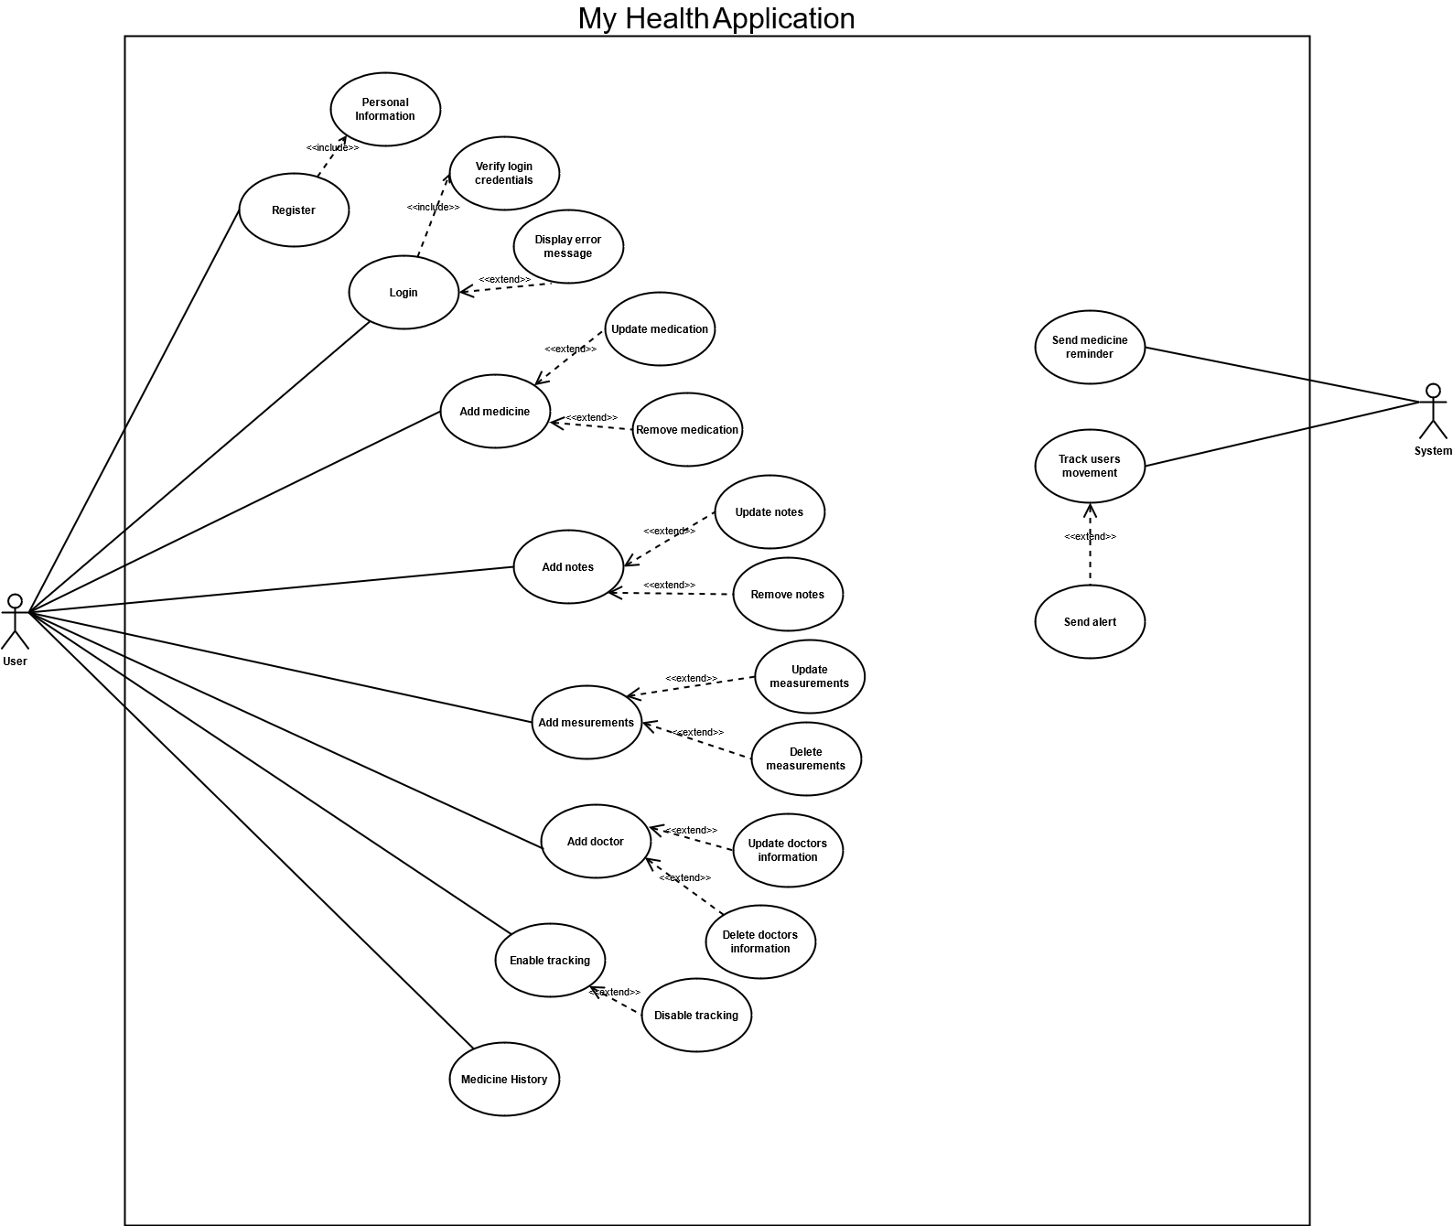

Figure Use Case Diagram for the overall system

The additional content of the system's design, such as Gantt Chart, Work Breakdown Structure, Flowcharts, High-level use case description, use case diagram of actors, DFD diagrams, and wireframes, are in the Appendix D section of the report.

### Activity Diagram

Activity diagram is an important diagram in UML used to describe the dynamic aspect of the system. It is like a flowchart that represents the flow from one activity to another activity. The activity can be described as an operation of the system. (tutorialspoint, 2021)

The activity diagrams drawn in this report show the overall functioning process of all the application's main features.

System Activity Diagram

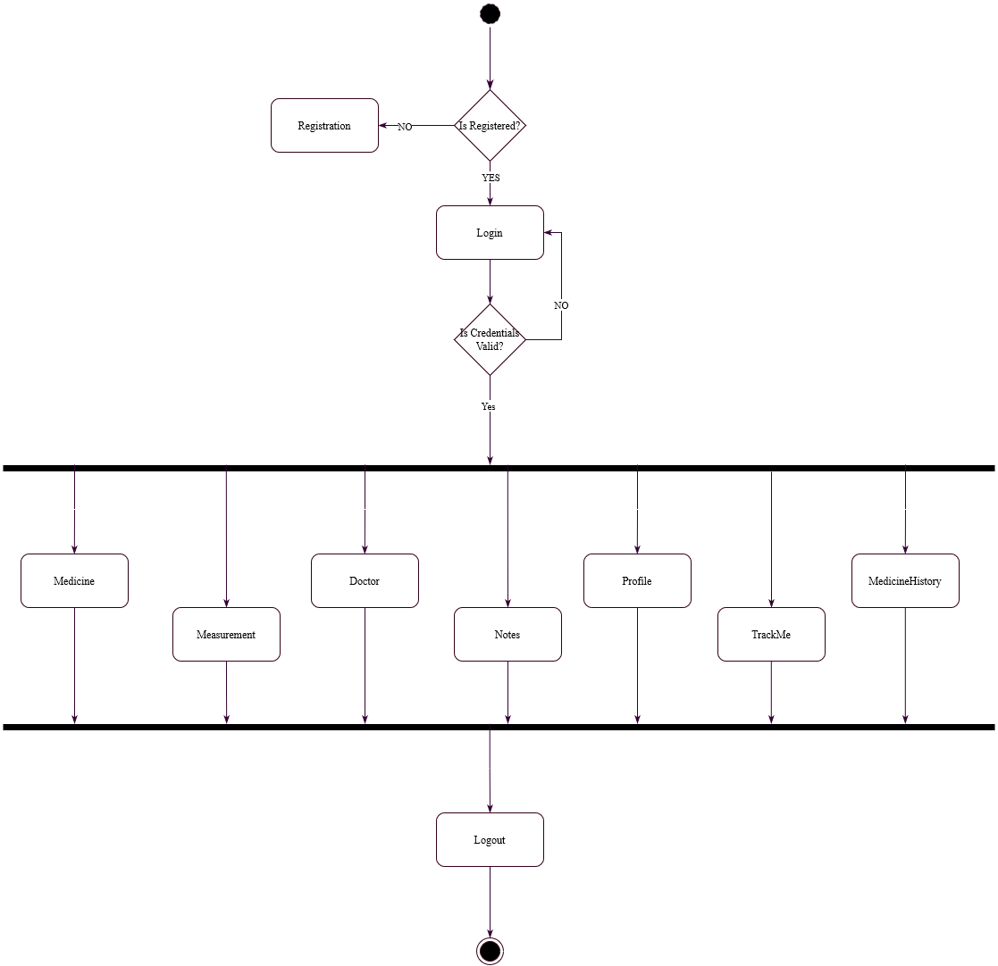

Figure System Activity Diagram

Login Activity Diagram

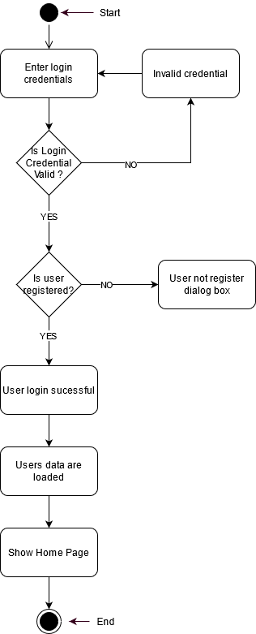

Figure Login Activity Diagram

Register Activity Diagram

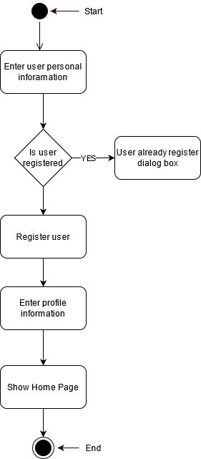

Figure Register Activity Diagram

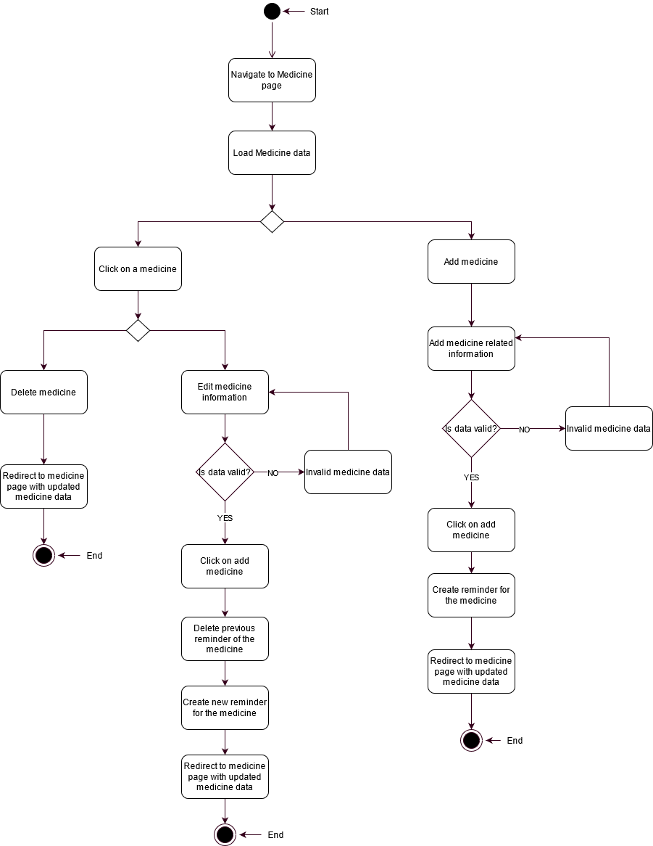Medicine Activity Diagram

Figure Medicine Activity Diagram

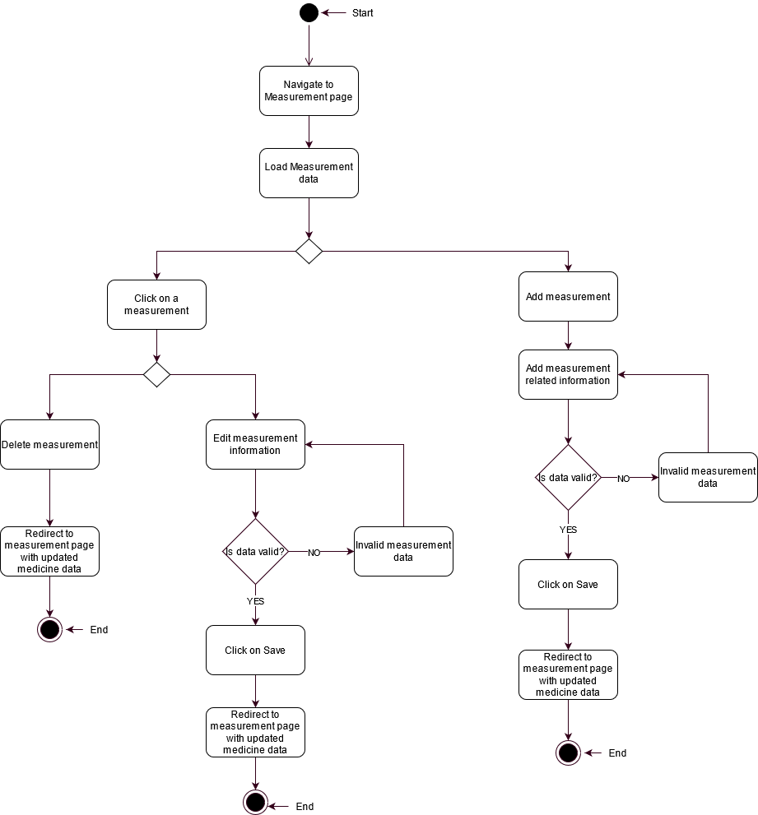Measurement Activity Diagram

Figure Measurement Activity Diagram

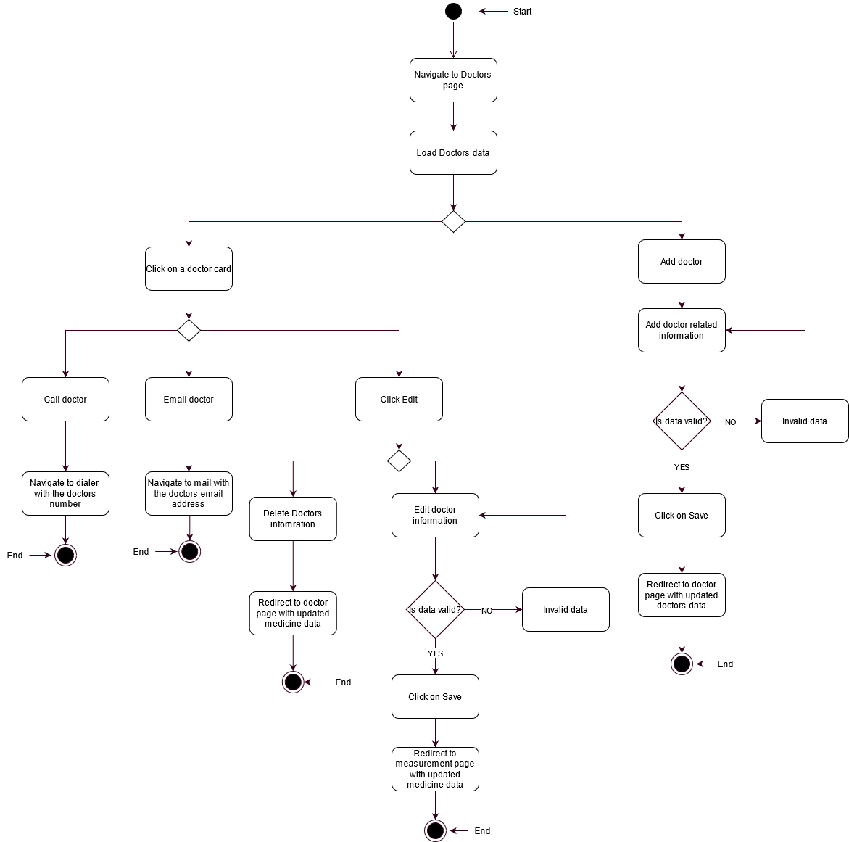Doctors Activity Diagram

Figure Doctors Activity Diagram

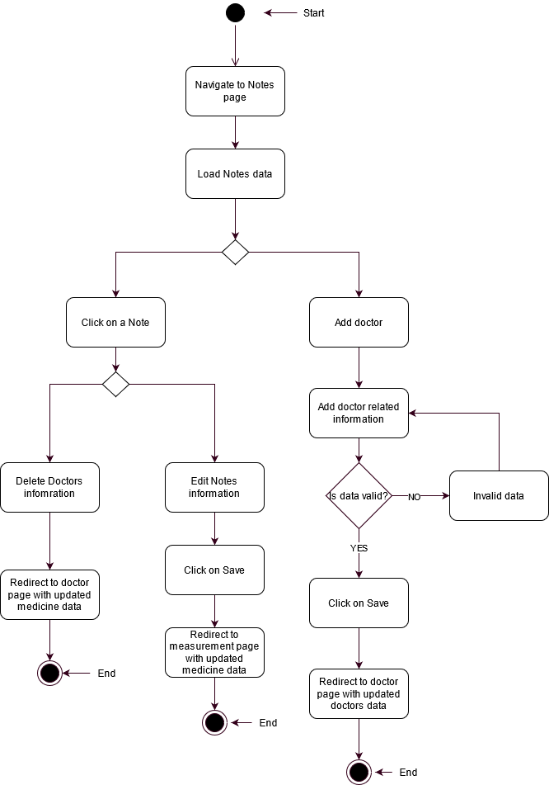Notes Activity Diagram

Figure Notes Activity Diagram

Profile Activity Diagram

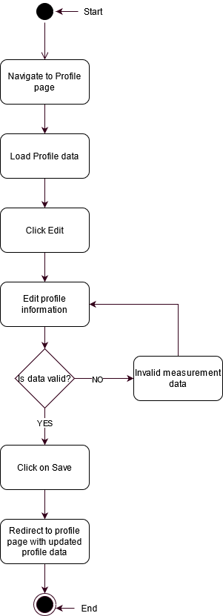

Figure Profile Activity Diagram

Track Me Activity Diagram

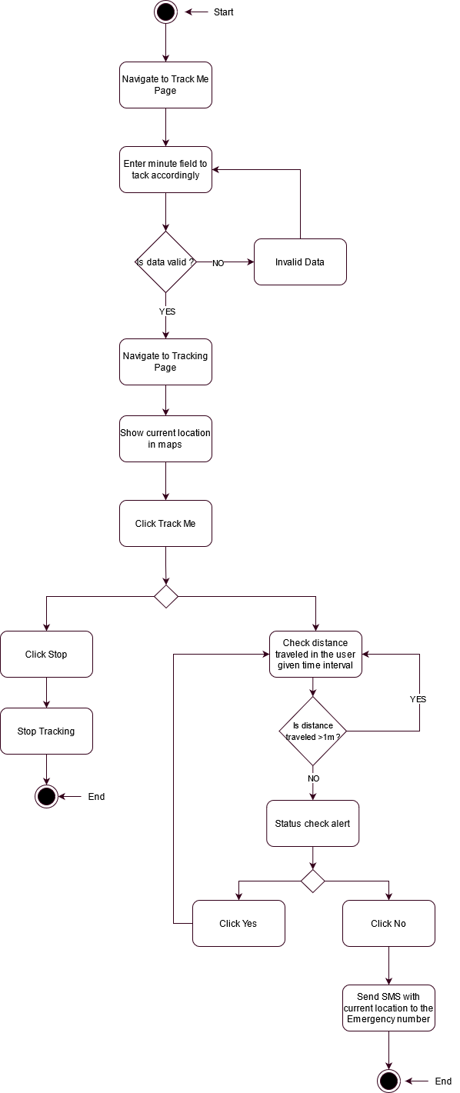

Figure Track Me Activity Diagram

Medicine History Activity Diagram

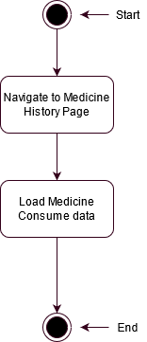

Figure Medicine History Activity Diagram

### Collaboration Diagram

Collaboration Diagram, also known as Communication Diagram in UML, is used to show how objects interact with each other within an overall IT architecture and how users can benefit from this collaboration. A collaboration diagram shows a form of visual chart that looks like a flow chart. (techopedia, 2021)

Login Collaboration Diagram

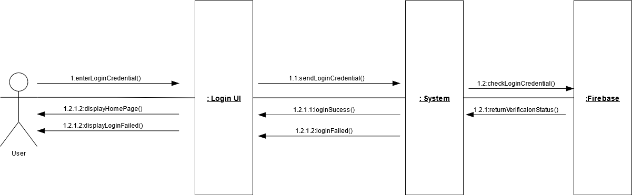

Figure Collaboration Diagram Login User

Register Collaboration Diagram

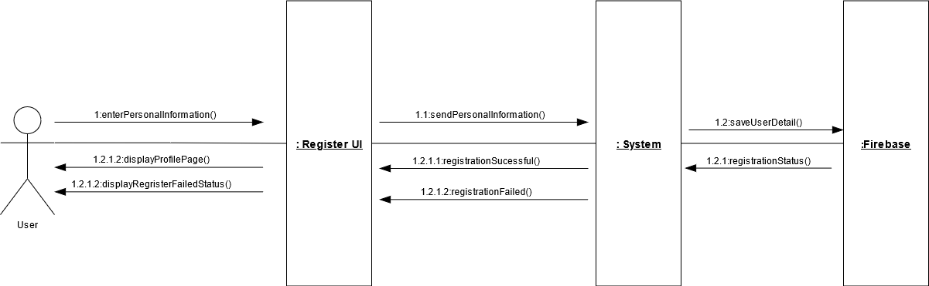

Figure Collaboration Diagram Register User

Medicine Collaboration Diagram

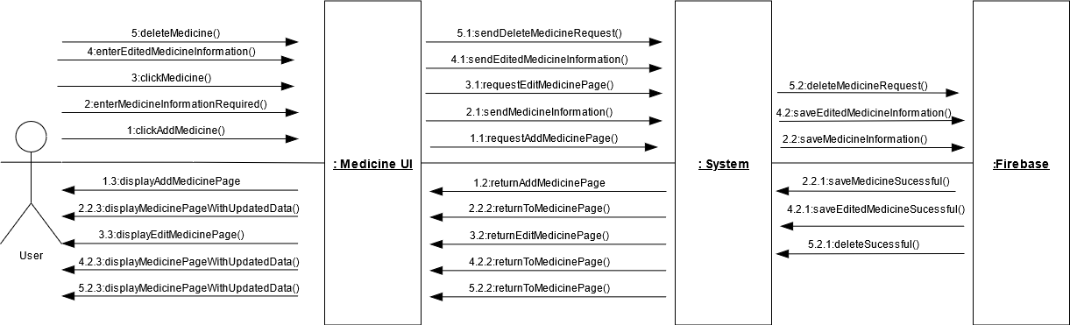

Figure Collaboration Diagram Add/Edit/Delete Medicine

Measurement Collaboration Diagram

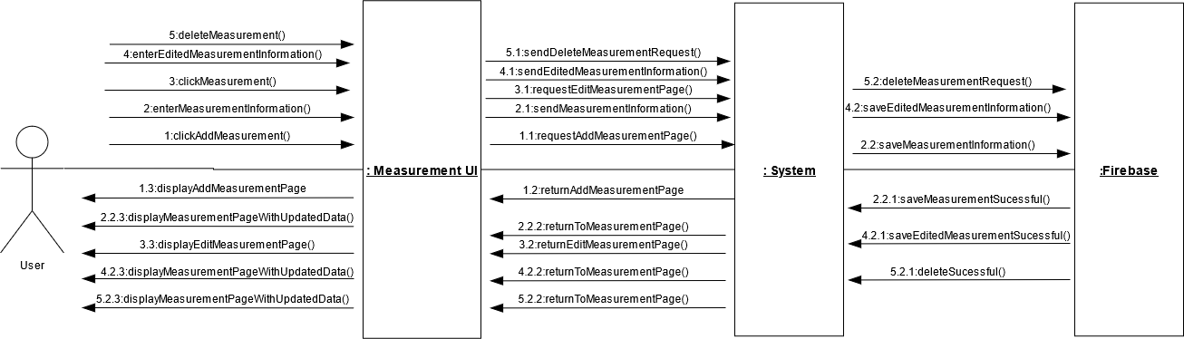

Figure Collaboration Diagram Add/Edit/Delete Measurement

Doctors Collaboration Diagram

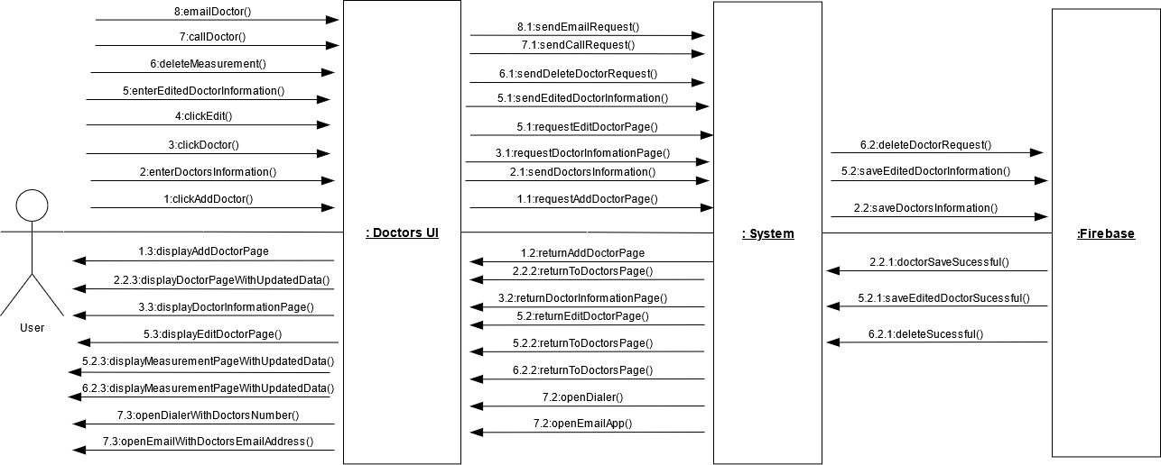

Figure Collaboration Diagram Add/Edit/Delete/Call/Email Doctor

Notes Collaboration Diagram

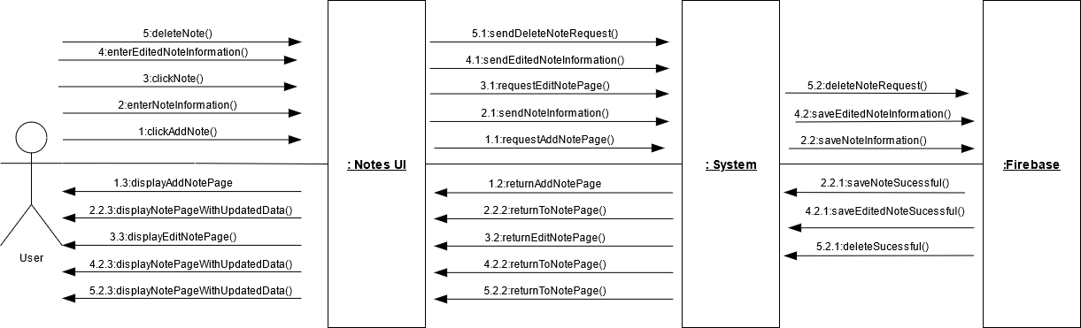

Figure Collaboration Diagram Add/Edit/Delete Notes

Profile Collaboration Diagram

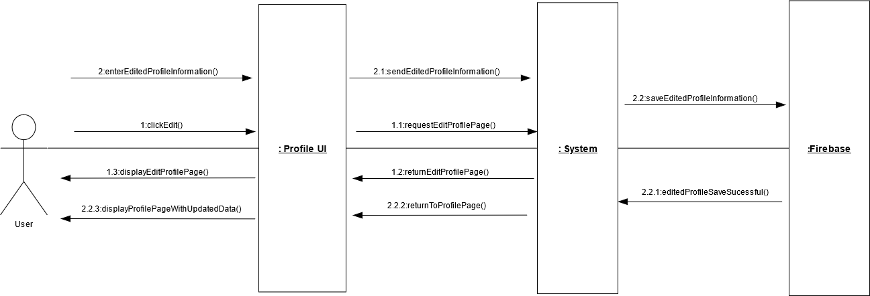

Figure Collaboration Diagram Edit Profile

Track Me Collaboration Diagram

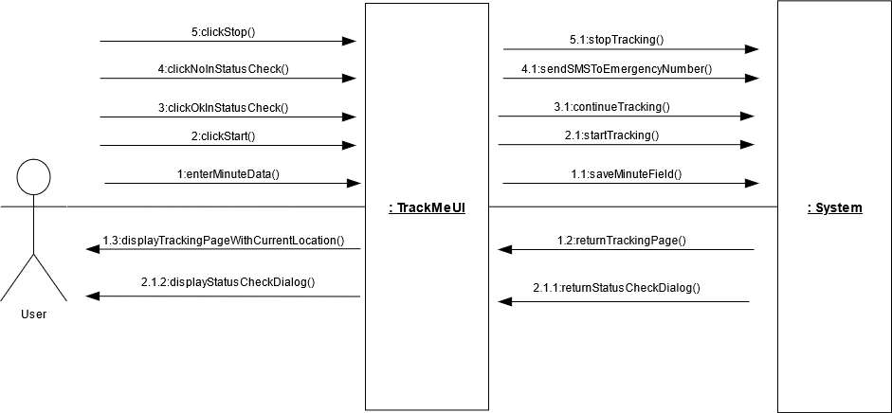

Figure Collaboration Diagram for Tracking

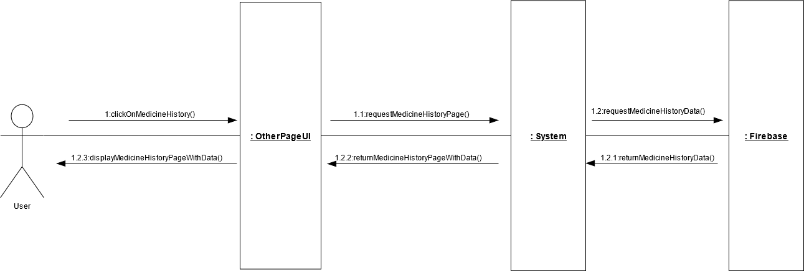Medicine History Collaboration Diagram

Figure Collaboration Diagram Medicine History

### Sequence Diagram

Sequence diagram is an interaction diagram in UML that shows how the operations are carried out. This diagram shows the interaction between objects in sequential order. They are also known as event diagrams or event scenarios. Sequence diagrams describe how and in what order the objects in a system function. (GeeksforGeeks, 2021)

Login Sequence Diagram

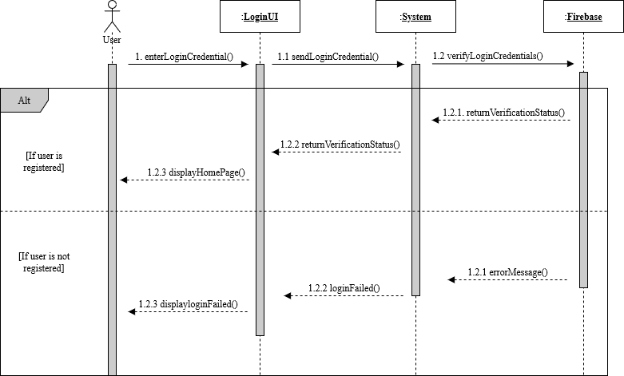

Figure Sequence Diagram Login User

Register Sequence Diagram

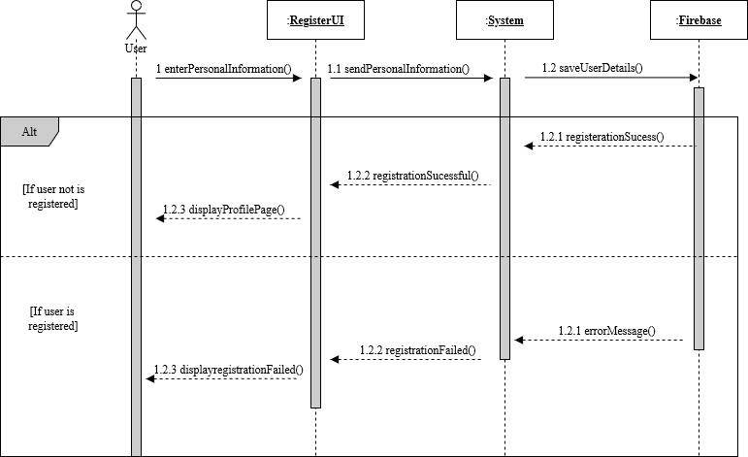

Figure Sequence Diagram Register User

Medicine Sequence Diagram

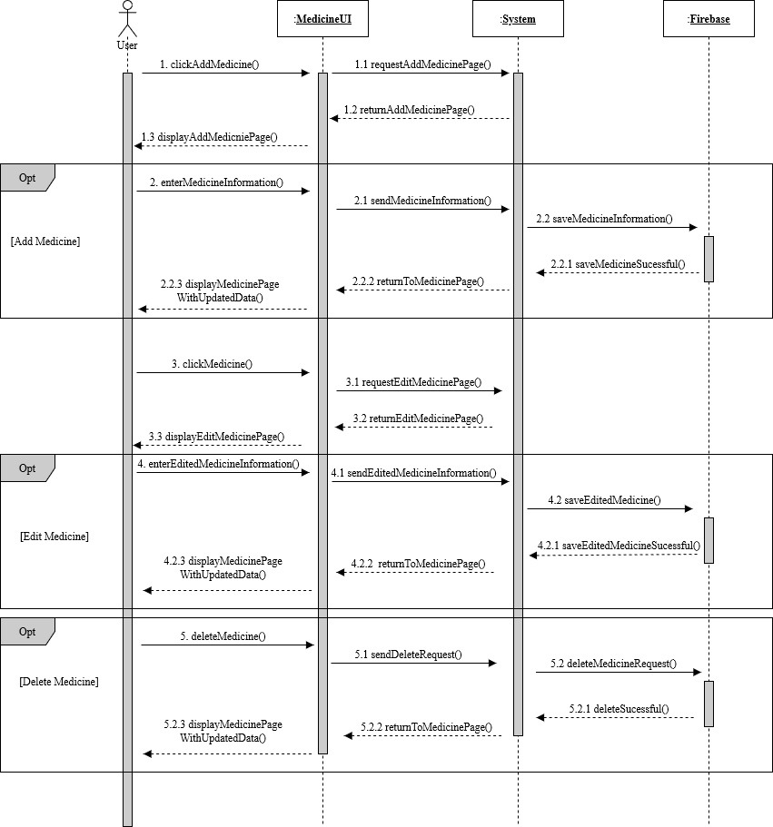

Figure Sequence Diagram for Add Medicine, Edit Medicine and Delete Medicine

Measurement Sequence Diagram

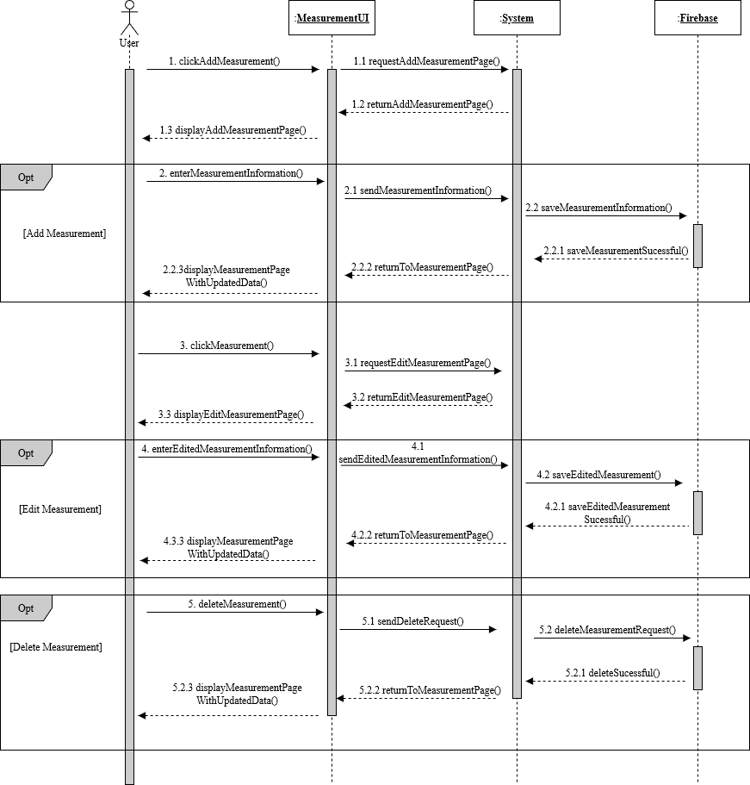

Figure Sequence Diagram for Add Measurement, Edit Measurement and Delete Medicine

Notes Sequence Diagram

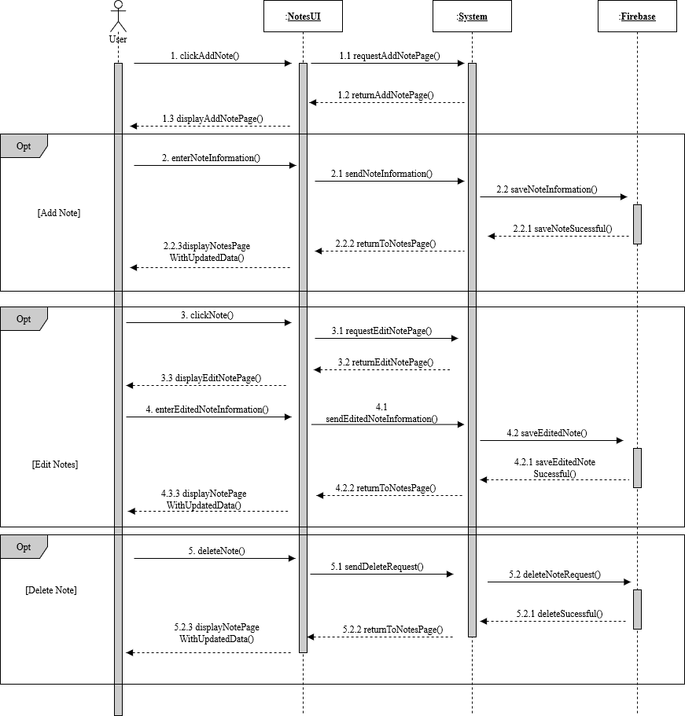

Figure Sequence Diagram for Add Note, Edit Note and Delete Note

Profile Sequence Diagram

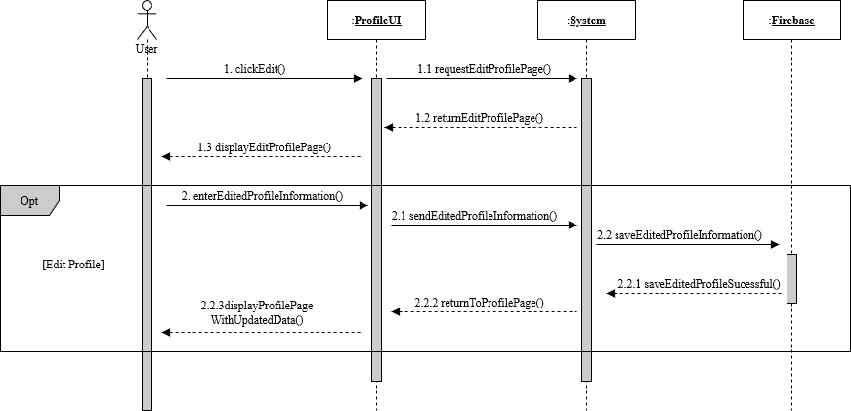

Figure Sequence Diagram for Edit Profile

Medicine History Sequence Diagram

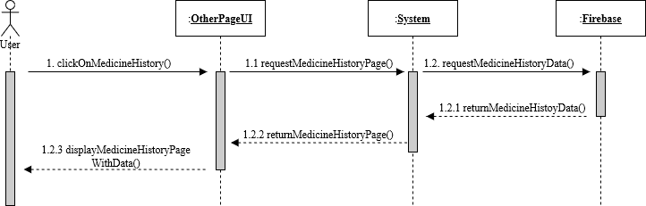

Figure Sequence Diagram for Medicine History

Track Me Sequence Diagram

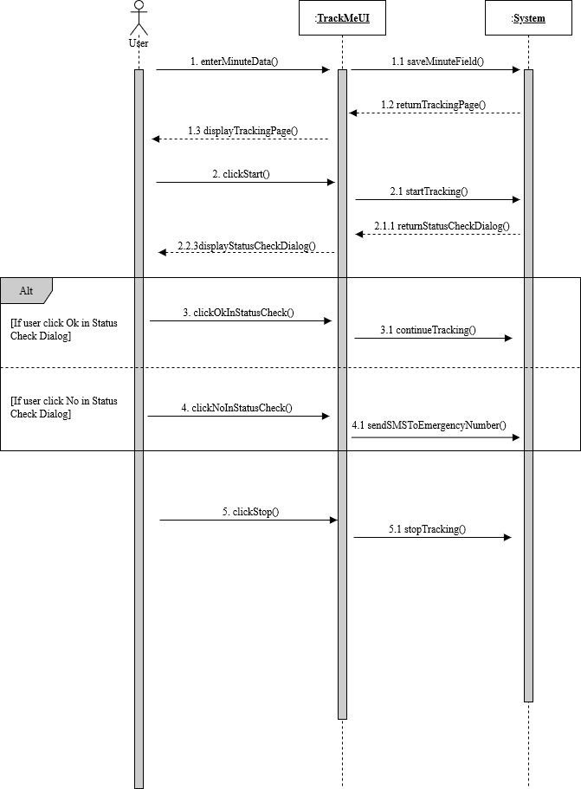

Figure Sequence Diagram for Track Me Functionality

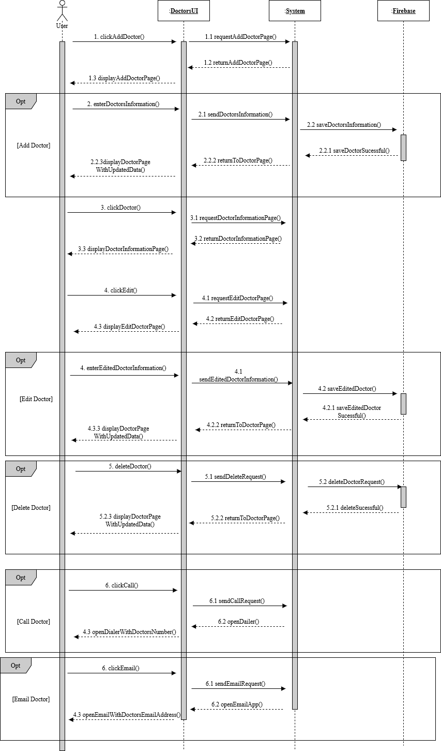Doctors Sequence Diagram

Figure Sequence Diagram for Add Doctor, Edit Doctor, Delete Doctor, Call Doctor and Email Doctor

## 3.7 IMPLEMENTATION

This section of the report consists of few screenshots of the core features of this application and the system architecture design of the application.

### 3.7.1. Core Features of the Application

1. **Medicine Reminder**

The functionality to provide a reminder for the medicine added by the user is one of the core features of this application. User Can set single or multiple reminders for their medication.

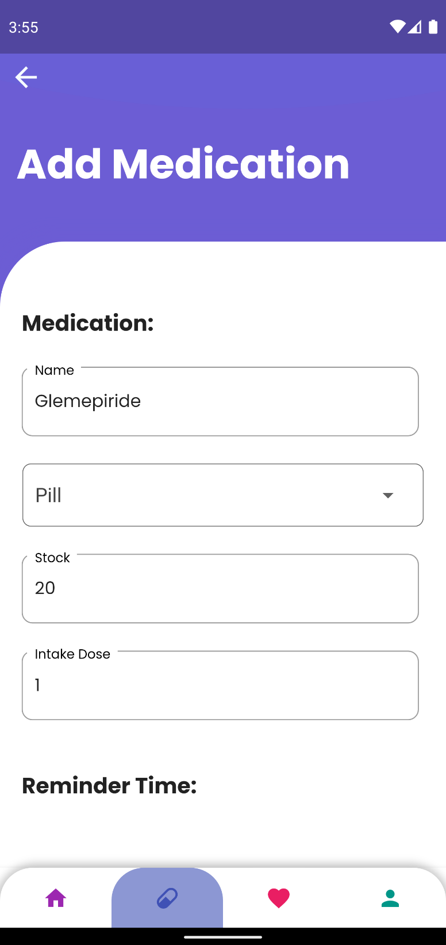

Figure Insert Medicine required Fields

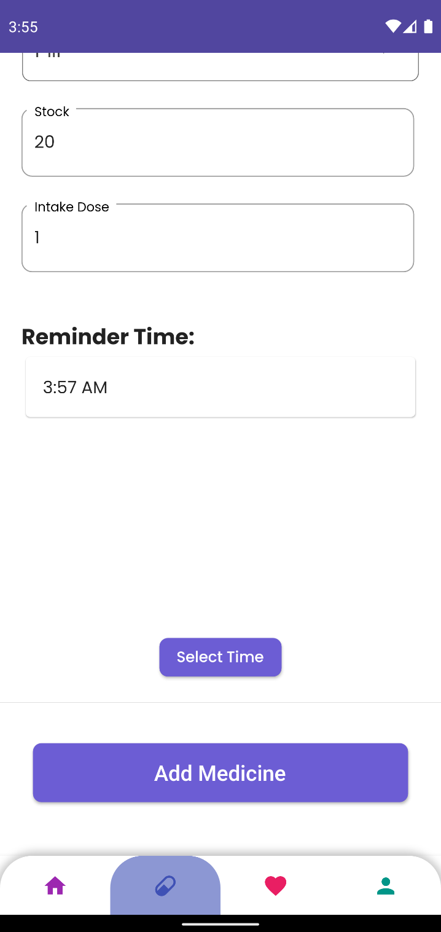

Figure Inserting the time to get a reminder

Here the user can set a single time or multiple time according to their needs.

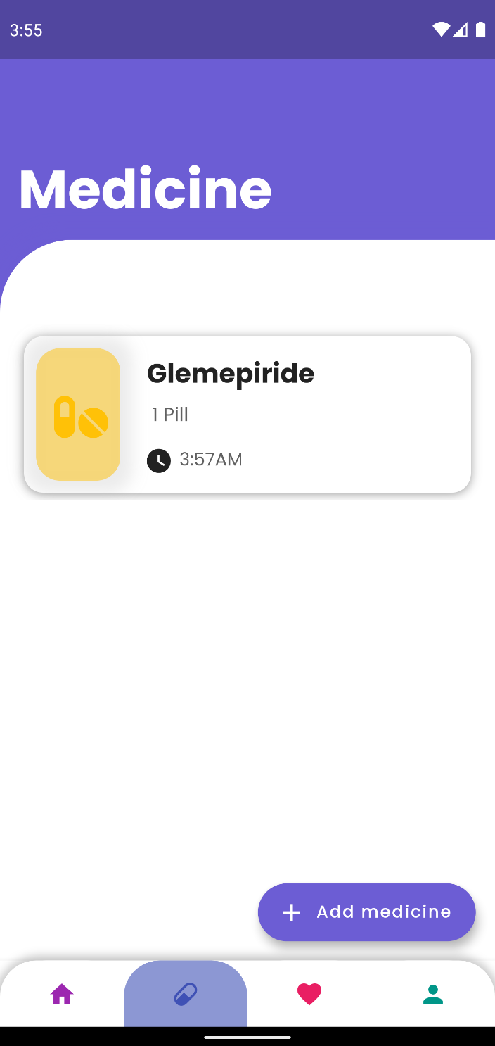

Figure The Medicine Added being show in the Medicine UI

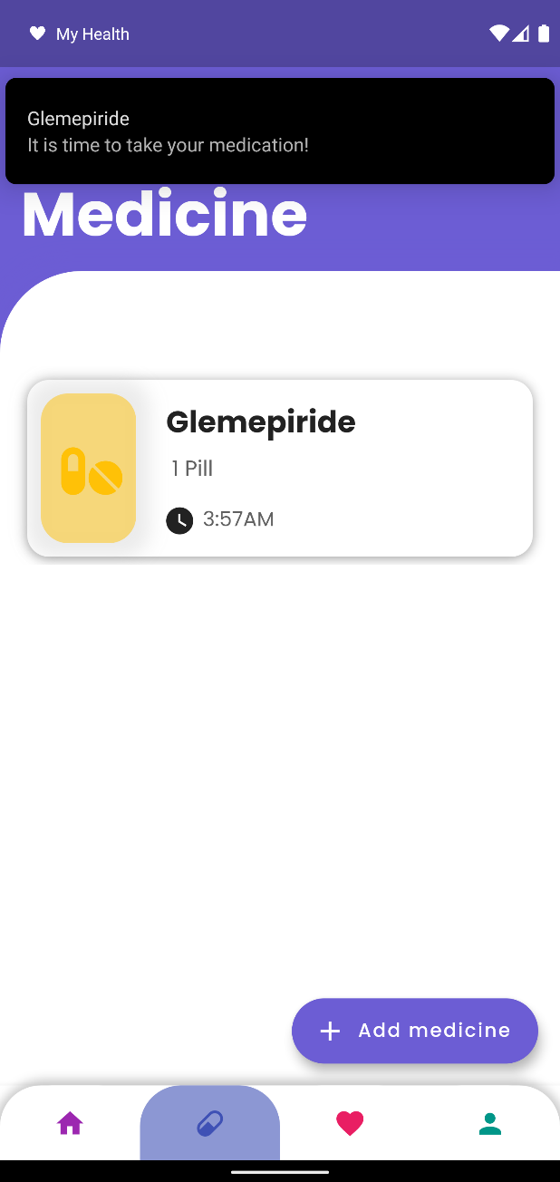

Figure Medicine reminder Notification being displayed on time

The user can also edit some information related to the medicine but has to setup a new reminder if he wants to do so. The user can also delete the medicine from here.

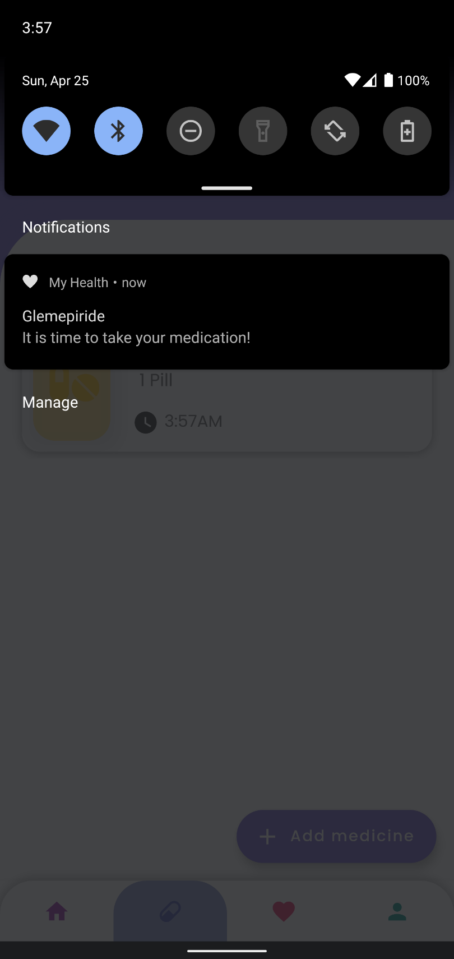

Figure Medicine Reminder being displayed in user define time

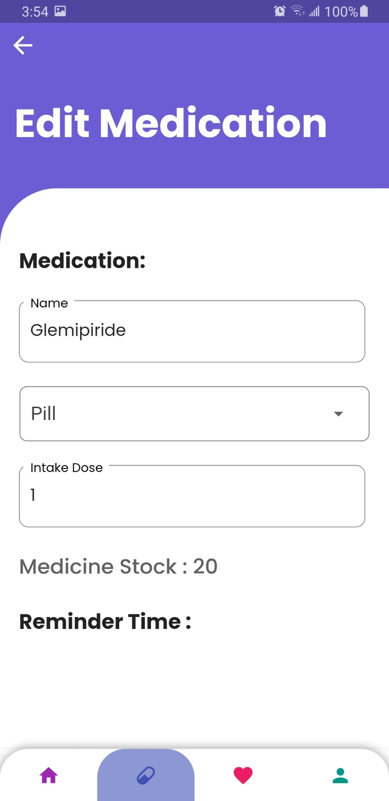

Figure Edit Medicine UI

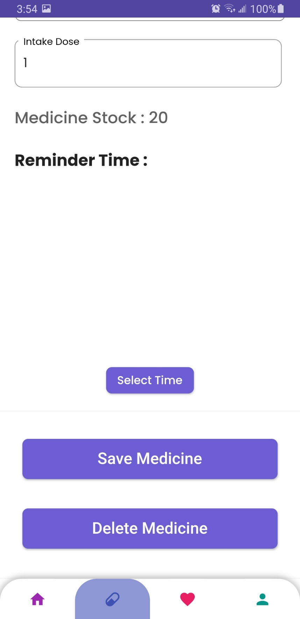

Figure Edit Medicine UI 2

1. **Medicine Stock Low/Empty Reminder**

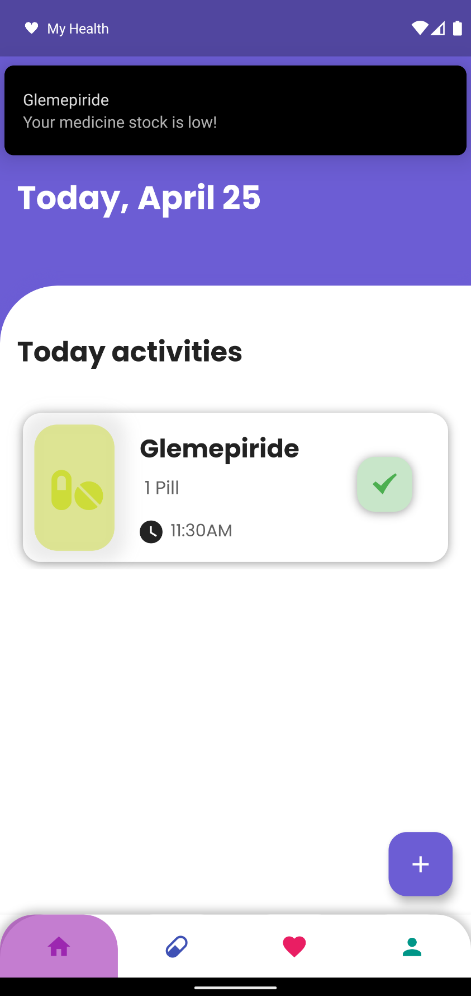

Figure Medicine Stock Low Reminder Being Displayed

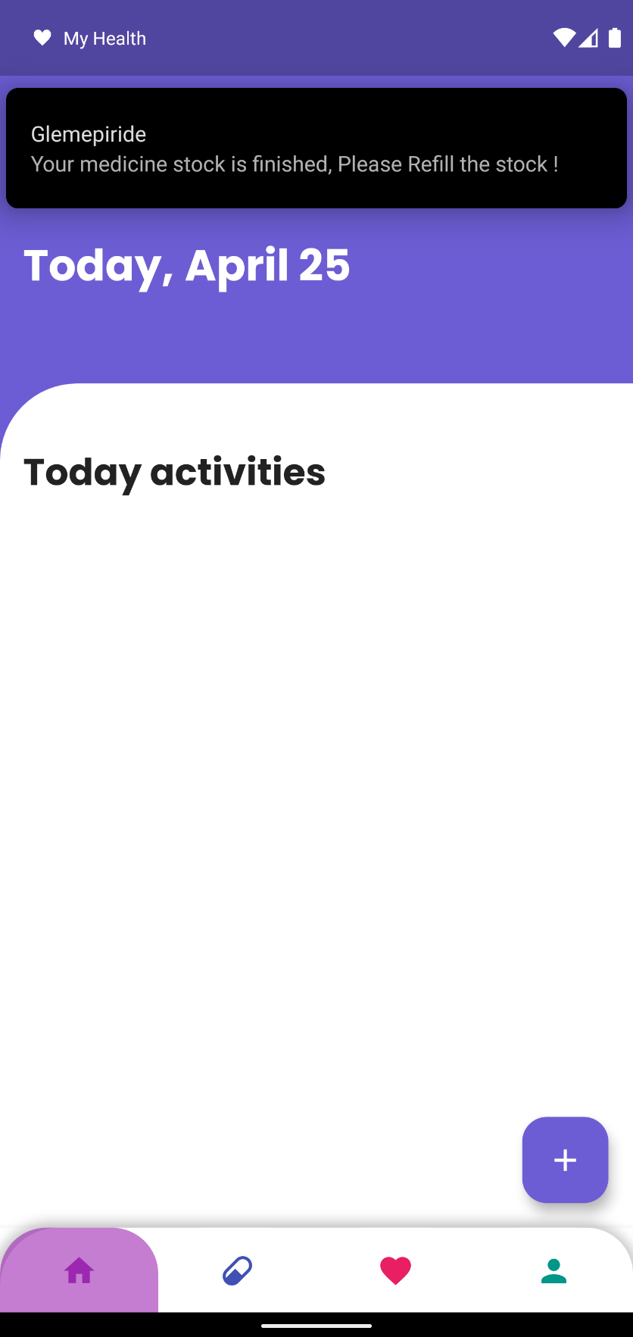

Figure Medicine Reminder Being shown when the stock has finished

1. **Notes**

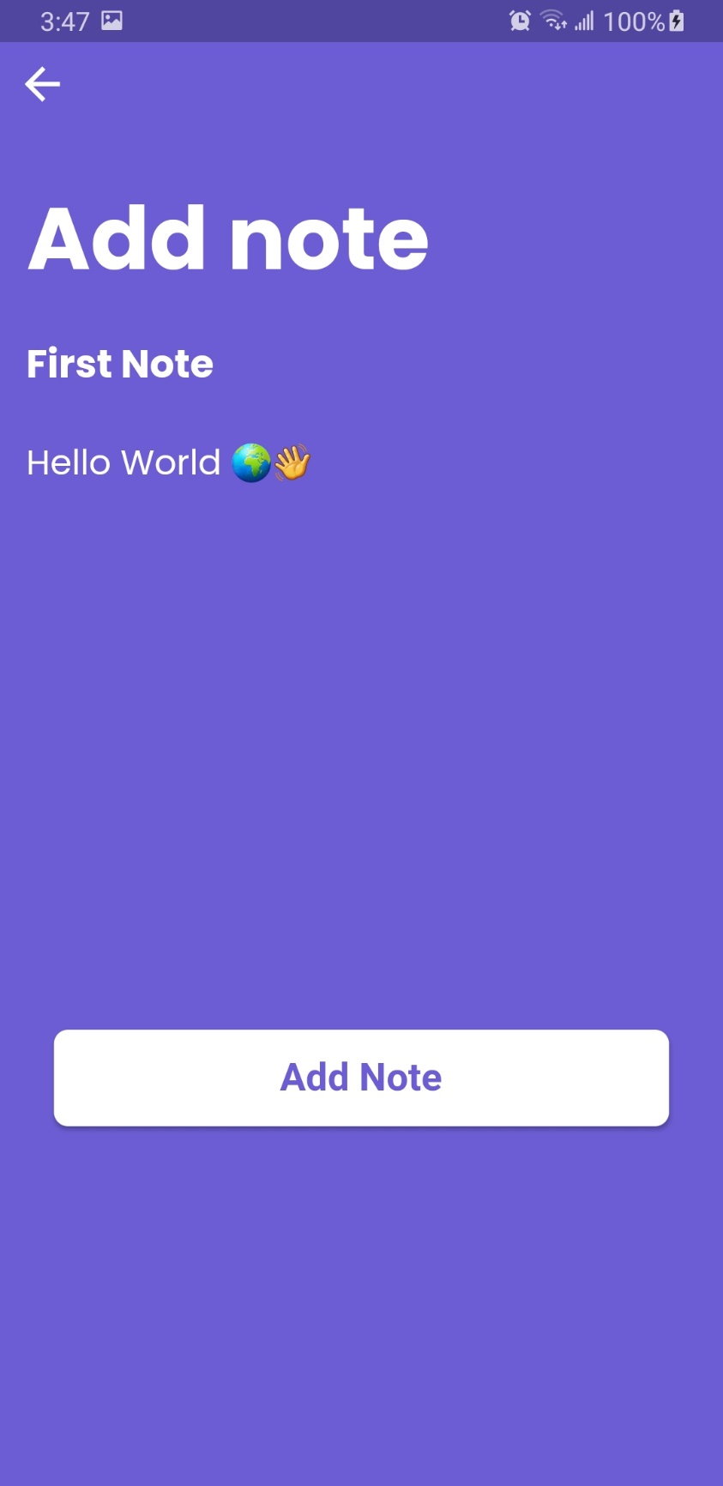

Figure Adding Notes into the system

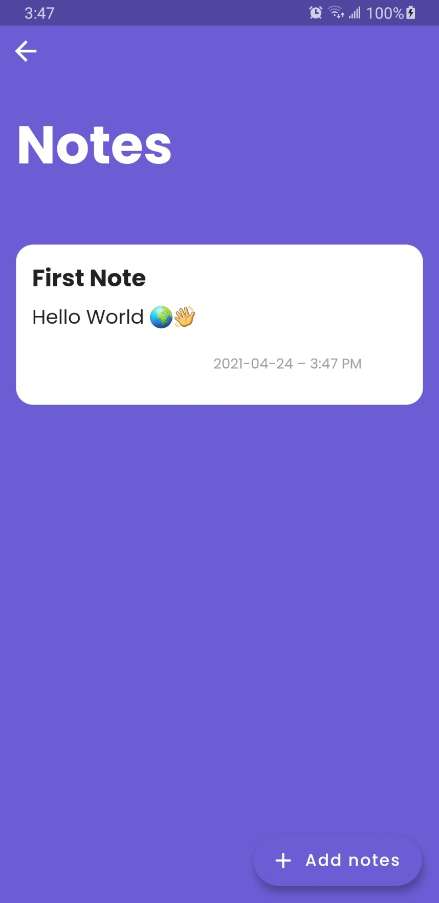

Figure Added Notes being displayed in Notes UI

The user can also edit the not if he/she desires.

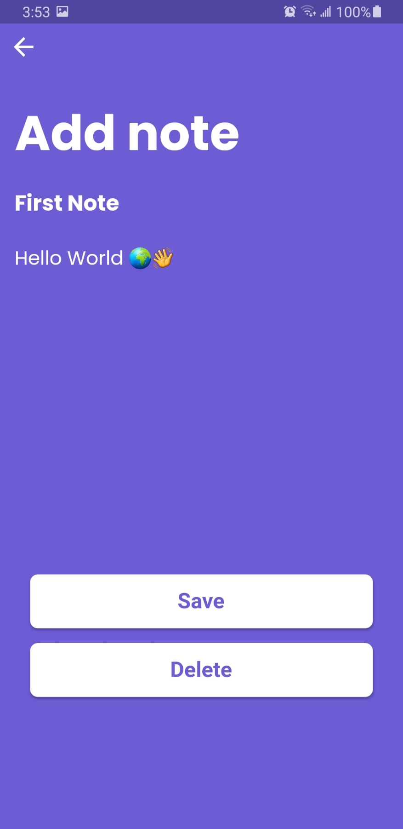

Figure Edit Note UI

1. **Add Doctor**

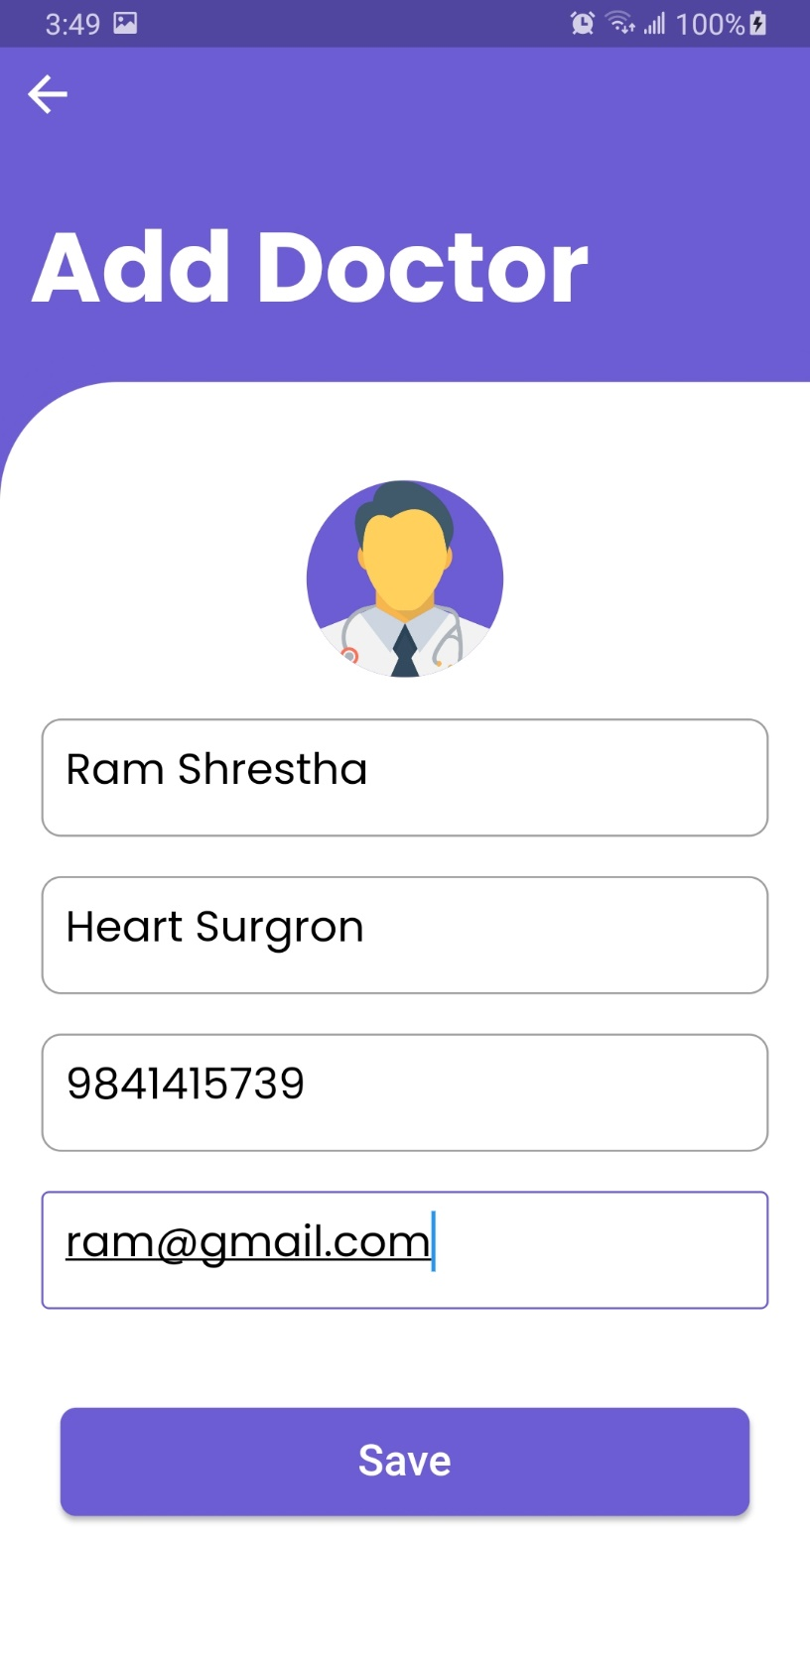

Figure Inserting Doctors information to add doctor

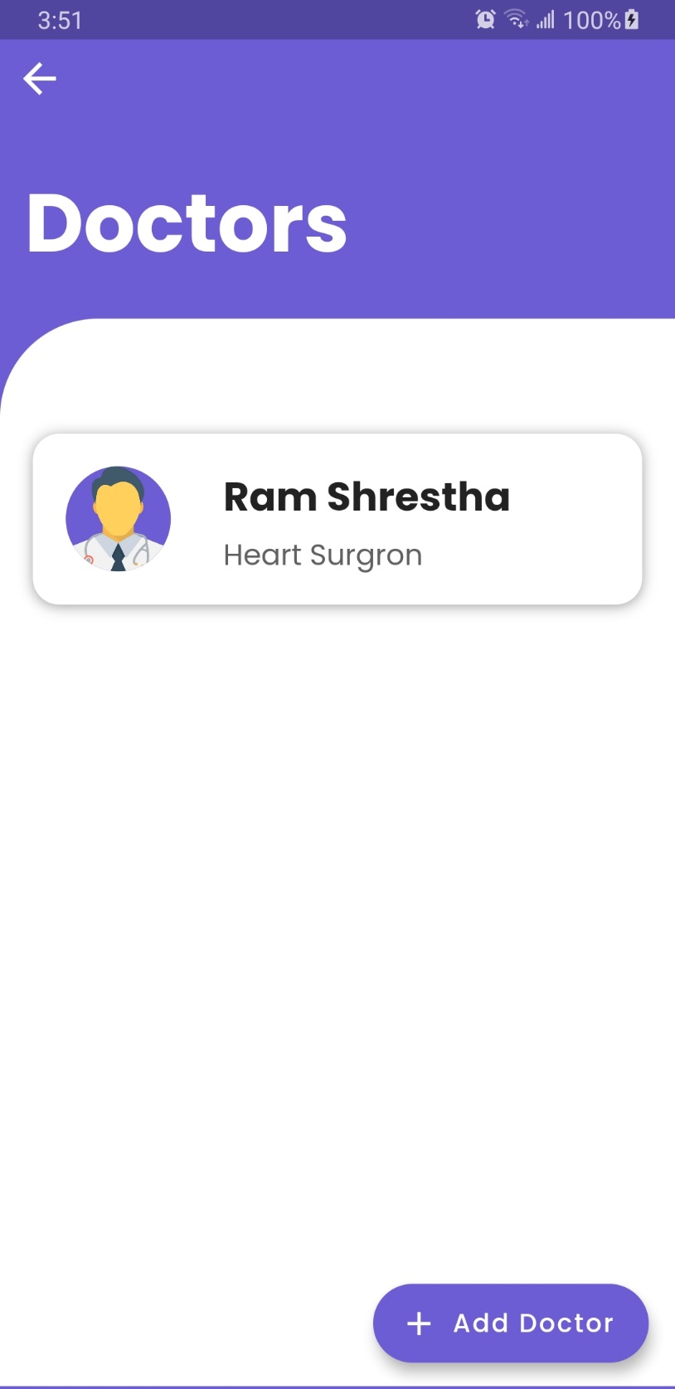

Figure Added Doctor being shown in Doctors UI

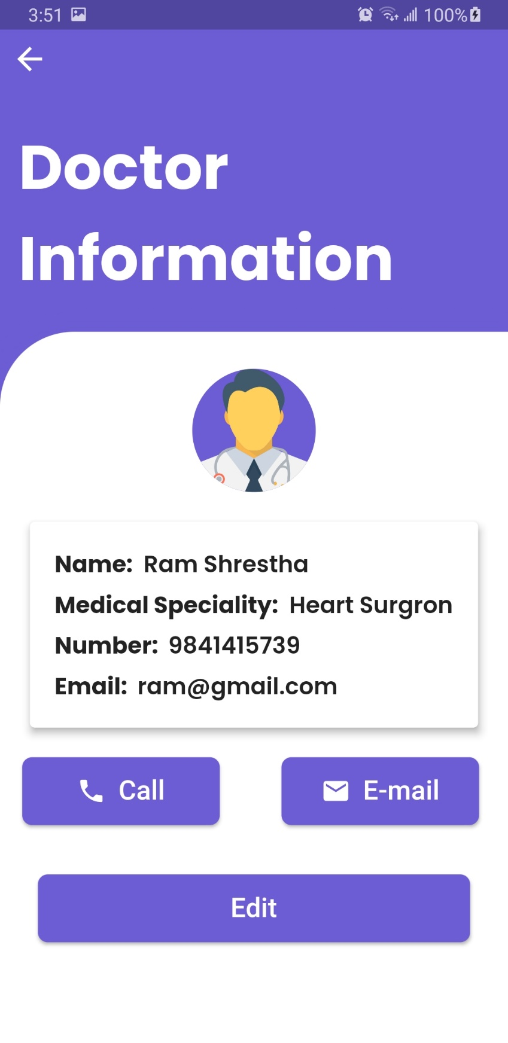

Figure Doctor Information UI

1. **Measurement**

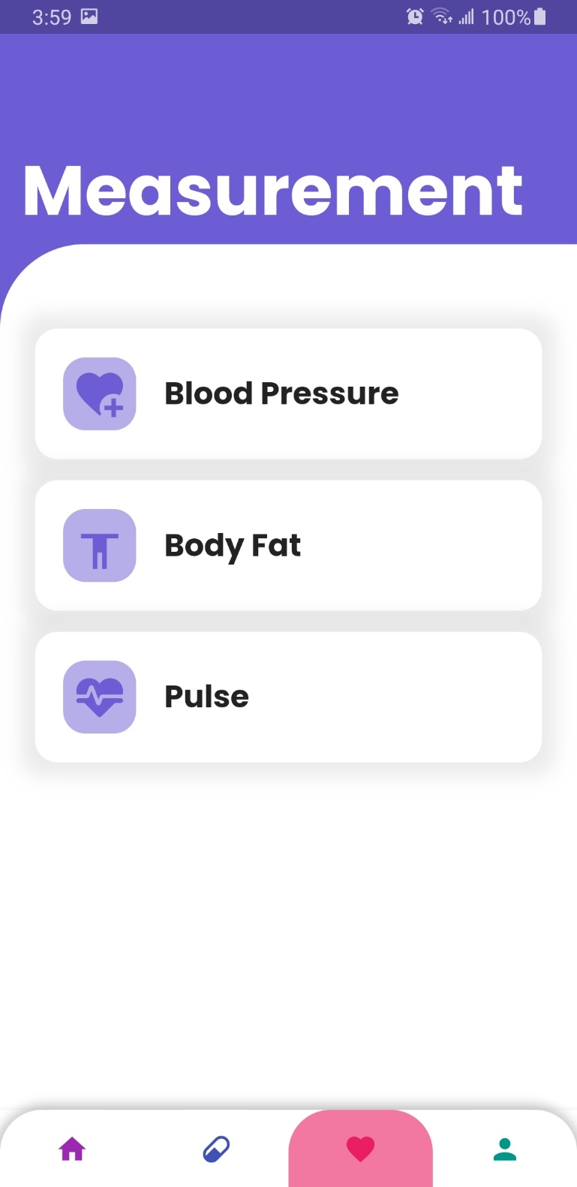

Figure Measurement UI

The user can add the measurement of their Blood Pressure, Body Fat and Pulse. The process of adding, editing, and deleting these health-related measurements for all there are the same. Thus, the screenshot for only one is shown below.

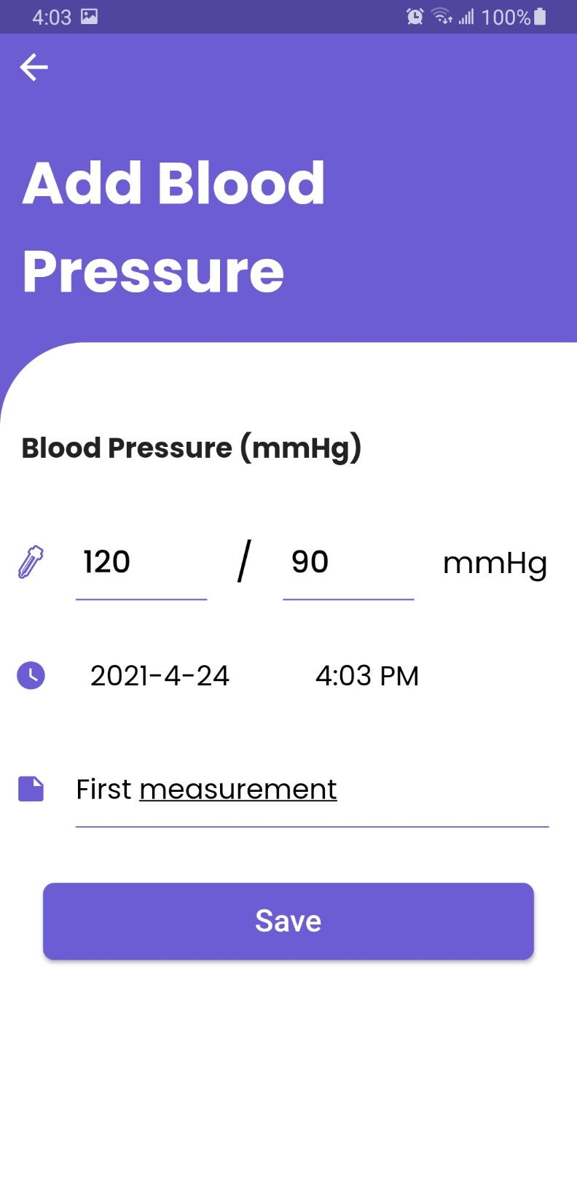

Figure Adding Measurement Blood Pressure

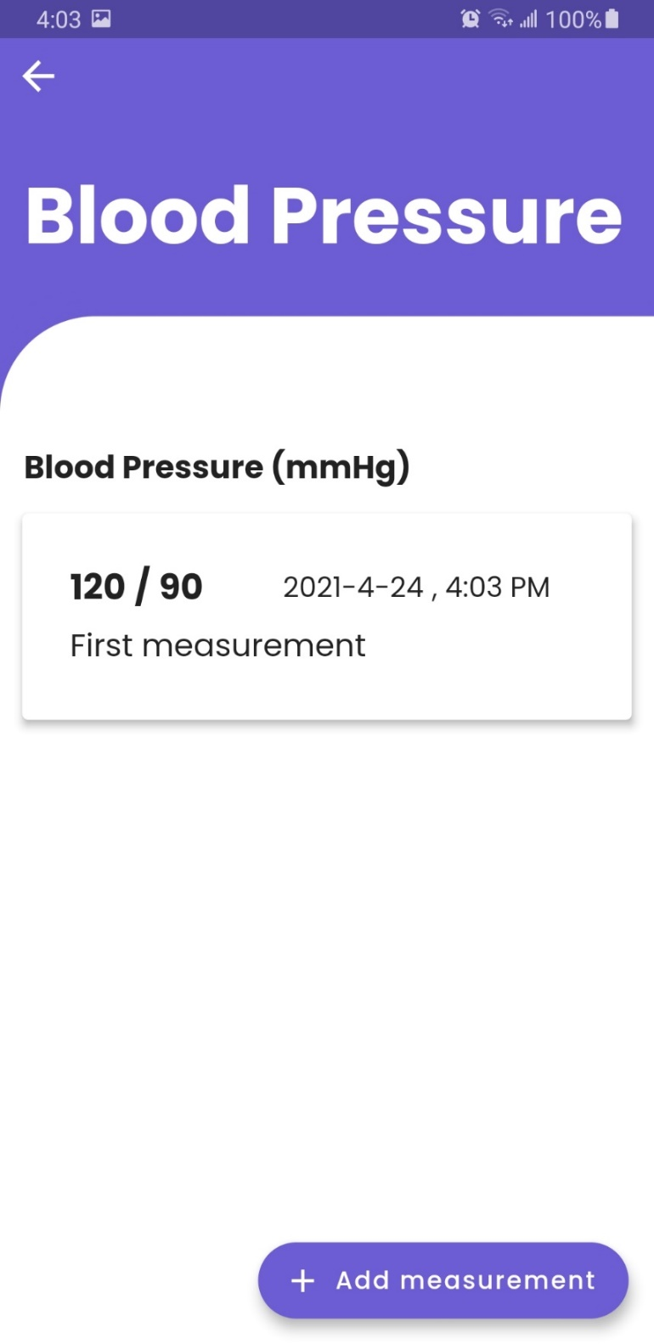

Figure Added Measurement Being displayed in the Measurement UI

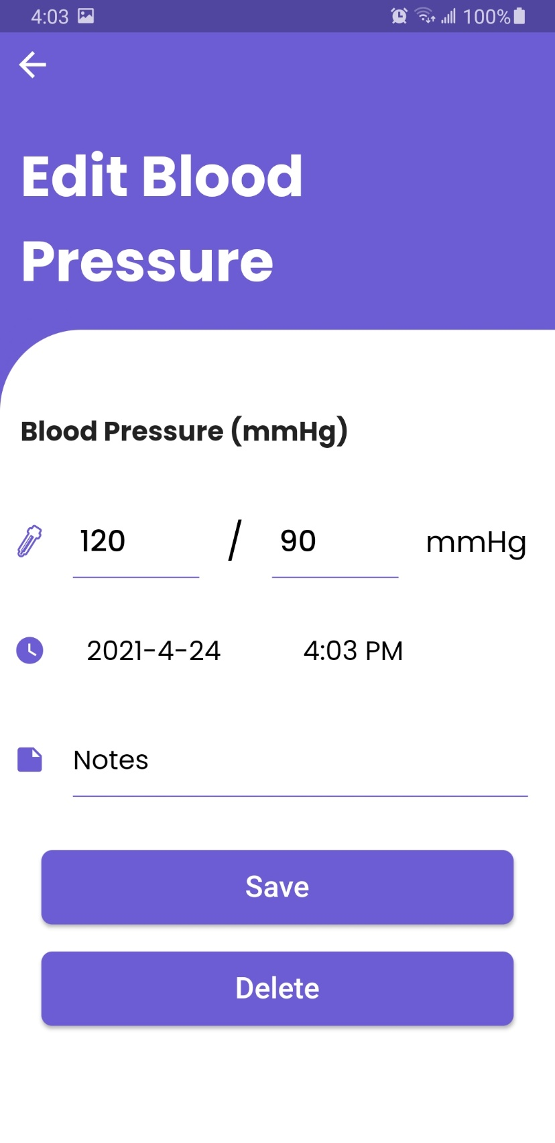

Figure Edit Measurement UI

1. **Track Me (Tracking Functionality)**

The application has a tracking feature that tracks the user location in the user entered minute interval. If the user has traveled a distance greater than 1 meter during this period, then the app keeps tracking. Otherwise, it shows a dialog box with vibration to ask if the user is alright and if the user clicks “No” in this dialog box, it sends an SMS to the emergency number saved by the user.

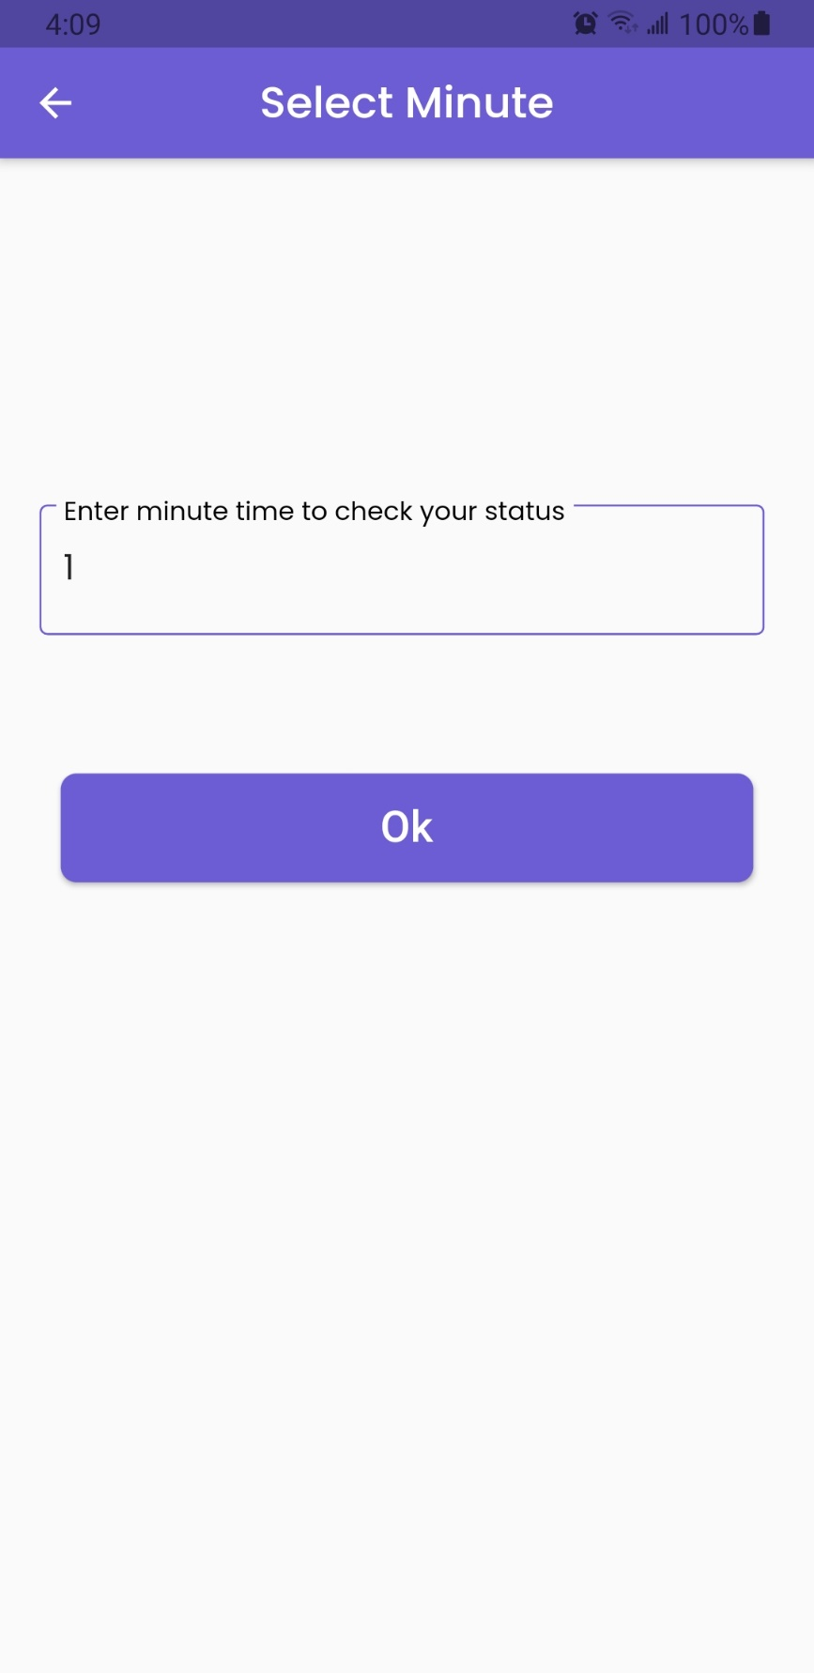

Figure Adding Minute Interval to Check Location

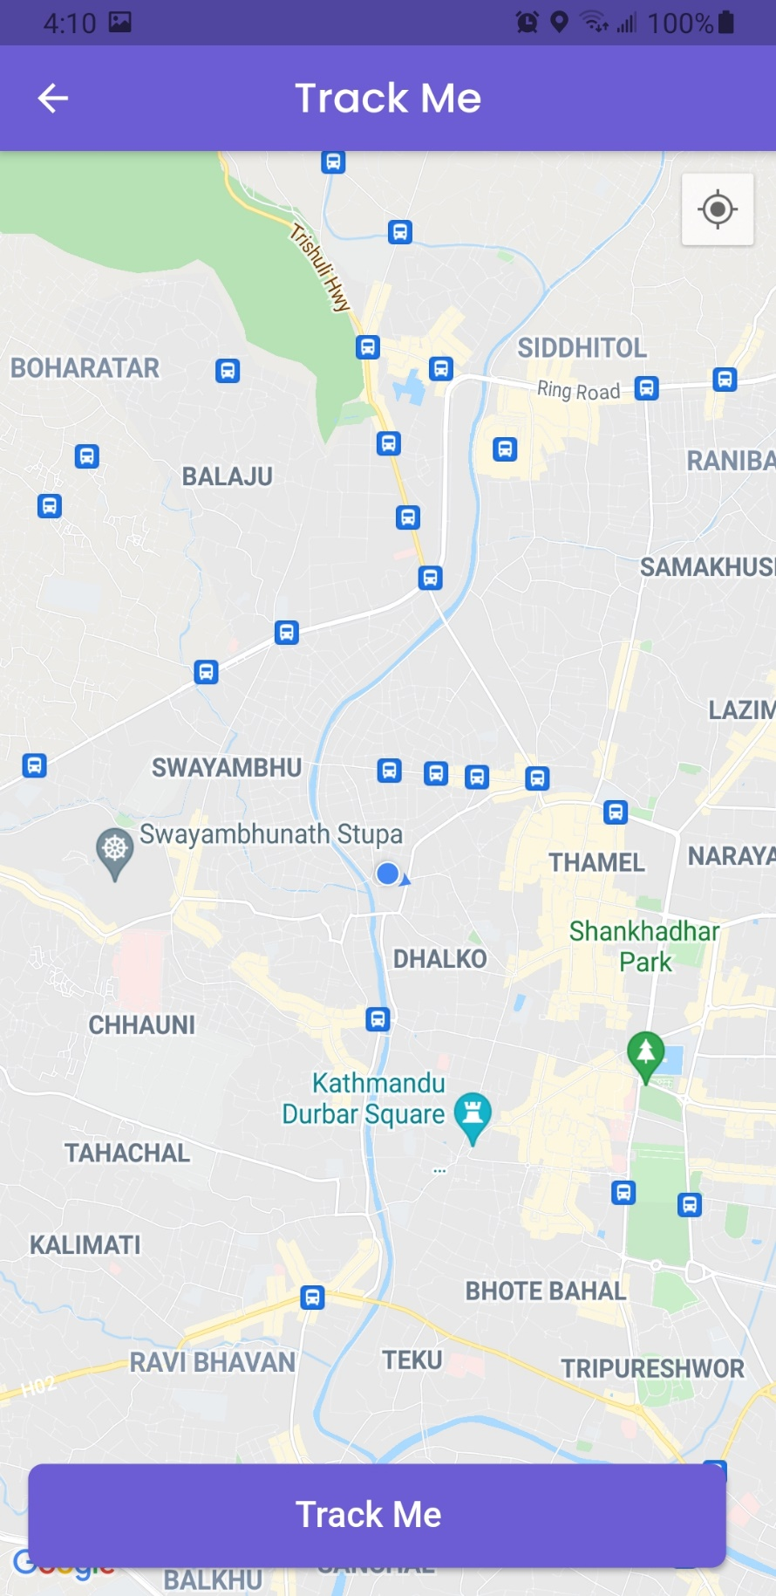

Figure Tracking UI

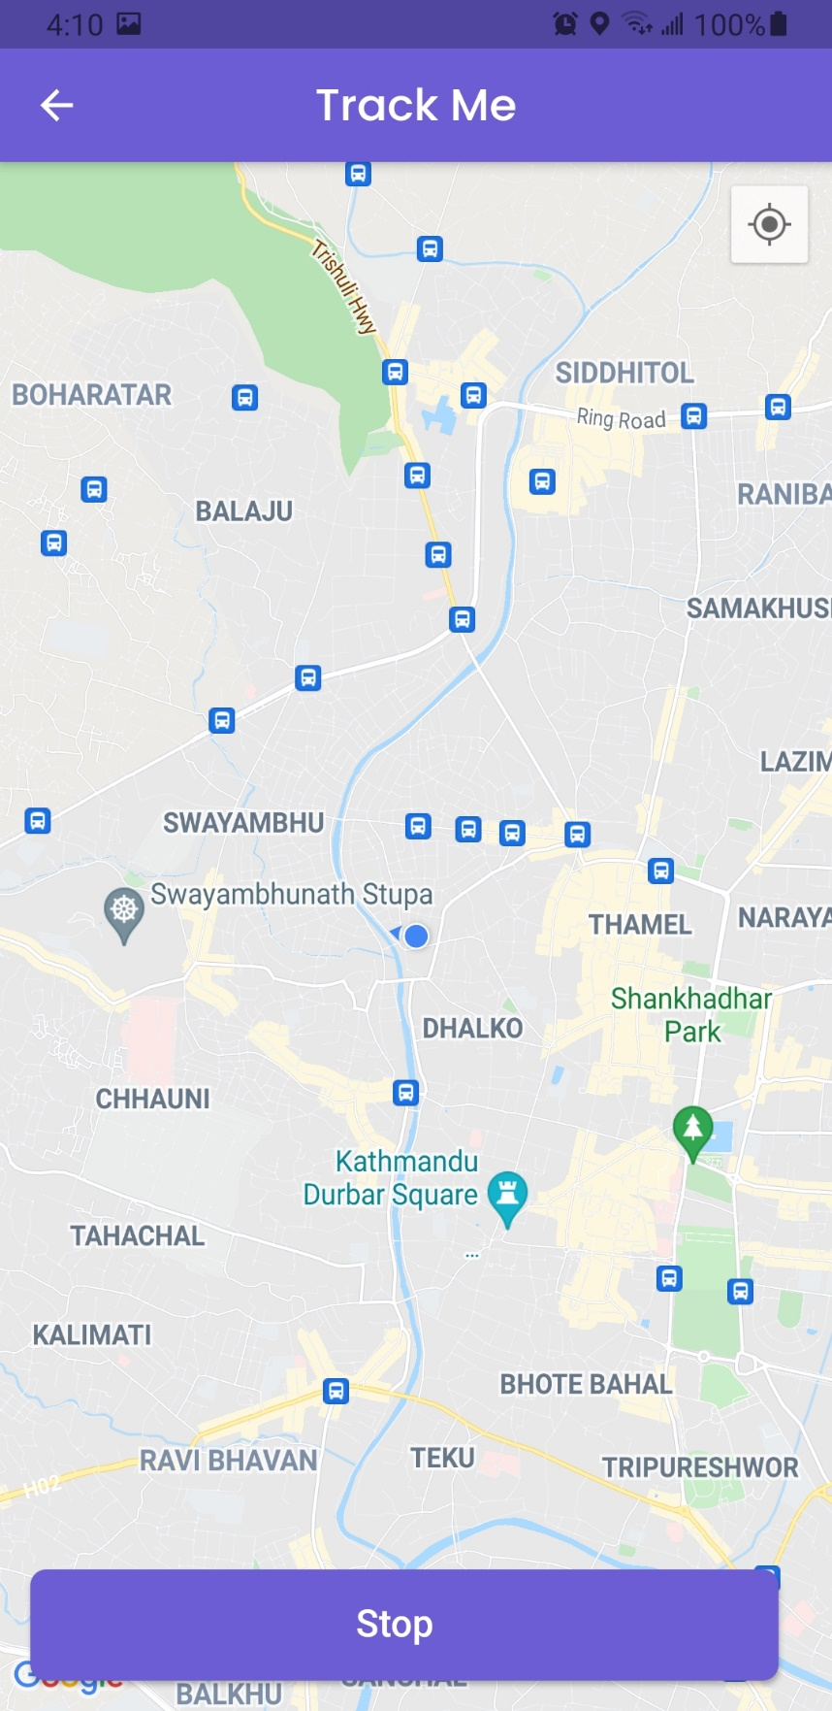

Figure Start Tracking

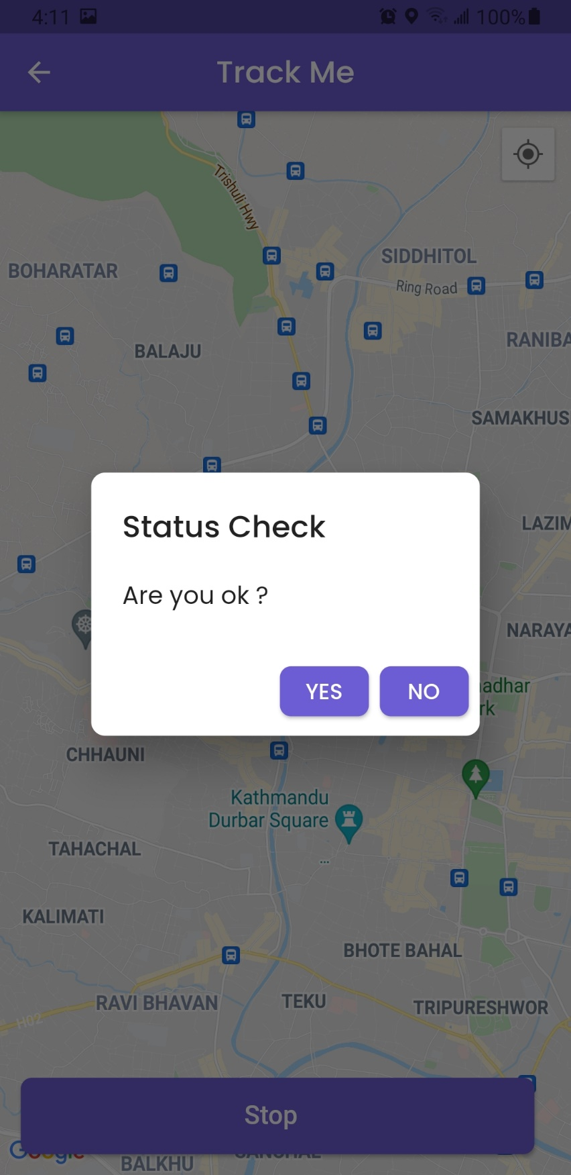

Figure Status Check Dialog Being Displayed as the User location has not changed

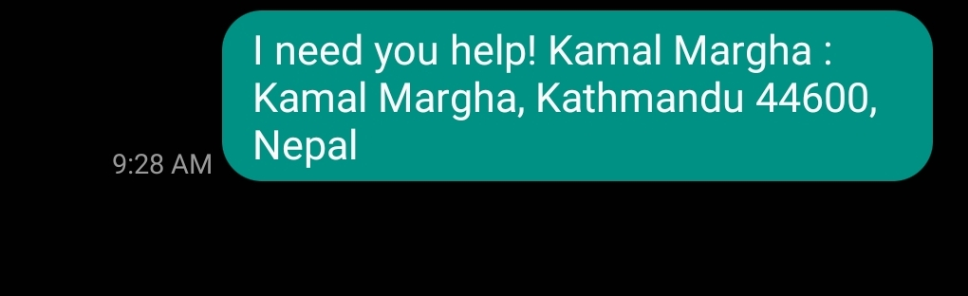

Figure SMS Sent If the user pressed No in Status Check

1. **Medicine History**

The app keeps track of user medicine consumption history if the user has interacted after taking or skipping their medication.

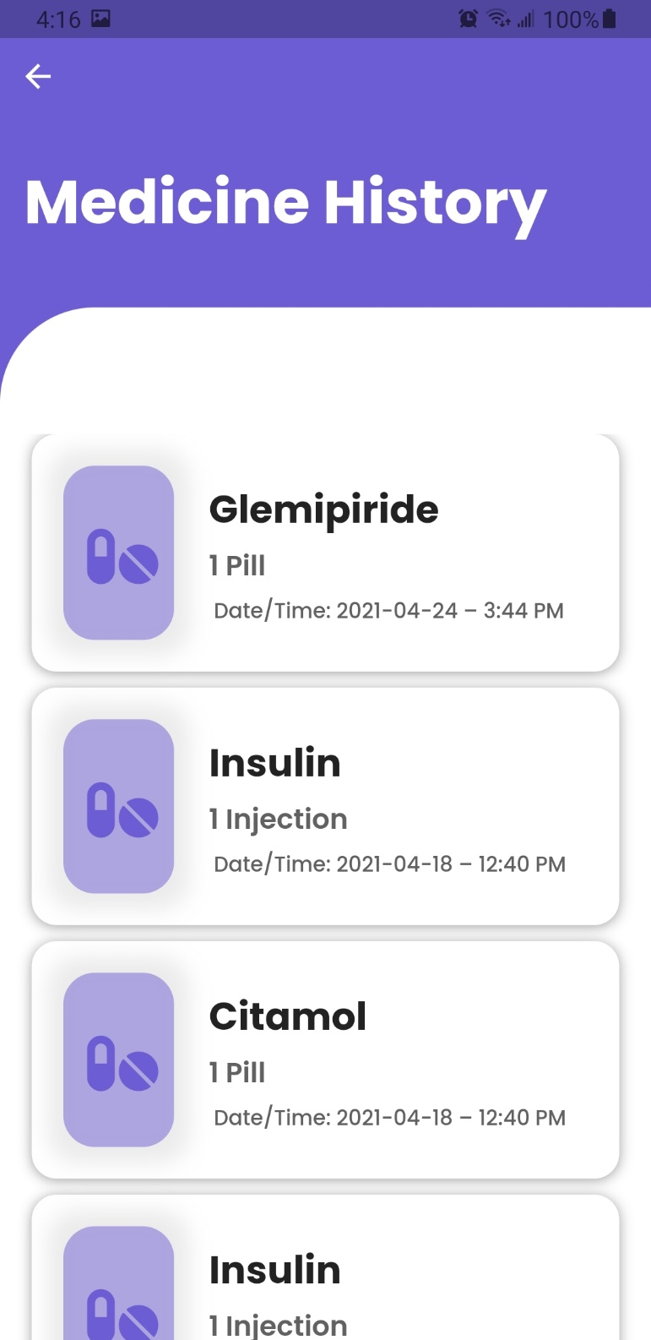

Figure Medicine History UI

1. **Saves User Data in Cloud (Firebase)**

Every data related to the user is stored in the firebase database. The records are deleted if the user wished to. Since that data are held in the firebase, the user does not have to worry about losing data in case of any accidents.

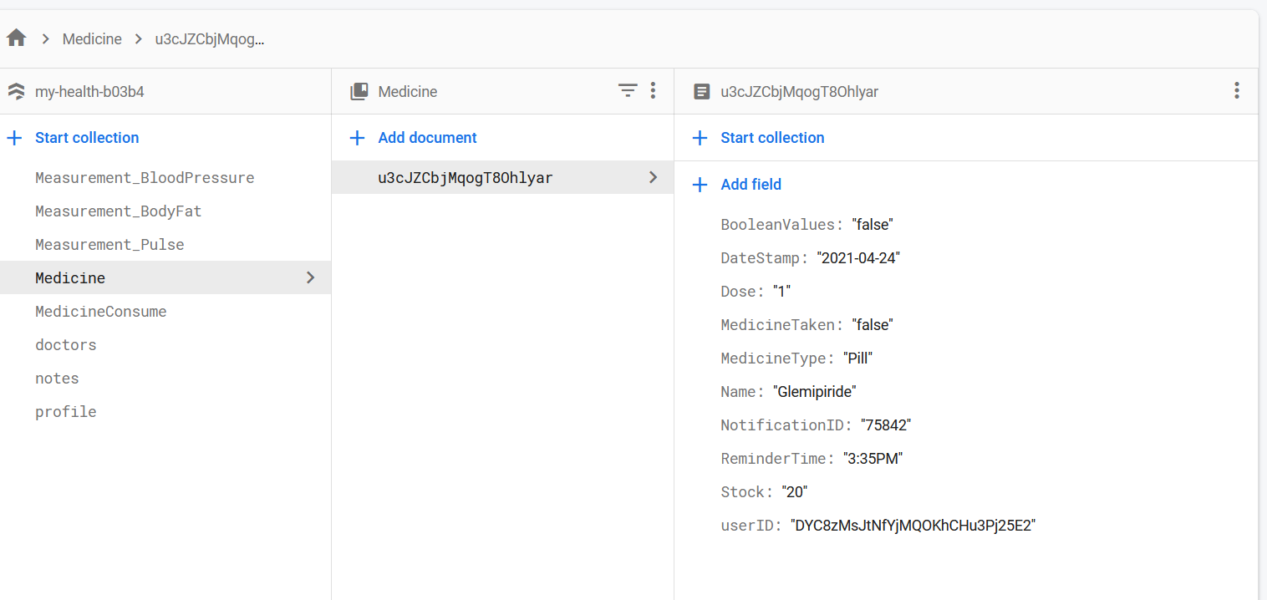

Figure User data being stored in the firebase

### 3.7.2. System Architecture Design

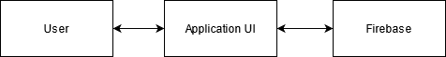

Figure Basic System Architecture

The above diagram shows the basic system architecture of the system. The user interacts with the application UI, and the Application UI interacts with the firebase database to get the necessary data related to the user.

Flutter – Architecture Design

The core concept of the Flutter framework is that everything is a widget. Widgets are basically user interface components used to create the user interface of the application.

In Flutter, the application itself is a widget. The application is the top-level widgets, and its UI is build using one or more widgets known as children, which again is build using other children widgets. This composability feature helps us to create a user interface of any complexity. (tutorialspoint, 2021)

The figure shown below shows a basic widget hierarchy of a Flutter application.

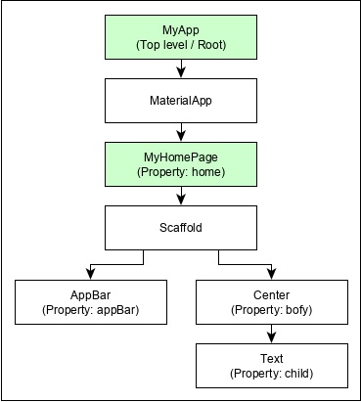

Figure Flutter Widget Hierarchy in Hello World Application (tutorialspoint, 2021)

System Architecture of My Health Application

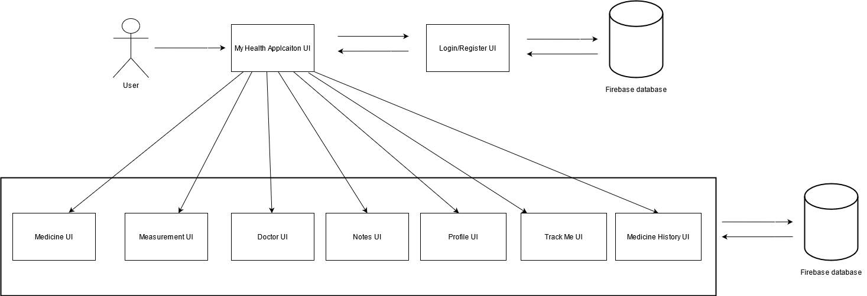

Figure System Architecture of My Health

The entire application that is developed for this project is based on flutter, so most of the components of this system are widgets. These widgets communicate with the firebase database and gain access to the data of the user.

# CHAPTER 4: TESTING AND ANALYSIS

## 4.1. TEST PLAN

This section of the report consists of the various tests carried out after the development of the application. The test cases carried out in this section are to ensure that the application does not contain any flaws and to test every feature and functionality of the application developed.

### 4.1.1. UNIT TESTING, TEST PLAN

|  |  |  |
| --- | --- | --- |
| No. | Test Case | Objective |
|  | Register User | To register a new user and check-in database. |
|  | Tick color change in multiple reminders | To check multiple medicine intake and check-in home screen. |
|  | Medicine low reminder | To check if reminders are triggered if the medicine is low. |
|  | Medicine finished reminder. | To check if reminders are triggered if the medicine is finished. |
|  | To test Tracking Functionality | To test tracking-related functionality. |
|  | To perform CRUD operation in any one feature related to database | To test if the database is updated while performing CRUD operation. |
|  | Medicine data being reset daily | To check if the medicine data are reset daily. |
|  | Medicine Skip Notification | To check if notification is triggered on medicine skip. |
|  | Medicine Data Update | To check if medicine data is updated after consuming the medicine. |
|  | Contact Doctor | To check if the contact button for the doctor is working. |

Table Unit Testing Test Plan

### 4.1.2. SYSTEM TESTING, TEST PLAN

|  |  |  |
| --- | --- | --- |
| **No.** | **Test Case** | **Objective** |
|  | Register User | To register a new user. |
|  | Register Validation | To register using invalid data |
|  | Login User | To login a user. |
|  | Login Validation | To test login using invalid data. |
|  | Medicine Reminder | To check if medicine reminder is triggered. |
|  | To Test CRUD operation for Medicine | To perform CRUD operation on every medicine, relate feature. |
|  | Medicine Input Validations | To input invalid data in input fields related to medicine. |
|  | To Test CRUD operation for Measurement | To perform CRUD operation on every measurement, relate feature. |
|  | Measurement Input Validations | To input invalid data in input fields related to measurement. |
|  | To Test CRUD operation for Notes | To perform CRUD operation on every note, relate feature. |
|  | To Test CRUD operation for Doctors | To perform CRUD operation on every doctor, relate feature. |
|  | Doctor Input Validations | To input invalid data in input fields related to doctor. |
|  | Edit Profile | To edit profile. |
|  | Edit Profile Validation | To input invalid data in the input filed of edit profile. |
|  | View Medicine History | To view the history of medicine consumed. |
|  | Logout user | To logout user from the application. |
|  | To test Forgot Password | To check if the user receives mail to reset the password. |

Table System Testing Test Plan

## UNIT TESTING

1. **Register User**

|  |  |
| --- | --- |
| **Objective** | To register a new user and check-in database. |
| **Action** | The required field to register a new user was entered, and a profile is set up. |
| **Expected Result** | The new user had to be registered, and after the profile setup, the user is redirected to the home page. |
| **Actual Result** | The new user and their profile are saved in the database, and the user was redirected to the home page. |
| **Conclusion** | Test Successful. |

Table Unit Testing Register User

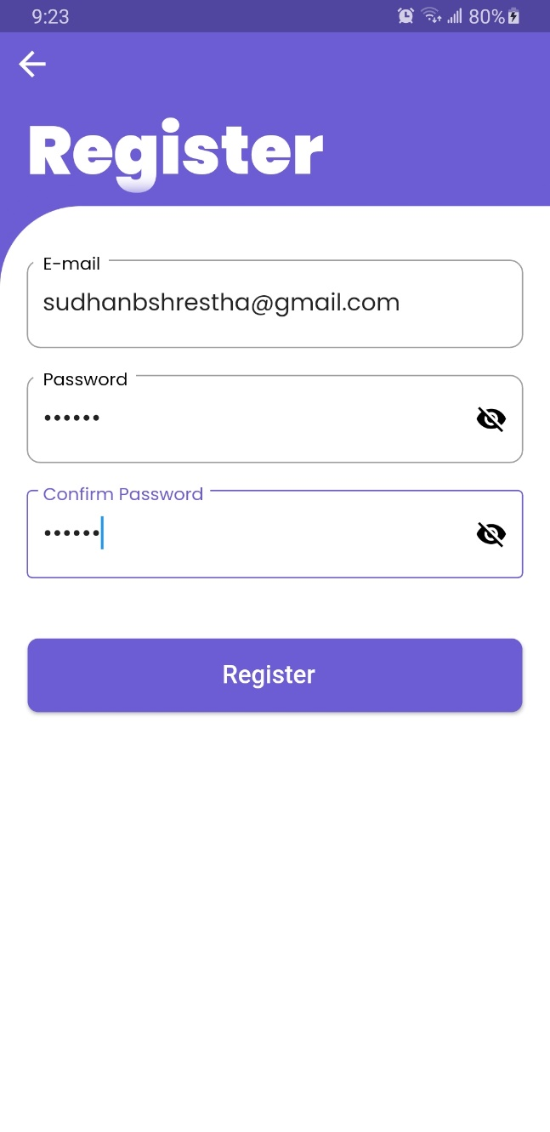

Figure Required input to register user being entered

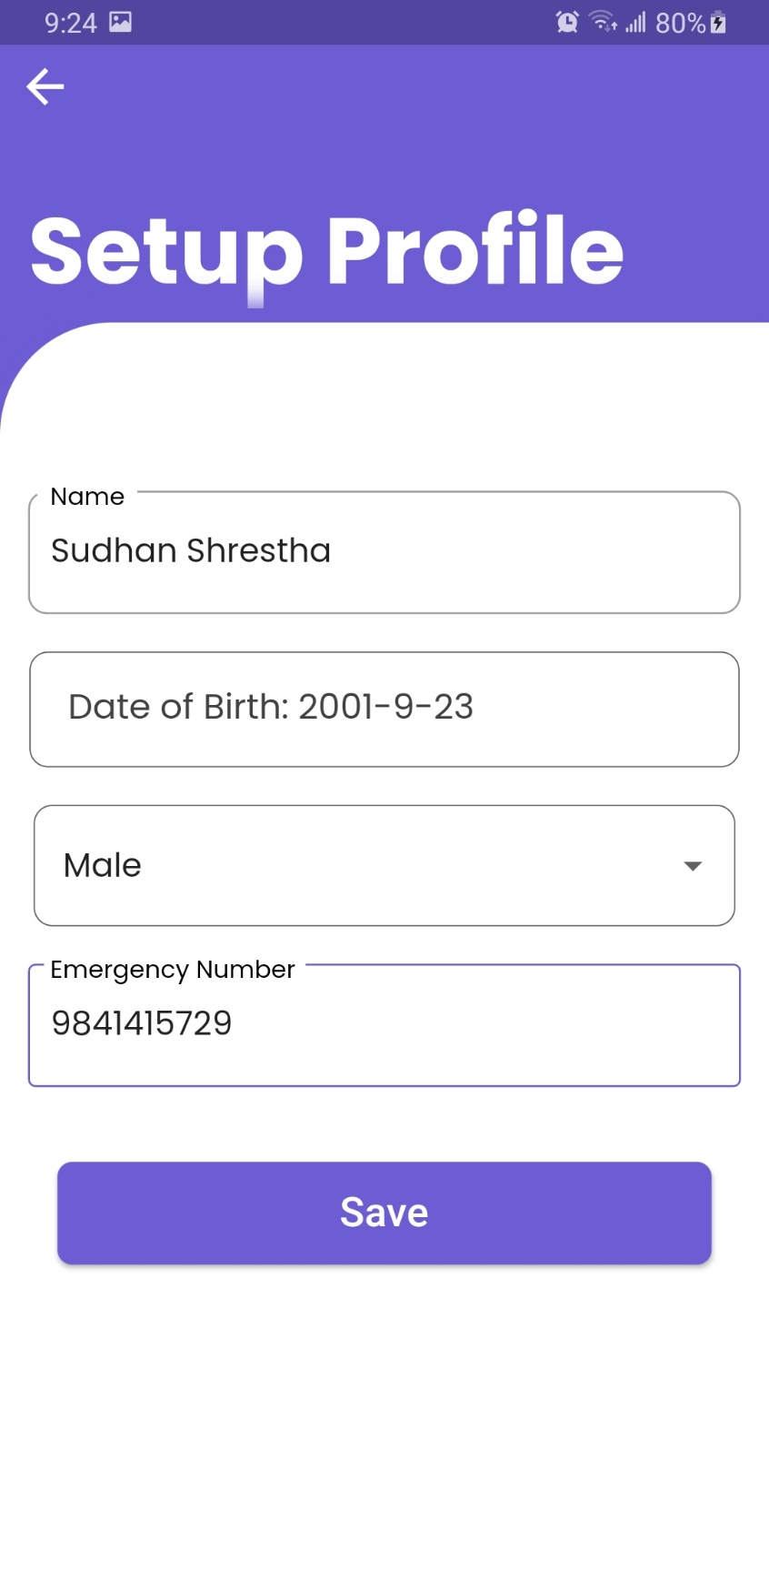

Figure Required input to setup profile being entered

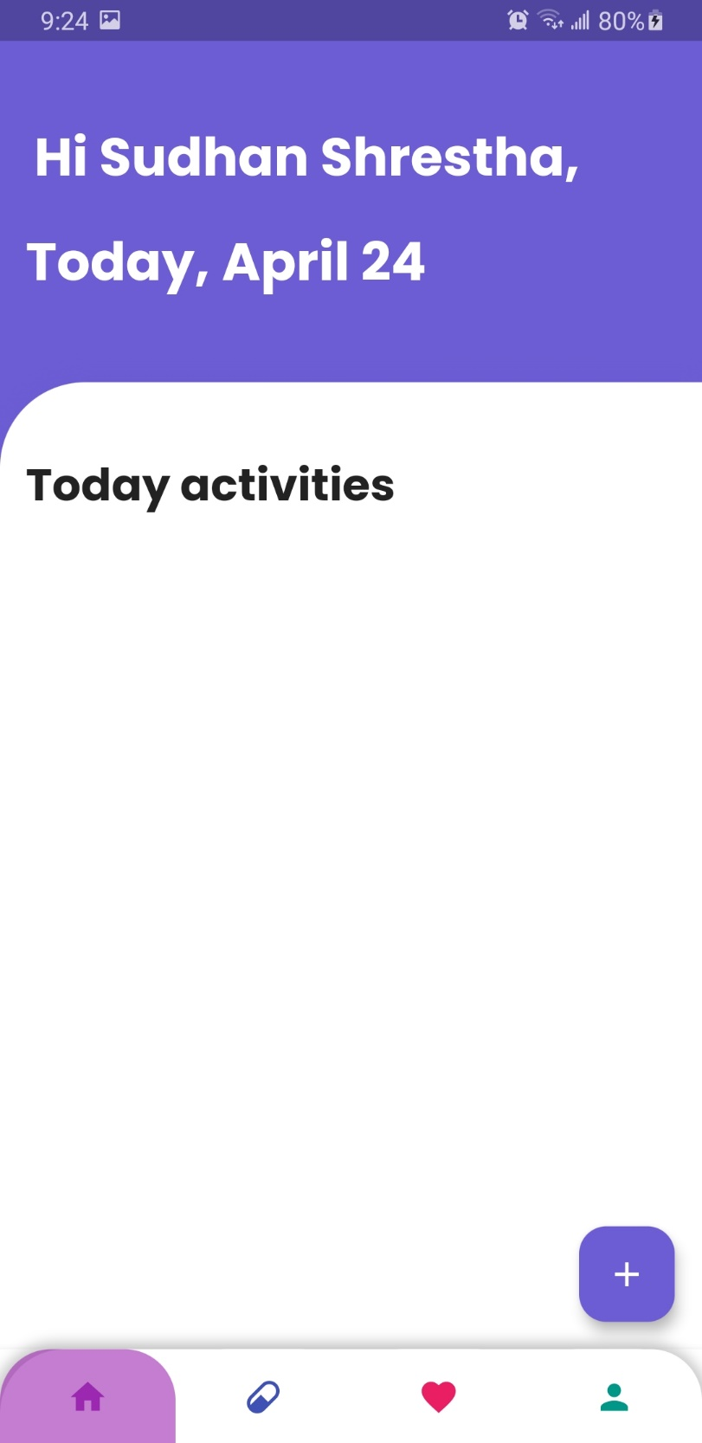

Figure User being redirected to the home page

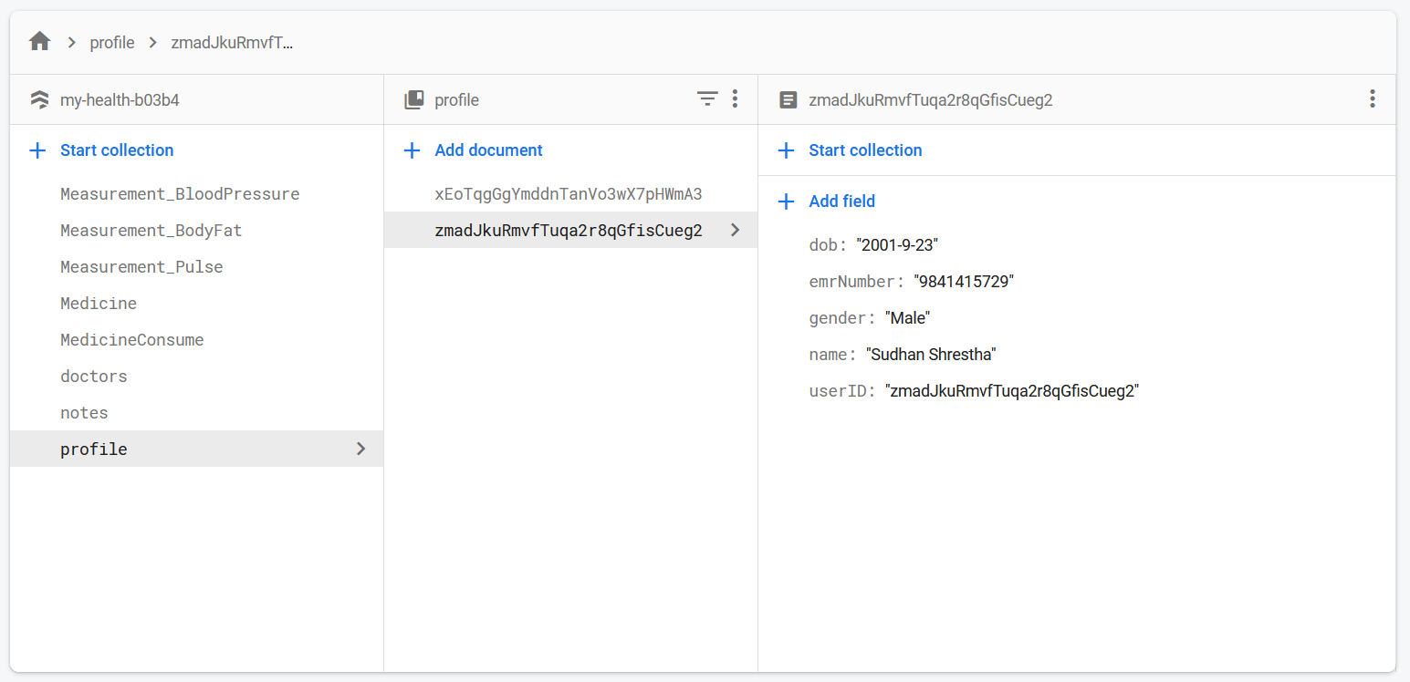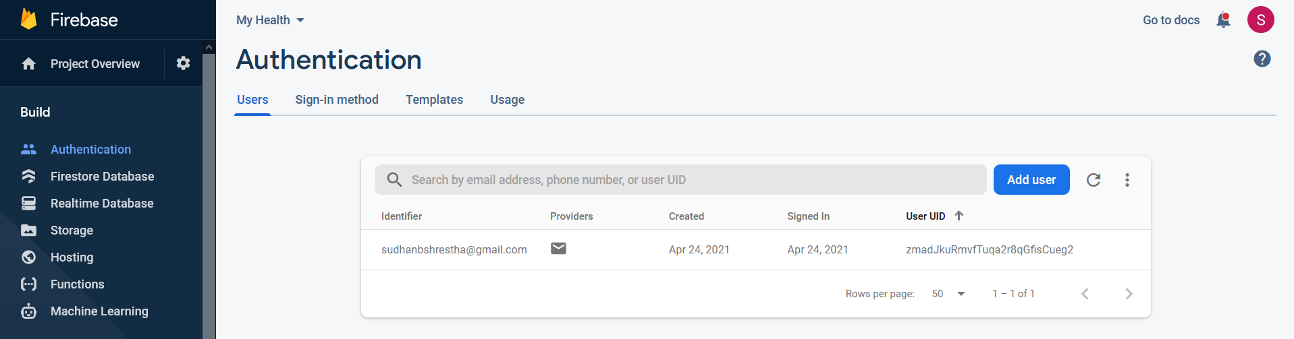

Figure User profile being saved in the database

Figure User being saved in the database

1. **Tick color change in multiple reminders.**

|  |  |
| --- | --- |
| **Objective** | To check if tick mark color is changed if there are multiple reminders |
| **Action** | To take medicine according to the number of reminders. |
| **Expected Result** | The tick mark should not change color to green until all the amount of medicine required for the day is taken. |
| **Actual Result** | The tick mark color only changed after the amount of medicine to be taken in a day is taken. |
| **Conclusion** | Test Successful. |

Table Unit Testing Tick Color change in multiple reminders.

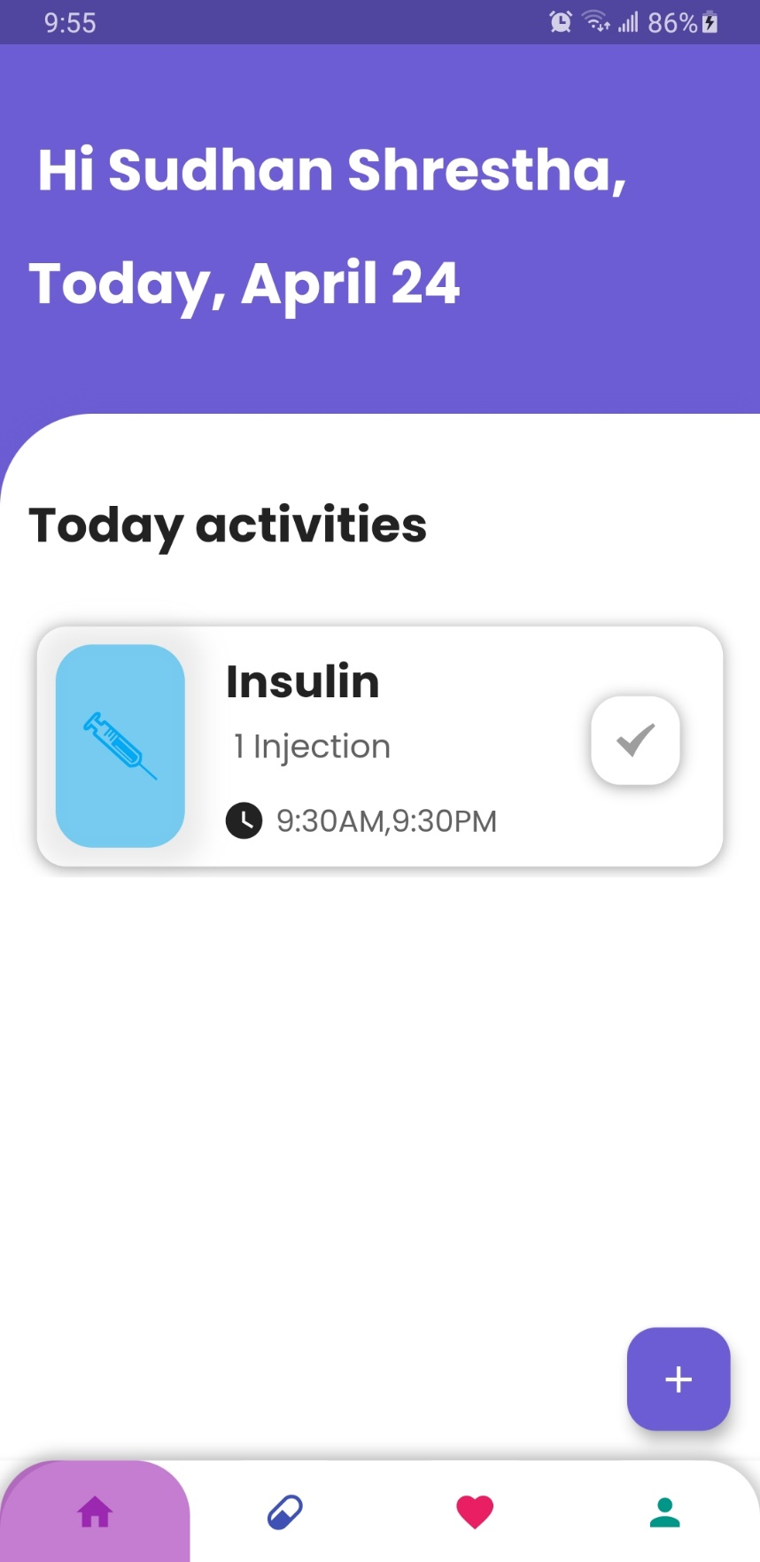

Figure Medicine Containing multiple reminders

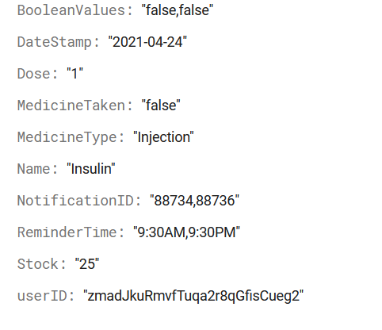

Figure Data in database before medicine taken

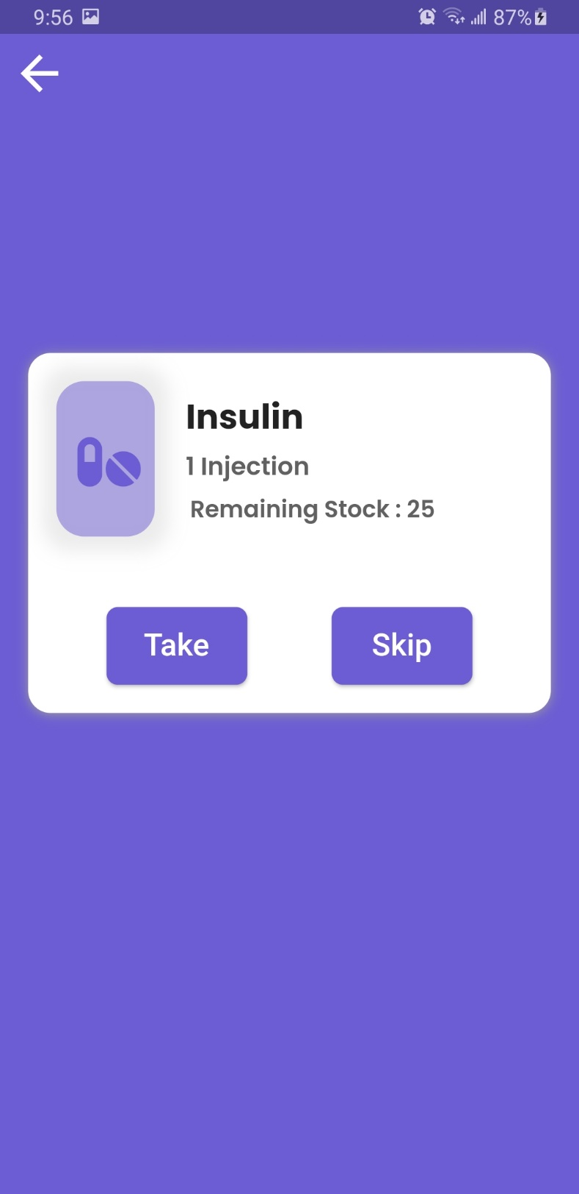

Figure Taking Medicine once

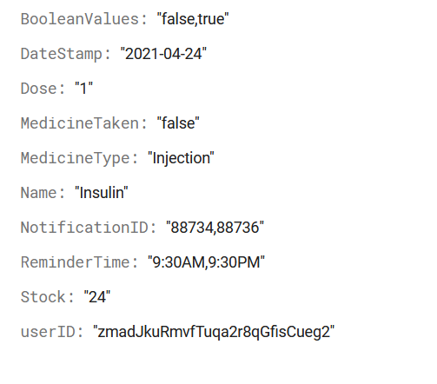

Figure Data in database after medicine taken once

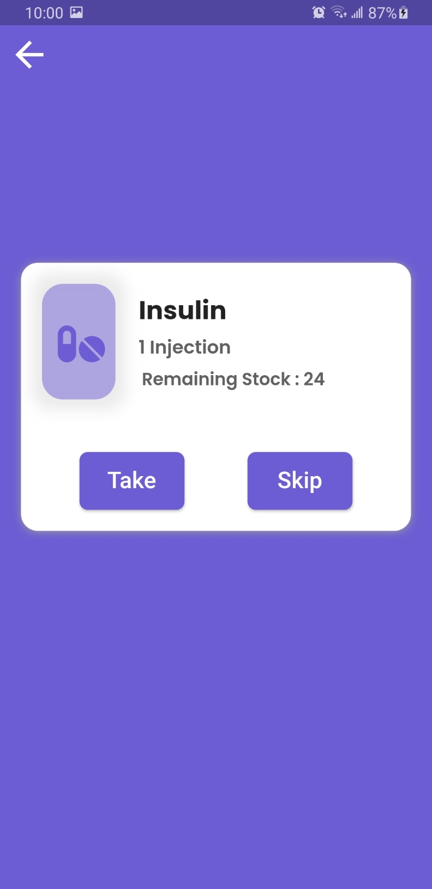

Figure Taking Medicine for the second time

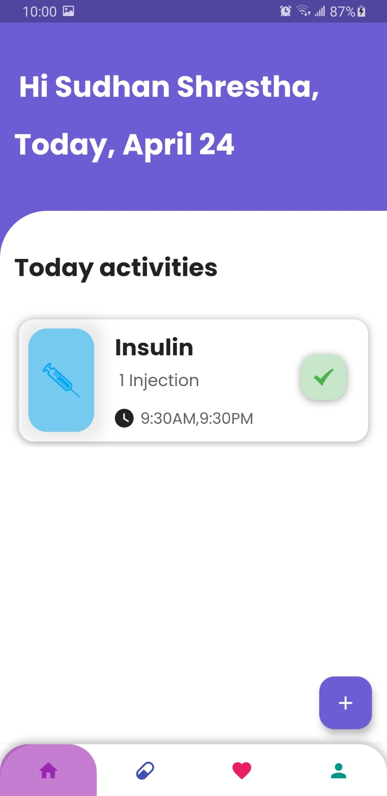

Figure Tick color changing after taking the required medication for the day

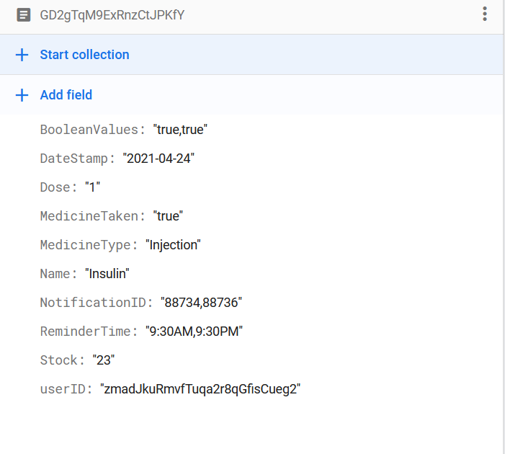

Figure Database data after taking the required medication for the day

1. **Medicine low reminder.**

|  |  |
| --- | --- |
| **Objective** | To check if the reminder is triggered when medicine stock is low. |
| **Action** | To take medicine with low stock and see if a reminder is triggered. |
| **Expected Result** | After taking medicine, a reminder had to be triggered after five seconds. |
| **Actual Result** | The medicine stock low reminder is triggered. |
| **Conclusion** | Test Successful. |

Table Unit Testing Medicine low reminder

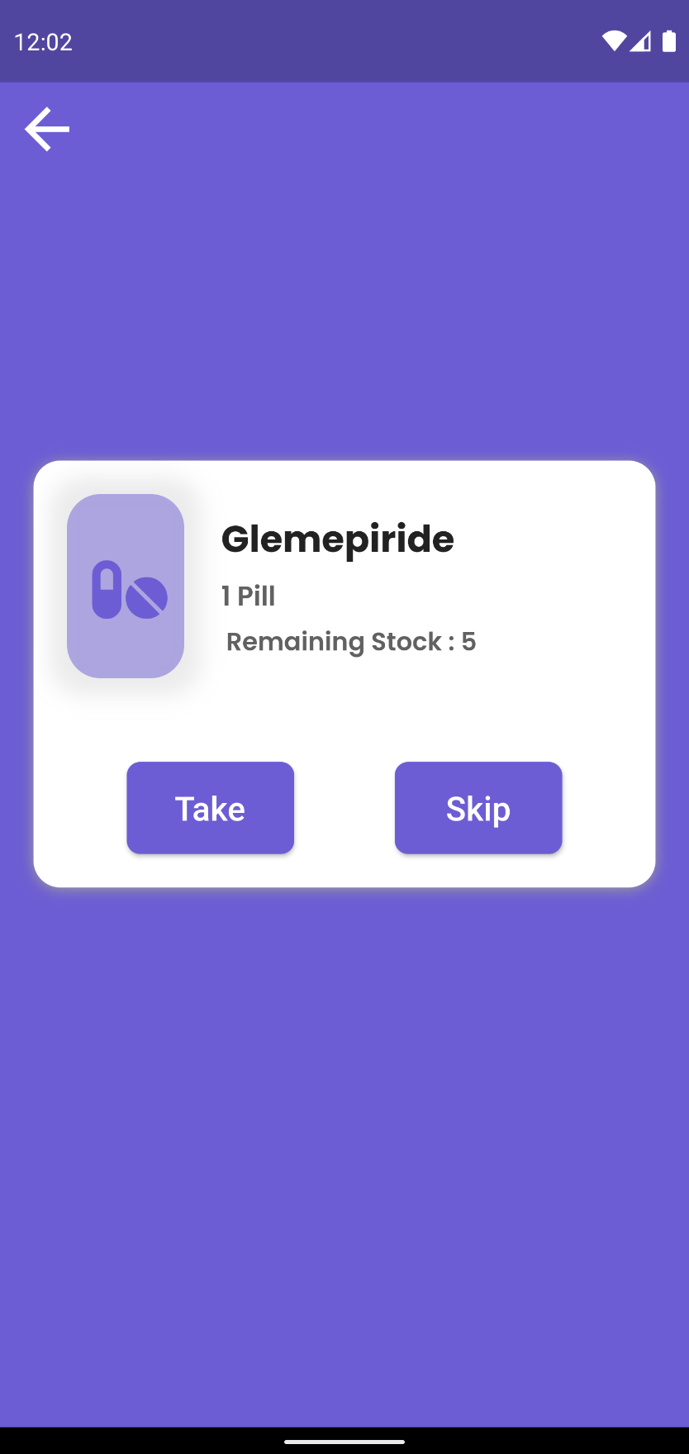

Figure Medicine With low stock being taken

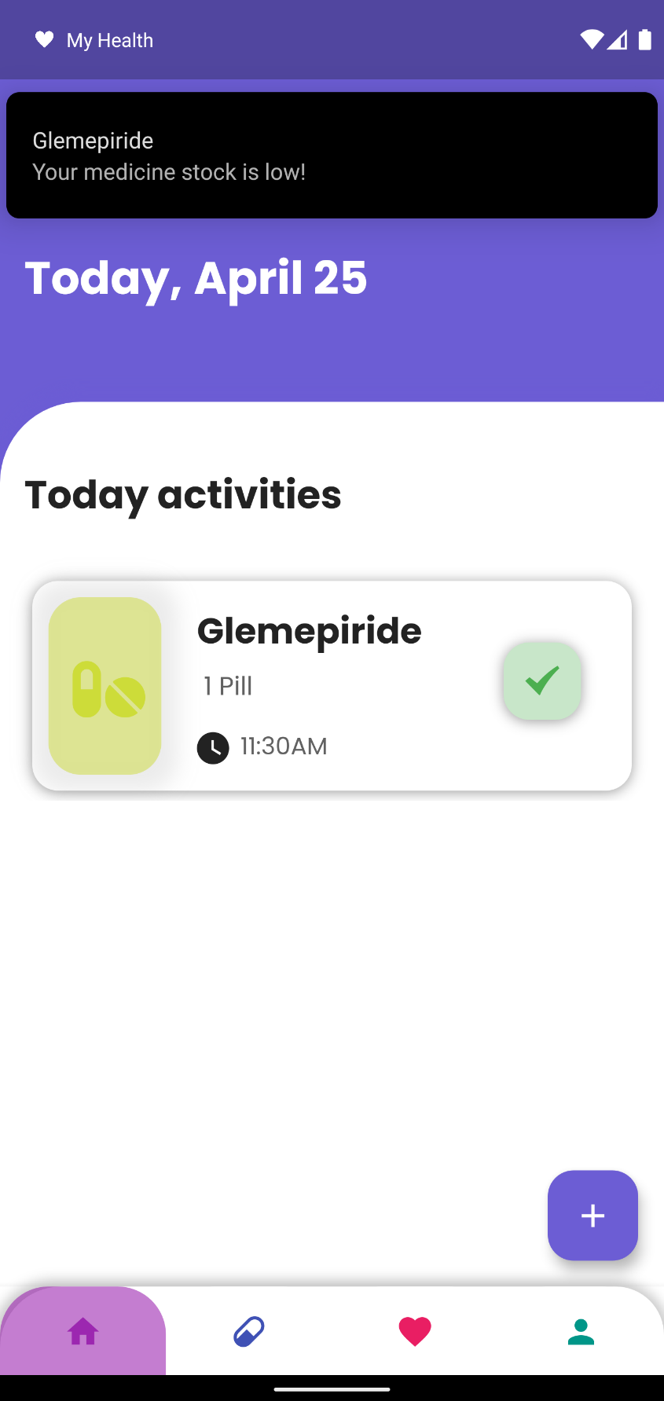

Figure Medicine Reminder being triggered when medicine stock low

1. **Medicine finished reminder.**

|  |  |
| --- | --- |
| **Objective** | To check if the reminder is triggered when medicine stock is empty/finished. |
| **Action** | To take medicine with the lowest stock and see if a reminder is triggered. |
| **Expected Result** | After taking medicine, a reminder had to be triggered after five seconds. |
| **Actual Result** | The medicine stock refill reminder is triggered. |
| **Conclusion** | Test Successful. |

Table Unit Testing Medicine finished reminder

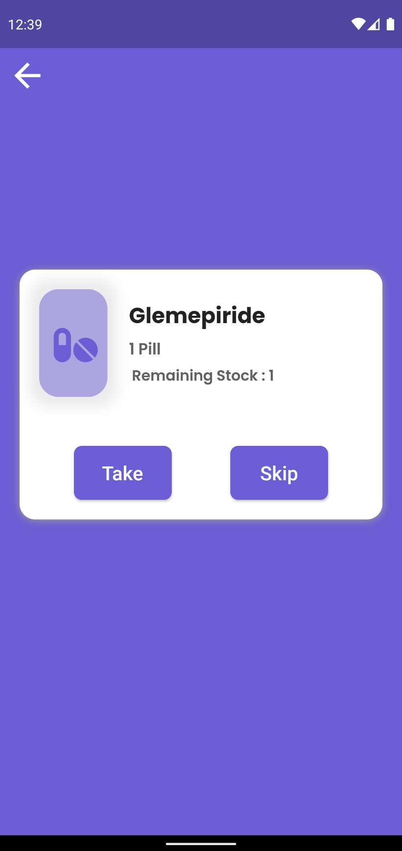

Figure Taking medicine when the stock is at the lowest

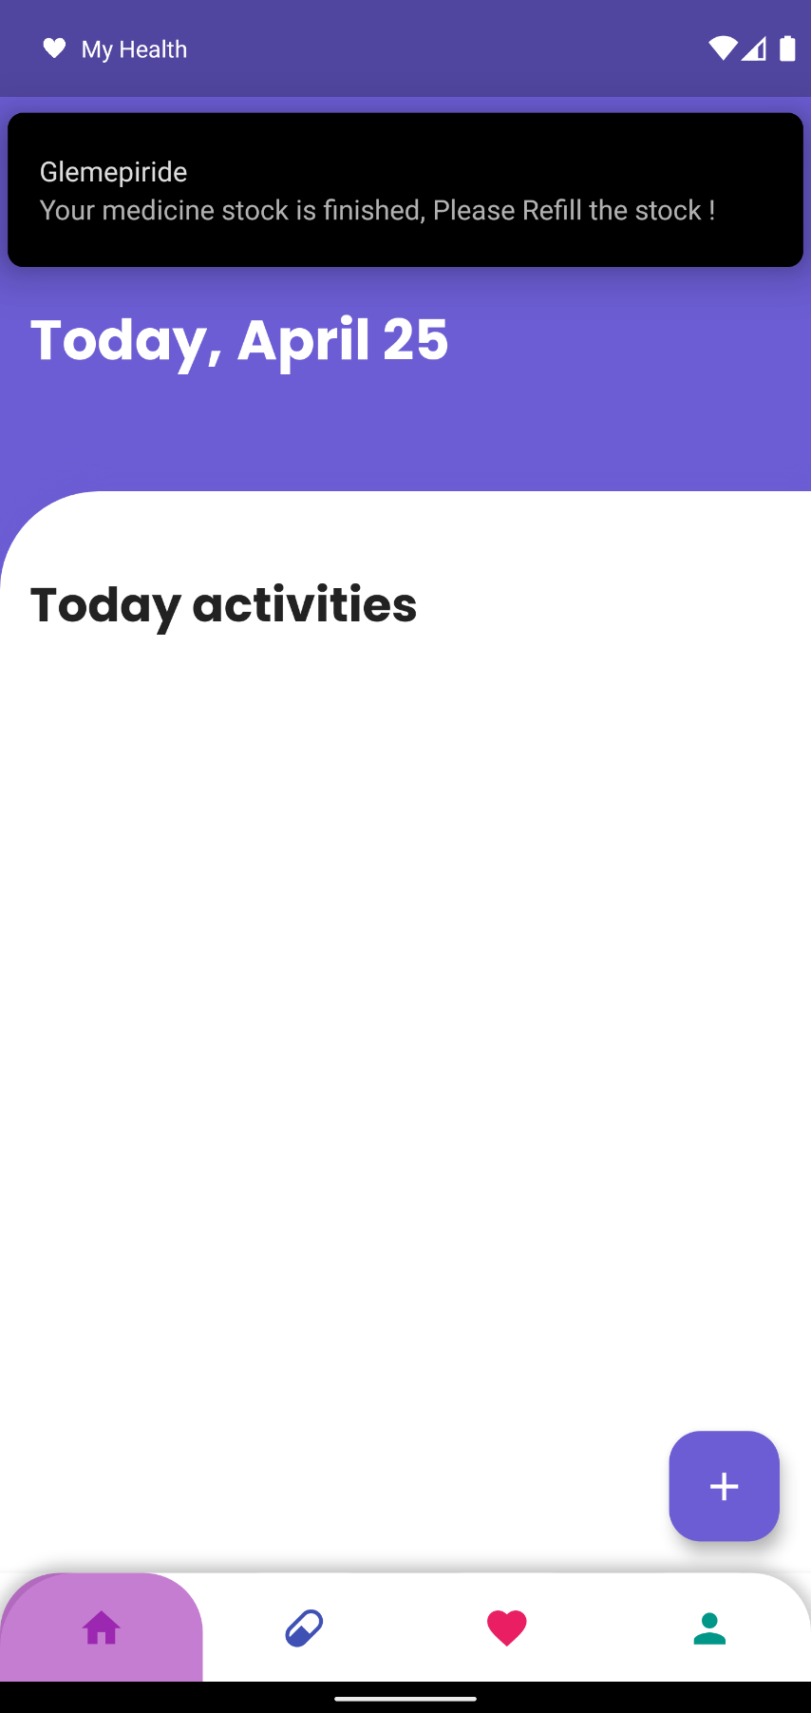

Figure Medicine refill reminder being triggered

1. **To test Tracking Functionality.**

|  |  |
| --- | --- |
| **Objective** | To check the functionality related to tracking. |
| **Action** | To start tracking and check results once by not changing position and again after changing position. |
| **Expected Result** | If the user position is not changed, a Status Check dialog box appears; if the position is changed, the app keeps tracking. |
| **Actual Result** | The Status Check dialog appears when the position is not changed but not shown when the user position changes. |
| **Conclusion** | Test Successful. |

Table Unit Testing To test Tracking Functionality

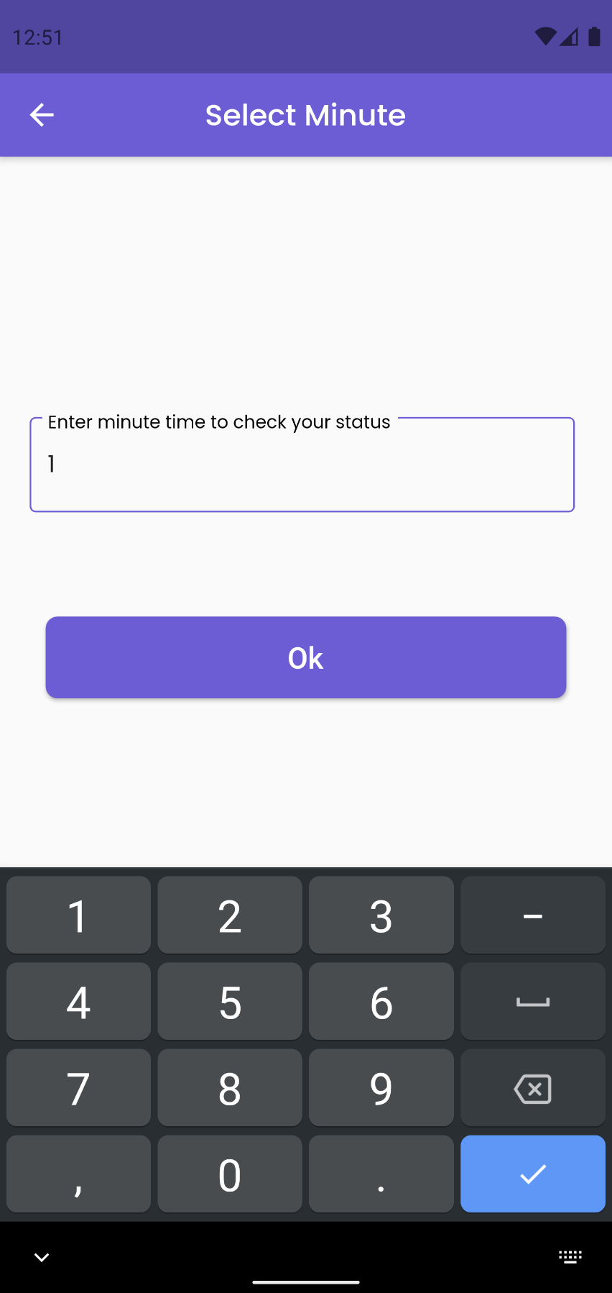

Figure Entering minute field as 1 for tracking

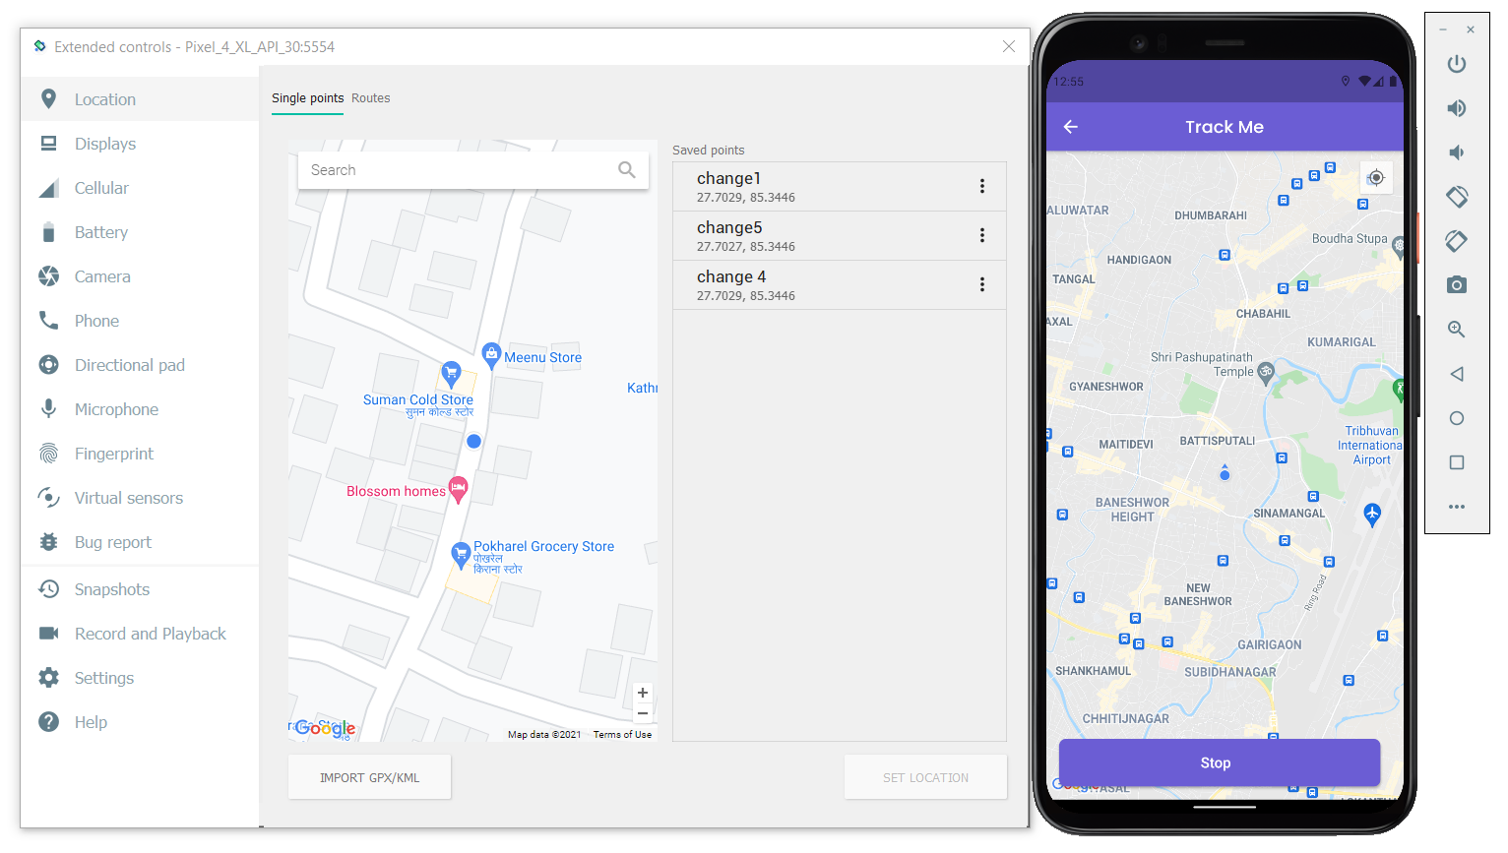

Figure Tracking without changing the user position

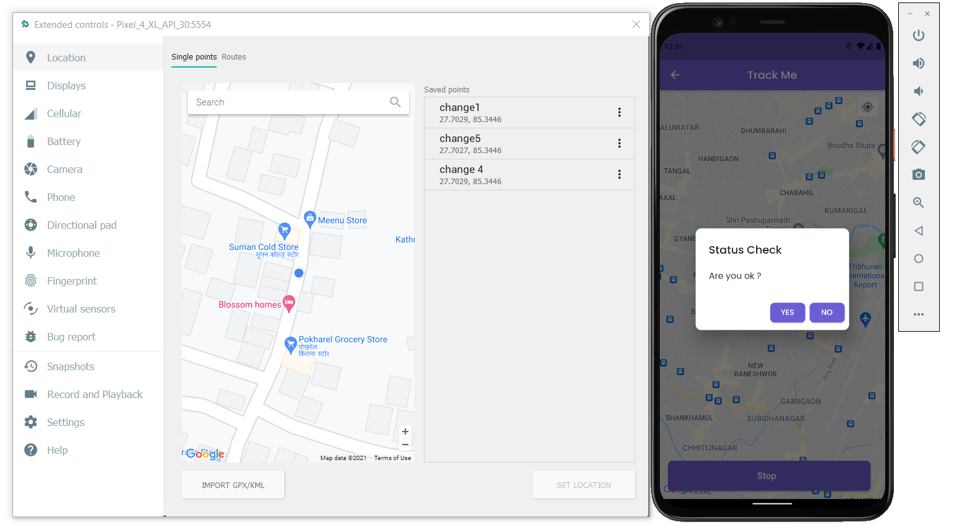

Figure Status Check being displayed when position not changed in entered minute interval

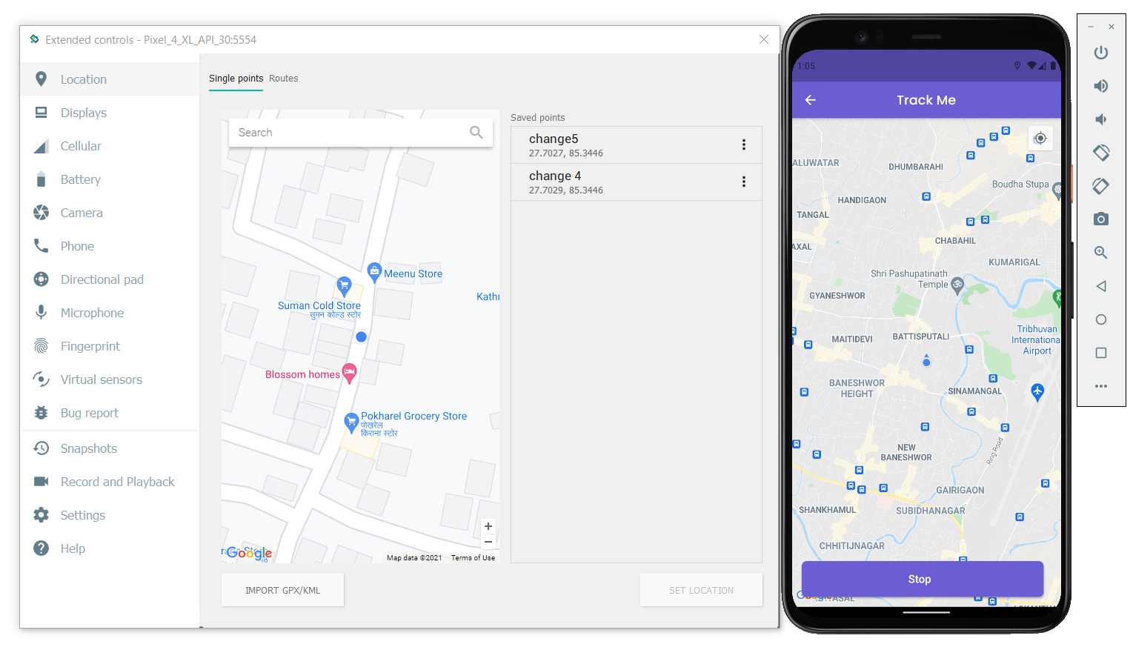

Figure Start tracking again with a position

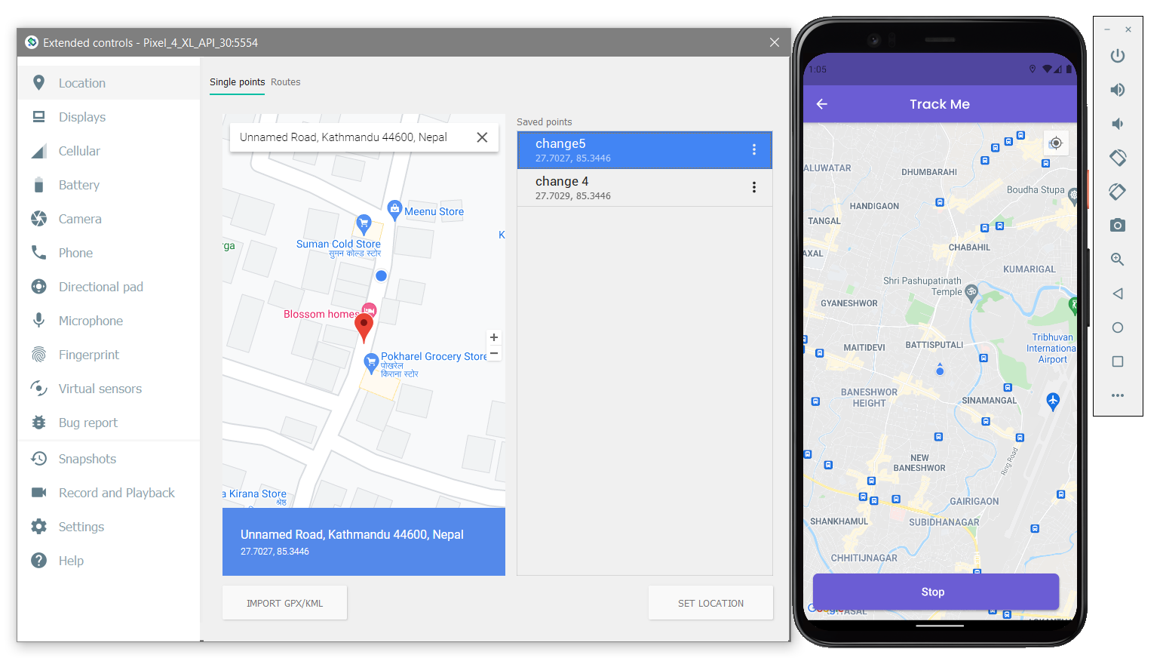

Figure Changing user position in the emulator

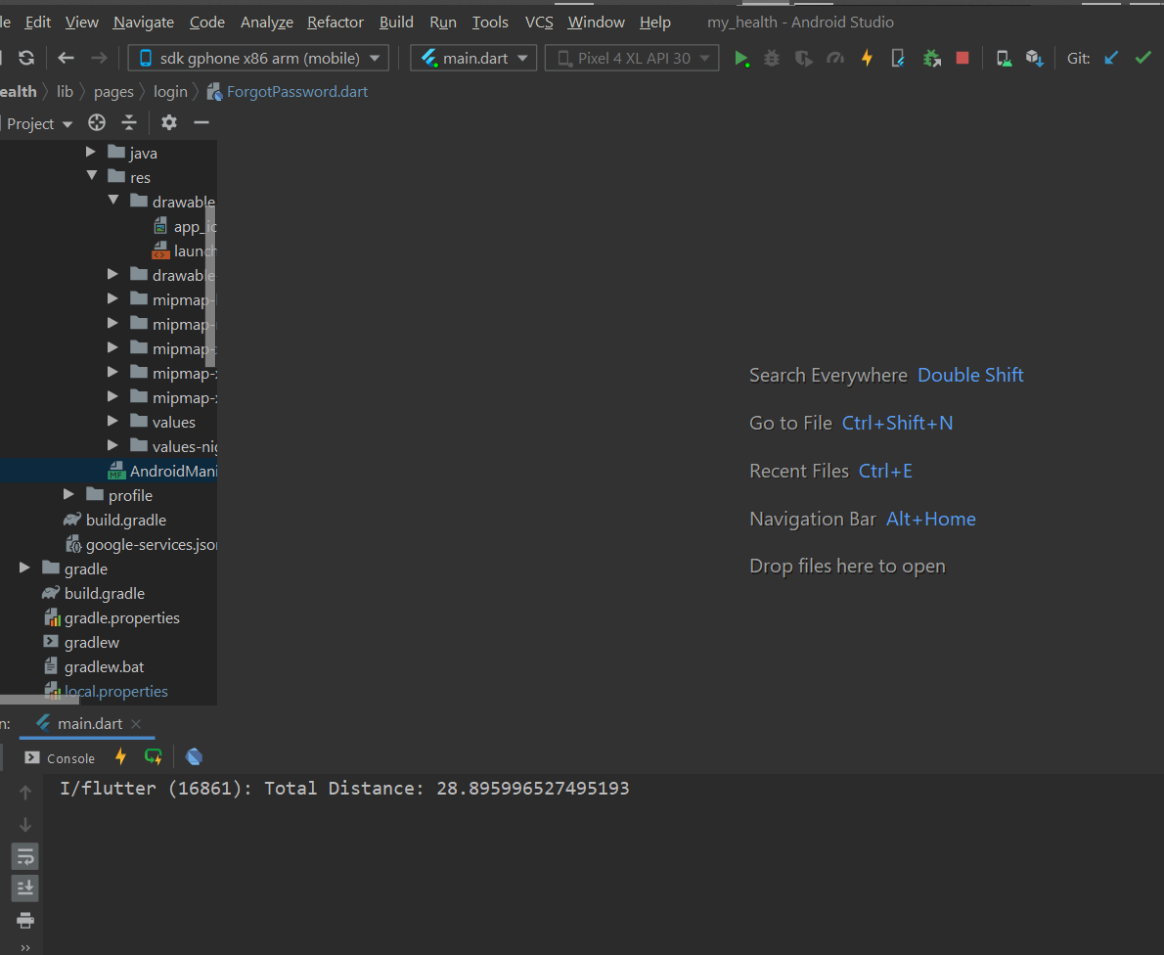

Figure User position change being showed by calculating distance travelled

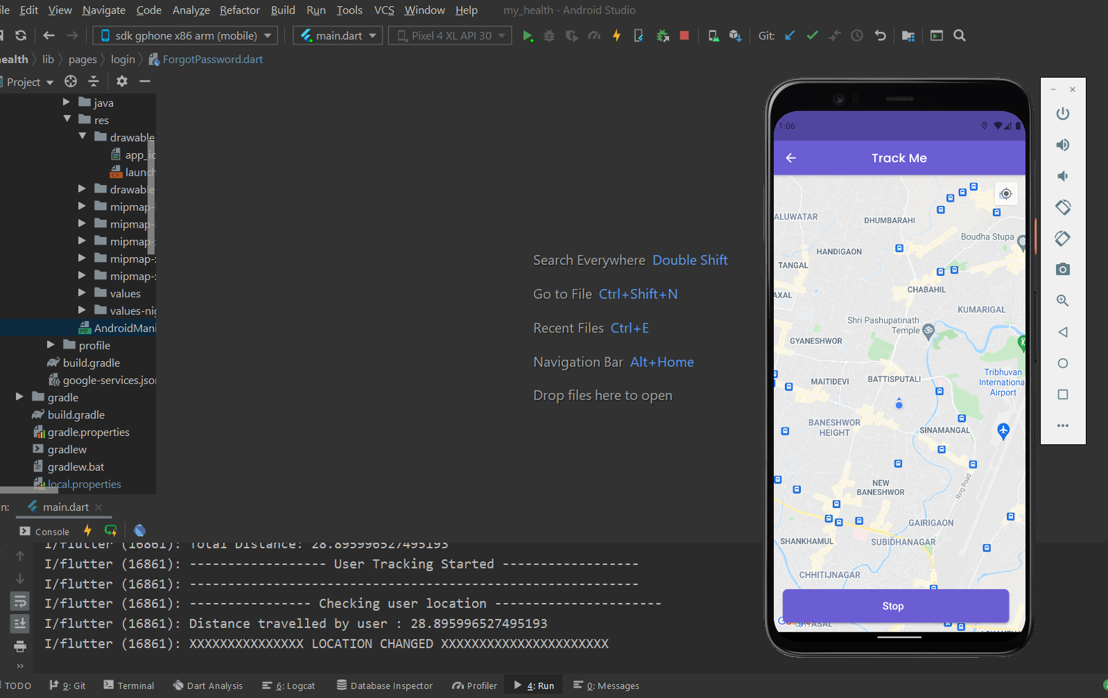

Figure Status Check dialog not shown as the user position was changed

1. **To perform CRUD operation in any one feature related to the database.**

|  |  |
| --- | --- |
| **Objective** | To perform CRUD operation in a feature related to database and check the changes in the database |
| **Action** | To perform CRUD operation in Medicine related feature and check changes in the database |
| **Expected Result** | The changes performed must be updated in the database. |
| **Actual Result** | The changes performed are updated in the database. |
| **Conclusion** | Test Successful. |

Table Unit Testing To perform CRUD operation in Medicine related features to see changes in the database

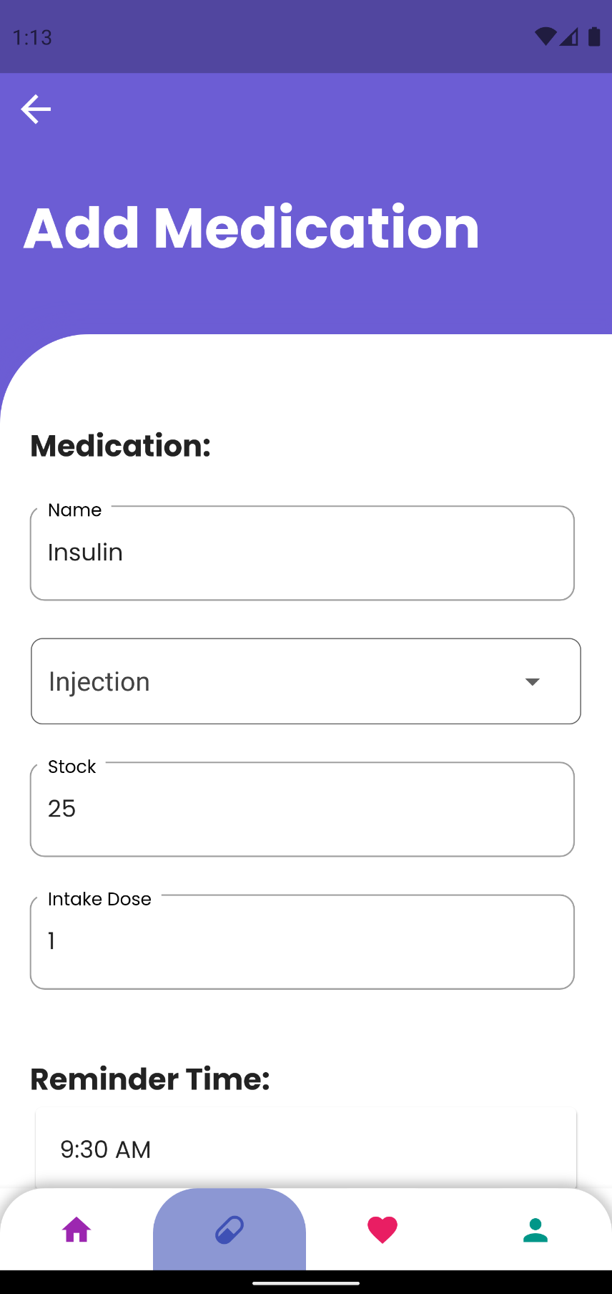

Figure A Medicine is added in the application.

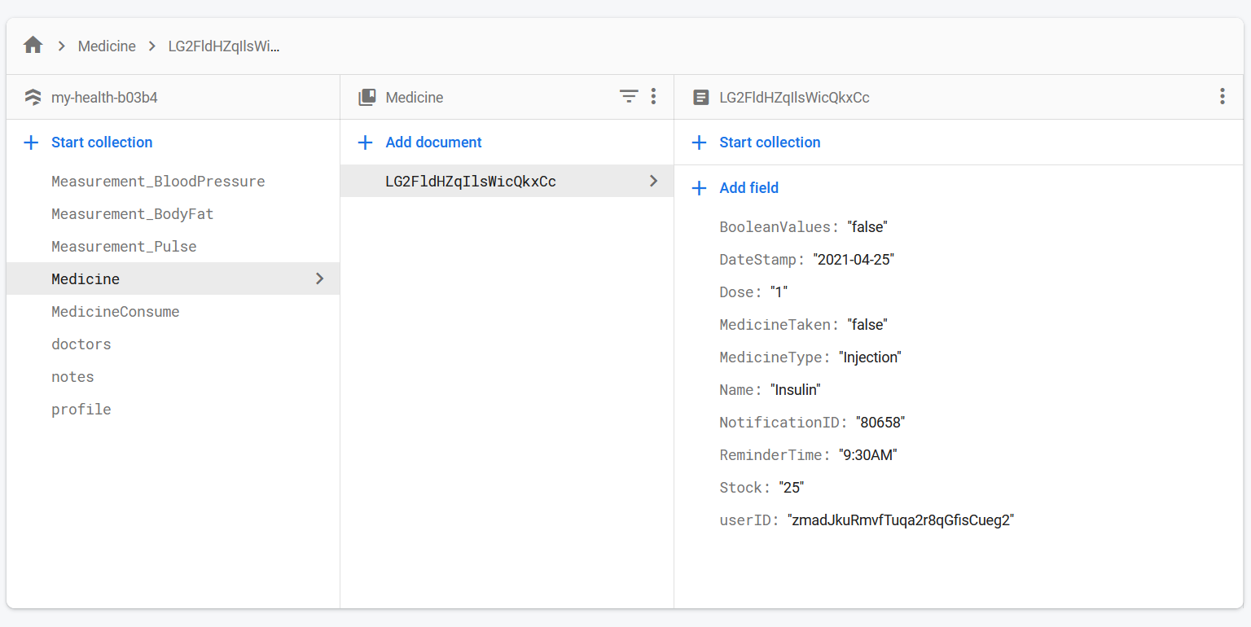

Figure The added medicine being shown in the database

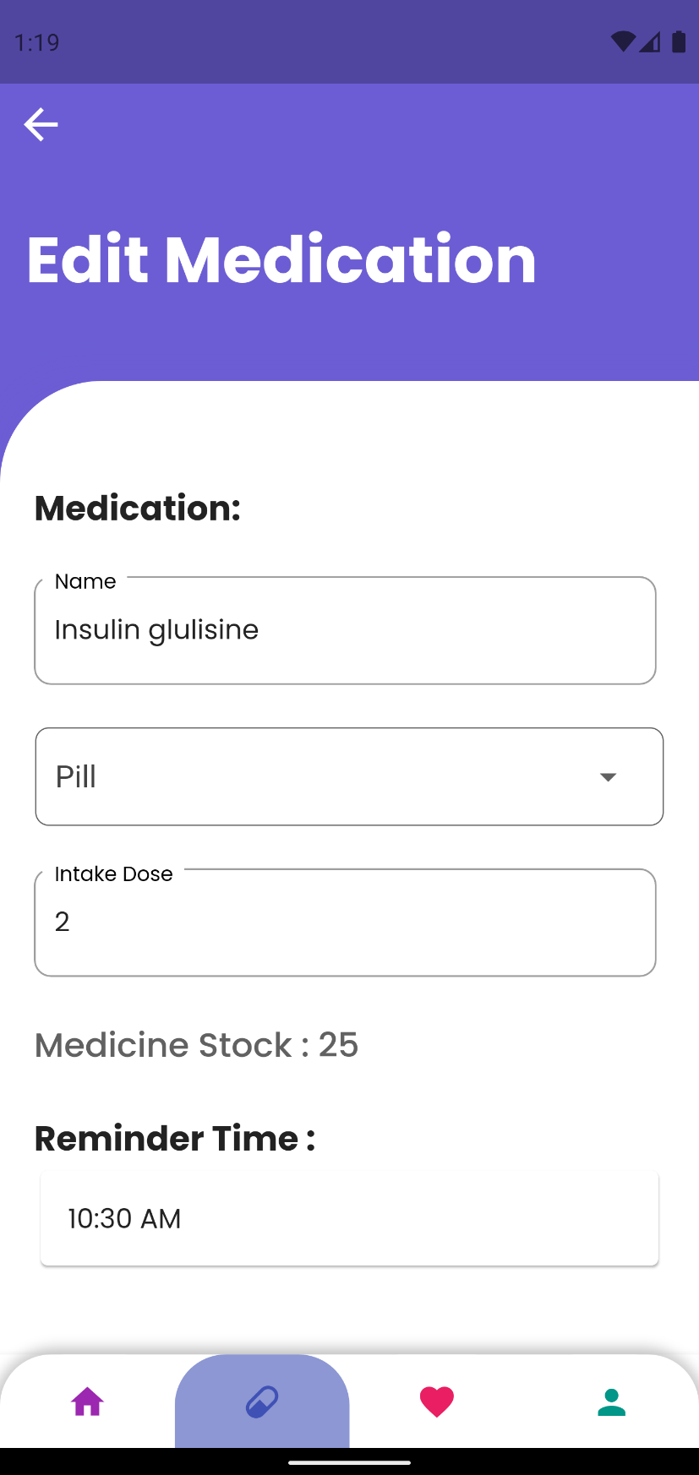

Figure Updating some information related to the medicine

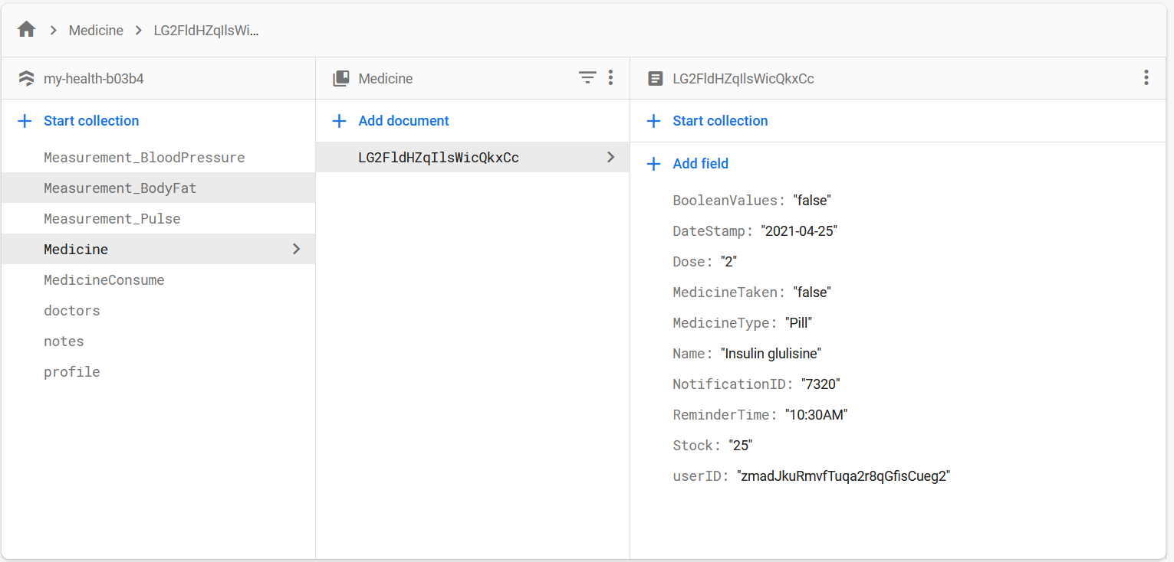

Figure Database data being updated after editing medicine

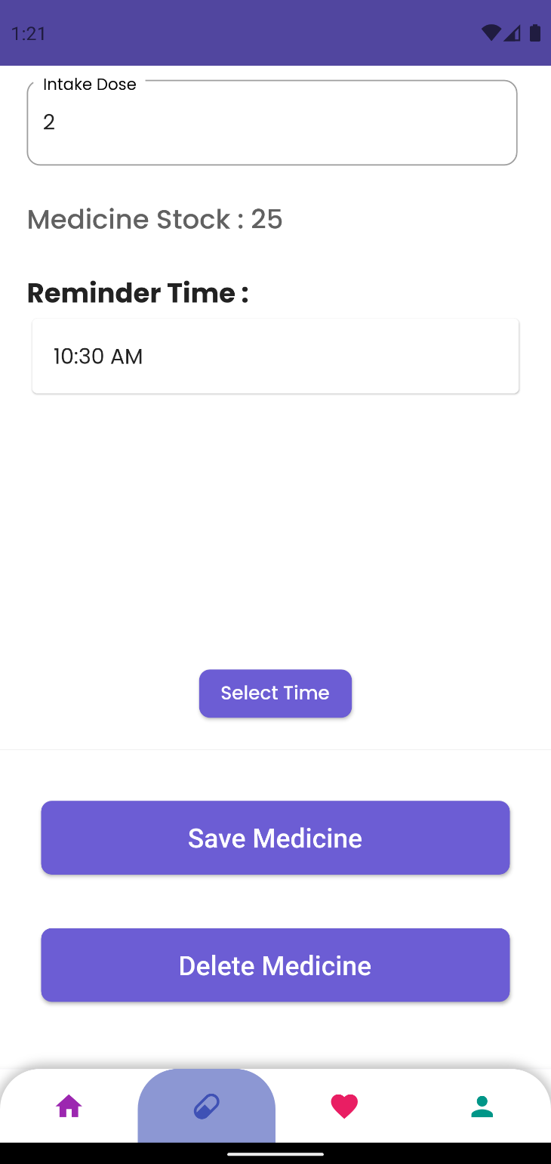

Figure Deleting the medicine

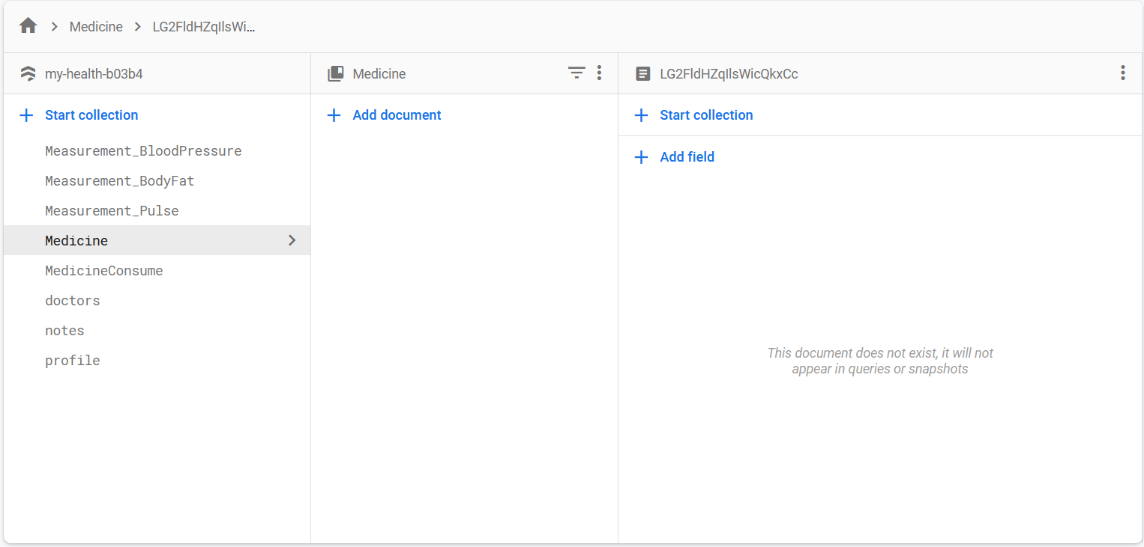

Figure Medicine data being deleted form the database as well

1. **Medicine data being reset daily.**

|  |  |
| --- | --- |
| **Objective** | To check if the medicine-related data are reset daily. |
| **Action** | To update medicine data into the previous day date and see if the date changes automatically after launching the application. |
| **Expected Result** | The medicine date should change along with the necessary values that needed to be changes daily. |
| **Actual Result** | The medicine date, along with other values to be changed, is changed after launching the application. |
| **Conclusion** | Test Successful. |

Table Unit Testing Medicine data being rest daily.

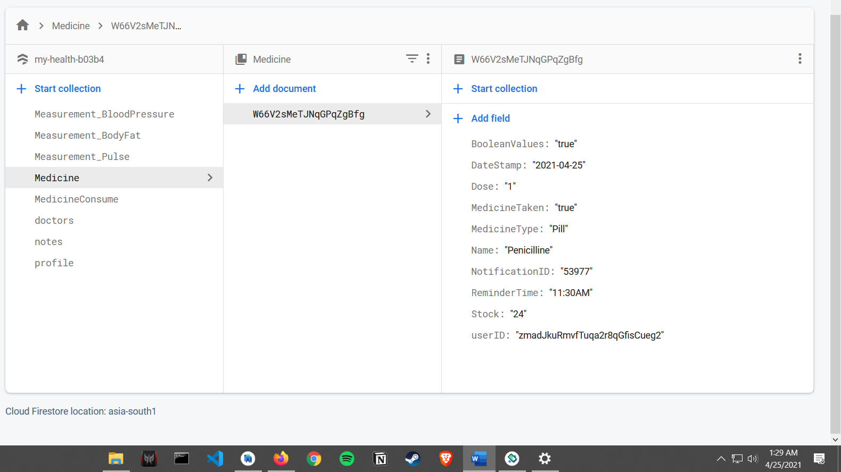

Figure Medicine data in database before making changes

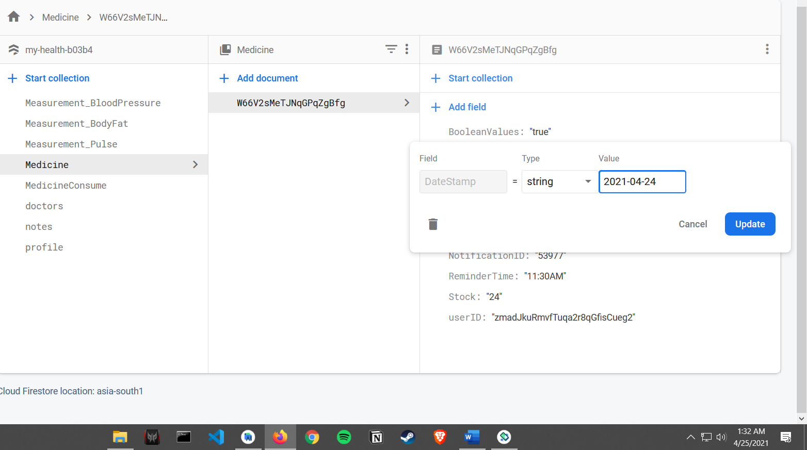

Figure Changing the date to yesterday’s date

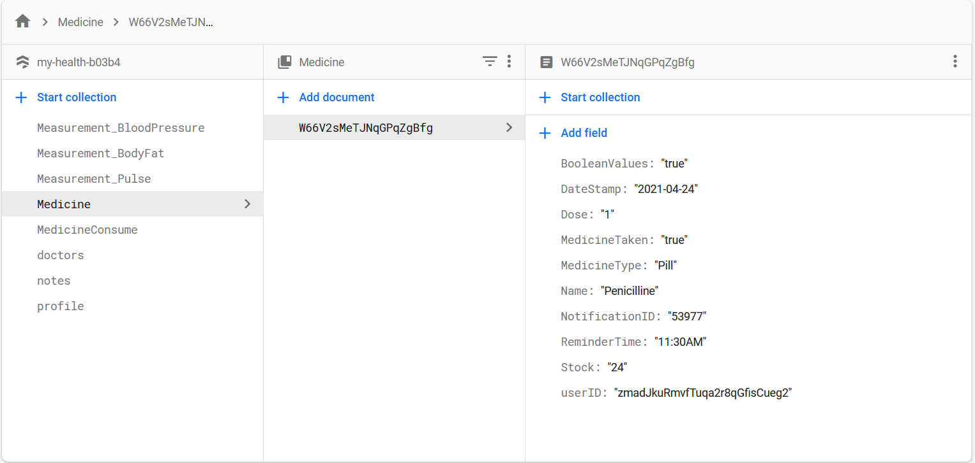

Figure Changes in database after changing the date.

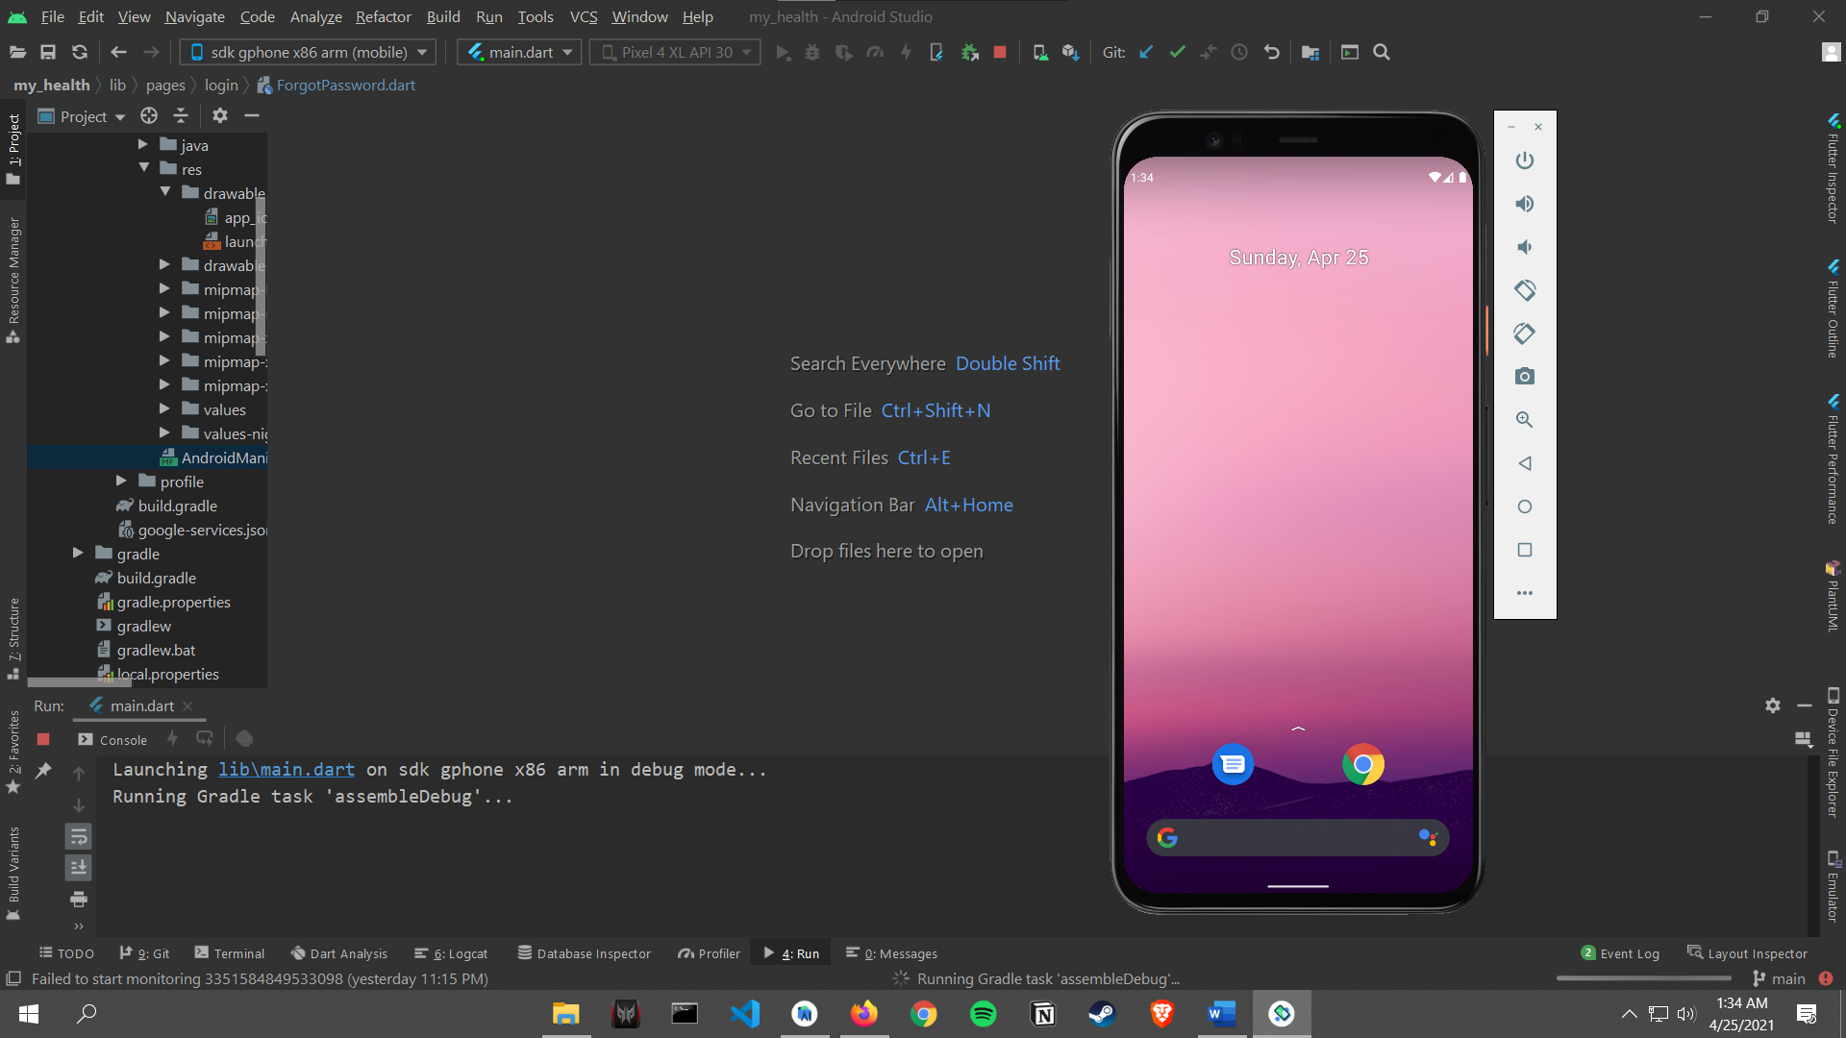

Figure Launching the application after changing the date to the previous day

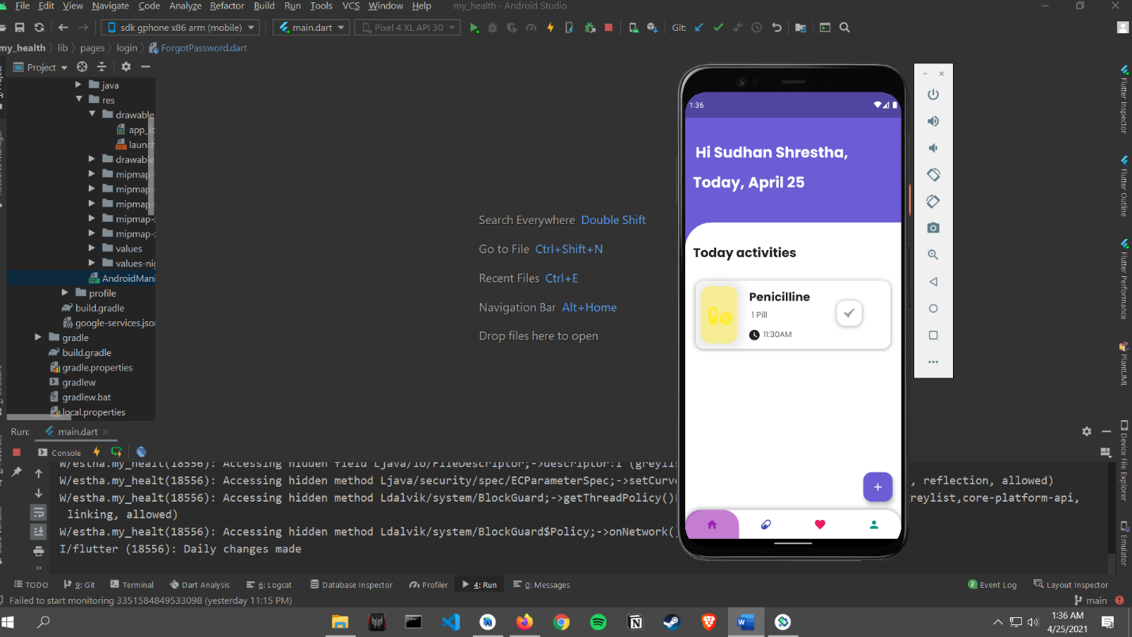

Figure Application being launched and daily changes being made

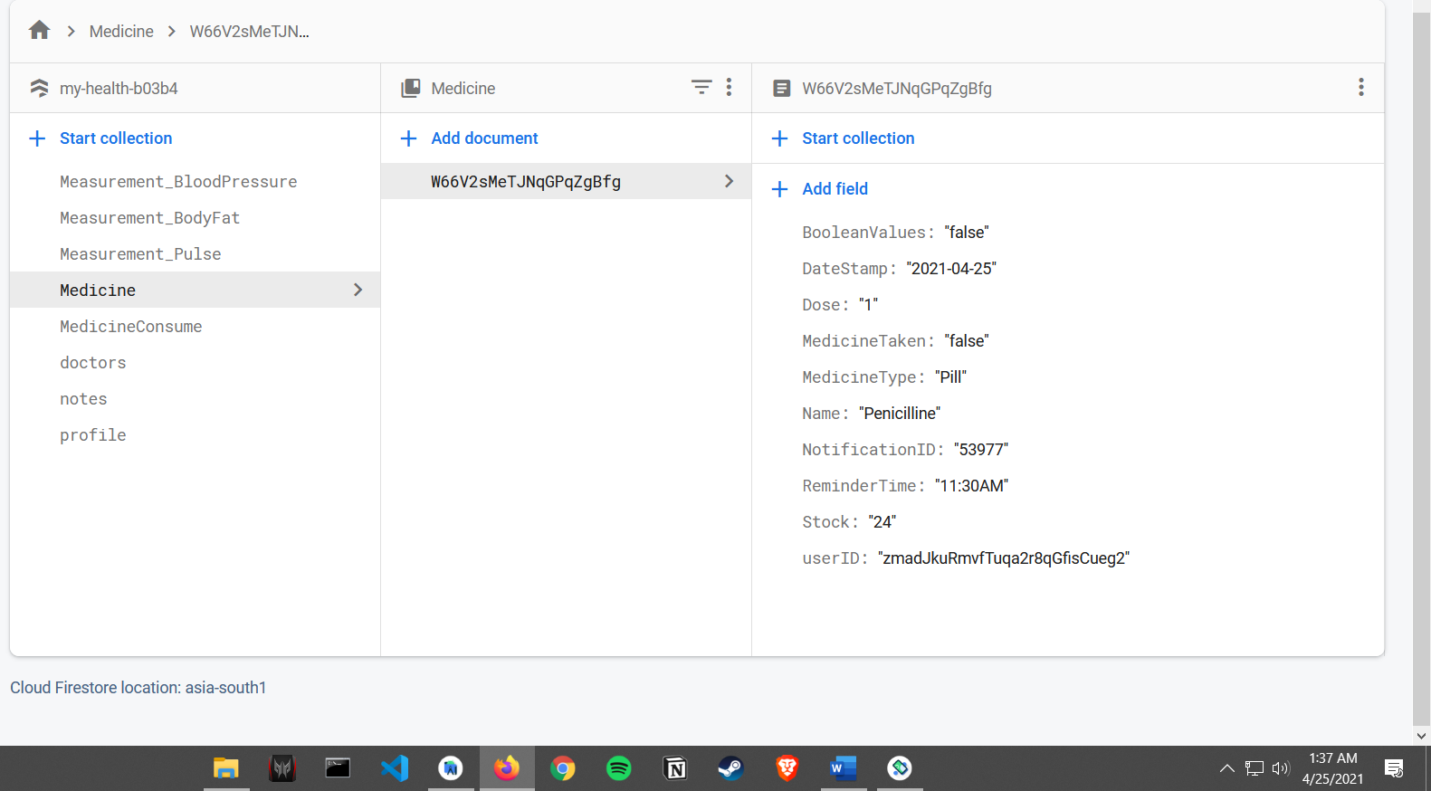

Figure The database data being updated automatically after launching the application

1. **Medicine Skip Notification**

|  |  |
| --- | --- |
| **Objective** | To see if a notification is triggered if medicine skip is pressed. |
| **Action** | To press skip medicine. |
| **Expected Result** | A notification stating medicine was not taken should be triggered after a couple of minutes. |
| **Actual Result** | The notification stating medicine was skipped is triggered after a couple of minutes. |
| **Conclusion** | Test Successful. |

Table Unit Testing Medicine Skip Notification

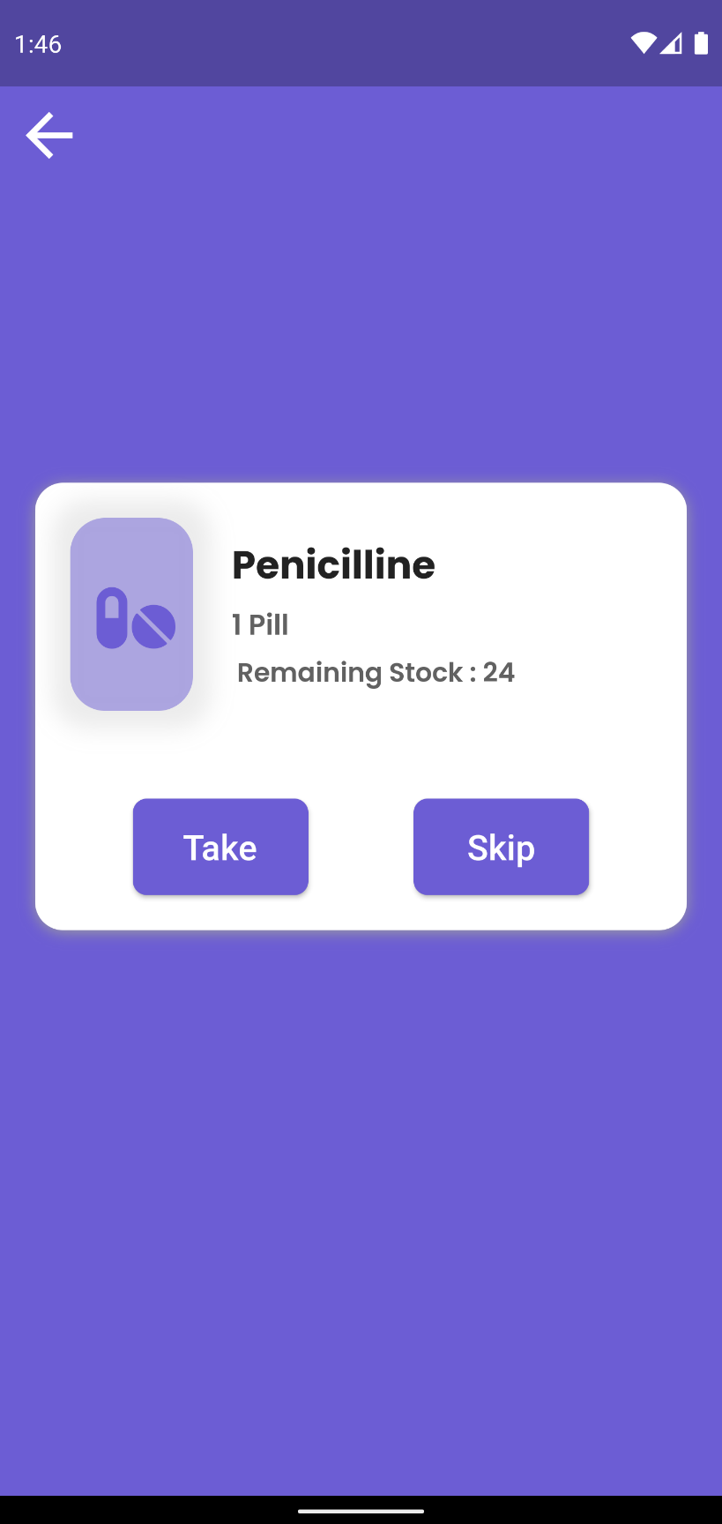

Figure Pressing Skip button

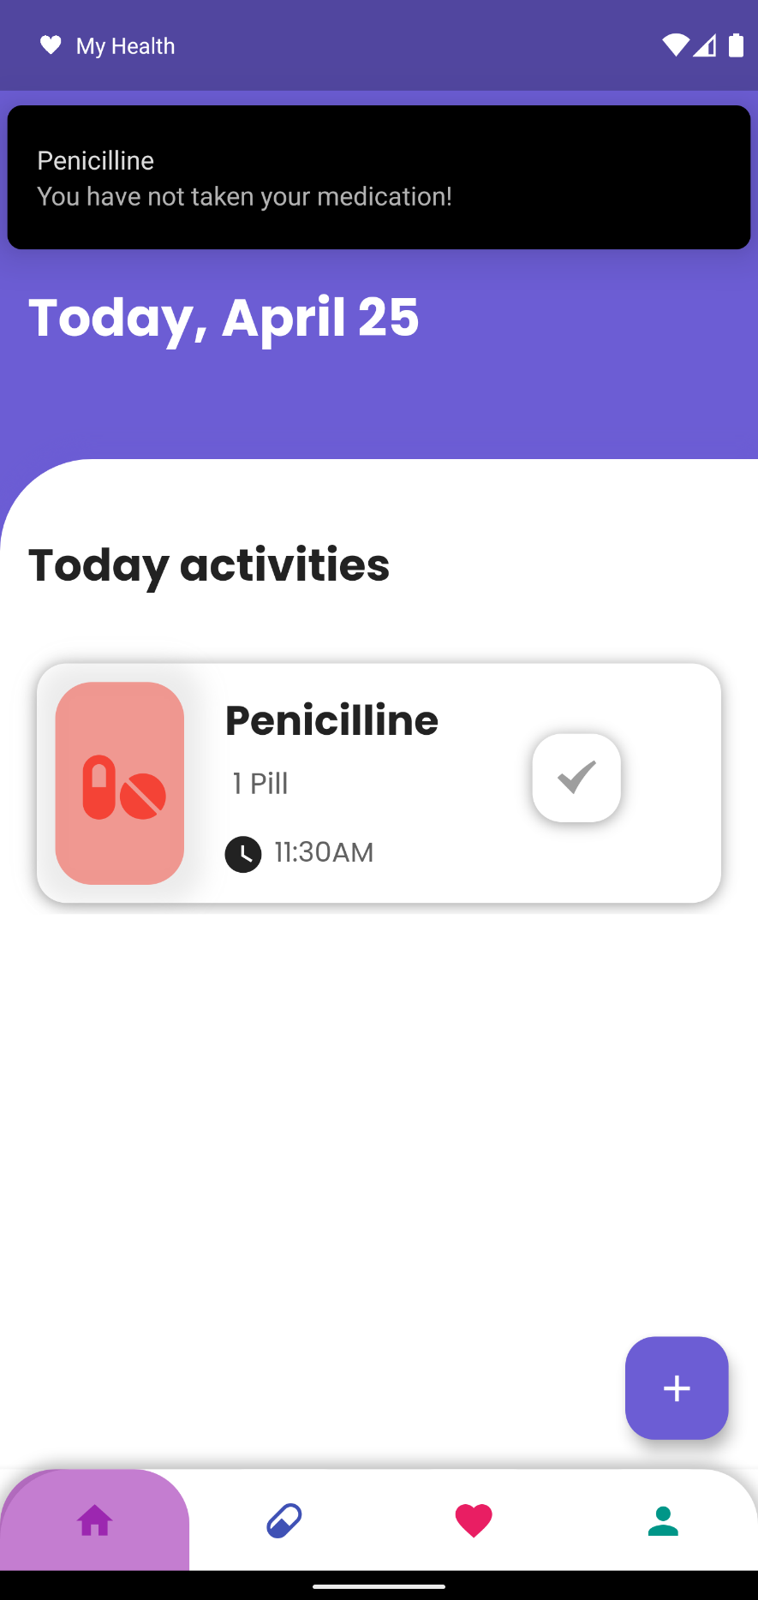

Figure Medicine Skip reminder being triggered

1. **Medicine Data Update**

|  |  |
| --- | --- |
| **Objective** | To see if medicine data are updated after a medicine take is pressed. |
| **Action** | To press take medicine. |
| **Expected Result** | The data related to medicine should be changed in the database. |
| **Actual Result** | The data related to the medicine is changed in the database. |
| **Conclusion** | Test Successful. |

Table Unit Testing Medicine Data Update

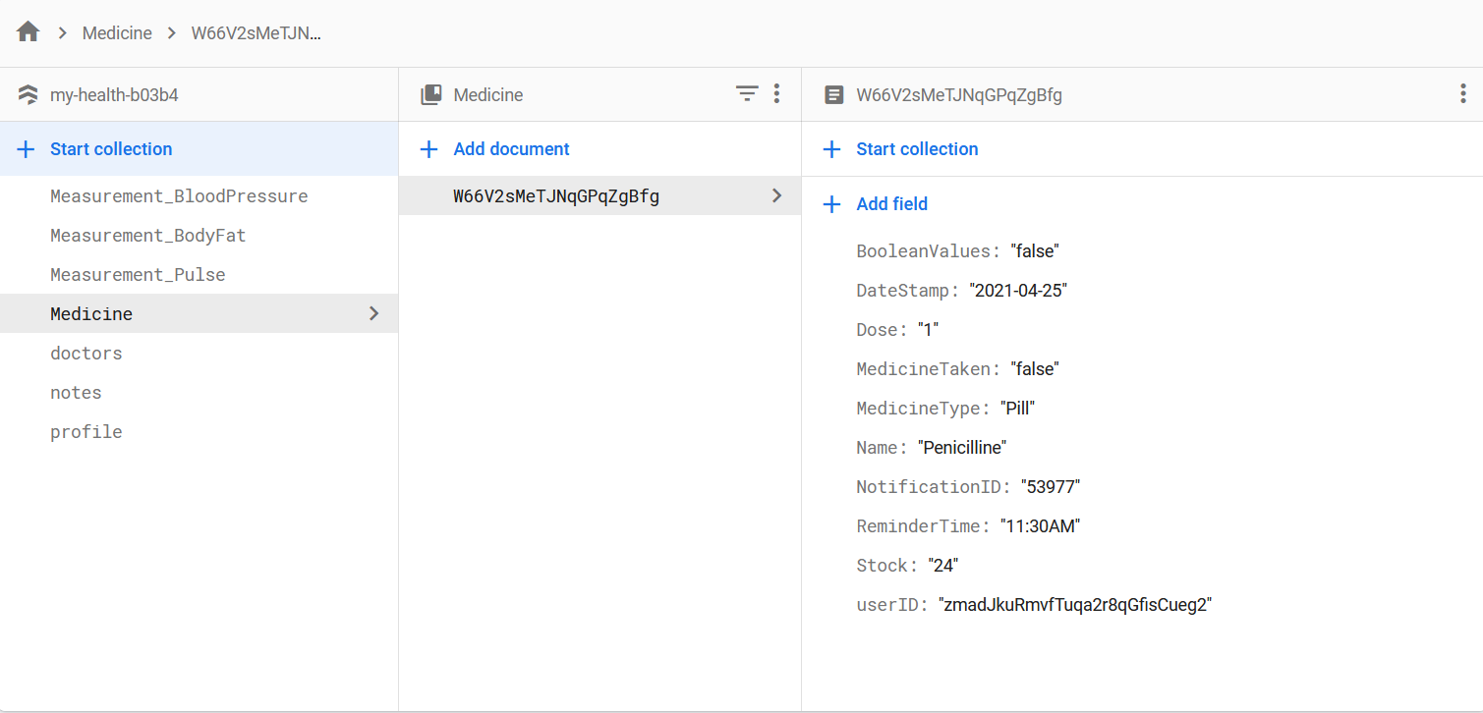

Figure Medicine data in the database before taking medicine

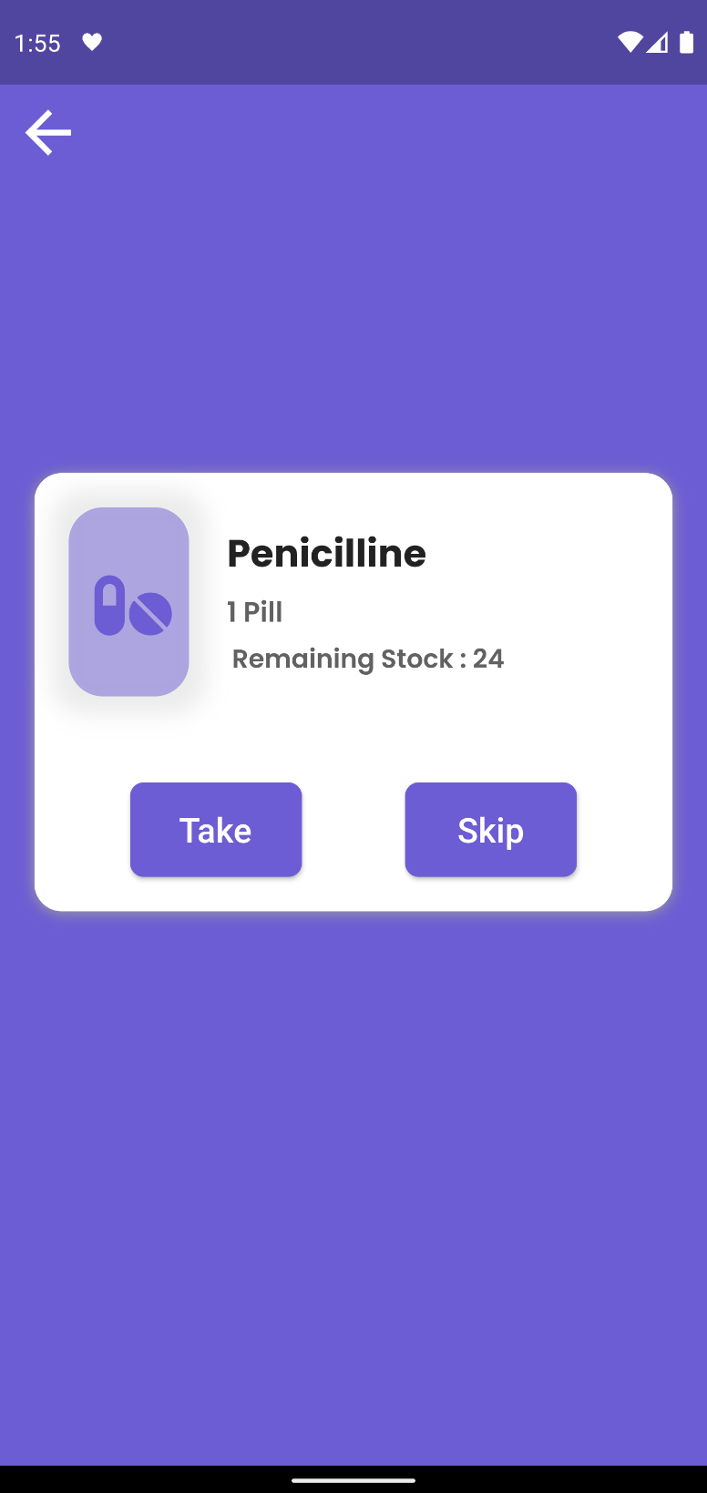

Figure Pressing Take button

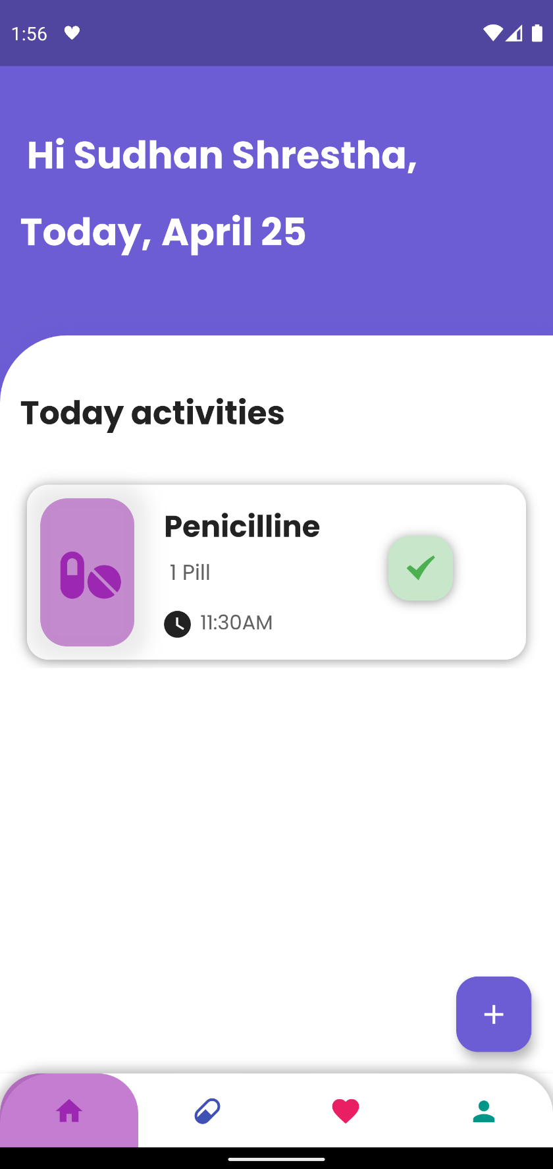

Figure Medicine Taken being displayed in the application

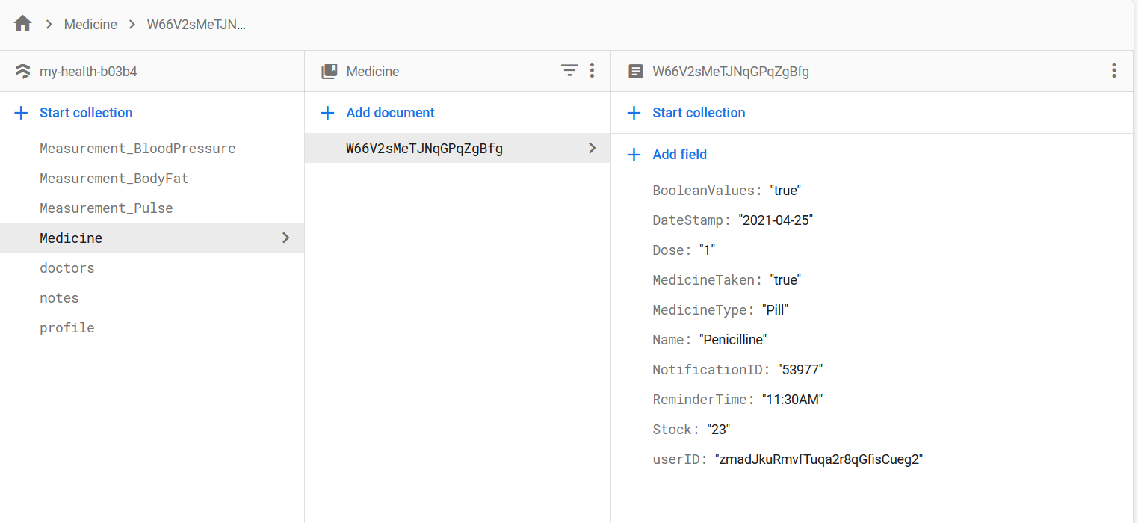

Figure Medicine related data being changed in the database

1. **Contact Doctor**

|  |  |
| --- | --- |
| **Objective** | To see if contact buttons for Doctor are functioning. |
| **Action** | To press call doctor and email doctor. |
| **Expected Result** | The user should be redirected to the dialer with the doctor’s number if pressed in call, and if pressed in the email, the user should be redirected to the email app with the doctor’s email. |
| **Actual Result** | The user was redirected to the dialer with the doctor’s number if pressed in call, and when pressed in the email, the user was redirected to the email app with the doctor’s email. |
| **Conclusion** | Test Successful. |

Table Unit Testing Contact Doctor

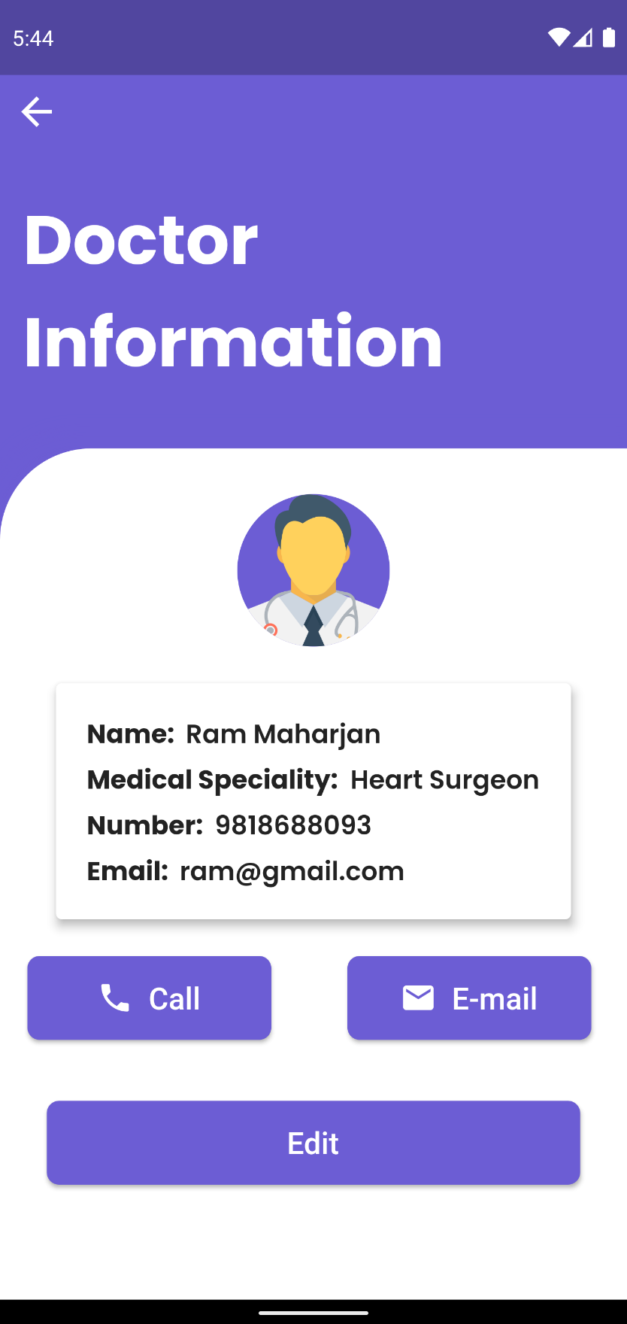

Figure Pressing Call in Doctors Information UI

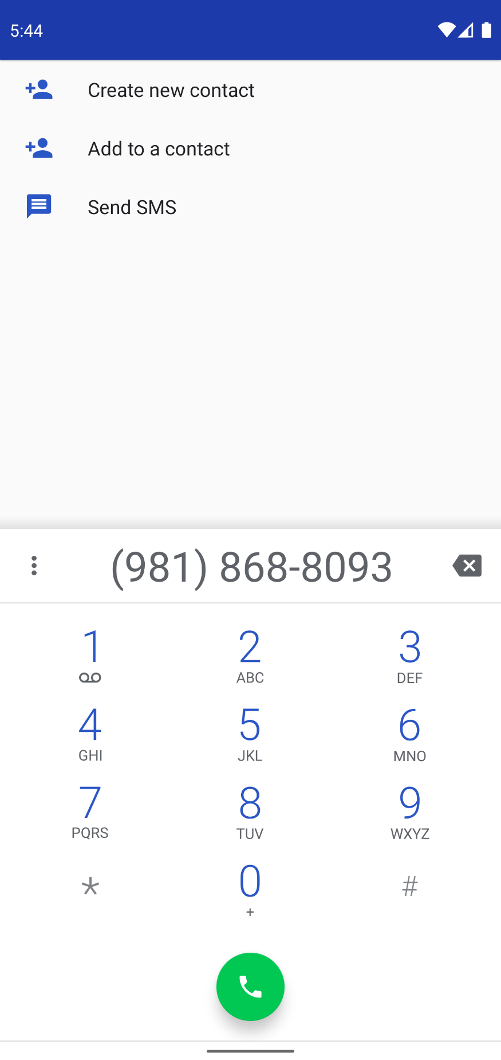

Figure User being redirected to dialer with doctor’s number

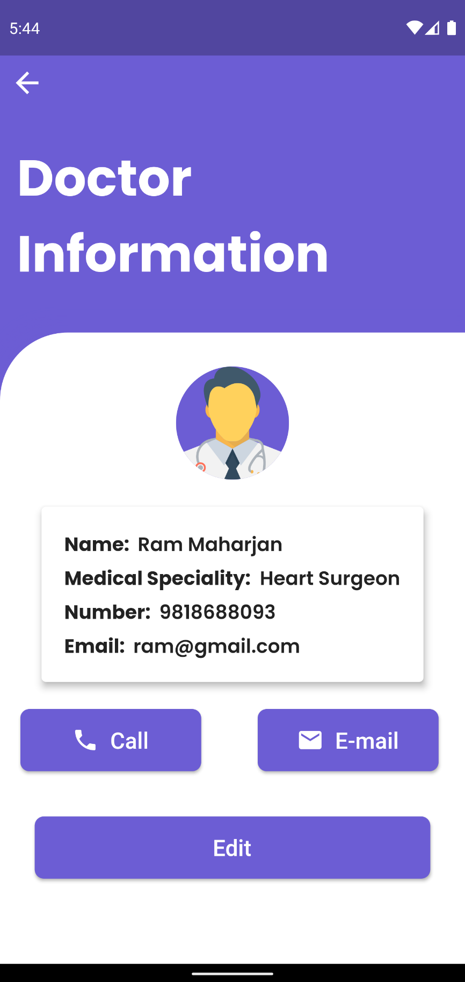

Figure Pressing Email on Doctors Information UI

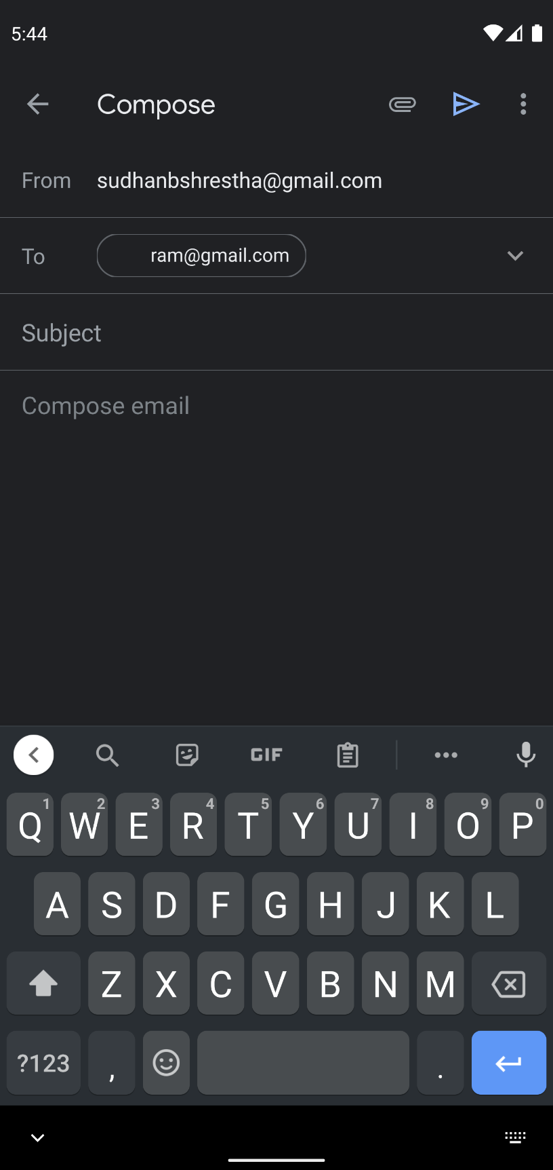

Figure User being redirected to email app with doctor’s email

## SYSTEM TESTING

1. **Register User**

|  |  |
| --- | --- |
| **Objective** | To register a new user. |
| **Action** | To register the user by entering the required field in register Ui and then setting up profile properly. |
| **Expected Result** | The user should first be redirected to the setup profile page after registering and then into the home screen. |
| **Actual Result** | The user is registered and is redirected to the home page. |
| **Conclusion** | Test Successful. |

Table System Testing Register User

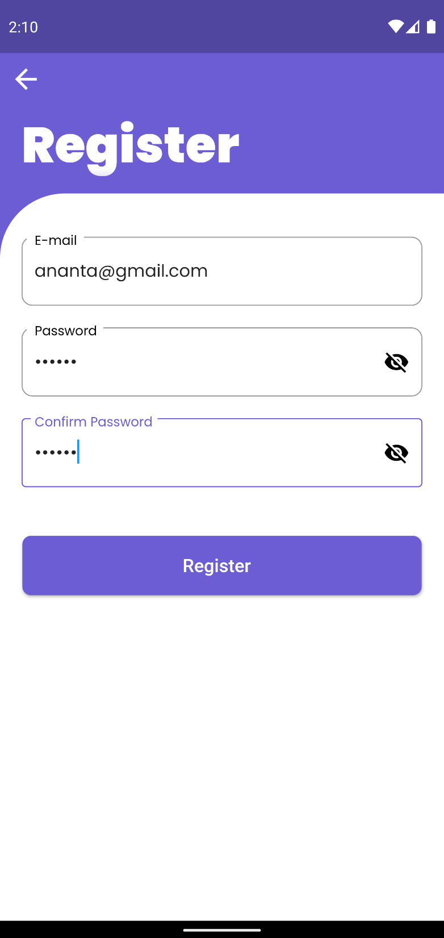

Figure Registering a new user

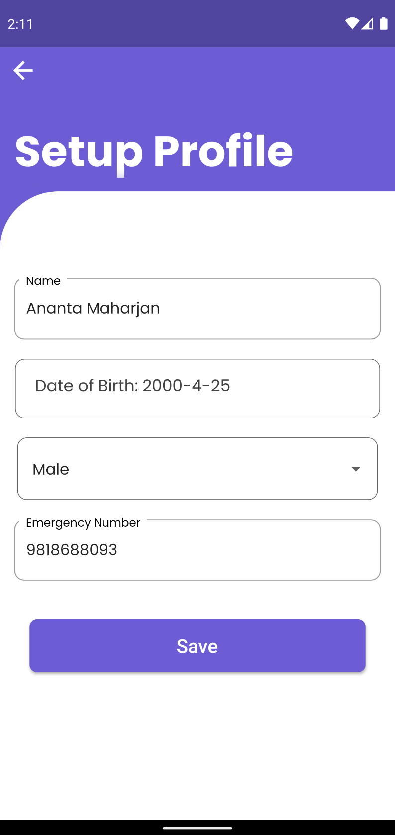

Figure Setting up profile for the new user

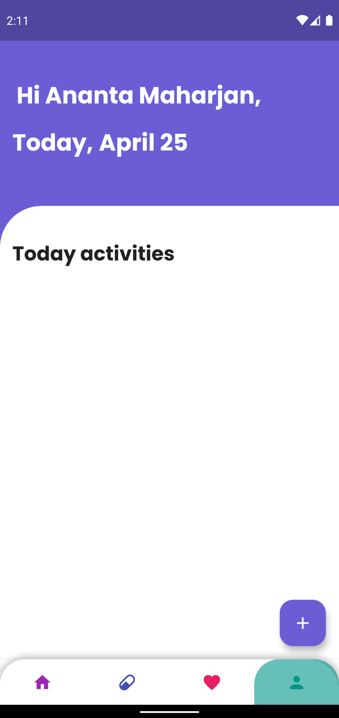

Figure New user being redirected to the home page

1. **Register Validation**

|  |  |
| --- | --- |
| **Objective** | To check register validation. |
| **Action** | To register a user using invalid data and data of an already registered user. |
| **Expected Result** | The user should not be registered, and an invalid data message should be displayed. |
| **Actual Result** | The user is not registered, and an invalid message is displayed. |
| **Conclusion** | Test Successful. |

Table System Testing Register Validation

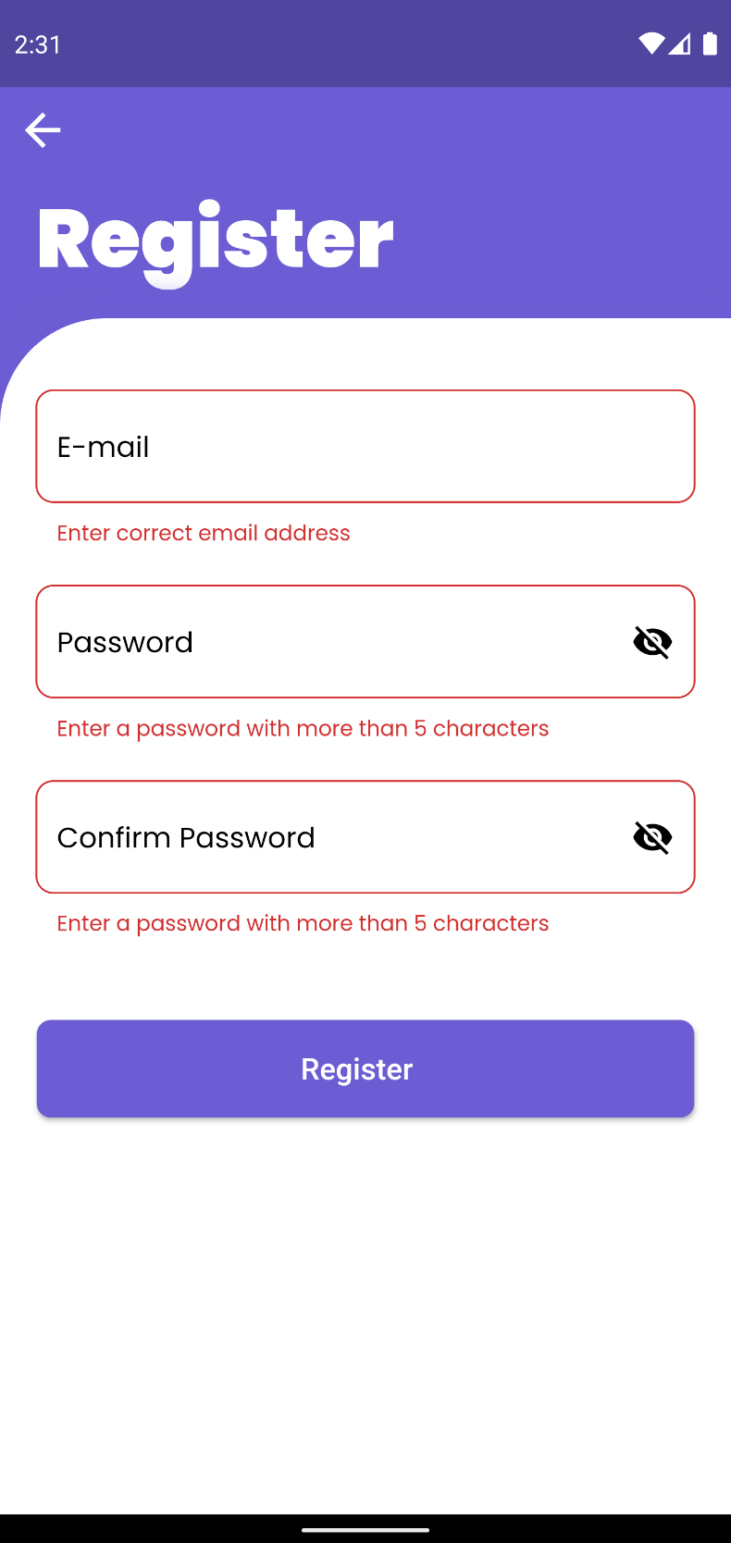

Figure Error message being displayed when trying to register using empty fields

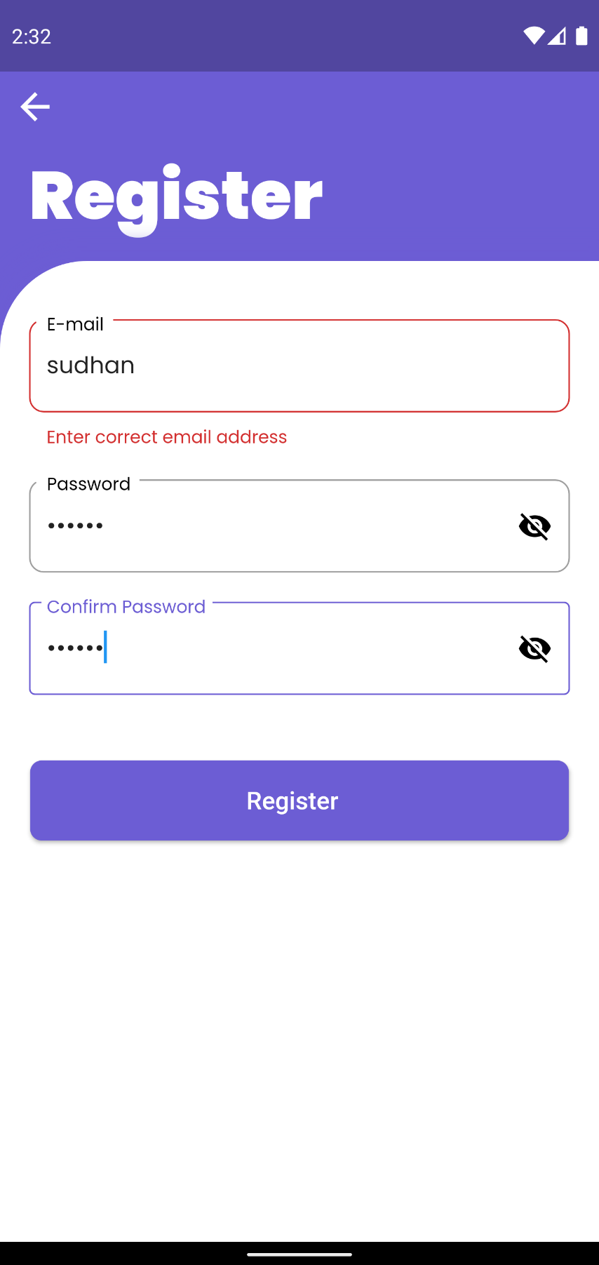

Figure Invalid email message being displayed when registering using the invalid email address

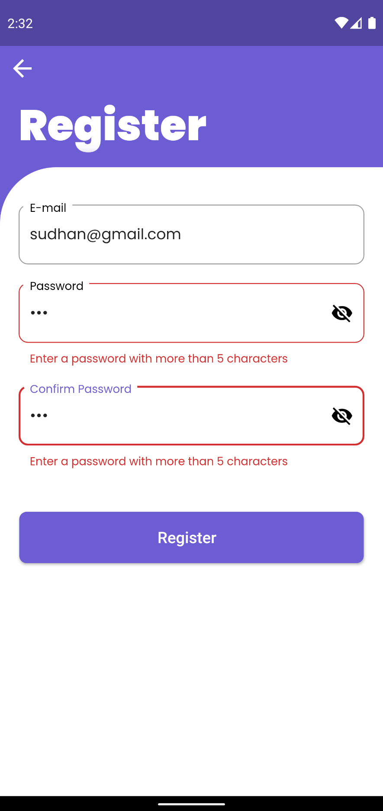

Figure Error Message being displayed when Invalid password is entered

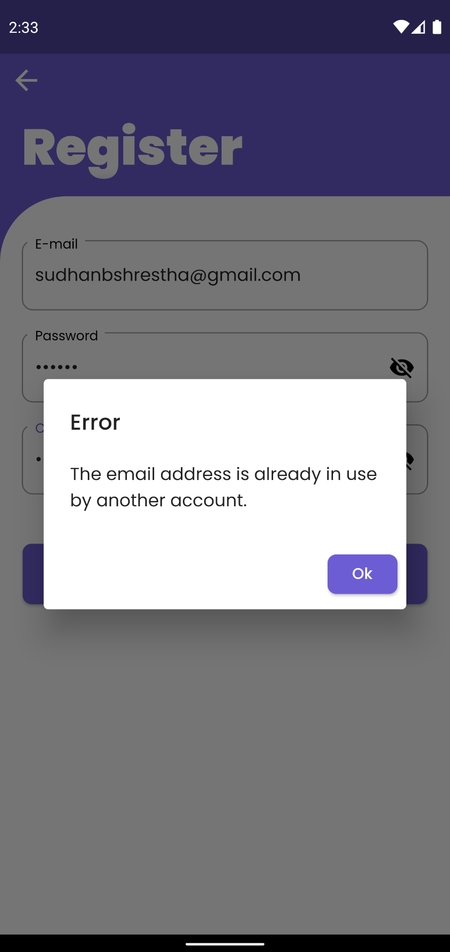

Figure Error dialog box being displayed when trying to register with an already registered account

1. **Login User**

|  |  |
| --- | --- |
| **Objective** | To login a registered user. |
| **Action** | To login a user using correct input fields. |
| **Expected Result** | The user should be logged into the application. |
| **Actual Result** | The user is logged into the application. |
| **Conclusion** | Test Successful. |

Table System Testing Login User

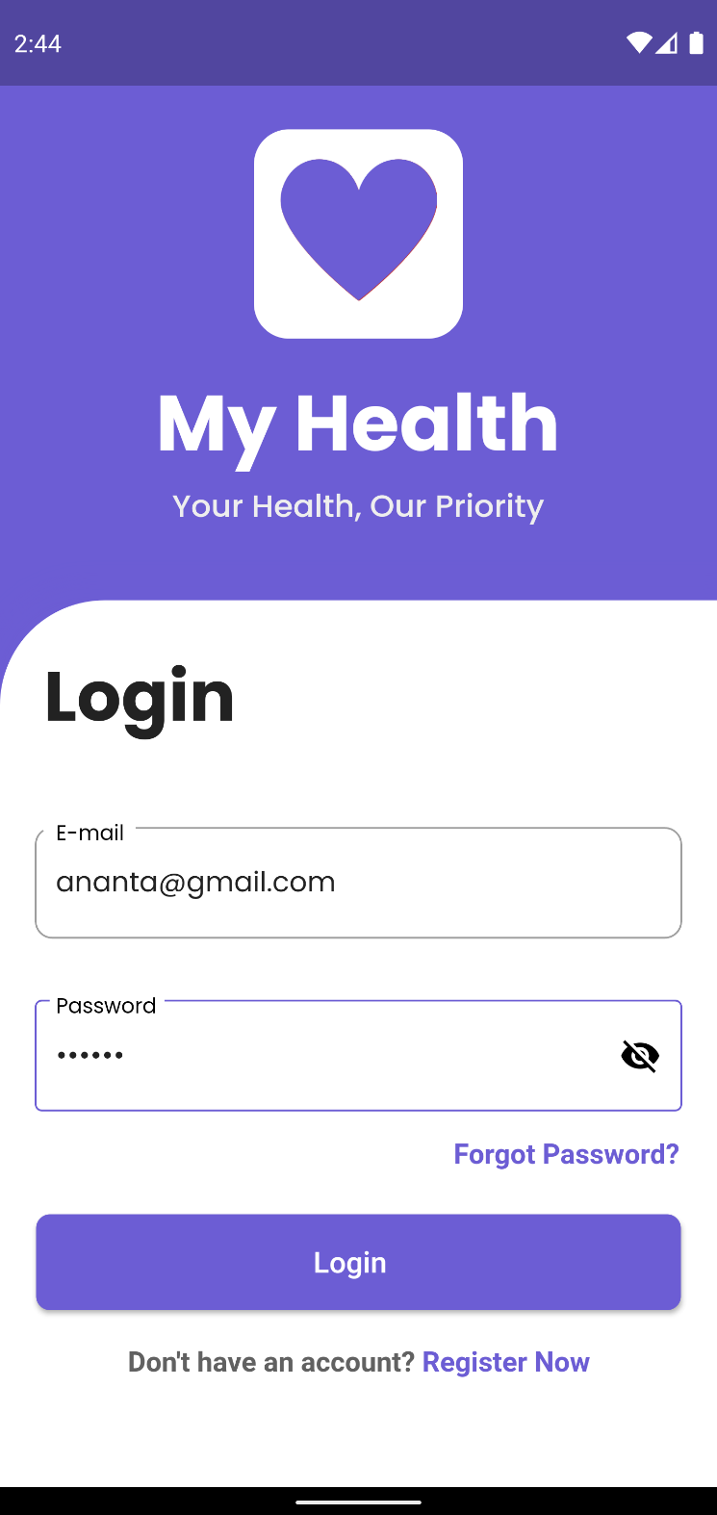

Figure Entering correct login credential

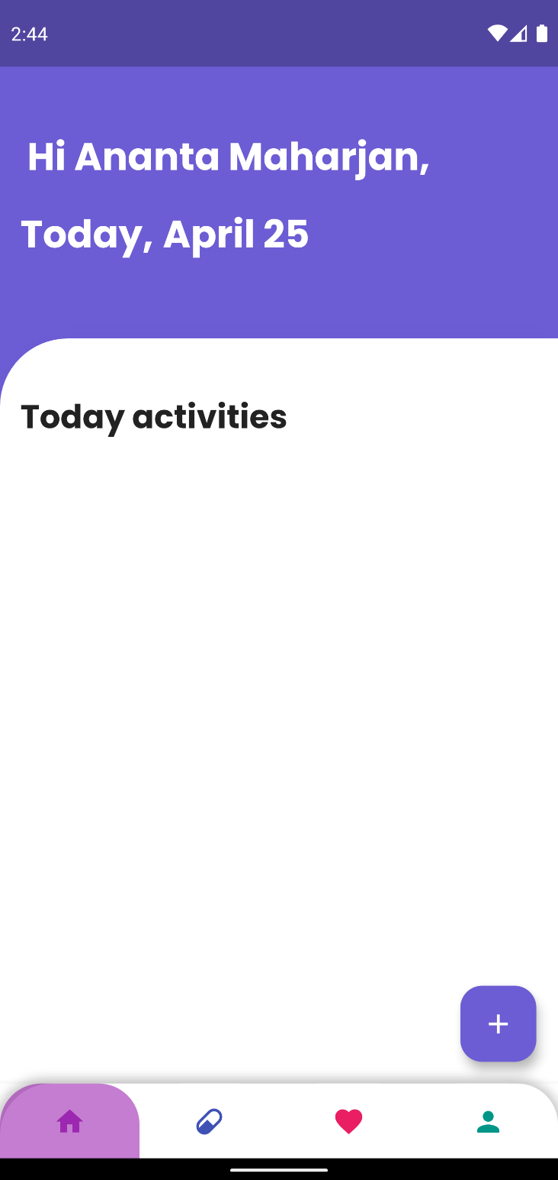

Figure User being logged into the system

1. **Login Validation**

|  |  |
| --- | --- |
| **Objective** | To check login validation. |
| **Action** | To login a user using incorrect input fields. |
| **Expected Result** | The user should not be logged into the application. |
| **Actual Result** | The user is not logged into the application. |
| **Conclusion** | Test Successful. |

Table System Testing Login Validation

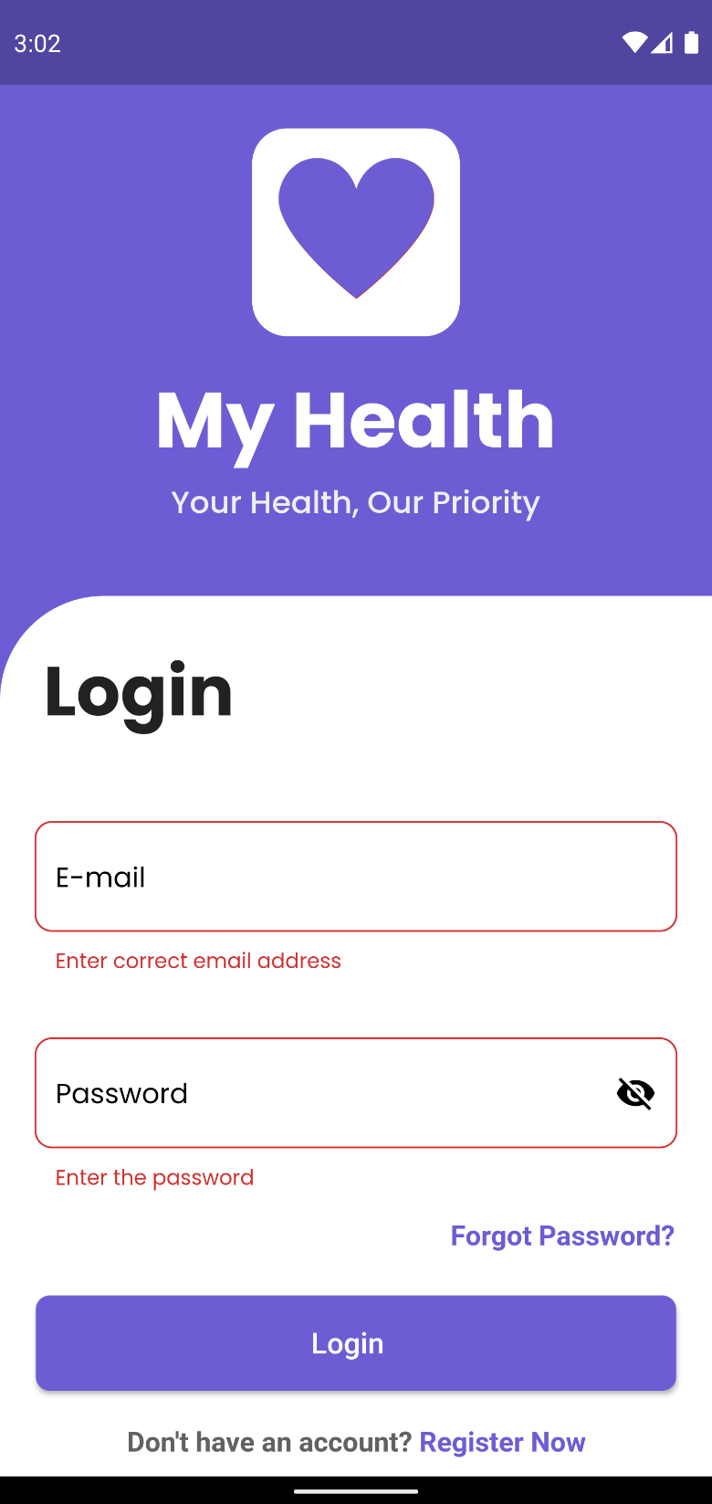

Figure Error message being displayed when login with empty fields

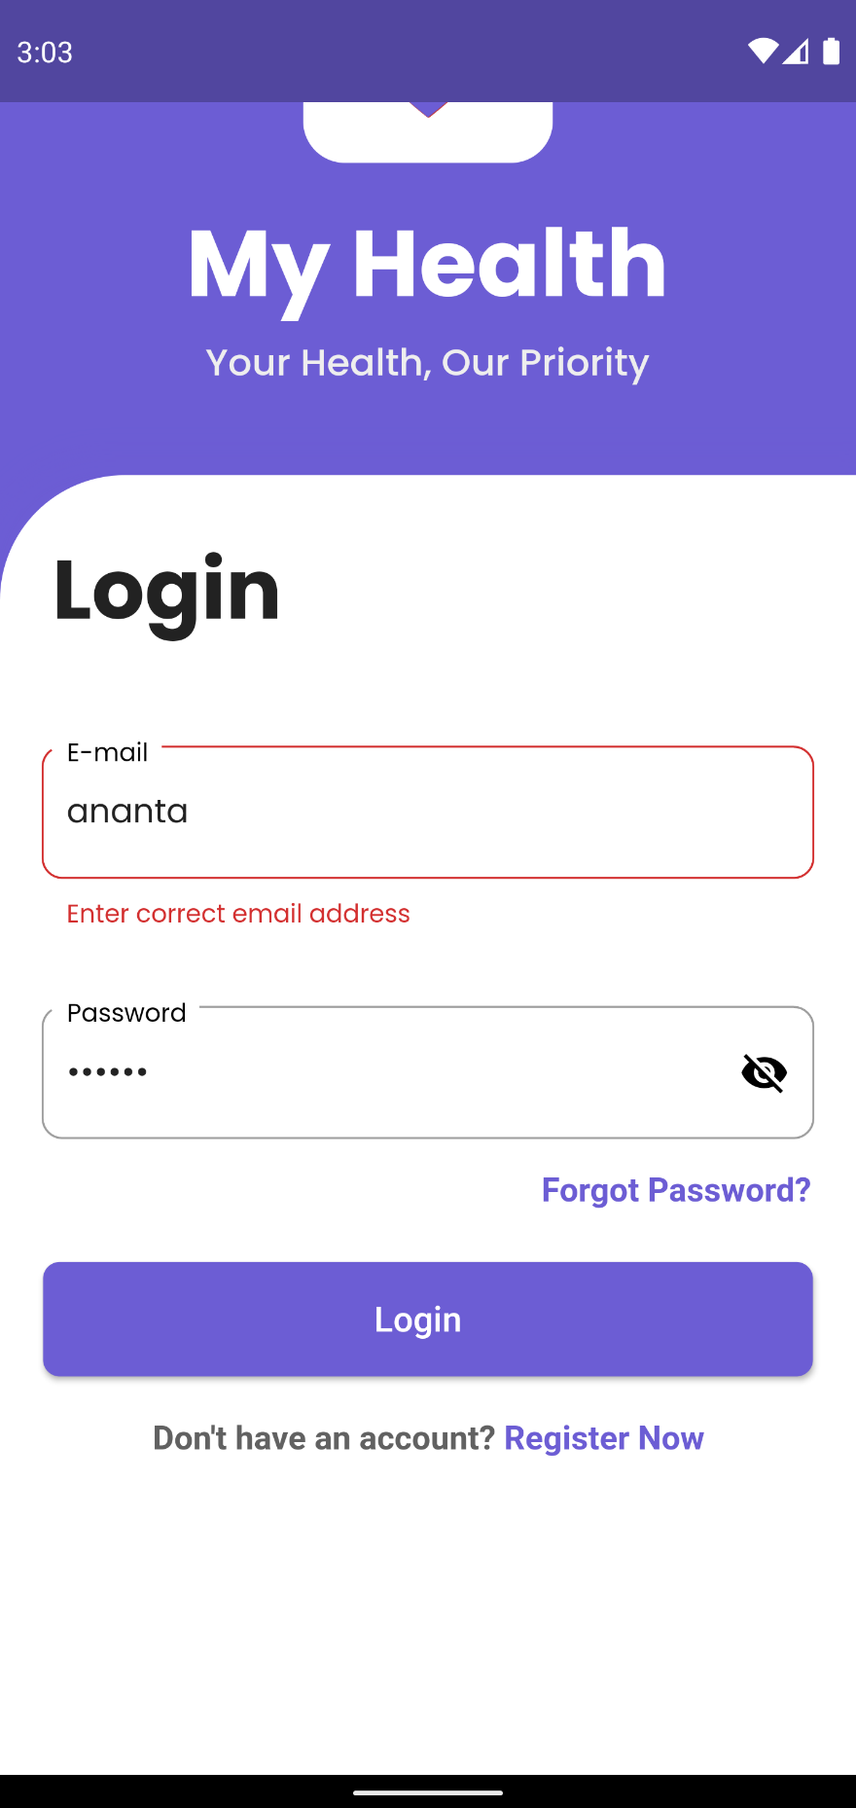

Figure Error message being displayed when login with invalid email address

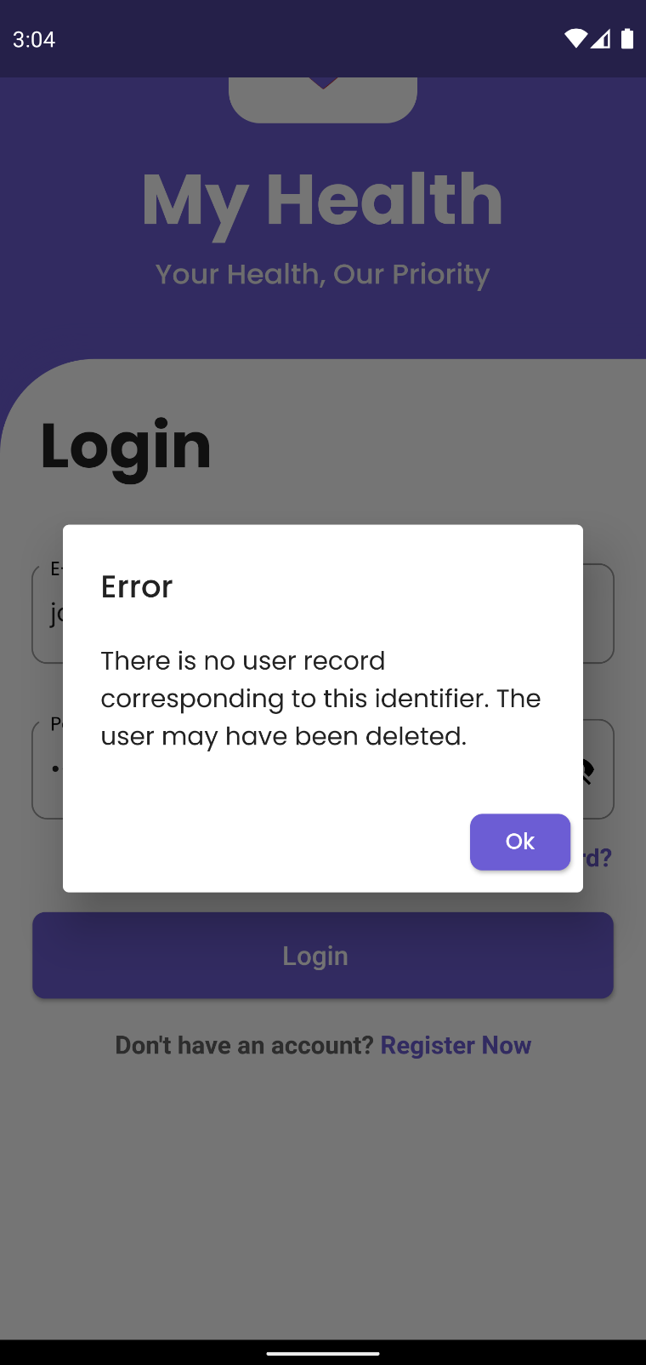

Figure Error dialog box being displayed when login in using an unregistered email

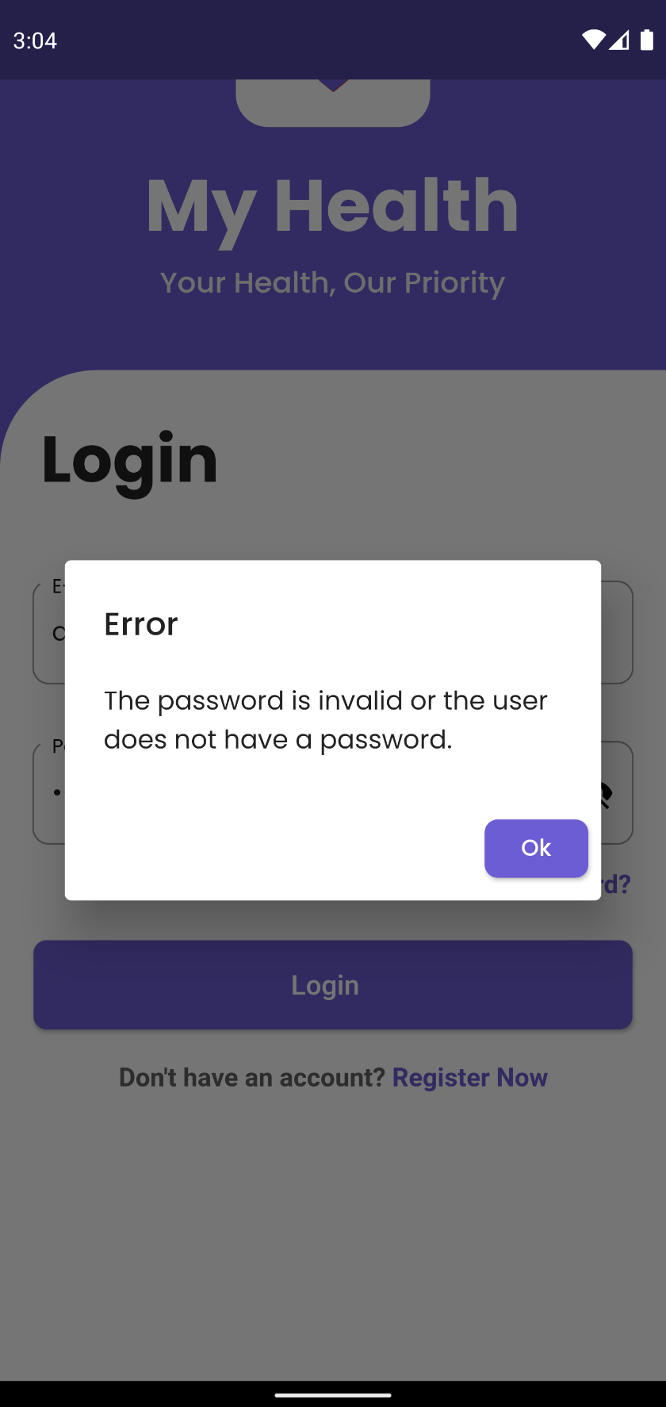

Figure Error dialog box being displayed when logging in using incorrect password for a registered user

1. **Medicine Reminder**

|  |  |
| --- | --- |
| **Objective** | To check if medicine reminder notification is triggered. |
| **Action** | To check if medicine reminder notification is triggered in the correct user-set time. |
| **Expected Result** | The notification is triggered in the user set time. |
| **Actual Result** | The notification is triggered in the user set time. |
| **Conclusion** | Test Successful. |

Table System Testing Medicine Reminder

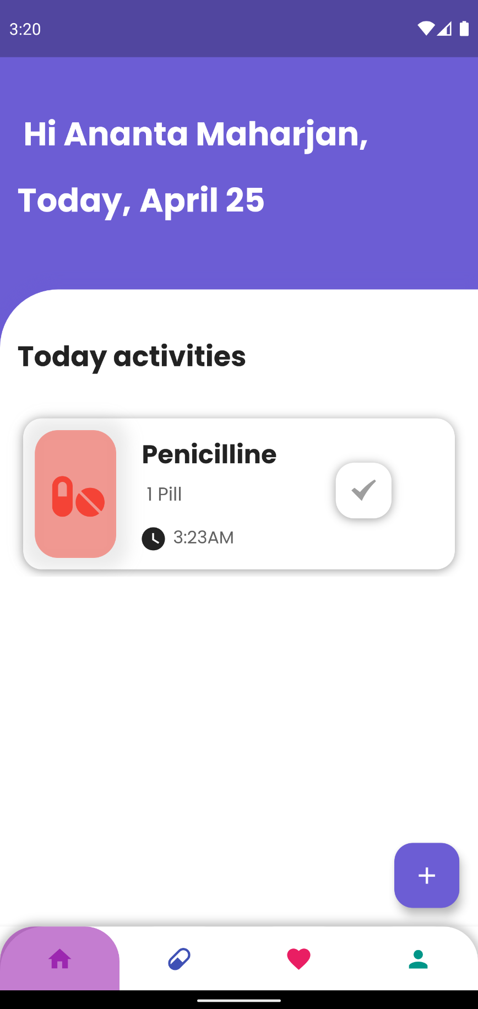

Figure Medicine with a reminder in user given time

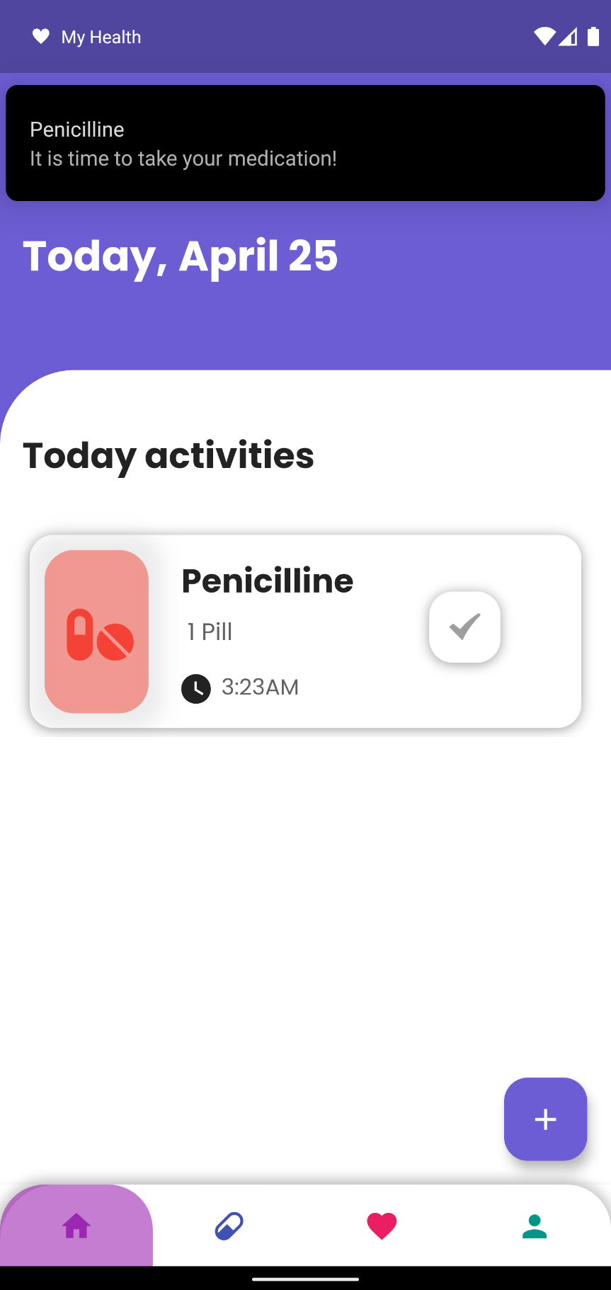

Figure Notification for Medicine reminder being triggered in user defined time

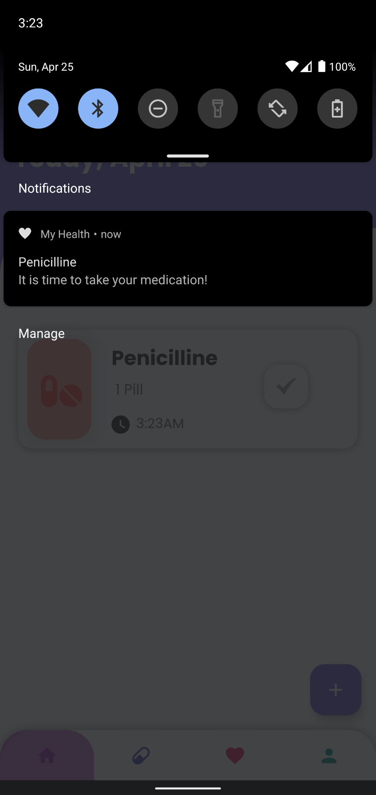

Figure Notification being triggered at the correct time

1. **To test CRUD operation for Medicine**

|  |  |
| --- | --- |
| **Objective** | To perform CRUD operation in Medicine, relate features |
| **Action** | To carry out CRUD operation in Medicine related features. |
| **Expected Result** | User will be able to Add medicine, update their medicine information and delete medicine. |
| **Actual Result** | User can Add medicine, update their medicine information and delete medicine. |
| **Conclusion** | Test Successful. |

Table System Test To test CRUD operation for Medicine

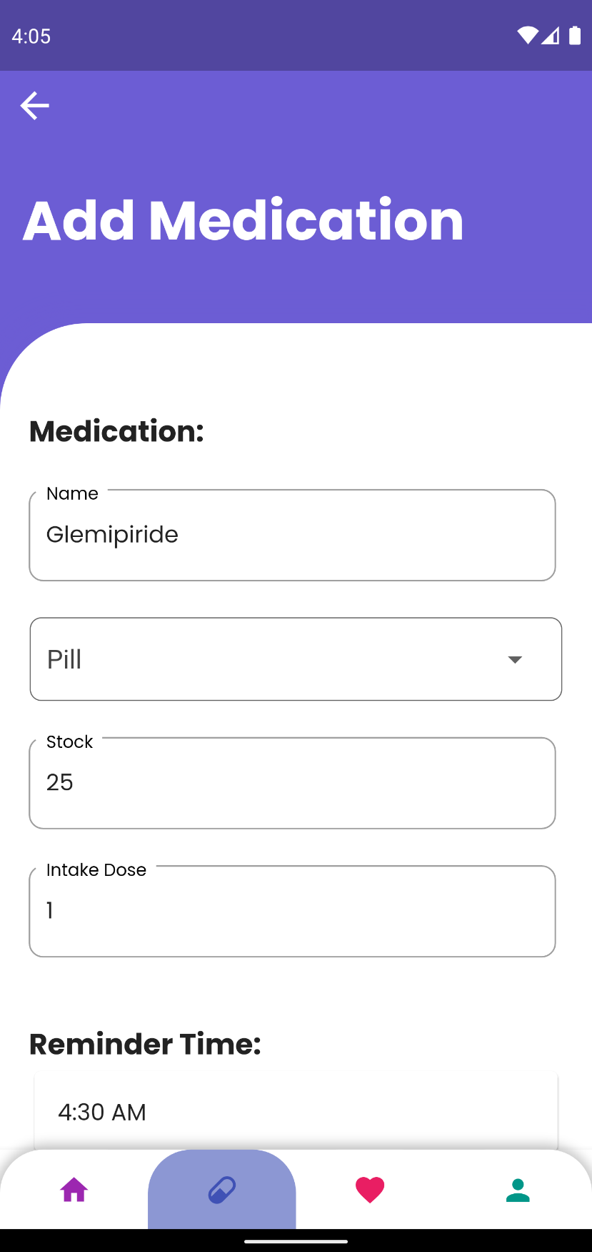

Figure Adding a medicine

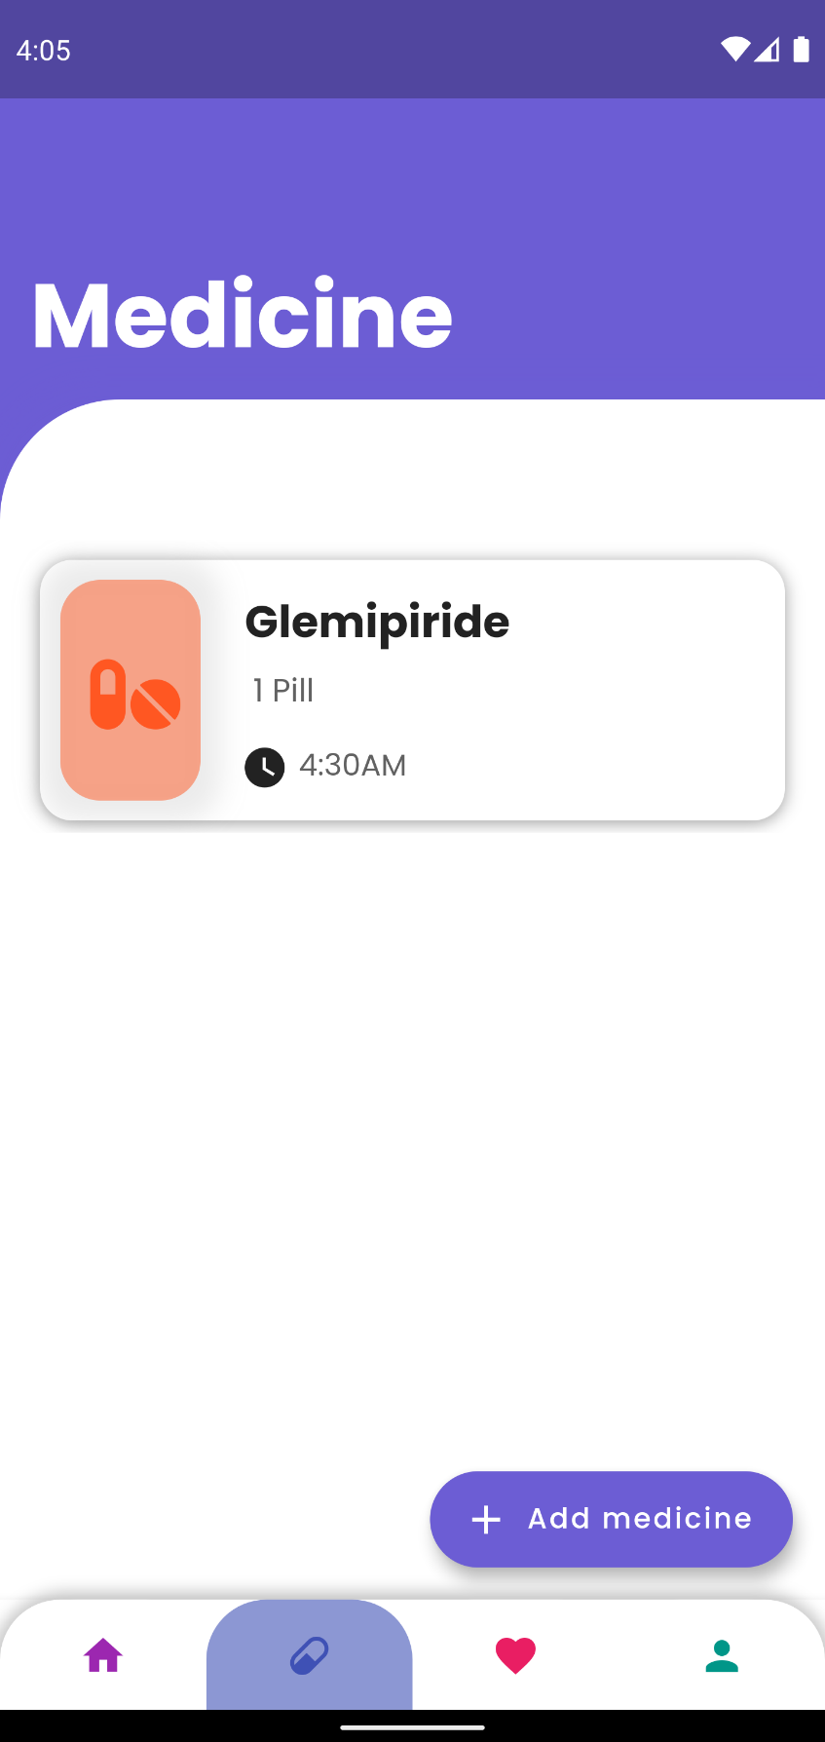

Figure The medicine added being displayed

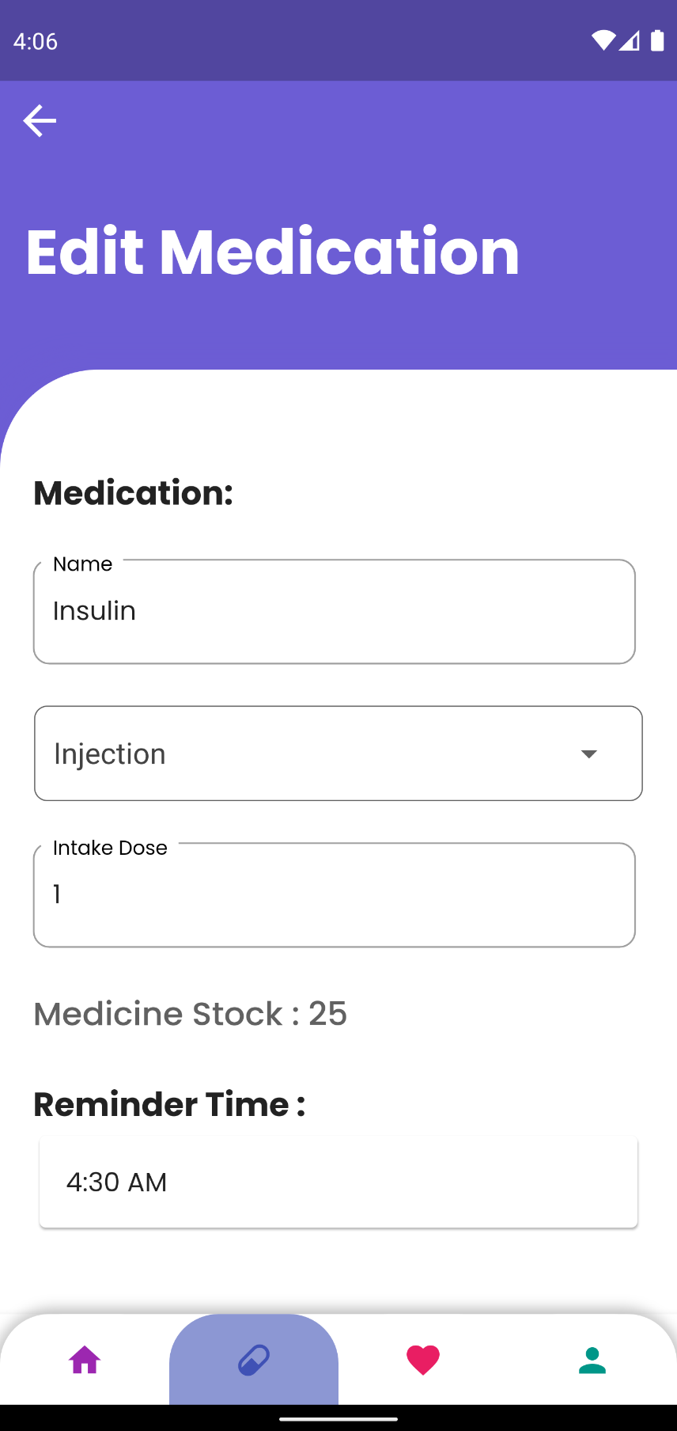

Figure Updating/Editing a medicine information

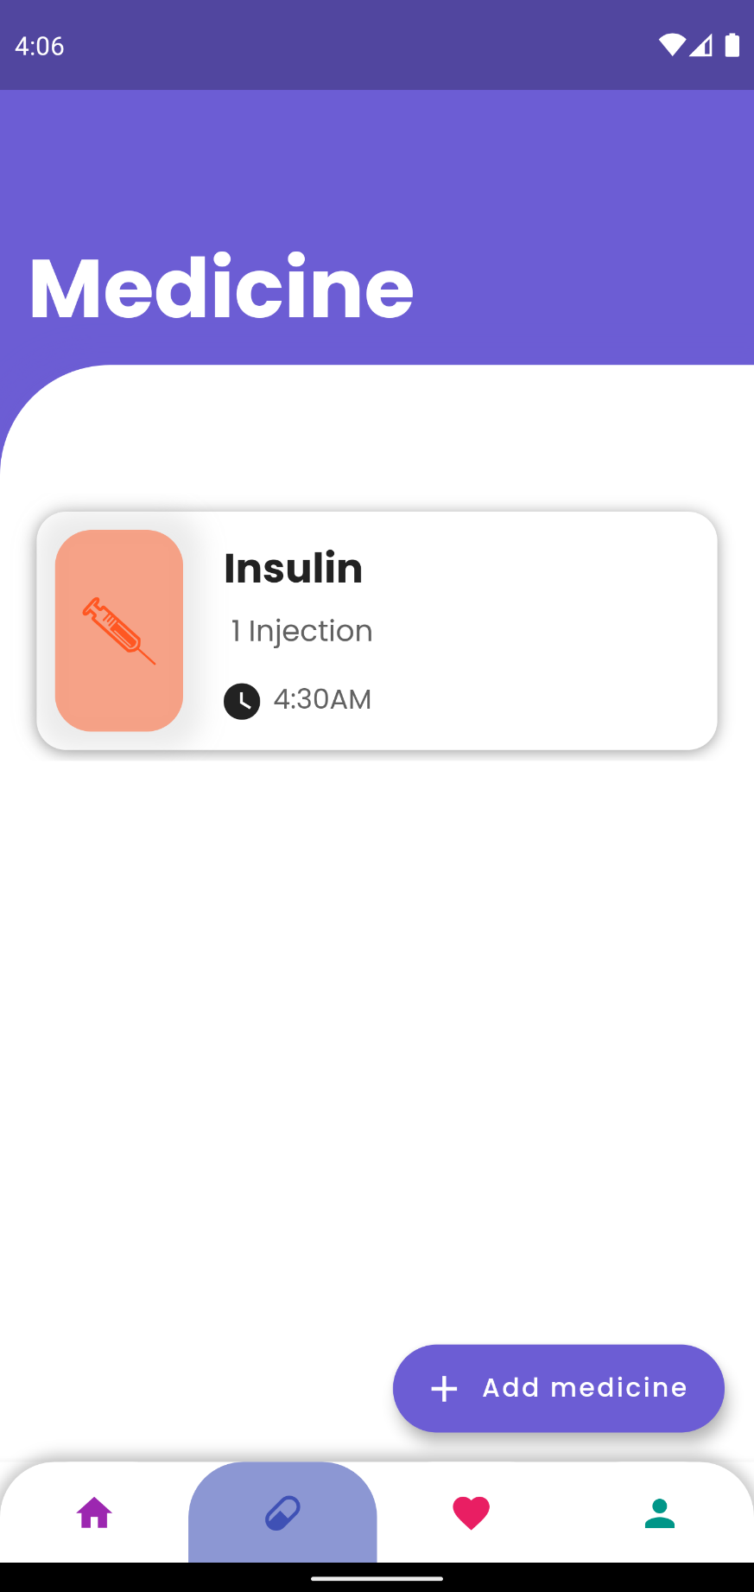

Figure Updated Medicine Changes being displayed

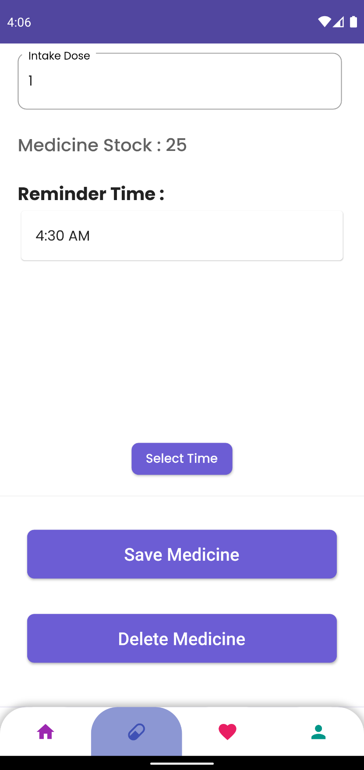

Figure Deleting a medicine

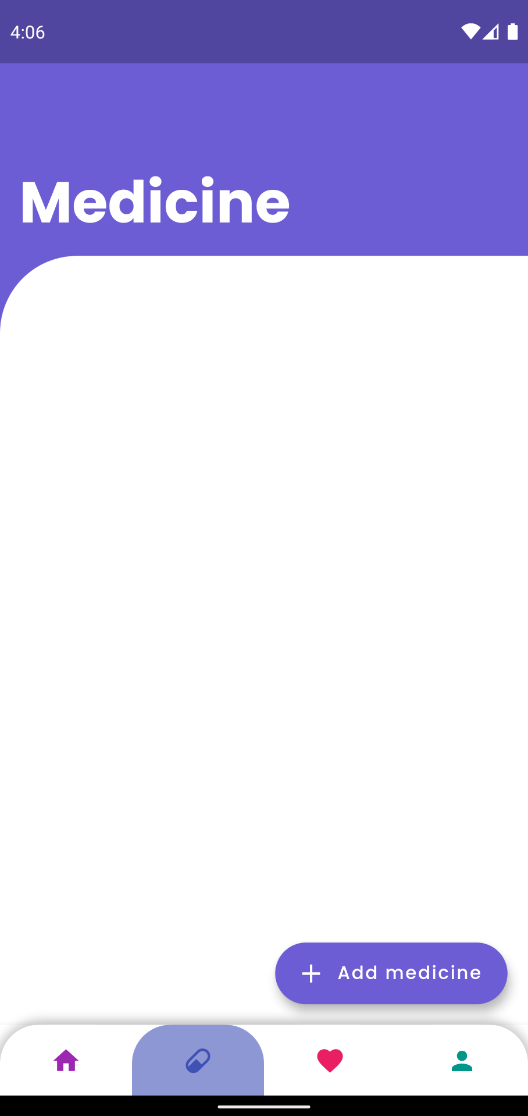

Figure Medicine not being shown after deleting

1. **Medicine Input Validation**

|  |  |
| --- | --- |
| **Objective** | To input invalid input in Medicine, related input fields. |
| **Action** | To input invalid data into medicine input fields. |
| **Expected Result** | The user will not be able to insert invalid data. |
| **Actual Result** | User were not able to insert invalid data. |
| **Conclusion** | Test Successful. |

Table System Testing Medicine Input Validation

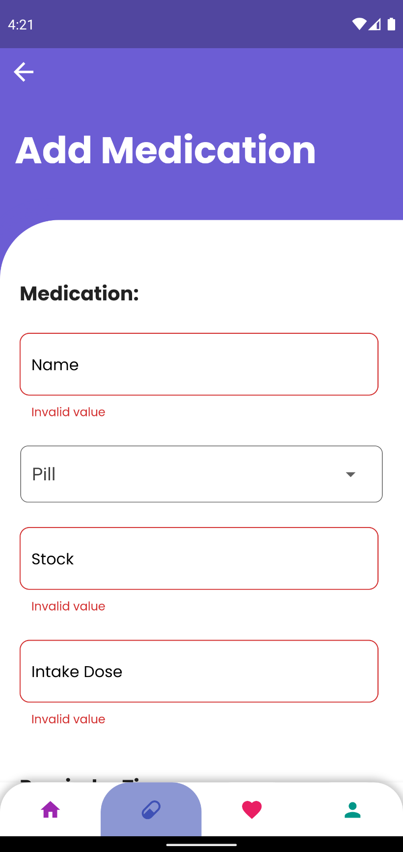

Figure Error message being displayed when trying to enter empty values in Add Medication

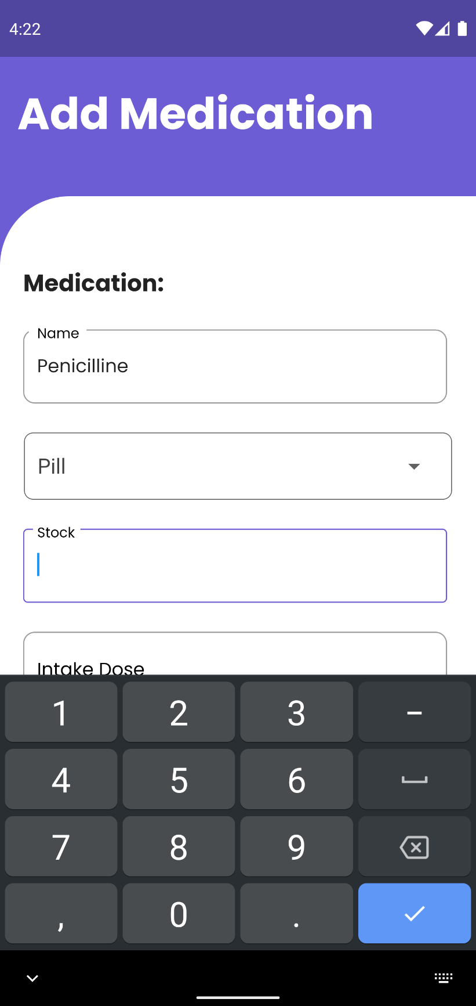

Figure Only Number being allowed to enter stock field of Add Medication

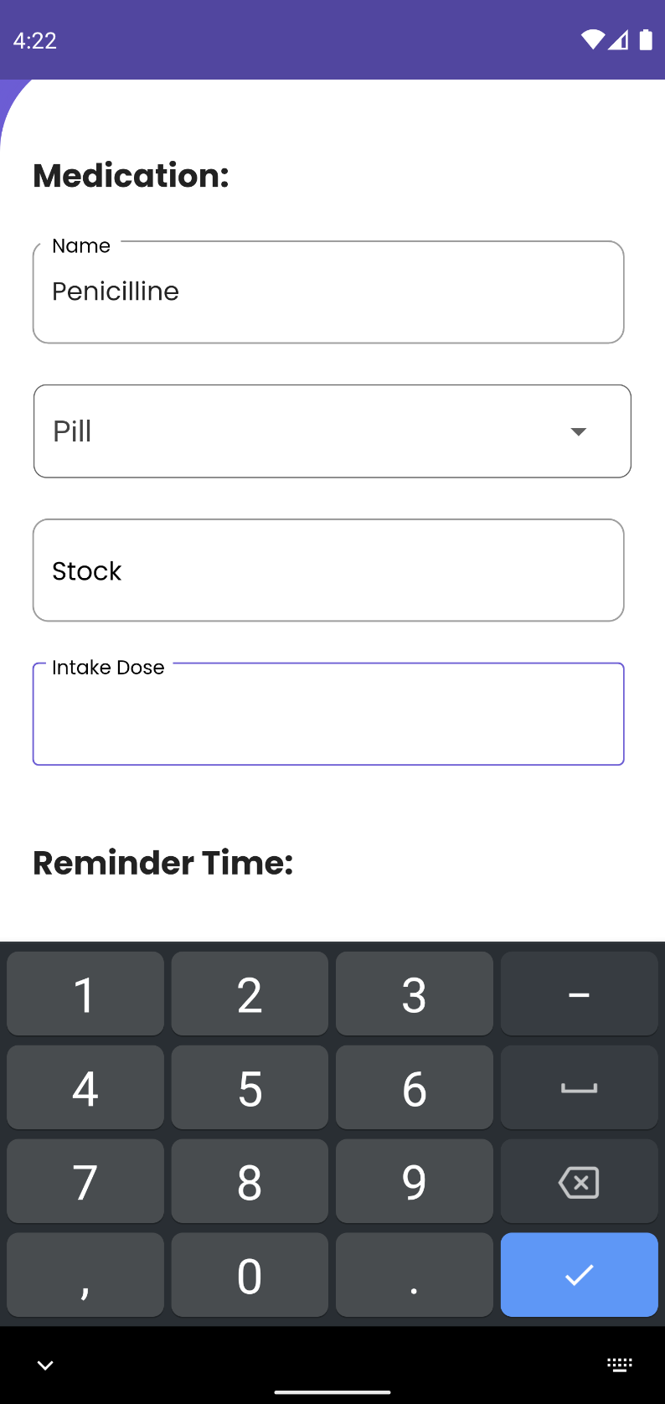

Figure Only number being allowed to enter in Intake dose field of Add Medication

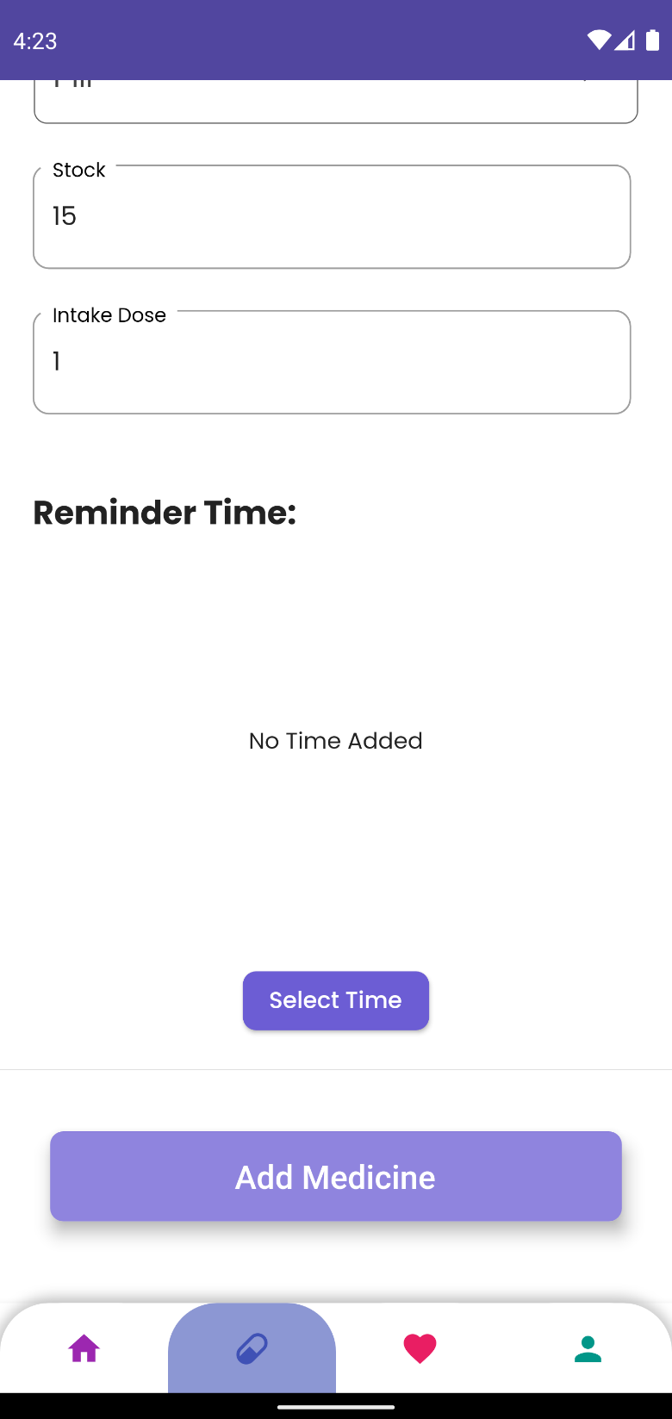

Figure Medicine not being added after pressing add button when reminder time is not added

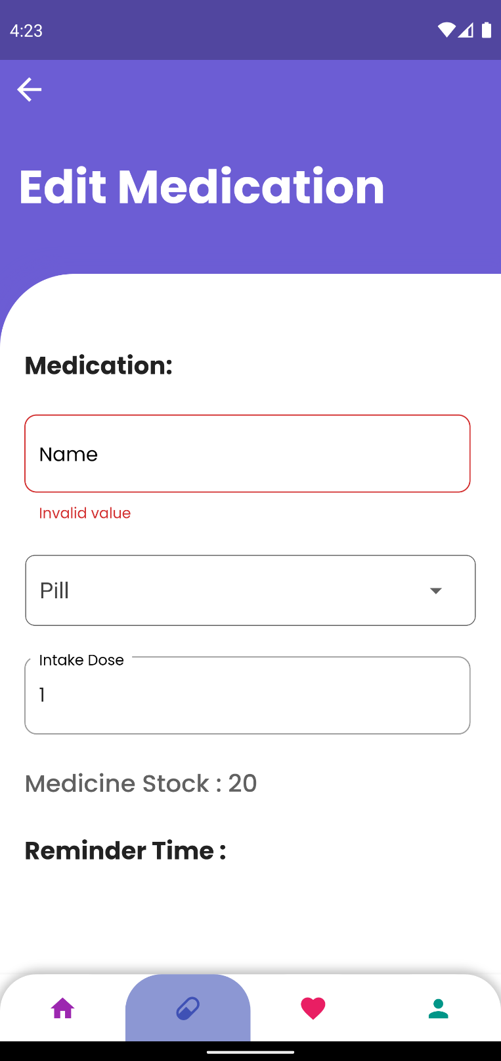

Figure Error message on empty value being entered in Edit Medication

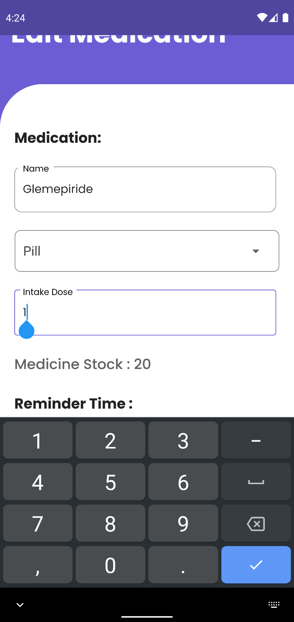

Figure Only number being allowed to enter on Intake dose field of Edit medication

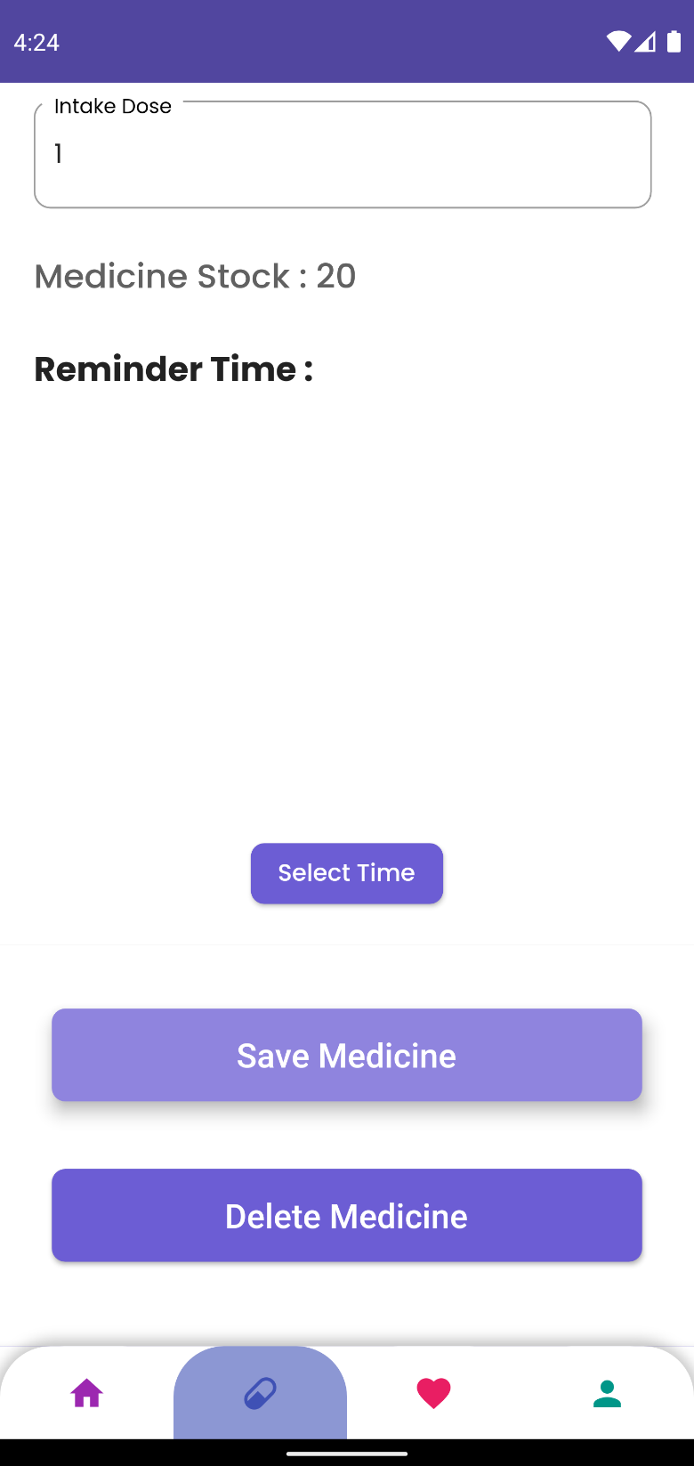

Figure Edited medicine not being saved after clicking save button if reminder time is empty

1. **To Test CRUD operation for Measurement**

|  |  |
| --- | --- |
| **Objective** | To perform CRUD operation in any one Measurement and its related feature. |
| **Action** | To carry out CRUD operation in any one Measurement and its related features. |
| **Expected Result** | User will be able to Add measurement, update their measurement information and delete measurement. |
| **Actual Result** | User can Add measurement, update their measurement information and delete measurement. |
| **Conclusion** | Test Successful. |

Table System Testing to Test CRUD operation for Measurement

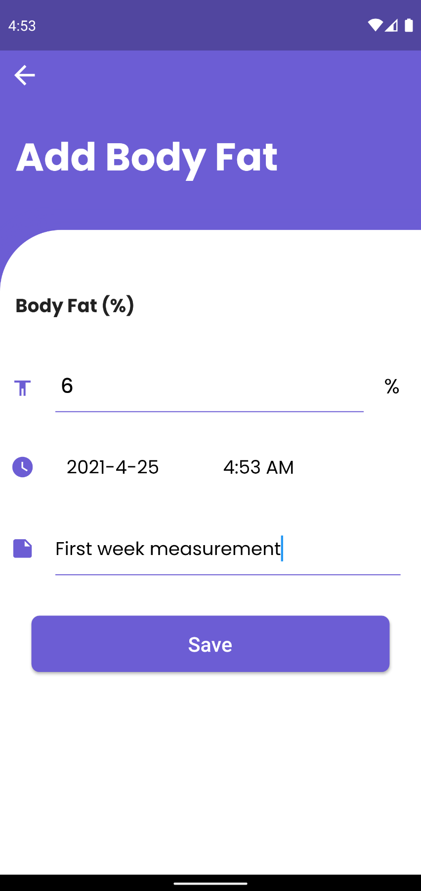

Figure Adding Body Fat Measurement

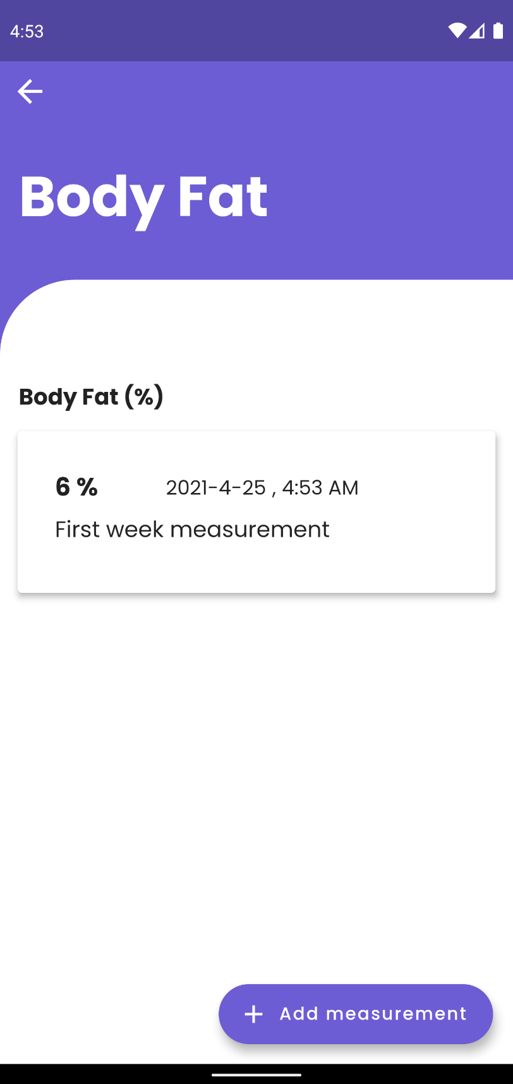

Figure Added Body Fat Measurement being displayed

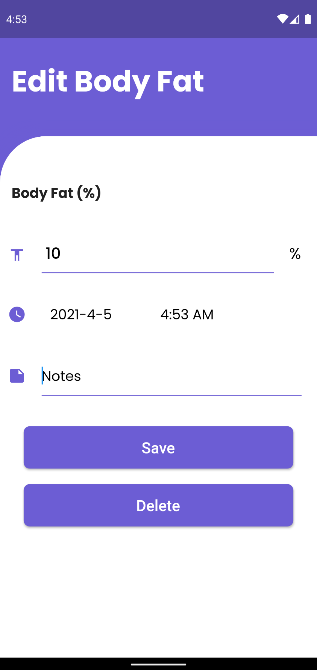

Figure Updating/Editing Body Fat Measurement data

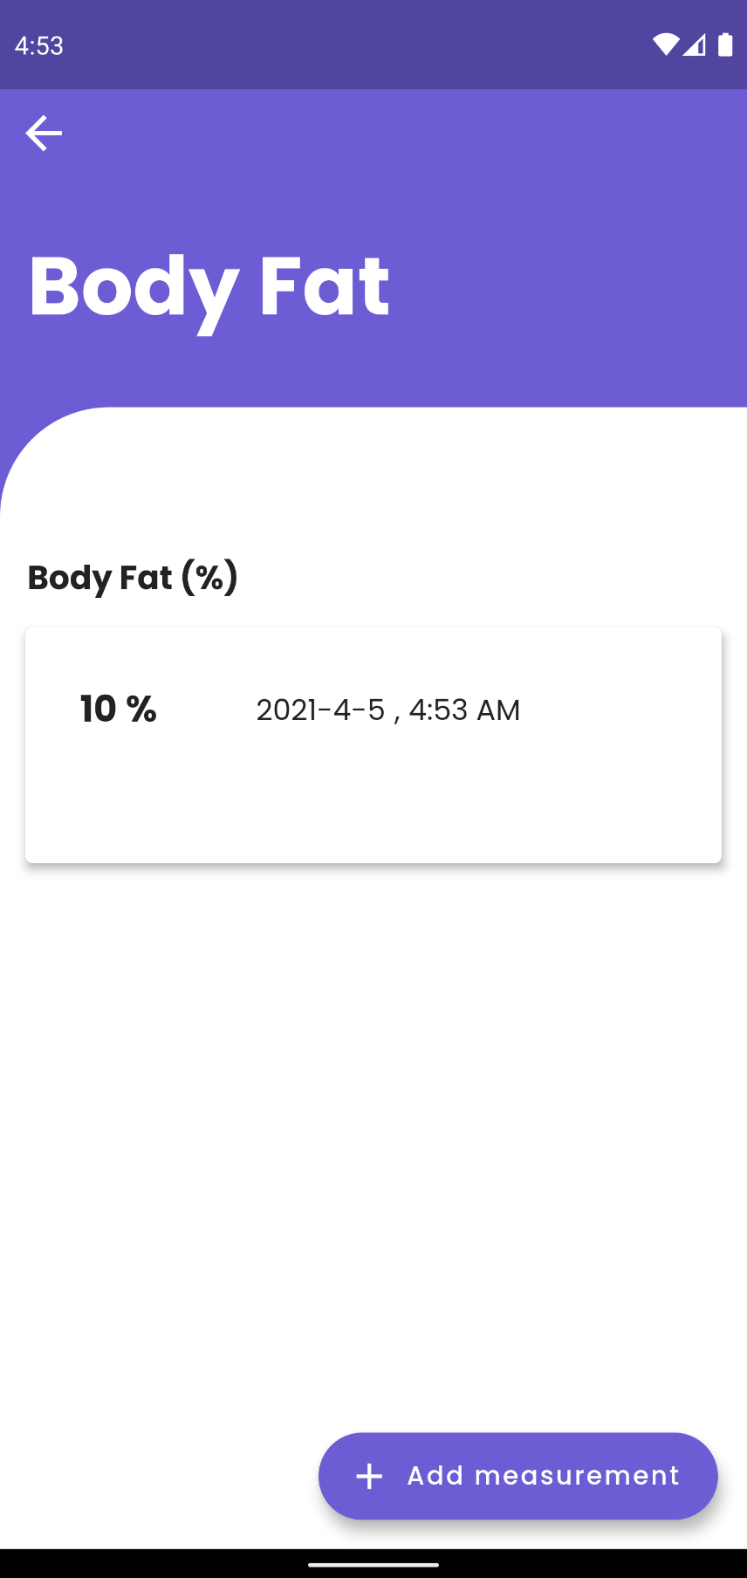

Figure Updated/Edited Body Fat Data being displayed

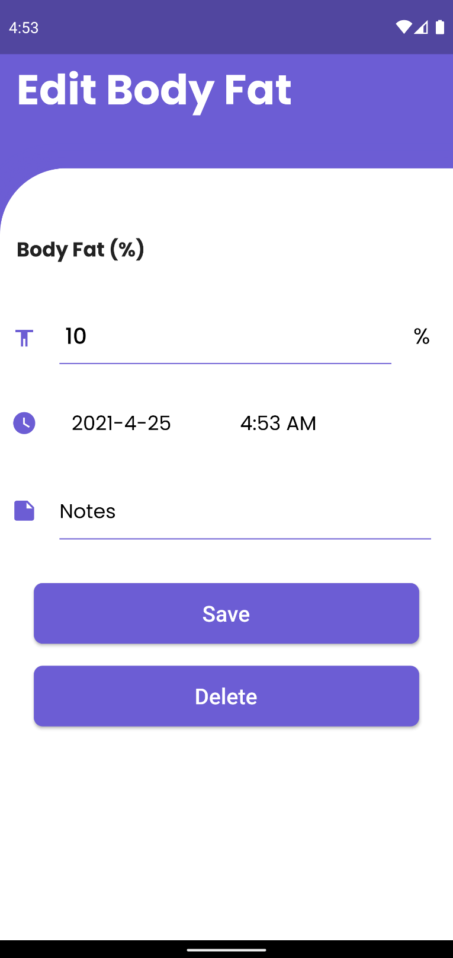

Figure Deleting a Body Fat Measurement

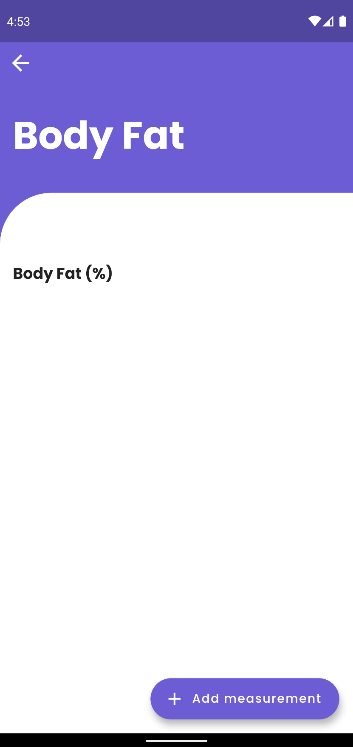

Figure Body Fat Measurement not being displayed after deleting

1. **Measurement Input Validation**

|  |  |
| --- | --- |
| **Objective** | To input invalid input in Measurement, relate input fields. |
| **Action** | To input invalid data into measurement input fields. |
| **Expected Result** | User will not be able to insert invalid data. |
| **Actual Result** | User were not able to insert invalid data. |
| **Conclusion** | Test Successful. |

Table System Testing Measurement Input Validation

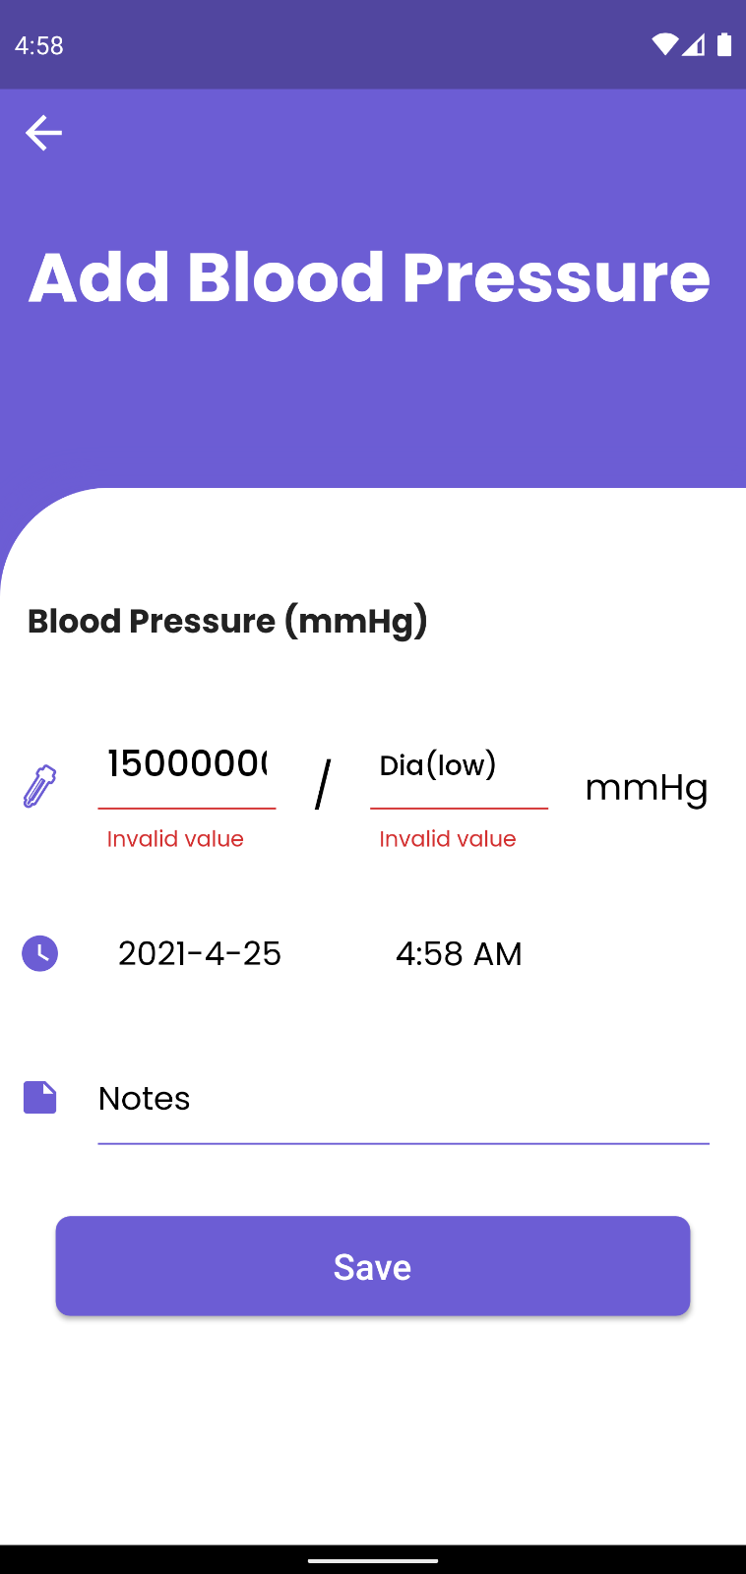

Figure Error message being displayed when entering invalid and empty data in Add Blood Pressure fields

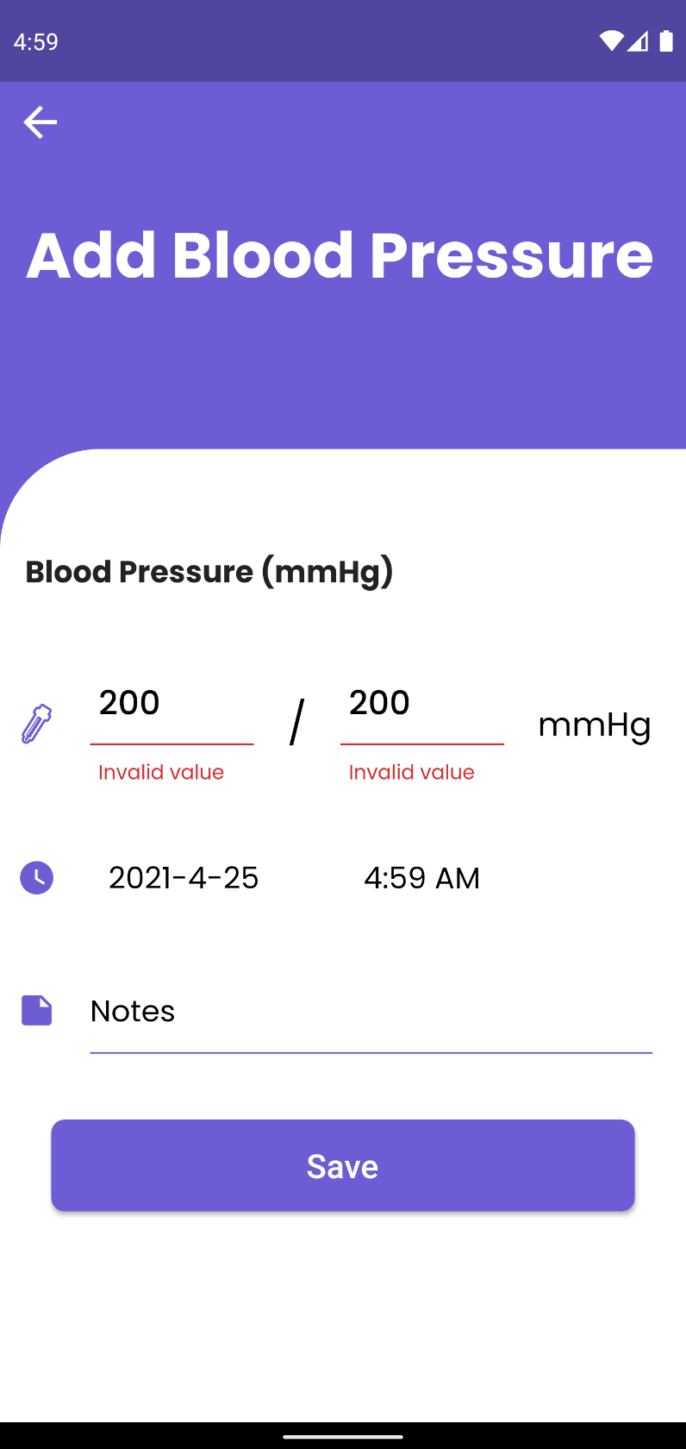

Figure Error message being displayed when entering invalid data both fields of Add Blood Pressure

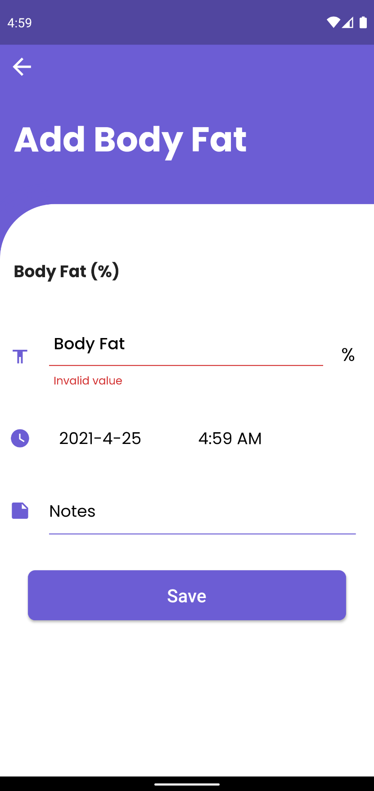

Figure Error message being displayed when an empty data in input field for Add Body Fat

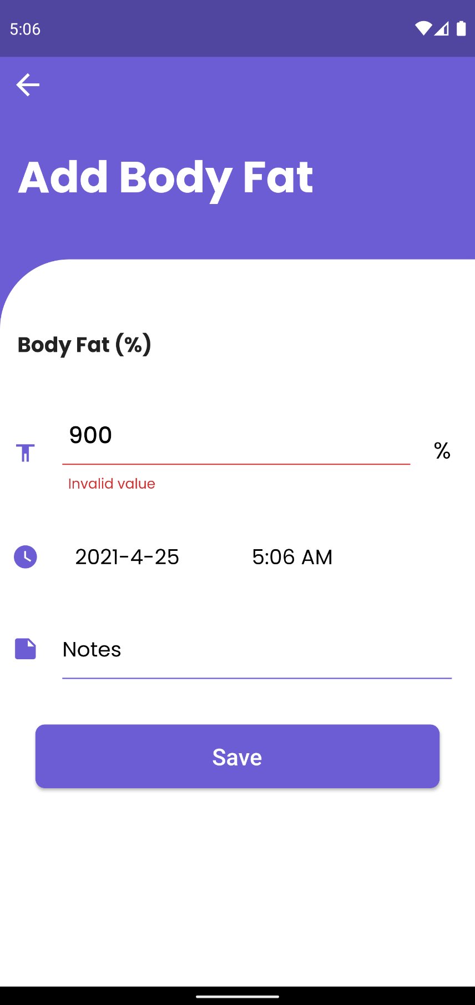

Figure Error message being displayed when and invalid data is entered into the input field of Add Body Fat

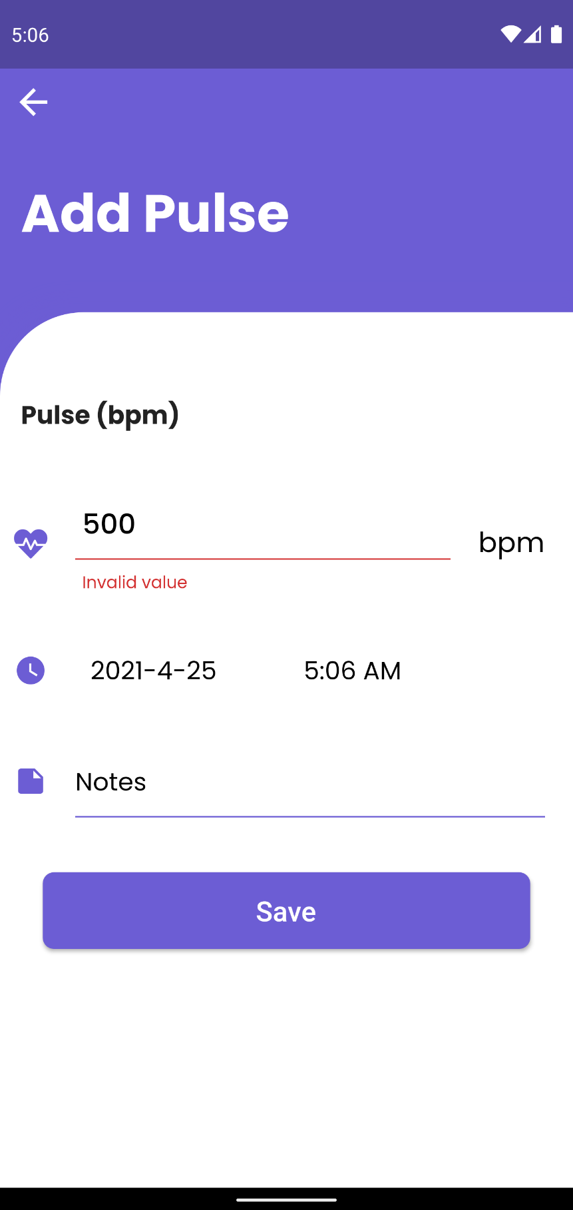

Figure Error message being displayed when and invalid data is entered into the input field of Add Pulse

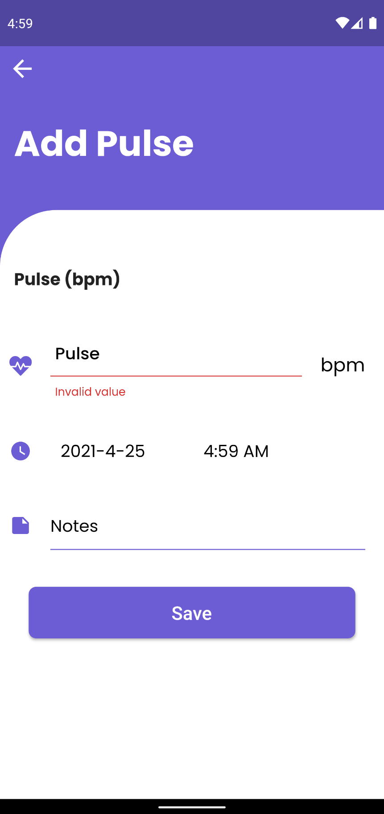

Figure Error message being displayed when an empty data in input field for Add Pulse

1. **To Test CRUD operation for Notes**

|  |  |
| --- | --- |
| **Objective** | To perform CRUD operation in Notes and its related feature. |
| **Action** | To carry out CRUD operation in Notes and its related features. |
| **Expected Result** | User will be able to Add notes, update their notes information and delete notes. |
| **Actual Result** | User can Add notes, update their notes information and delete notes. |
| **Conclusion** | Test Successful. |

Table System Testing to Test CRUD operation for Notes

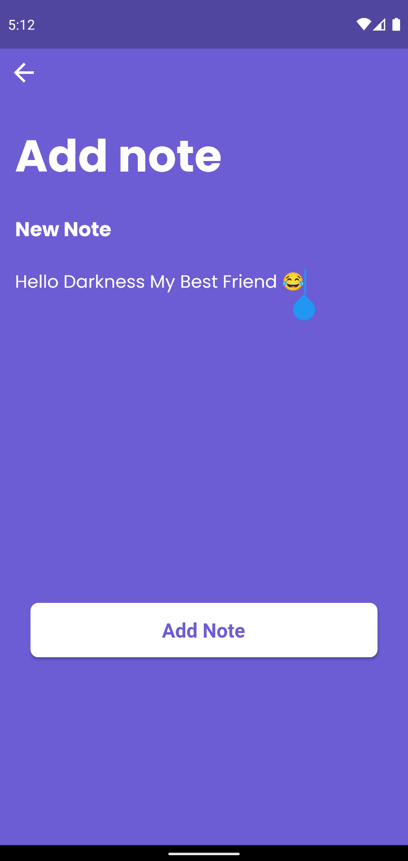

Figure Adding a new note

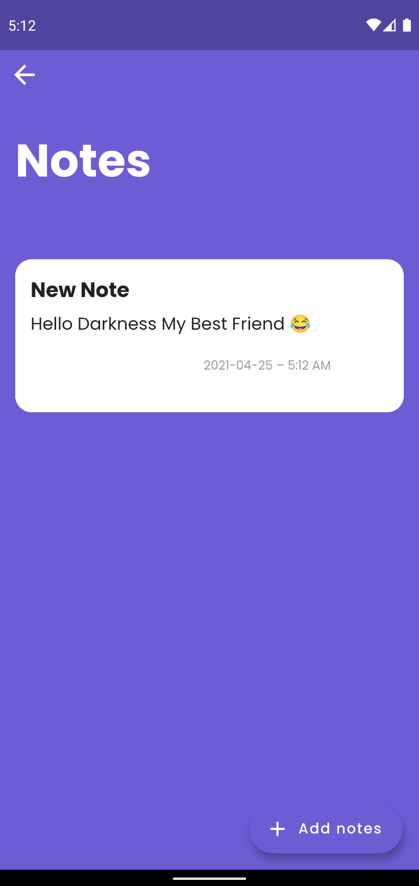

Figure New note added being displayed in the Notes UI

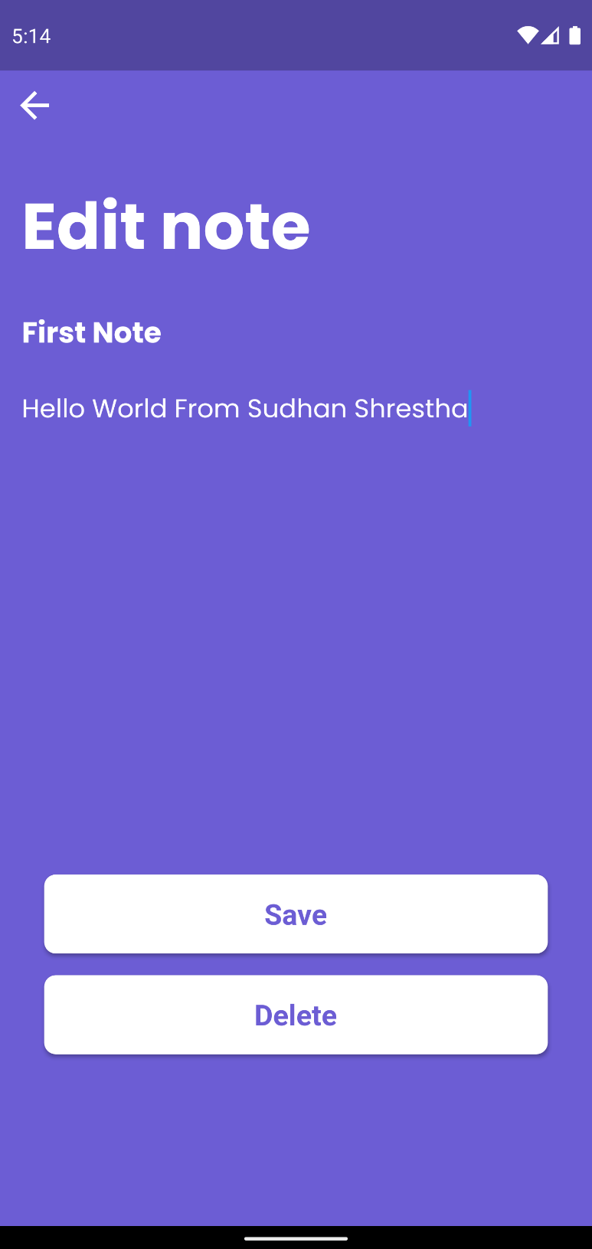

Figure Updating/Editing a Note

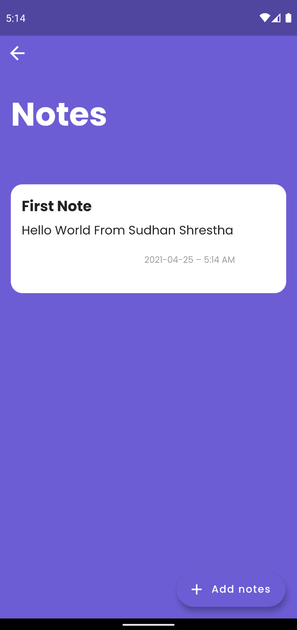

Figure Updated/Edited Note data being displayed in the Notes UI

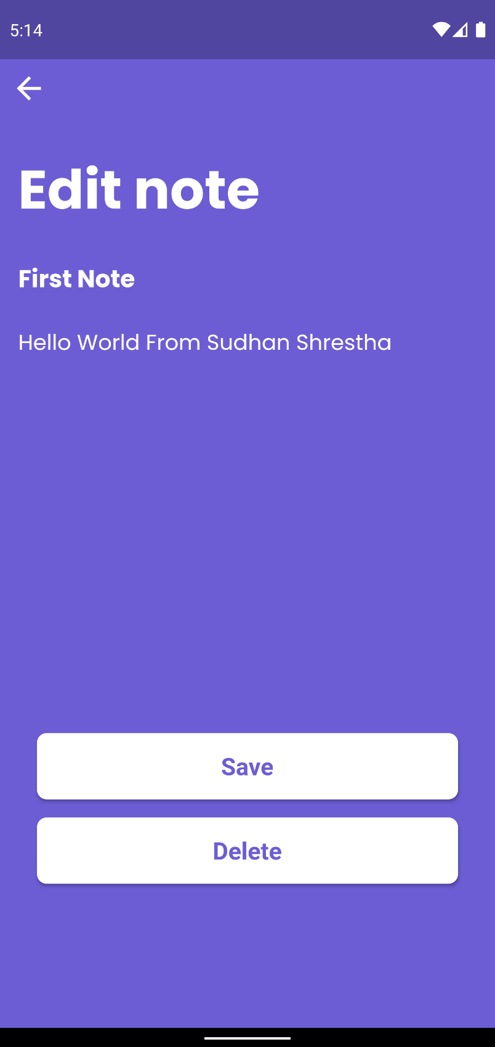

Figure Deleting a Note

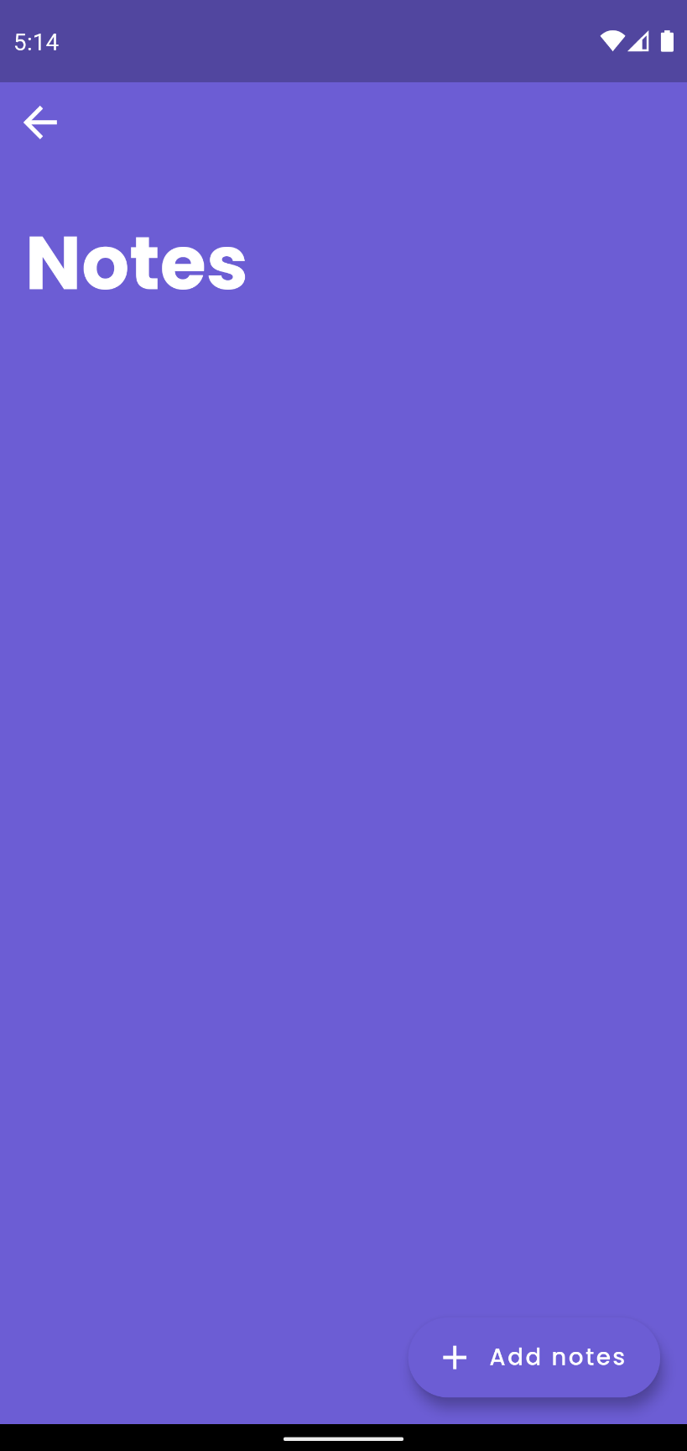

Figure Note not being shown after being deleted

The additional system testing is listed in the Appendix F section of the report.

## CRITICAL ANALYSIS

The development of this application was done with a lot of hard work and effort, and during the process, a lot of valuable lessons were learned. To full fill, the proposed features set for the application, intensive research, and hard effort were put into it. While developing the application, numerous bugs and errors were encountered, which were debugged with a lot of thinking and research. To meet the required features set for the application, new ways to implement the required features were searched, and after all the hard work and effort, the application was finally developed.

Before the development phase of the project, not many things regarding the application system were known, but as we carried out the researches and looked into similar applications, the idea regarding the application to be developed became clearer. As Flutter was relatively new, many difficulties were found during the development process as most of the solution to the error encountered was not solved in the internet. As the development was done following the Kanban methodology, each feature of the application was developed one by one within a specific time; by doing this, many errors and bugs were prevented in the system. After development in the testing phase, some minor bugs were faced as many bugs were handled already during the development.

As there was a limited time period for the completion of this project and the project was already behind planned schedule, it faced a significant setback, and the development of the application was rushed with only the purposed main features being developed for the application. This project is not perfect as many improvements could have been made to make this application more smooth and better functioning with a more attractive design. The backend portion was a bit negated due to it being based on firebase. Had there been more time, the project could have been done more efficiently by creating a custom API and a different database instead of firebase. Although the application was developed with its purposed features, it still lacks in some areas compared to other similar real-world applications.

# CHAPTER 5: CONCLUSION

## 5.1. LEGAL, SOCIAL AND ETHICAL ISSUES

### 5.1.1. LEGAL ISSUES

Legal issue is a legal question with is the foundation of a case and requires the court’s decision. It can also be referred to a point on which the evidence is undisputed, the outcome of which depends on the court’s interpretation of the law. (USLEGAL, 2021)

Although not many people use these types of health application in Nepal, it is fairly used in other countries. The intake of medicine is necessary for people dependent on medication daily, while this application poses no threat to the user. However, in some cases where the user inputs the wrong medicine name or sets the wrong medicine reminder time and takes medicine in the wrong order or the wrong medication, the user might face some issues related to health. There is also a matter of issue concerning data privacy as the medical history associated with the user is saved in the database, and the users location is also tracked in the tracking feature of the application. This issue can be related to the violation of rights, privacy, and data misuse. Hence, if the application is ever released for public use, it should address these issues and do it in a manner that conforms to the law.

### 5.1.2. SOCIAL ISSUES

A social issue or problem is an issue that has been recognized by society as a problem that is preventing society from functioning at an optimal level. (Study.com, 2021)

Since the use of medicine reminders are not widely used in the context of Nepal, people might be hesitant to use such application other than that since the app stores the user-related data which concerns their health which may create some social uncertainties regearing if their data is being stored as people may not want any of their health-related data being stored as they think that this data may be used by other people of companies. The application also has a tracking feature that people might mistake for tracking their location and saving the data. Hence if this application was to be released to the public, the application must be legally approved and safe to use, and there is no misuse of the users’ data which might cause social issues.

### 5.1.3. ETHICAL ISSUES

Ethical issues occur when a given decision, scenario, or activity creates a conflict with a society’s moral principles. (MyAcountingCourse, 2021)

The ethical issues that may arise related to the development of this application are that since the application collects the user’s health-related data, a moral issue may occur if the users are not aware that their data are being collected and stored. This issue can be seen as a privacy violation and misuse of data. Not only that, but if the user-related password were ever to get leaked, the user’s health-related data could be exposed. The if the application is to be released to the general public, they should inform the public that their data is being collected and stored for their ease of use, and the security regarding the application must be robust.

### 5.2. ADVANTAGES

The advantages of the developed system are listed below:

* Reminders the user when it is time to take their medication.
* Reminds the user if their medicine stock is low or finished.
* Simple and easy to use.
* It saves their health-related measurements and medicine consumption data which can be helpful the next time the user goes for a health checkup.
* Saves information related to user’s doctor.
* Allows user tracking to ensure the users safety.
* User friendly.

### 5.3. LIMITATIONS

The application was developed with my best effort, but due to limited time period given to complete the application, there are still some setbacks in the application. The application has some sectors which could use more improvements.

The limitation of the developed system are listed below:

* Limited storage space due to the use of firebase.
* Limited amount of user due to use of firebase.
* Lack of list of health-related measurements.
* Lack of customized reminder for medicine.

### 5.4. FUTURE WORK

The project development was completed, with the major objectives and features being fulfilled. However, some sectors can be works on, and some additional features can be added to this application. Hence, here is the list of things that can be done in the future update of the application to enhance the system.

The list of future works that can be done on the application are:

* Add more health-related measurements.
* Customization related to medicine reminder.
* Use of better database service and custom API’s
* Enhance user experience and UI designs.
* Better medicine tracker.
* Additional features such as Medicine side effect note, drink water reminder, meditation, etc.
* Release the application in the app market.

# CHAPTER 6: REFERENCES

Dan Radigan. (2021) *What is kanban?* [Online]. Available from: <https://www.atlassian.com/agile/kanban> [Accessed 20 April 2021].

designshack. (2020) *What Is Adobe XD? a 101 Intro* [Online]. Available from: <https://designshack.net/articles/software/what-is-adobe-xd/> [Accessed 21 April 2021].

Esplin, C. (2016) *What is Firebase?* [Online]. Available from: <https://howtofirebase.com/what-is-firebase-fcb8614ba442> [Accessed 21 April 2021].

Feltman, D. (2020) *Consequences of Not Taking Your Medication Properly* [Online]. Available from: <https://www.homehelpershomecare.com/southern-bergen-county/community-blog/2017/may/consequences-of-not-taking-your-medication-prope/> [Accessed 18 December 2020].

GeeksforGeeks. (2021) *Unified Modeling Language (UML) | Sequence Diagrams* [Online]. Available from: <https://www.geeksforgeeks.org/unified-modeling-language-uml-sequence-diagrams/> [Accessed 24 April 2021].

javatpoint. (2021) *What is Dart Programming* [Online]. Available from: <https://www.javatpoint.com/flutter-dart-programming> [Accessed 25 April 2021].

Lewis, S. (2021) *Prototyping Modal* [Online]. Available from: <https://searchcio.techtarget.com/definition/Prototyping-Model> [Accessed 20 April 2021].

MyAcountingCourse. (2021) *What are Ethical Issues?* [Online]. Available from: <https://www.myaccountingcourse.com/accounting-dictionary/ethical-issues> [Accessed 25 April 2021].

Rouse, M. (2021) *Android Studio* [Online]. Available from: <https://searchmobilecomputing.techtarget.com/definition/Android-Studio> [Accessed 21 April 2021].

Siderova, S. (2018) *The Top 10 Benefits of Kanban* [Online]. Available from: <https://getnave.com/blog/kanban-benefits/> [Accessed 20 April 2021].

smartdraw. (2021) *Use Case Diagram* [Online]. Available from: <https://www.smartdraw.com/use-case-diagram/> [Accessed 21 April 2021].

Study.com. (2021) *Social Issues: Definition & Examples* [Online]. Available from: <https://study.com/academy/lesson/social-issues-definition-examples.html> [Accessed 25 April 2021].

technopedia. (2020) *Mobile Application (Mobile App)* [Online]. Available from: <https://www.techopedia.com/definition/2953/mobile-application-mobile-app> [Accessed 18 December 2020].

techopedia. (2021) *Collaboration Diagram* [Online]. Available from: <https://www.techopedia.com/definition/16467/collaboration-diagram> [Accessed 24 April 2021].

TechTerms. (2021) *RUP* [Online]. Available from: <https://techterms.com/definition/rup> [Accessed 20 April 2021].

tutorialspoint. (2021) *Flutter - Architecture Application* [Online]. Available from: <https://www.tutorialspoint.com/flutter/flutter_architecture_application.htm> [Accessed 24 April 2021].

tutorialspoint. (2021) *UML - Activity Diagrams* [Online]. Available from: <https://www.tutorialspoint.com/uml/uml_activity_diagram.htm> [Accessed 24 April 2021].

USLEGAL. (2021) *Legal Issue Law and Legal Definition* [Online]. Available from: <https://definitions.uslegal.com/l/legal-issue/> [Accessed 25 April 2021].

# CHAPTER 7: APPENDIX

## APPENDIX A: BACKGROUND

* + 1. UNDERSTANDING THE SOLUTION

The reasons for developing this type of system are as follows:

* Users will be reminded to take their medication on time.
* Users can buy the medicine before it runs out by getting a medicine low or a refill reminder.
* Keeps all the health-related data in a single application which might be helpful during the next visit to the hospital.
* Reduces the risk of not taking the medication on time.
* Reduces the risk of health-related measurement notes and other health-related notes being lost as the data is saved in the cloud with database.
* In case of emergency or uneasiness when outside a help, SMS is sent to the emergency number, which might prevent an accident.

**Advantages of the system**

* Reduces loss of data as it is saved in the cloud with firebase.
* All health-related data are within a single application.
* User friendly.
* Easy to use
* Keeps track of user’s medicine intake.

**Disadvantages of the system**

* Needs active internet to store the data properly.
* The default language is English, so some people may find the application challenging to use (Applicable in the context of Nepal).

## APPENDIX B: DEVELOPMENT

### CONSIDERED METHODOLOGY

1. Prototype Model

**Justification for considering this approach**

* Allows flexibility in design.
* Easy to detect errors and missing functionality.
* Modal is straightforward and easy to understand.
* Can actively involve users in the development phase.

**Reasons for not choosing Prototype Model**

This modal was first considered as this methodology was used explicitly if the project requirements were already defined, which was the case for this project as the requirements for the project was already determined, and as this methodology is used to get user feedback quickly, which helps to improve the overall application. However, since there was a limited amount of time for the development of the application and the Prototype model may increase the complexity of the systems and take more time, this methodology was not chosen.

1. RUP Methodology

**Justification for considering this approach**

* Emphasis on accurate documentation.
* Familiarity with this methodology due to having worked on it previously in coursework.
* Flexibility in changing the requirements of the system.
* Less development time is required due to the reuse of components.

**Reasons for not choosing RUP Methodology**

This methodology was considered because of it being familiar out of all the methodology as I had worked on this methodology for an assignment and its emphasis on documentation and iterative process. This methodology was not used as it contains an iterative process that might be difficult to utilize due to the limited time for developing the application.

1. Kanban Methodology

**Reasons for selecting Kanban Methodology**

This methodology was selected for the development of the application because it is flexible and not necessarily iterative. This methodology helps with better visualization of the project as it has a Kanban board. In this board, every project has a backlog task, which will go through a series of process state before it is delivered. Project progress visualization helps us spot bottlenecks if they form and help the work progress more efficiently by eliminating these bottlenecks. Since there is limited time for development and Kanban follows the principle of limiting work in progress, I can deliver the app with its core functionality on time and improve the application if the time suffices. Thus, these are the reasons Kanban methodology was selected for the development of this application. (Siderova, 2018).

## APPENDIX C: PRE-SURVEY

### PRE-SURVEY FORM

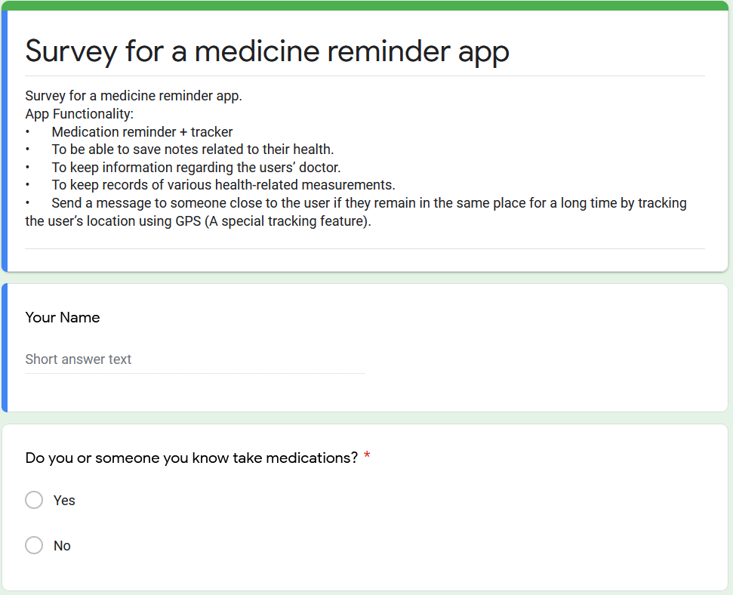

Figure Pre-Survey Form

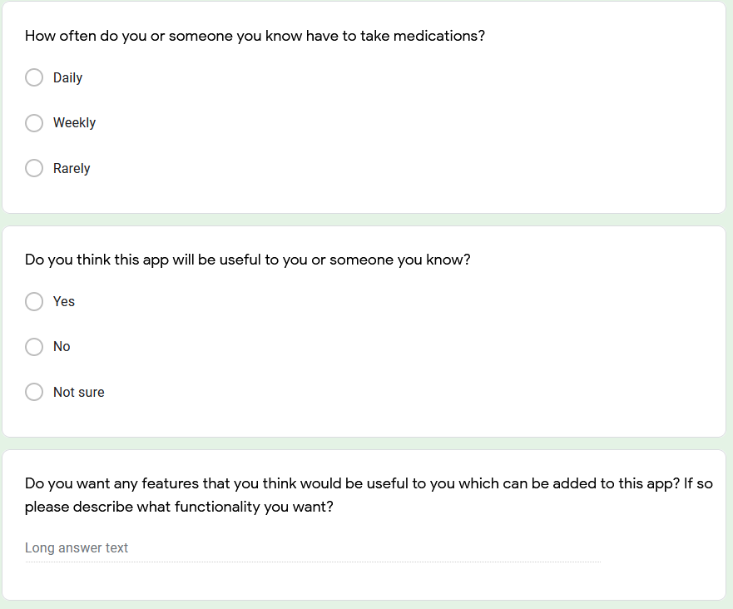

Figure Pre-Survey Form

### SAMPLE OF FILLED PRE-SURVEY FORMS

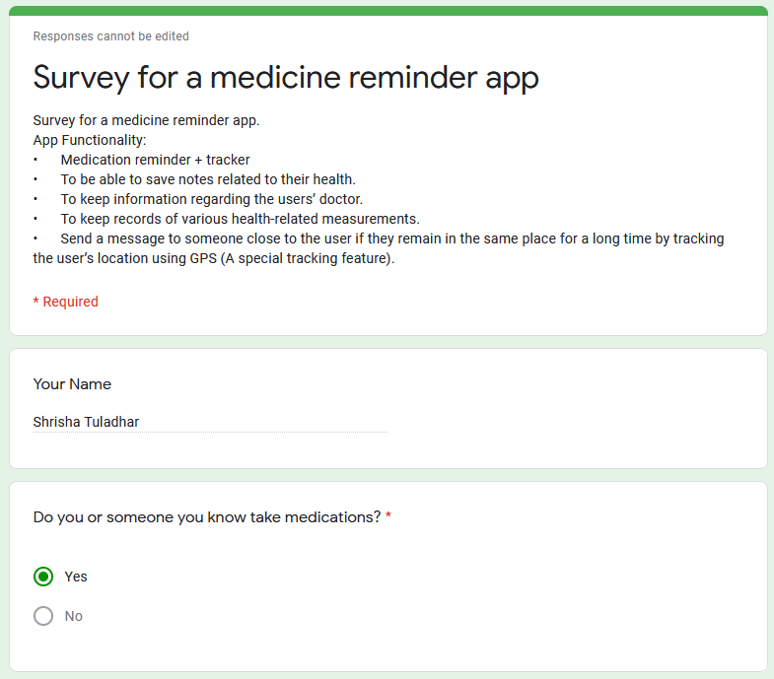

Figure Sample of Filled Post-Survey Form

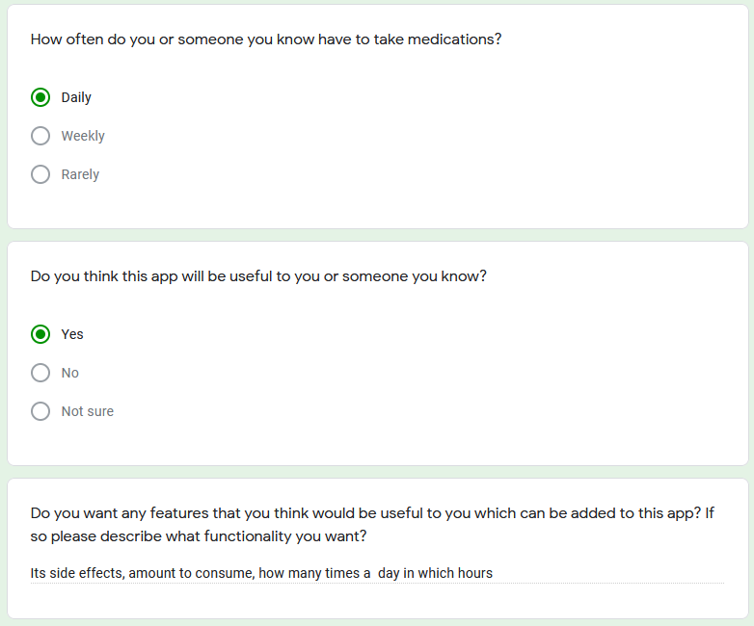

Figure Sample of Filled Post-Survey Form

### PRE-SURVEY RESULT

This survey was conducted before the development phase to get some ideas on whether the general public was interested in this type of application and get some of the suggestions from them.

The list of participants for this survey was a total of fifteen people, and the questions they were asked were as follows:

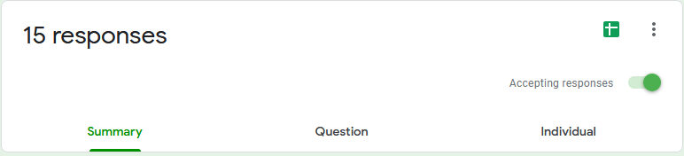

Figure Pre-Survey Number of Response

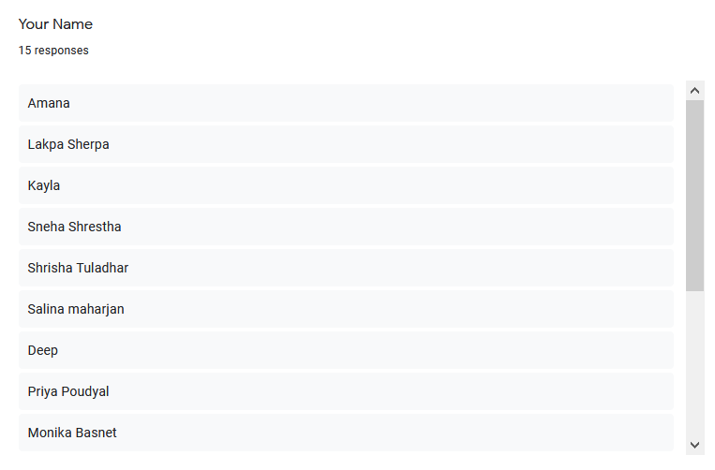

Figure Pre-Survey List of Names of People participated

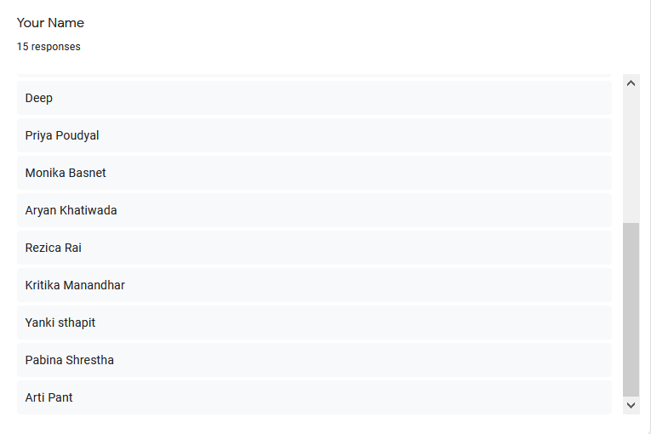

Figure Pre-Survey List of Names of People participated

**Question 1:**

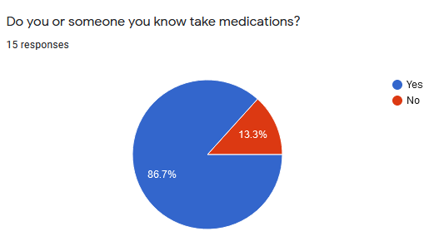

Figure Pre-Survey Result Question 1

As shown in the chart, about 86.7% of the people among 15 people had someone they knew, or themself were dependent on medication, which indicates that most people take medicine.

**Question 2:**

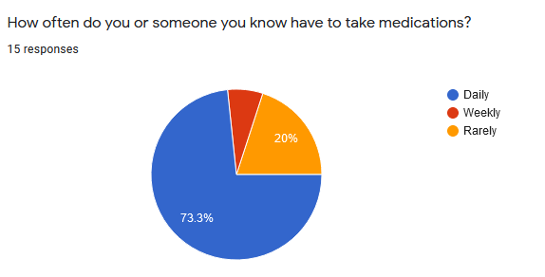

Figure Pre-Survey Result Question 2

We can see from the chart above that most people, about 73.3% consume medication daily. Since they take medication daily, they must have some health complications. The application that I am developing will be helpful to them as the targeted audience depends on medication daily.

**Question 3:**

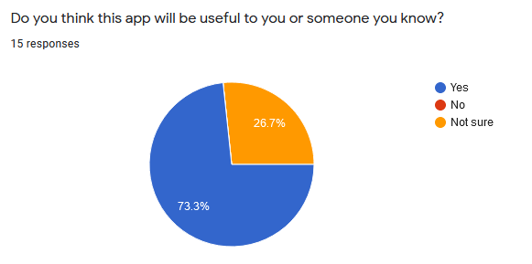

Figure Pre-Survey Result Question 3

When asked whether the application will be helpful to them, most of them answered yes, about 73.3%, proving that this application will help most people in their daily life.

**Question 4:**

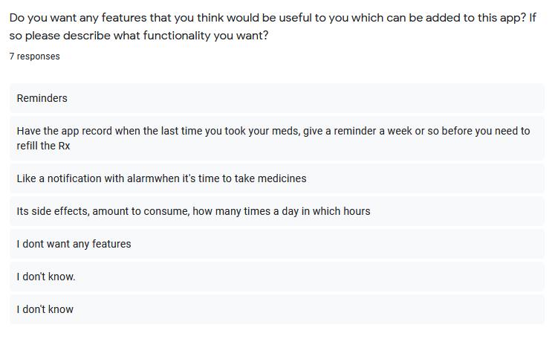

Figure Pre-Survey Result Question 4

When asked if they wanted some not listed features, some of them gave pretty good suggestions that I am considering adding some of these features in the future updates.

## APPENDIX B: POST-SURVEY

### POST-SURVEY FORM

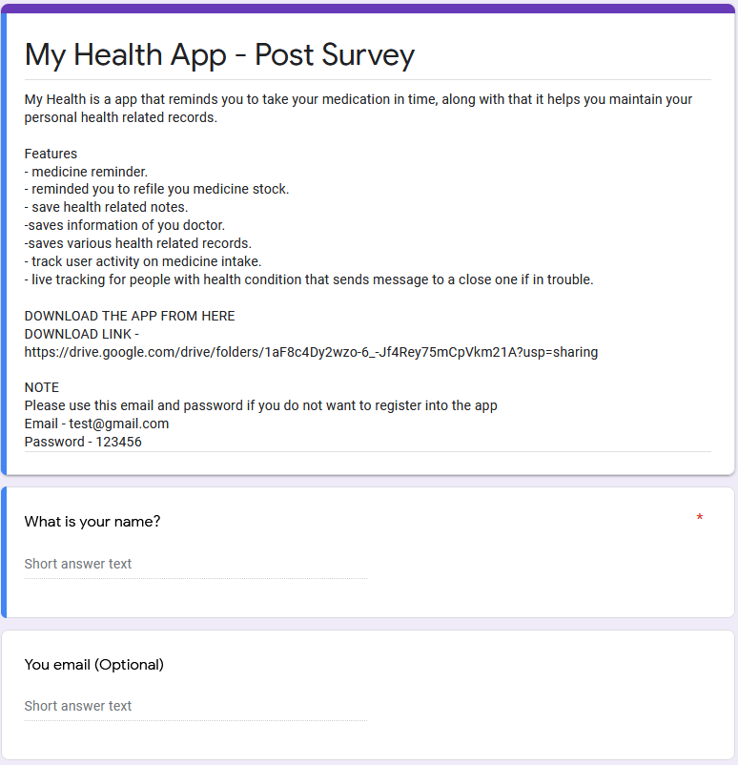

Figure Post-Survey Form

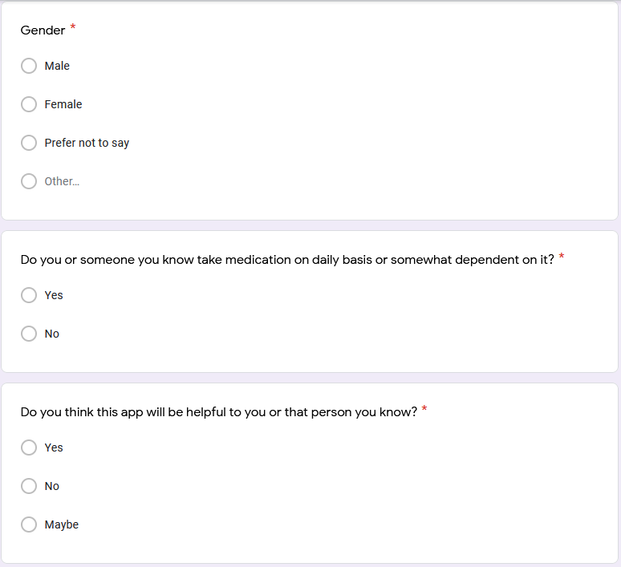

Figure Post-Survey Form

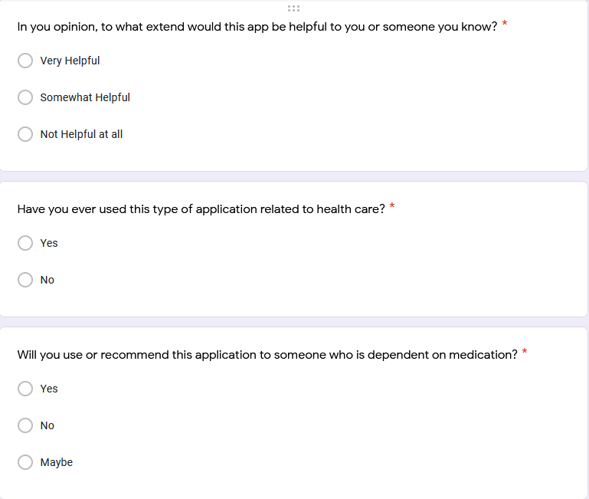

Figure Post-Survey Form

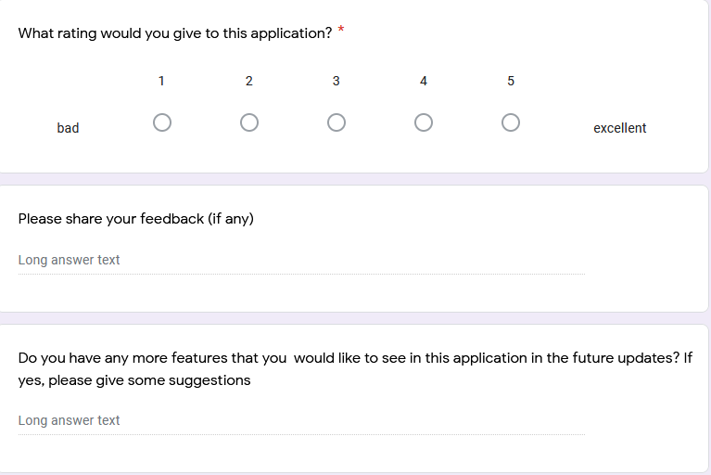

Figure Post-Survey Form

### SAMPLE OF FILLED POST-SURVEY FORM

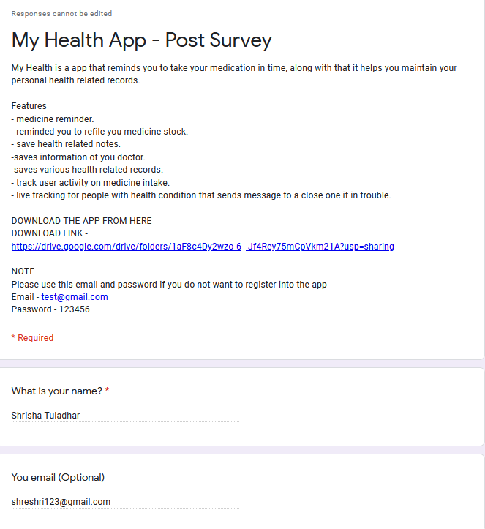

Figure Sample of Filled Post-Survey Form

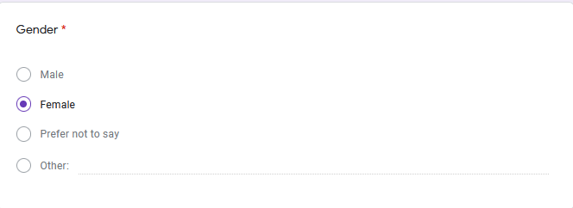

Figure Sample of Filled Post-Survey Form Question 1

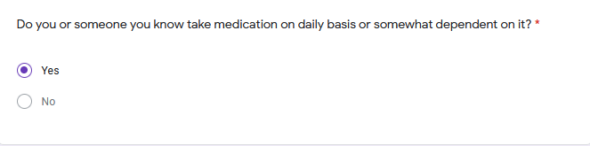

Figure Sample of Filled Post-Survey Form Question 2

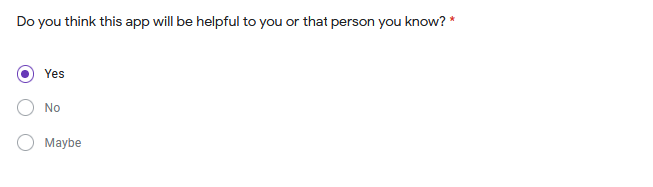

Figure Sample of Filled Post-Survey Form Question 3

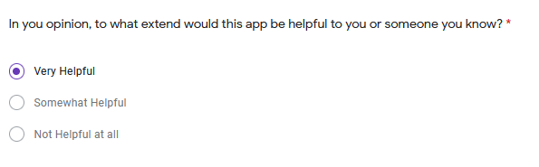

Figure Sample of Filled Post-Survey Form Question 4

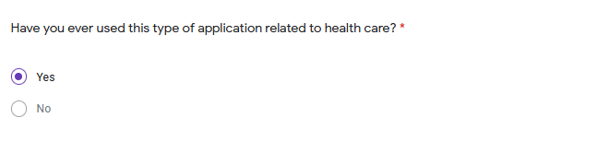

Figure Sample of Filled Post-Survey Form Question 5

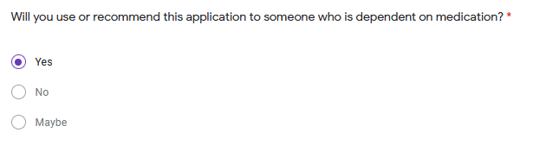

Figure Sample of Filled Post-Survey Form Question 6

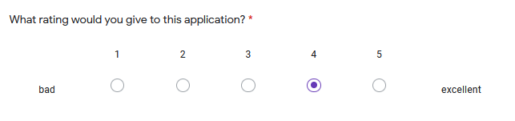

Figure Sample of Filled Post-Survey Form Question 7

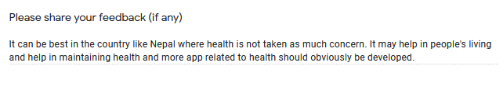

Figure Sample of Filled Post-Survey Form Question 8

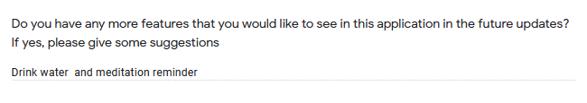

Figure Sample of Filled Post-Survey Form Question 9

### POST-SURVEY RESULT

The post-survey was conducted after completing the application, and in this survey, the general public was allowed to download the application and used it. During this survey, the questions asked were done to know how they liked the application and whether they might find it helpful to them or someone they know. The overall response was very positive.

The list of participants for this survey was a total of twenty-four people, and the questions they were asked were as follows:

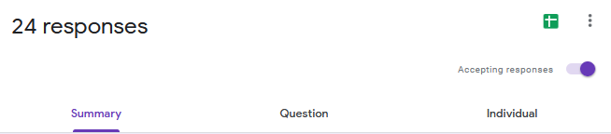

Figure Post- Survey Number of Response

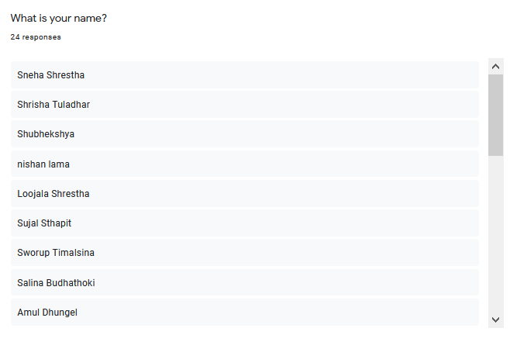

Figure Post-Survey Name of Participants

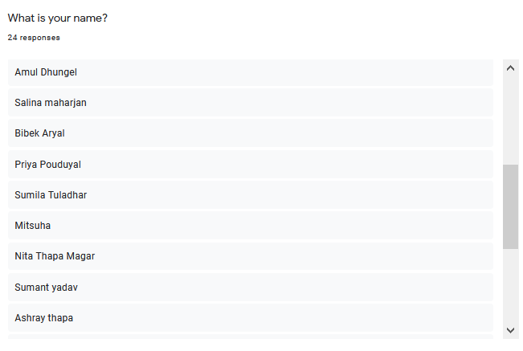

Figure Post-Survey Name of Participants

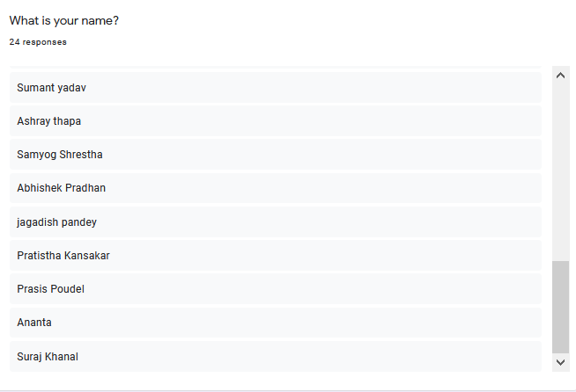

Figure Post-Survey Name of Participants

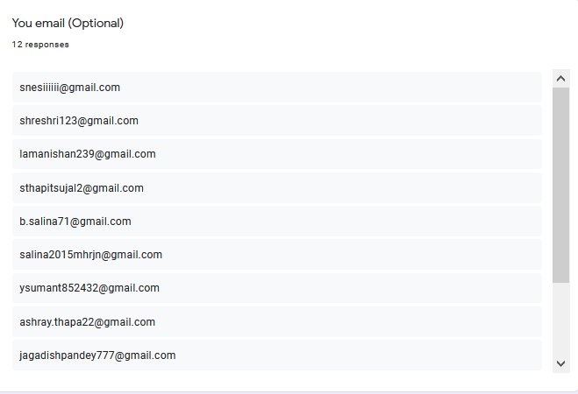

Figure Post-Survey Email of Participants

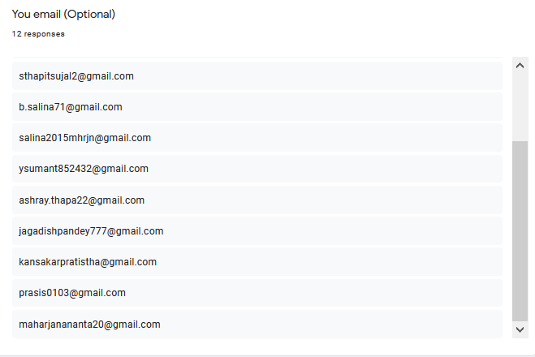

Figure Post-Survey Email of Participants

**Question 1:**

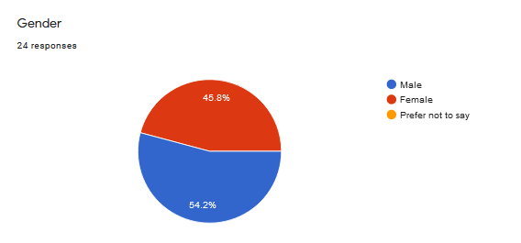

Figure Post-Survey Result Question 1

From the above chart, we can see that about 46% of the people who participated in this survey were female, and about 54% participated were Male.

**Question 2:**

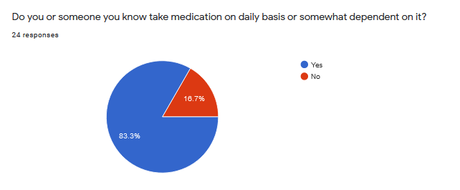

Figure Post-Survey Result Question 2

The above chart represents that 83.3% of the people that participated in the survey knew someone that take medication on a daily basis or are themselves dependent on it, which just goes to show that majority of the people nowadays are dependent on medication and that the application that I developed might be helpful to them is some ways.

**Question 3:**

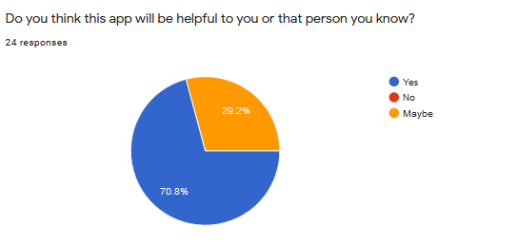

Figure Post-Survey Result Question 3

When asked if this application might be helpful to them or someone, they know most of them showed a positive response as 70.8% of people said “Yes” whereas 29.2% of the people said “Maybe,” which goes to show that most of the people liked the application and that they were interested in using it and thought that this application might be helpful to them.

**Question 4:**

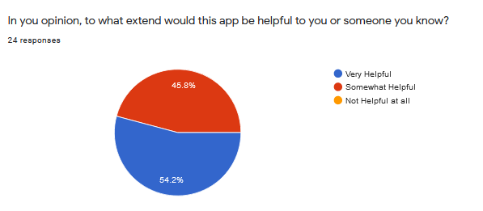

Figure Post-Survey Result Question 4

When asked to what extent this application might be useful to them, 54.2% of the participants said that this application might be very helpful, whereas 45.8% said that the application might be somewhat helpful to them.

**Question 5:**

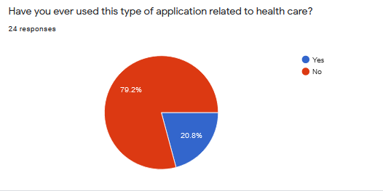

Figure Post-Survey Result Question 5

When asked if they have ever used this type of application, about 79.2% said they had not used such a type of application whereas 20.8% of people used this type of application. This difference in answers shows that the use of the health-related application in Nepal is quite low as most people are unaware of them.

**Question 6:**

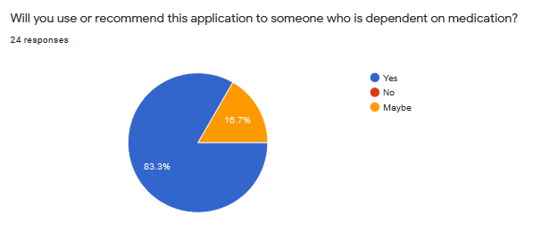

Figure Post-Survey Result Question 6

When asked if they would like to use this application or recommend this application, the response was mostly positive as 83.3% said “Yes” whereas only 16.7% were not sure and voted for “Maybe”. As seen, most of the people voted “Yes,” which gives a gist that most of the people used the application and were satisfied with it and had some consideration in using it or recommending it to someone they know.

**Question 7:**

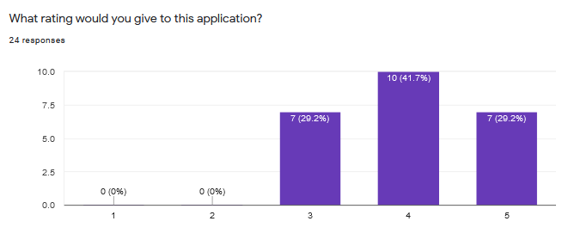

Figure Post-Survey Result Question 7

When the participant was asked to rate the application at the range of 1 to 5 where 1 was bad, and 5 was excellent. 7 out of 23 people, which were 29.2% of the total participant gave the application a rating of 5, 41.7% of people which were 10 out of 23 people gave the application a rating of 4 whereas 29.2% of people which is 7 out of 23 people gave the application a rating of 3.

**Question 8:**

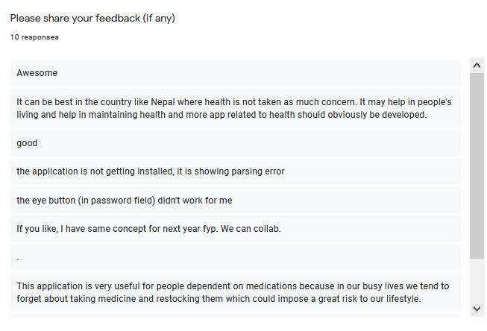

Figure Post-Survey Feedback Response

When asked to share feedback on the application, which was optional, about 10 people gave some feedback in which most of the people gave positive feedback while some of the people were facing some issue.

**Question 9:**

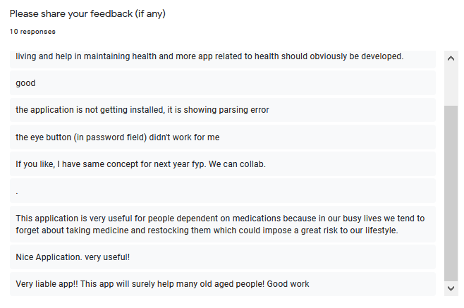

Figure Post-Survey Feedback Response

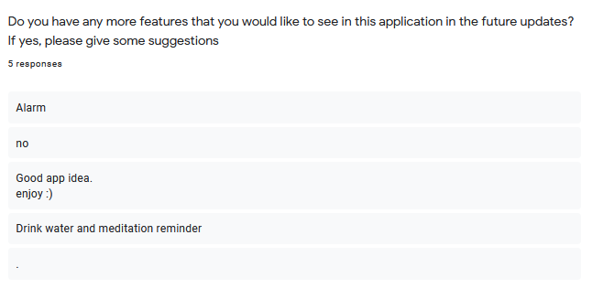

Figure Post-Survey Response for suggestion for future updates

When asked to give some suggestions regarding what features the people would like to see on the future update, which was also an optional question, a few interesting suggestions were received, which might be implemented in the future if I decide to continue working on the application.

## APPENDIX D: SAMPLE CODES

### SAMPLE CODE OF THE CORE FEATURE

7.3.1.1 Sample Code of Reminders/Notification.

import 'package:flutter_local_notifications/flutter_local_notifications.dart';

class NotificationPlugin {

FlutterLocalNotificationsPlugin _flutterLocalNotificationsPlugin;

NotificationPlugin() {

_initializeNotifications();

}

void _initializeNotifications() {

_flutterLocalNotificationsPlugin = FlutterLocalNotificationsPlugin();

final initializationSettingsAndroid =

AndroidInitializationSettings('app_icon');

final initializationSettingsIOS = IOSInitializationSettings();

final initializationSettings = new InitializationSettings(

android: initializationSettingsAndroid, iOS: initializationSettingsIOS);

_flutterLocalNotificationsPlugin.initialize(

initializationSettings,

onSelectNotification: onSelectNotification,

);

}

Future onSelectNotification(String payload) async {

if (payload != null) {

print('notification payload: ' + payload);

}

}

Future<void> showDailyAtTime(Time time, int id, String title, String description) async {

final androidPlatformChannelSpecifics = AndroidNotificationDetails(

'show weekly channel id',

'show weekly channel name',

'show weekly description',

importance: Importance.max,

priority: Priority.high,

ongoing: true

);

final iOSPlatformChannelSpecifics = IOSNotificationDetails();

final platformChannelSpecifics = NotificationDetails(

android: androidPlatformChannelSpecifics,

iOS: iOSPlatformChannelSpecifics,

);

// ignore: deprecated_member_use

await _flutterLocalNotificationsPlugin.showDailyAtTime(

id,

title,

description,

time,

platformChannelSpecifics,

);

print('notification created ');

}

Future<void> schedule(DateTime time, int id, String title, String description) async {

final androidPlatformChannelSpecifics = AndroidNotificationDetails(

'show weekly channel id',

'show weekly channel name',

'show weekly description',

importance: Importance.defaultImportance,

priority: Priority.defaultPriority,

);

final iOSPlatformChannelSpecifics = IOSNotificationDetails();

final platformChannelSpecifics = NotificationDetails(

android: androidPlatformChannelSpecifics,

iOS: iOSPlatformChannelSpecifics,

);

// ignore: deprecated_member_use

await _flutterLocalNotificationsPlugin.schedule(

id,

title,

description,

time,

platformChannelSpecifics,

);

print('notification created ');

}

Future<List<PendingNotificationRequest>> getScheduledNotifications() async {

final pendingNotifications =

await _flutterLocalNotificationsPlugin.pendingNotificationRequests();

return pendingNotifications;

}

Future<void> cancelNotification(int id) async {

await _flutterLocalNotificationsPlugin.cancel(id);

}

Future<void> cancelAllNotifications() async {

await _flutterLocalNotificationsPlugin.cancelAll();

}

}

7.3.1.2. Sample Code for Taking Medicine.

Widget build(BuildContext context) {

return Scaffold(

backgroundColor: mainColor,

body: SafeArea(

child: Column(

mainAxisAlignment: MainAxisAlignment.start,

crossAxisAlignment: CrossAxisAlignment.start,

children: <Widget>[

Stack(

children: [

IconButton(

icon: Icon(

Icons.arrow_back,

color: Colors.white,

),

iconSize: 40.0,

onPressed: () {

Navigator.pop(context);

}),

],

),

SizedBox(

height: 150,

),

Center(

child: Padding(

padding: const EdgeInsets.all(20.0),

child: Container(

decoration: BoxDecoration(

borderRadius: BorderRadius.circular(16.0),

color: Colors.white,

boxShadow: [

BoxShadow(

color: Colors.grey,

offset: Offset(0.0, 1.0),

blurRadius: 6.0,

),

]),

child: Padding(

padding: const EdgeInsets.all(20.0),

child: Container(

child: Column(

children: [

Row(

children: [

Column(

mainAxisAlignment: MainAxisAlignment.start,

crossAxisAlignment: CrossAxisAlignment.start,

children: [

Container(

decoration: BoxDecoration(

color: mainColor.withOpacity(0.5),

borderRadius: BorderRadius.all(

Radius.circular(20.0),

),

boxShadow: [

BoxShadow(

color: Colors.grey.withOpacity(0.2),

spreadRadius: 10,

blurRadius: 10,

),

],

),

child: Padding(

padding: const EdgeInsets.only(

top: 35.0,

left: 15.0,

right: 15.0,

bottom: 35.0),

child: Icon(

FontAwesomeIcons.pills,

size: 40.0,

color: mainColor,

),

),

),

],

),

SizedBox(

width: 20.0,

),

Column(

mainAxisAlignment: MainAxisAlignment.start,

crossAxisAlignment: CrossAxisAlignment.start,

children: [

Padding(

padding: const EdgeInsets.only(left: 2.0),

child: Text(

medicineName,

style: TextStyle(

fontSize: 22.0,

fontWeight: FontWeight.bold),

),

),

SizedBox(

height: 5.0,

),

Padding(

padding: const EdgeInsets.only(left: 2.0),

child: Text(

"$medicineDose $medicineType",

style: TextStyle(

fontSize: 16.0,

fontWeight: FontWeight.w600,

color: Colors.grey[700]),

),

),

SizedBox(

height: 5.0,

),

Row(

crossAxisAlignment:

CrossAxisAlignment.start,

mainAxisAlignment: MainAxisAlignment.start,

children: [

SizedBox(

width: 5.0,

),

Text(

"Remaining Stock : $medicineStock",

style: TextStyle(

fontSize: 15.0,

fontWeight: FontWeight.w600,

color: Colors.grey[700]),

),

],

),

],

),

],

),

SizedBox(

height: 50,

),

Center(

child: Row(

crossAxisAlignment: CrossAxisAlignment.center,

mainAxisAlignment: MainAxisAlignment.center,

children: [

TinyButton(

buttonTitle: 'Take',

onPressed: () {

/*

* On medicine intake to save intake history stored in a seperate table

* Some specific information related to taken medicine is stored

*

* */

DateTime now = DateTime.now();

var dateStamp =

DateFormat('yyyy-MM-dd – h:mm a')

.format(now);

print(dateStamp);

_firestore

.collection('MedicineConsume')

.add({

'userID': UserID,

'Name': medicineName,

'MedicineType': medicineType,

'ConsumeAmount': intakeDose,

'DateTime': dateStamp,

'FK_docID': docID,

});

/*

* After storing the consumption history

* Changing the boolean values once as a medicine is taken only once if multiple reminders

* */

int count = 1;

for (var i = 0; i < boolVal.length; i++) {

if (count == 1) {

boolVal.removeAt(0);

boolVal.add('true');

count = count + 1;

}

}

/*

* Checking the boolean value to send the boolean to indicate medicine taken status

* */

int totalTrue = 0;

int totalItems = boolVal.length;

print(totalItems);

int length = totalItems;

for (var i = 0; i < length; i++) {

print('Values in list :');

print(boolVal[i]);

print('loop started');

// ' true' is added as firebase list is entered with space

if (boolVal[i] == 'true' ||

boolVal[i] == ' true' ||

boolVal[i] == ' true'

) {

print("Boolean Value");

print(boolVal[i]);

totalTrue = totalTrue + 1;

}

}

print('Total item : $totalItems');

print('Total true : $totalTrue');

if (totalTrue == totalItems) {

widget.docToEdit.reference.update({

'MedicineTaken': 'true',

});

} else {

widget.docToEdit.reference.update({

'MedicineTaken': 'false',

});

}

//Checking medicine stock to send reminder

// medicineTaken = true;

/*

* Updating the stock in the medicine and the boolean values

* */

int newStock = 0;

int dose = int.parse(medicineDose);

newStock = int.parse(medicineStock) - dose;

if (newStock == 0 || newStock < 0) {

createRefillNotification();

widget.docToEdit.reference

.delete();

Navigator.pop(context);

}

print(newStock);

if (newStock <= 5) {

createNotification();

}

widget.docToEdit.reference.update({

'userID': UserID,

'Name': medicineName,

'MedicineType': medicineType,

'Stock': newStock.toString(),

'Dose': intakeDose,

'BooleanValues': (boolVal

.toString()

.replaceAll("]", ""))

.replaceAll("[", "").replaceAll(' ', '')

});

Navigator.pushReplacement(

context,

MaterialPageRoute(

builder: (context) => HomePage()),

);

},

),

SizedBox(

width: 60.0,

),

TinyButton(

buttonTitle: 'Skip',

onPressed: () {

/*

* Stores in the consumption history as not taken

* */

skipNotification();

Navigator.pushReplacement(

context,

MaterialPageRoute(

builder: (context) => HomePage()),

);

},

),

],

),

),

],

),

),

),

),

),

),

],

),

),

);

}

}

7.3.1.3. Sample Code for Add Medicine

Widget build(BuildContext context) {

FocusNode focusNodeMedicineName = FocusNode();

FocusNode focusNodeStock = FocusNode();

FocusNode focusNodeDose = FocusNode();

final _firestore = FirebaseFirestore.instance;

return Scaffold(

backgroundColor: mainColor,

body: SafeArea(

child: SingleChildScrollView(

child: Column(

crossAxisAlignment: CrossAxisAlignment.start,

mainAxisAlignment: MainAxisAlignment.start,

children: [

Stack(

children: [

Container(

height: 175.0,

child: Padding(

padding: const EdgeInsets.only(left: 15.0, top: 75.0),

child: Text(

"Add Medication",

style: TextStyle(

color: Colors.white,

fontSize: 38.0,

fontWeight: FontWeight.bold),

),

),

),

IconButton(

icon: Icon(

Icons.arrow_back,

color: Colors.white,

),

iconSize: 30.0,

onPressed: () {

Navigator.pop(context);

}),

],

),

SingleChildScrollView(

child: Container(

width: double.infinity,

decoration: BoxDecoration(

color: Colors.white,

borderRadius: BorderRadius.only(

topLeft: Radius.circular(60),

),

boxShadow: [

BoxShadow(

color: mainColor.withOpacity(1.0),

spreadRadius: 10,

blurRadius: 10,

),

],

),

child: Form(

key:_formKey,

child: Column(

crossAxisAlignment: CrossAxisAlignment.start,

mainAxisAlignment: MainAxisAlignment.start,

children: <Widget>[

SizedBox(

height: 60.0,

),

Padding(

padding: const EdgeInsets.only(left: 20.0),

child: Text(

"Medication:",

style: TextStyle(

fontSize: 20.0, fontWeight: FontWeight.bold),

),

),

Container(

padding:

EdgeInsets.only(top: 25.0, left: 20.0, right: 25.0, bottom: 20.0),

child: TextFormField(

focusNode: focusNodeMedicineName,

controller: medicineName,

validator: (val) => val.isEmpty ? 'Invalid value' : null,

decoration: InputDecoration(

labelText: "Name",

labelStyle: TextStyle(

color: focusNodeMedicineName.hasFocus ? mainColor : Colors.black),

border: OutlineInputBorder(

borderSide: BorderSide(color: Colors.black),

borderRadius: BorderRadius.circular(10),

),

focusedBorder: OutlineInputBorder(

borderSide: BorderSide(color: mainColor),

),

disabledBorder: OutlineInputBorder(

borderSide: BorderSide(color: Colors.black),

),

),

),

),

SizedBox(

height: 5.0,

),

Center(

child: Container(

width: 370.0,

height: 58.0,

padding: EdgeInsets.fromLTRB(11, 1, 20, 1),

decoration: BoxDecoration(

borderRadius: BorderRadius.circular(8.0),

color: Colors.white,

border: Border.all(

width: 0.7,

color: Colors.grey[700],

)),

child: DropdownButtonHideUnderline(

child: DropdownButton(

style: TextStyle(

fontSize: 18.0,

color: Colors.grey[800],

),

hint: Text("Select Type"),

value: _selectedItem,

items: _dropdownMenuItems,

onChanged: (value) {

setState(() {

_selectedItem = value;

itemCount =_medicineType.indexOf(value);

print(itemCount);

medType = _medicineType.elementAt(itemCount).name;

});

}),

),

),

),

Container(

padding:

EdgeInsets.only(top: 25.0, left: 20.0, right: 25.0, ),

child: TextFormField(

focusNode: focusNodeStock,

controller: medicineStock,

keyboardType: TextInputType.number,

inputFormatters: [FilteringTextInputFormatter.digitsOnly],

validator: (val) => val.isEmpty || int.parse(val)>100 ? 'Invalid value' : null,

decoration: InputDecoration(

labelText: "Stock",

labelStyle: TextStyle(

color: focusNodeStock.hasFocus ? mainColor : Colors.black),

border: OutlineInputBorder(

borderSide: BorderSide(color: Colors.black),

borderRadius: BorderRadius.circular(10),

),

focusedBorder: OutlineInputBorder(

borderSide: BorderSide(color: mainColor),

),

disabledBorder: OutlineInputBorder(

borderSide: BorderSide(color: Colors.black),

),

),

),

),

Container(

padding:

EdgeInsets.only(top: 25.0, left: 20.0, right: 25.0, bottom: 20.0),

child: TextFormField(

focusNode: focusNodeDose,

keyboardType: TextInputType.number,

controller: intakeDose,

inputFormatters: [FilteringTextInputFormatter.digitsOnly],

validator: (val) => val.isEmpty || int.parse(val)>10 ? 'Invalid value' : null,

decoration: InputDecoration(

labelText: "Intake Dose",

labelStyle: TextStyle(

color: focusNodeDose.hasFocus ? mainColor : Colors.black),

border: OutlineInputBorder(

borderSide: BorderSide(color: Colors.black),

borderRadius: BorderRadius.circular(10),

),

focusedBorder: OutlineInputBorder(

borderSide: BorderSide(color: mainColor),

),

disabledBorder: OutlineInputBorder(

borderSide: BorderSide(color: Colors.black),

),

),

),

),

SizedBox(

height: 25.0,

),

Padding(

padding: const EdgeInsets.only(left: 20.0),

child: Text(

"Reminder Time:",

style: TextStyle(

fontSize: 20.0, fontWeight: FontWeight.bold),

),

),

Column(

mainAxisAlignment: MainAxisAlignment.center,

children: <Widget>[

Container(

height: 250.0,

child: timeAdded.length == 0

? Center(child: Text('No Time Added'))

: ListView.builder(

itemCount: timeAdded.length,

itemBuilder: (context, index) =>

Dismissible(

key: Key(timeAdded[index].toString()),

onDismissed: (direction) {

setState(() {

timeAdded.removeAt(index);

});

},

child: Padding(

padding: const EdgeInsets.only(

left: 20.0, right: 20.0),

child: Card(

elevation: 1,

child: ListTile(

title: Text(timeAdded[index]

.toString()),

),

),

),

),

),

),

// Text(

// _time.format(context),

// textAlign: TextAlign.center,

// style: TextStyle(fontSize: 22.0),

// ),

SizedBox(height: 10),

ElevatedButton(

style: ElevatedButton.styleFrom(

primary: mainColor,

shape: RoundedRectangleBorder(

borderRadius: BorderRadius.circular(8),

),

),

onPressed: () {

//change this to change the number of timers

if(timeAdded.length<6)

{

Navigator.of(context).push(

showPicker(

context: context,

value: _time,

onChange: onTimeChanged,

blurredBackground: true,

minuteInterval: MinuteInterval.ONE,

disableHour: false,

disableMinute: false,

minMinute: 0,

iosStylePicker: true,

maxMinute: 59,

// Optional onChange to receive value as DateTime

onChangeDateTime: (DateTime dateTime) {

timeChecker =true;

String tempTime = _time.format(context);

for(int i=0; i<timeAdded.length; i++){

if(timeAdded[i] == tempTime){

timeChecker = false;

break;

}

}

if(timeChecker == true)

{

timeAdded.add(_time.format(context));

}

},

),

);

}

},

child: Text(

"Select Time",

style: TextStyle(color: Colors.white),

),

),

SizedBox(height: 10),

Divider(),

SizedBox(height: 10),

],

),

Padding(

padding:

const EdgeInsets.only(top: 20.0, bottom: 50.0),

child: Center(

child: SmallButton(

buttonTitle: "Add Medicine",

onPressed: () {

//creating loop for each reminder

if (_formKey.currentState.validate() && timeAdded.length>0 ) {

notifiID.clear();

boolVal.clear();

for(var i =0; i<timeAdded.length; i++){

print(timeAdded[i]);

String date = timeAdded[i];

DateTime date1= DateFormat.jm().parse(date);

reminderTime = date1;

createNotification();

}

DateTime now = DateTime.now();

var dateStamp = DateFormat('yyyy-MM-dd').format(now);

_firestore.collection('Medicine').add({

'userID':UserID,

'Name': medicineName.text,

'MedicineType': _medicineType.elementAt(itemCount).name.toString(),

'Stock': medicineStock.text,

'Dose': intakeDose.text,

'ReminderTime': (timeAdded.toString().replaceAll("]","")).replaceAll("[","").replaceAll(' ', ''),

'NotificationID' : (notifiID.toString().replaceAll("]","")).replaceAll("[","").replaceAll(' ', ''),

'DateStamp': dateStamp,

'BooleanValues': (boolVal.toString().replaceAll("]","")).replaceAll("[","").replaceAll(' ', ''),

'MedicineTaken': 'false',

});

Navigator.pushReplacement(context, MaterialPageRoute(builder: (context) => MedicinePage()),);

}

},

),

),

),

]),

),

),

),

],

),

),

),

bottomNavigationBar: BottomNavigation(),

);

}

}

7.3.1.4. **Sample Code for Editing Medicine**

Widget build(BuildContext context) {

final _formKey = GlobalKey<FormState>();

FocusNode focusNodeMedicineName = FocusNode();

FocusNode focusNodeStock = FocusNode();

FocusNode focusNodeDose = FocusNode();

final _firestore = FirebaseFirestore.instance;

return Scaffold(

resizeToAvoidBottomInset: false,

backgroundColor: mainColor,

body: SafeArea(

child: SingleChildScrollView(

child: Column(

crossAxisAlignment: CrossAxisAlignment.start,

mainAxisAlignment: MainAxisAlignment.start,

children: [

Stack(

children: [

Container(

height: 175.0,

child: Padding(

padding: const EdgeInsets.only(left: 15.0, top: 75.0),

child: Text(

"Edit Medication",

style: TextStyle(

color: Colors.white,

fontSize: 38.0,

fontWeight: FontWeight.bold),

),

),

),

IconButton(

icon: Icon(

Icons.arrow_back,

color: Colors.white,

),

iconSize: 30.0,

onPressed: () {

Navigator.pop(context);

}),

],

),

SingleChildScrollView(

child: Container(

width: double.infinity,

decoration: BoxDecoration(

color: Colors.white,

borderRadius: BorderRadius.only(

topLeft: Radius.circular(60),

),

boxShadow: [

BoxShadow(

color: mainColor.withOpacity(1.0),

spreadRadius: 10,

blurRadius: 10,

),

],

),

child: Form(

key:_formKey,

child: Column(

crossAxisAlignment: CrossAxisAlignment.start,

mainAxisAlignment: MainAxisAlignment.start,

children: <Widget>[

SizedBox(

height: 60.0,

),

Padding(

padding: const EdgeInsets.only(left: 20.0),

child: Text(

"Medication:",

style: TextStyle(

fontSize: 20.0, fontWeight: FontWeight.bold),

),

),

Container(

padding:

EdgeInsets.only(top: 25.0, left: 20.0, right: 25.0, bottom: 20.0),

child: TextFormField(

focusNode: focusNodeMedicineName,

controller: medicineName,

validator: (val) => val.isEmpty ? 'Invalid value' : null,

decoration: InputDecoration(

labelText: "Name",

labelStyle: TextStyle(

color: focusNodeMedicineName.hasFocus ? mainColor : Colors.black),

border: OutlineInputBorder(

borderSide: BorderSide(color: Colors.black),

borderRadius: BorderRadius.circular(10),

),

focusedBorder: OutlineInputBorder(

borderSide: BorderSide(color: mainColor),

),

disabledBorder: OutlineInputBorder(

borderSide: BorderSide(color: Colors.black),

),

),

),

),

SizedBox(

height: 5.0,

),

Center(

child: Container(

width: 370.0,

height: 58.0,

padding: EdgeInsets.fromLTRB(11, 1, 20, 1),

decoration: BoxDecoration(

borderRadius: BorderRadius.circular(8.0),

color: Colors.white,

border: Border.all(

width: 0.7,

color: Colors.grey[700],

)),

child: DropdownButtonHideUnderline(

child: DropdownButton(

style: TextStyle(

fontSize: 18.0,

color: Colors.grey[800],

),

hint: Text("Select Type"),

value: _selectedItem,

items: _dropdownMenuItems,

onChanged: (value) {

setState(() {

_selectedItem = value;

itemCount =_medicineType.indexOf(value);

print(itemCount);

medType = _medicineType.elementAt(itemCount).name;

});

}),

),

),

),

Container(

padding:

EdgeInsets.only(top: 25.0, left: 20.0, right: 25.0, bottom: 20.0),

child: TextFormField(

focusNode: focusNodeDose,

keyboardType: TextInputType.number,

controller: intakeDose,

inputFormatters: [FilteringTextInputFormatter.digitsOnly],

validator: (val) => val.isEmpty || int.parse(val)>10 ? 'Invalid value' : null,

decoration: InputDecoration(

labelText: "Intake Dose",

labelStyle: TextStyle(

color: focusNodeDose.hasFocus ? mainColor : Colors.black),

border: OutlineInputBorder(

borderSide: BorderSide(color: Colors.black),

borderRadius: BorderRadius.circular(10),

),

focusedBorder: OutlineInputBorder(

borderSide: BorderSide(color: mainColor),

),

disabledBorder: OutlineInputBorder(

borderSide: BorderSide(color: Colors.black),

),

),

),

),

/*

* Medicine Stock being taken out after re designing the medicne and adding the user history

* */

SizedBox(height: 5.0,),

Padding(

padding: const EdgeInsets.only(left: 20.0),

child: Text(

"Medicine Stock : $medicineStock ",

style: TextStyle(

fontSize: 20.0, fontWeight: FontWeight.w500,color: Colors.grey[700]),

),

),

SizedBox(

height: 25.0,

),

Padding(

padding: const EdgeInsets.only(left: 20.0),

child: Text(

"Reminder Time :",

style: TextStyle(

fontSize: 20.0, fontWeight: FontWeight.bold),

),

),

Column(

mainAxisAlignment: MainAxisAlignment.center,

children: <Widget>[

Container(

height: 250.0,

child: timeAdded == null

? Center(child: Text('No Time Added'))

: ListView.builder(

itemCount: timeAdded.length,

itemBuilder: (context, index) =>

Dismissible(

key: Key(timeAdded[index].toString()),

onDismissed: (direction) {

setState(() {

timeAdded.removeAt(index);

});

},

child: Padding(

padding: const EdgeInsets.only(

left: 20.0, right: 20.0),

child: Card(

elevation: 1,

child: ListTile(

title: Text(timeAdded[index]

.toString()),

),

),

),

),

),

),

// Text(

// _time.format(context),

// textAlign: TextAlign.center,

// style: TextStyle(fontSize: 22.0),

// ),

SizedBox(height: 10),

ElevatedButton(

style: ElevatedButton.styleFrom(

primary: mainColor,

shape: RoundedRectangleBorder(

borderRadius: BorderRadius.circular(8),

),

),

onPressed: () {

//change this to change the number of timers

if(timeAdded.length<6){

Navigator.of(context).push(

showPicker(

context: context,

value: _time,

onChange: onTimeChanged,

minuteInterval: MinuteInterval.ONE,

blurredBackground: true,

disableHour: false,

disableMinute: false,

minMinute: 0,

iosStylePicker: true,

maxMinute: 59,

// Optional onChange to receive value as DateTime

onChangeDateTime: (DateTime dateTime) {

timeAdded.add(_time.format(context));

},

),

);

}

},

child: Text(

"Select Time",

style: TextStyle(color: Colors.white),

),

),

SizedBox(height: 10),

Divider(),

SizedBox(height: 10),

],

),

Padding(

padding:

const EdgeInsets.only(top: 20.0, bottom: 20.0),

child: Center(

child: SmallButton(

buttonTitle: "Save Medicine",

onPressed: () {

if (_formKey.currentState.validate() && timeAdded.length>0) {

for (var i = 0; i<nID.length; i++){

int x =0;

print("notification id canceled:");

print(nID[i]);

x = int.parse(nID[i]);

_notificationPlugin.cancelNotification(x);

}

notifiID.clear();

boolVal.clear();

for(var i =0; i<timeAdded.length; i++){

print(timeAdded[i]);

String date = timeAdded[i];

DateTime date1= DateFormat.jm().parse(date);

reminderTime = date1;

createNotification();

}

DateTime now = DateTime.now();

var dateStamp = DateFormat('yyyy-MM-dd').format(now);

widget.docToEdit.reference.update({

'userID':UserID,

'Name': medicineName.text,

'MedicineType': _medicineType.elementAt(itemCount).name.toString(),

// 'Stock': medicineStock.text,

'Dose': intakeDose.text,

'ReminderTime': (timeAdded.toString().replaceAll("]","")).replaceAll("[","").replaceAll(' ', ''),

'NotificationID' : (notifiID.toString().replaceAll("]","")).replaceAll("[","").replaceAll(' ', ''),

'DateStamp': dateStamp,

'BooleanValues': (boolVal.toString().replaceAll("]","")).replaceAll("[","").replaceAll(' ', ''),

});

Navigator.pop(context);

}

},

),

),

),

Padding(

padding:

const EdgeInsets.only(top: 20.0, bottom: 50.0),

child: Center(

child: SmallButton(

buttonTitle: "Delete Medicine",

onPressed: () {

for (var i = 0; i<nID.length; i++){

int x =0;

print("notification id canceled:");

print(nID[i]);

x = int.parse(nID[i]);

_notificationPlugin.cancelNotification(x);

}

widget.docToEdit.reference.delete();

Navigator.pop(context);

},

),

),

),

]),

),

),

),

],

),

),

),

bottomNavigationBar: BottomNavigation(),

);

7.3.1.5. Sample Code for Adding Measurement (Pulse)

Widget build(BuildContext context) {

return Scaffold(

backgroundColor: mainColor,

body: SafeArea(

child: SingleChildScrollView(

child: Column(

crossAxisAlignment: CrossAxisAlignment.start,

mainAxisAlignment: MainAxisAlignment.start,

children: [

Stack(

children: [

Container(

height: 175.0,

child: Padding(

padding: const EdgeInsets.only(left: 15.0, top: 75.0),

child: Text(

"Add Pulse",

style: TextStyle(

color: Colors.white,

fontSize: 38.0,

fontWeight: FontWeight.bold),

),

),

),

IconButton(

icon: Icon(

Icons.arrow_back,

color: Colors.white,

),

iconSize: 30.0,

onPressed: () {

Navigator.pop(context);

}),

],

),

Container(

width: double.infinity,

height: 700,

decoration: BoxDecoration(

color: Colors.white,

borderRadius: BorderRadius.only(

topLeft: Radius.circular(60),

),

boxShadow: [

BoxShadow(

color: mainColor.withOpacity(1.0),

spreadRadius: 10,

blurRadius: 10,

),

],

),

child: SingleChildScrollView(

child: Form(

key: _formKey,

child: Column(

crossAxisAlignment: CrossAxisAlignment.start,

mainAxisAlignment: MainAxisAlignment.start,

children: <Widget>[

SizedBox(

height: 60.0,

),

Padding(

padding: const EdgeInsets.only(left: 15.0),

child: Text(

"Pulse (bpm)",

style: TextStyle(

fontSize: 18.0, fontWeight: FontWeight.bold),

),

),

SizedBox(

height: 20.0,

),

Row(

children: [

SizedBox(

width: 10,

),

Icon(

FontAwesomeIcons.heartbeat,

color: mainColor,

),

Flexible(

child: Container(

padding: EdgeInsets.all(20),

child: TextFormField(

controller: pulse,

validator: (val) =>

val.isEmpty || int.parse(val) > 250 || int.parse(val) < 55

? 'Invalid value'

: null,

inputFormatters: [

FilteringTextInputFormatter.digitsOnly

],

keyboardType: TextInputType.number,

decoration: InputDecoration(

contentPadding: EdgeInsets.fromLTRB(

5.0, 10.0, 5.0, 10.0),

enabledBorder: UnderlineInputBorder(

borderSide:

BorderSide(color: mainColor),

),

focusedBorder: UnderlineInputBorder(

borderSide:

BorderSide(color: mainColor),

),

hintText: "Pulse",

hintStyle: TextStyle(

fontSize: 18.0,

fontWeight: FontWeight.w500,

color: Colors.black),

),

style: TextStyle(

fontSize: 20.0,

fontWeight: FontWeight.w500,

color: Colors.black),

),

),

),

Text(

"bpm",

style: TextStyle(

fontSize: 20.0,

fontWeight: FontWeight.normal,

color: Colors.black),

),

SizedBox(

width: 20,

),

],

),

SizedBox(

height: 10,

),

Row(

children: [

SizedBox(

width: 10,

),

Icon(

MdiIcons.clock,

color: mainColor,

),

SizedBox(

width: 15.0,

),

ElevatedButton(

style: ElevatedButton.styleFrom(

primary: Colors.white,

elevation: 0,

),

onPressed: () => _selectDate(context),

child: Text(

'${selectedDate.year}-${selectedDate.month}-${selectedDate.day}'

.toString(),

style: TextStyle(

fontSize: 18.0,

fontWeight: FontWeight.normal,

color: Colors.black),

),

),

SizedBox(

width: 30,

),

ElevatedButton(

style: ElevatedButton.styleFrom(

primary: Colors.white,

elevation: 0,

),

onPressed: () => Navigator.of(context).push(

showPicker(

value: _selectedTime,

onChange: onTimeChanged,

blurredBackground: true,

iosStylePicker: true

),

),

child: Text(

formatTimeOfDay(_selectedTime),

style: TextStyle(

fontSize: 18.0,

fontWeight: FontWeight.normal,

color: Colors.black),

),

),

],

),

// FlatButton(

// onPressed: () {

// DatePicker.showDateTimePicker(context,

// showTitleActions: true,

// minTime: DateTime(1980, 1, 1),

// maxTime: DateTime(2099, 12, 30), onChanged: (date) {

// print('change $date');

// }, onConfirm: (date) {

// print('confirm $date');

// }, currentTime: DateTime.now(), locale: LocaleType.en);

// },

// child: Text(

// 'Pick Date',

// style: TextStyle(color: Colors.blue),

// )),

SizedBox(

height: 10,

),

Row(

children: [

SizedBox(

width: 10,

),

Icon(

MdiIcons.note,

color: mainColor,

),

Flexible(

child: Padding(

padding: const EdgeInsets.all(20.0),

child: TextField(

controller: pulseNote,

maxLines: null,

decoration: InputDecoration(

enabledBorder: UnderlineInputBorder(

borderSide:

BorderSide(color: mainColor),

),

focusedBorder: UnderlineInputBorder(

borderSide:

BorderSide(color: mainColor),

),

hintText: "Notes ",

hintStyle: TextStyle(

fontSize: 18.0, color: Colors.black),

),

style: TextStyle(

fontSize: 18.0, color: Colors.black),

),

),

),

],

),

SizedBox(

height: 20,

),

Center(

child: SmallButton(

buttonTitle: "Save",

onPressed: () {

if (_formKey.currentState.validate()) {

_firestore.collection('Measurement_Pulse').add({

'userID': UserID,

'pulse': pulse.text,

'date': date,

'time': formatTimeOfDay(_selectedTime),

'note': pulseNote.text,

});

Navigator.pop(context);

}

},

)),

]),

),

),

),

],

),

),

),

);

7.3.1.6. Sample Code for Editing Measurement (Pulse)

Widget build(BuildContext context) {

return Scaffold(

backgroundColor: mainColor,

body: SafeArea(

child: SingleChildScrollView(

child: Column(

crossAxisAlignment: CrossAxisAlignment.start,

mainAxisAlignment: MainAxisAlignment.start,

children: [

Stack(

children: [

Container(

height: 175.0,

child: Padding(

padding: const EdgeInsets.only(left: 15.0, top: 75.0),

child: Text(

"Edit Pulse",

style: TextStyle(

color: Colors.white,

fontSize: 38.0,

fontWeight: FontWeight.bold),

),

),

),

IconButton(

icon: Icon(

Icons.arrow_back,

color: Colors.white,

),

iconSize: 30.0,

onPressed: () {

Navigator.pop(context);

}),

],

),

Container(

width: double.infinity,

height: 700,

decoration: BoxDecoration(

color: Colors.white,

borderRadius: BorderRadius.only(

topLeft: Radius.circular(60),

),

boxShadow: [

BoxShadow(

color: mainColor.withOpacity(1.0),

spreadRadius: 10,

blurRadius: 10,

),

],

),

child: SingleChildScrollView(

child: Form(

key: _formKey,

child: Column(

crossAxisAlignment: CrossAxisAlignment.start,

mainAxisAlignment: MainAxisAlignment.start,

children: <Widget>[

SizedBox(

height: 60.0,

),

Padding(

padding: const EdgeInsets.only(left: 15.0),

child: Text(

"Pulse (bpm)",

style: TextStyle(

fontSize: 18.0, fontWeight: FontWeight.bold),

),

),

SizedBox(

height: 20.0,

),

Row(

children: [

SizedBox(

width: 10,

),

Icon(

FontAwesomeIcons.heartbeat,

color: mainColor,

),

Flexible(

child: Container(

padding: EdgeInsets.all(20),

child: TextFormField(

controller: pulse,

validator: (val) =>

val.isEmpty || int.parse(val) > 250 || int.parse(val) < 55

? 'Invalid value'

: null,

keyboardType: TextInputType.number,

inputFormatters: [FilteringTextInputFormatter.digitsOnly],

decoration: InputDecoration(

contentPadding: EdgeInsets.fromLTRB(

5.0, 10.0, 5.0, 10.0),

enabledBorder: UnderlineInputBorder(

borderSide:

BorderSide(color: mainColor),

),

focusedBorder: UnderlineInputBorder(

borderSide:

BorderSide(color: mainColor),

),

hintText: "Pulse",

hintStyle: TextStyle(

fontSize: 18.0,

fontWeight: FontWeight.w500,

color: Colors.black),

),

style: TextStyle(

fontSize: 20.0,

fontWeight: FontWeight.w500,

color: Colors.black),

),

),

),

Text(

"bpm",

style: TextStyle(

fontSize: 20.0,

fontWeight: FontWeight.normal,

color: Colors.black),

),

SizedBox(

width: 20,

),

],

),

SizedBox(

height: 10,

),

Row(

children: [

SizedBox(

width: 10,

),

Icon(

MdiIcons.clock,

color: mainColor,

),

SizedBox(

width: 15.0,

),

ElevatedButton(

style: ElevatedButton.styleFrom(

primary: Colors.white,

elevation: 0,

),

onPressed: () => _selectDate(context),

child: Text(

'${selectedDate.year}-${selectedDate.month}-${selectedDate.day}'

.toString(),

style: TextStyle(

fontSize: 18.0,

fontWeight: FontWeight.normal,

color: Colors.black),

),

),

SizedBox(

width: 30,

),

ElevatedButton(

style: ElevatedButton.styleFrom(

primary: Colors.white,

elevation: 0,

),

onPressed: () => Navigator.of(context).push(

showPicker(

value: _selectedTime,

onChange: onTimeChanged,

blurredBackground: true,

iosStylePicker: true

),

),

// _selectTime(context),

child: Text(

formatTimeOfDay(_selectedTime),

style: TextStyle(

fontSize: 18.0,

fontWeight: FontWeight.normal,

color: Colors.black),

),

),

],

),

// FlatButton(

// onPressed: () {

// DatePicker.showDateTimePicker(context,

// showTitleActions: true,

// minTime: DateTime(1980, 1, 1),

// maxTime: DateTime(2099, 12, 30), onChanged: (date) {

// print('change $date');

// }, onConfirm: (date) {

// print('confirm $date');

// }, currentTime: DateTime.now(), locale: LocaleType.en);

// },

// child: Text(

// 'Pick Date',

// style: TextStyle(color: Colors.blue),

// )),

SizedBox(

height: 10,

),

Row(

children: [

SizedBox(

width: 10,

),

Icon(

MdiIcons.note,

color: mainColor,

),

Flexible(

child: Padding(

padding: const EdgeInsets.all(20.0),

child: TextField(

controller: pulseNote,

maxLines: null,

decoration: InputDecoration(

enabledBorder: UnderlineInputBorder(

borderSide:

BorderSide(color: mainColor),

),

focusedBorder: UnderlineInputBorder(

borderSide:

BorderSide(color: mainColor),

),

hintText: "Notes ",

hintStyle: TextStyle(

fontSize: 18.0, color: Colors.black),

),

style: TextStyle(

fontSize: 18.0, color: Colors.black),

),

),

),

],

),

SizedBox(

height: 20,

),

Center(

child: SmallButton(

buttonTitle: "Save",

onPressed: () {

if (_formKey.currentState.validate()) {

widget.docToEdit.reference.update({

'pulse': pulse.text,

'date': date,

'time': formatTimeOfDay(_selectedTime),

'note': pulseNote.text,

});

Navigator.pop(context);

}

},

),

),

SizedBox(height: 20,),

Center(

child: SmallButton(

buttonTitle: "Delete",

onPressed: () {

widget.docToEdit.reference.delete();

Navigator.pop(context);

},

),

),

]),

),

),

),

],

),

),

),

);

7.3.1.7. Sample Code for Adding Note

@override

Widget build(BuildContext context) {

TextEditingController title = TextEditingController();

TextEditingController description = TextEditingController();

final _firestore = FirebaseFirestore.instance;

return Scaffold(

backgroundColor: mainColor,

body: SafeArea(

child: SingleChildScrollView(

child: Column(

crossAxisAlignment: CrossAxisAlignment.start,

mainAxisAlignment: MainAxisAlignment.start,

children: [

Stack(

children: [

Container(

height: 140.0,

child: Padding(

padding: const EdgeInsets.only(left: 15.0, top: 75.0),

child: Text(

"Add note",

style: TextStyle(

color: Colors.white,

fontSize: 45.0,

fontWeight: FontWeight.bold),

),

),

),

IconButton(

icon: Icon(

Icons.arrow_back,

color: Colors.white,

),

iconSize: 30.0,

onPressed: () {

Navigator.pop(context);

}),

],

),

SingleChildScrollView(

child: Padding(

padding: const EdgeInsets.all(15.0),

child: Column(

crossAxisAlignment: CrossAxisAlignment.start,

mainAxisAlignment: MainAxisAlignment.start,

children: <Widget>[

TextField(

controller: title,

decoration: InputDecoration(

border: InputBorder.none,

hintText: "Enter title",

hintStyle: TextStyle(

fontSize: 20.0,

fontWeight: FontWeight.bold,

color: Colors.white),

),

style: TextStyle(

fontSize: 20.0,

fontWeight: FontWeight.bold,

color: Colors.white),

),

SizedBox(

height: 350.0,

child: TextField(

controller: description,

maxLines: null,

expands: true,

decoration: InputDecoration(

border: InputBorder.none,

hintText: "Enter description",

hintStyle:

TextStyle(fontSize: 18.0, color: Colors.white),

),

style: TextStyle(fontSize: 18.0, color: Colors.white),

),

),

Center(

child: AddButton(

buttonTitle: "Add Note",

onPressed: () {

DateTime now = DateTime.now();

var dateStamp =

DateFormat('yyyy-MM-dd – h:mm a')

.format(now);

print(dateStamp);

_firestore.collection('notes').add({

'userID':UserID,

'title': title.text,

'description': description.text,

'DateTime': dateStamp,

});

Navigator.pop(context);

},

),

),

],

),

),

),

],

),

),

),

);

7.3.1.7. Sample Code for Editing Note

Widget build(BuildContext context) {

return Scaffold(

backgroundColor: mainColor,

body: SafeArea(

child: SingleChildScrollView(

child: Column(

crossAxisAlignment: CrossAxisAlignment.start,

mainAxisAlignment: MainAxisAlignment.start,

children: [

Stack(

children: [

Container(

height: 140.0,

child: Padding(

padding: const EdgeInsets.only(left: 15.0, top: 75.0),

child: Text(

"Edit note",

style: TextStyle(

color: Colors.white,

fontSize: 45.0,

fontWeight: FontWeight.bold),

),

),

),

IconButton(

icon: Icon(

Icons.arrow_back,

color: Colors.white,

),

iconSize: 30.0,

onPressed: () {

Navigator.pop(context);

}),

],

),

SingleChildScrollView(

child: Padding(

padding: const EdgeInsets.all(15.0),

child: Column(

crossAxisAlignment: CrossAxisAlignment.start,

mainAxisAlignment: MainAxisAlignment.start,

children: <Widget>[

TextField(

controller: title,

decoration: InputDecoration(

border: InputBorder.none,

hintText: "Enter title",

hintStyle: TextStyle(

fontSize: 20.0,

fontWeight: FontWeight.bold,

color: Colors.white),

),

style: TextStyle(

fontSize: 20.0,

fontWeight: FontWeight.bold,

color: Colors.white),

),

SizedBox(

height: 350.0,

child: TextField(

controller: description,

maxLines: null,

expands: true,

decoration: InputDecoration(

border: InputBorder.none,

hintText: "Enter description",

hintStyle:

TextStyle(fontSize: 18.0, color: Colors.white),

),

style: TextStyle(fontSize: 18.0, color: Colors.white),

),

),

Center(

child: Button_edt(

buttonTitle: "Save",

onPressed: () {

DateTime now = DateTime.now();

var dateStamp =

DateFormat('yyyy-MM-dd – h:mm a')

.format(now);

print(dateStamp);

widget.docToEdit.reference.update({

'title': title.text,

'description': description.text,

'DateTime': dateStamp,

});

Navigator.pop(context);

// _firestore.collection('notes').add({

// 'title': title.text,

// 'description': description.text,

// }).whenComplete(() => Navigator.pop(context));

},

),

),

SizedBox(height: 15.0,),

Center(

child: Button_edt(

buttonTitle: "Delete",

onPressed: () {

widget.docToEdit.reference.delete();

Navigator.pop(context);

},

),

),

],

),

),

),

],

),

),

),

);

7.3.1.8. Sample Code for Adding Doctor

Widget build(BuildContext context) {

return Scaffold(

backgroundColor: mainColor,

body: SafeArea(

child: SingleChildScrollView(

child: Column(

crossAxisAlignment: CrossAxisAlignment.start,

mainAxisAlignment: MainAxisAlignment.start,

children: [

Stack(

children: [

Container(

height: 170.0,

child: Padding(

padding: const EdgeInsets.only(left: 15.0, top: 75.0),

child: Text(

"Add Doctor",

style: TextStyle(

color: Colors.white,

fontSize: 45.0,

fontWeight: FontWeight.bold),

),

),

),

IconButton(

icon: Icon(

Icons.arrow_back,

color: Colors.white,

),

iconSize: 30.0,

onPressed: () {

Navigator.pop(context);

}),

],

),

Container(

width: double.infinity,

height: 700,

decoration: BoxDecoration(

color: Colors.white,

borderRadius: BorderRadius.only(

topLeft: Radius.circular(60),

),

boxShadow: [

BoxShadow(

color: mainColor.withOpacity(1.0),

spreadRadius: 10,

blurRadius: 10,

),

],

),

child: Column(

crossAxisAlignment: CrossAxisAlignment.start,

mainAxisAlignment: MainAxisAlignment.start,

children: <Widget>[

SizedBox(

height: 50,

),

Center(

child: CircleAvatar(

backgroundImage: AssetImage("images/Doctor.png"),

backgroundColor: mainColor,

radius: 50),

),

SingleChildScrollView(

child: Padding(

padding: const EdgeInsets.all(1.0),

child: Form(

key: _formKey,

child: Column(

crossAxisAlignment: CrossAxisAlignment.start,

mainAxisAlignment: MainAxisAlignment.start,

children: <Widget>[

Padding(

padding: const EdgeInsets.only(

left: 20.0, right: 20.0, top: 20.0),

child: Container(

height: 60,

child: TextFormField(

controller: docName,

validator: (val) => val.isEmpty ? 'Enter the name' : null,

decoration: InputDecoration(

border: OutlineInputBorder(

borderSide:

BorderSide(color: Colors.black),

borderRadius: BorderRadius.circular(10),

),

focusedBorder: OutlineInputBorder(

borderSide:

BorderSide(color: mainColor),

),

disabledBorder: OutlineInputBorder(

borderSide:

BorderSide(color: Colors.black),

),

hintText: "Enter name",

hintStyle: TextStyle(

fontSize: 20.0,

fontWeight: FontWeight.normal,

color: Colors.grey[700]),

),

style: TextStyle(

fontSize: 20.0,

fontWeight: FontWeight.normal,

color: Colors.black),

),

),

),

Padding(

padding: const EdgeInsets.only(

left: 20.0, right: 20.0, top: 20.0),

child: Container(

height: 60,

child: TextFormField(

controller: docSpeciality,

validator: (val) => val.isEmpty ? 'Enter the speciality' : null,

decoration: InputDecoration(

border: OutlineInputBorder(

borderSide:

BorderSide(color: Colors.black),

borderRadius: BorderRadius.circular(10),

),

focusedBorder: OutlineInputBorder(

borderSide:

BorderSide(color: mainColor),

),

disabledBorder: OutlineInputBorder(

borderSide:

BorderSide(color: Colors.black),

),

hintText: "Medical speciality",

hintStyle: TextStyle(

fontSize: 20.0,

fontWeight: FontWeight.normal,

color: Colors.grey[700]),

),

style: TextStyle(

fontSize: 20.0,

fontWeight: FontWeight.normal,

color: Colors.black),

),

),

),

Padding(

padding: const EdgeInsets.only(

left: 20.0, right: 20.0, top: 20.0),

child: Container(

height: 60,

child: TextFormField(

controller: docNumber,

validator: (val) => val.length != 10 ? 'Enter the number properly' : null,

keyboardType: TextInputType.number,

decoration: InputDecoration(

border: OutlineInputBorder(

borderSide:

BorderSide(color: Colors.black),

borderRadius: BorderRadius.circular(10),

),

focusedBorder: OutlineInputBorder(

borderSide:

BorderSide(color: mainColor),

),

disabledBorder: OutlineInputBorder(

borderSide:

BorderSide(color: Colors.black),

),

hintText: "Enter number",

hintStyle: TextStyle(

fontSize: 20.0,

fontWeight: FontWeight.normal,

color: Colors.grey[700]),

),

style: TextStyle(

fontSize: 20.0,

fontWeight: FontWeight.normal,

color: Colors.black),

),

),

),

Padding(

padding: const EdgeInsets.only(

left: 20.0, right: 20.0, top: 20.0),

child: Container(

height: 60,

child: TextFormField(

controller: docEmail,

validator: (val) => EmailValidator.validate(val) ? null : 'Enter correct email address',

keyboardType: TextInputType.emailAddress,

decoration: InputDecoration(

border: OutlineInputBorder(

borderSide:

BorderSide(color: Colors.black),

borderRadius: BorderRadius.circular(10),

),

focusedBorder: OutlineInputBorder(

borderSide:

BorderSide(color: mainColor),

),

disabledBorder: OutlineInputBorder(

borderSide:

BorderSide(color: Colors.black),

),

hintText: "Enter email",

hintStyle: TextStyle(

fontSize: 20.0,

fontWeight: FontWeight.normal,

color: Colors.grey[700]),

),

style: TextStyle(

fontSize: 20.0,

fontWeight: FontWeight.normal,

color: Colors.black),

),

),

),

SizedBox(

height: 50.0,

),

Center(

child: SmallButton(

buttonTitle: "Save",

onPressed: () {

if (_formKey.currentState.validate()) {

_firestore.collection('doctors').add({

'userID':UserID,

'Name': docName.text,

'Speciality': docSpeciality.text,

'Number': docNumber.text,

'Email': docEmail.text,

});

Navigator.pop(context);

}

},

),

),

SizedBox(

height: 15.0,

),

],

),

),

),

),

]),

),

],

),

),

),

);

7.3.1.9. Sample Code for Editing Doctor

Widget build(BuildContext context) {

return Scaffold(

backgroundColor: mainColor,

body: SafeArea(

child: SingleChildScrollView(

child: Column(

crossAxisAlignment: CrossAxisAlignment.start,

mainAxisAlignment: MainAxisAlignment.start,

children: [

Stack(

children: [

Container(

height: 150.0,

child: Padding(

padding: const EdgeInsets.only(left: 15.0, top: 75.0),

child: Text(

"Edit Doctor",

style: TextStyle(

color: Colors.white,

fontSize: 45.0,

fontWeight: FontWeight.bold),

),

),

),

IconButton(

icon: Icon(

Icons.arrow_back,

color: Colors.white,

),

iconSize: 30.0,

onPressed: () {

Navigator.pop(context);

}),

],

),

Container(

width: double.infinity,

height: 900,

decoration: BoxDecoration(

color: Colors.white,

borderRadius: BorderRadius.only(

topLeft: Radius.circular(60),

),

boxShadow: [

BoxShadow(

color: mainColor.withOpacity(1.0),

spreadRadius: 10,

blurRadius: 10,

),

],

),

child: Column(

crossAxisAlignment: CrossAxisAlignment.start,

mainAxisAlignment: MainAxisAlignment.start,

children: <Widget>[

SizedBox(

height: 50,

),

Center(

child: CircleAvatar(

backgroundImage: AssetImage("images/Doctor.png"),

backgroundColor: mainColor,

radius: 50),

),

Padding(

padding: const EdgeInsets.all(1.0),

child: Form(

key: _formKey,

child: Column(

crossAxisAlignment: CrossAxisAlignment.start,

mainAxisAlignment: MainAxisAlignment.start,

children: <Widget>[

Column(

crossAxisAlignment:

CrossAxisAlignment.start,

children: [

SizedBox(

height: 30,

),

Padding(

padding: const EdgeInsets.only(

left: 20.0, right: 20.0, top: 20.0),

child: Container(

height: 60,

child: TextFormField(

controller: docName,

validator: (val) => val.isEmpty ? 'Enter the name' : null,

decoration: InputDecoration(

border: OutlineInputBorder(

borderSide:

BorderSide(color: Colors.black),

borderRadius: BorderRadius.circular(10),

),

focusedBorder: OutlineInputBorder(

borderSide:

BorderSide(color: mainColor),

),

disabledBorder: OutlineInputBorder(

borderSide:

BorderSide(color: Colors.black),

),

hintText: "Enter name",

hintStyle: TextStyle(

fontSize: 20.0,

fontWeight: FontWeight.normal,

color: Colors.grey[700]),

),

style: TextStyle(

fontSize: 20.0,

fontWeight: FontWeight.normal,

color: Colors.black),

),

),

),

SizedBox(

height: 5.0,

),

Padding(

padding: const EdgeInsets.only(

left: 20.0, right: 20.0, top: 20.0),

child: Container(

height: 60,

child: TextFormField(

controller: docSpeciality,

validator: (val) => val.isEmpty ? 'Enter the speciality' : null,

decoration: InputDecoration(

border: OutlineInputBorder(

borderSide:

BorderSide(color: Colors.black),

borderRadius: BorderRadius.circular(10),

),

focusedBorder: OutlineInputBorder(

borderSide:

BorderSide(color: mainColor),

),

disabledBorder: OutlineInputBorder(

borderSide:

BorderSide(color: Colors.black),

),

hintText: "Medical speciality",

hintStyle: TextStyle(

fontSize: 20.0,

fontWeight: FontWeight.normal,

color: Colors.grey[700]),

),

style: TextStyle(

fontSize: 20.0,

fontWeight: FontWeight.normal,

color: Colors.black),

),

),

),

SizedBox(

height: 5.0,

),

Padding(

padding: const EdgeInsets.only(

left: 20.0, right: 20.0, top: 20.0),

child: Container(

height: 60,

child: TextFormField(

controller: docNumber,

validator: (val) => val.length != 10 ? 'Enter the number properly' : null,

keyboardType: TextInputType.number,

decoration: InputDecoration(

border: OutlineInputBorder(

borderSide:

BorderSide(color: Colors.black),

borderRadius: BorderRadius.circular(10),

),

focusedBorder: OutlineInputBorder(

borderSide:

BorderSide(color: mainColor),

),

disabledBorder: OutlineInputBorder(

borderSide:

BorderSide(color: Colors.black),

),

hintText: "Enter number",

hintStyle: TextStyle(

fontSize: 20.0,

fontWeight: FontWeight.normal,

color: Colors.grey[700]),

),

style: TextStyle(

fontSize: 20.0,

fontWeight: FontWeight.normal,

color: Colors.black),

),

),

),

Padding(

padding: const EdgeInsets.only(

left: 20.0, right: 20.0, top: 20.0),

child: Container(

height: 60,

child: TextFormField(

controller: docEmail,

validator: (val) => EmailValidator.validate(val) ? null : 'Enter correct email address',

keyboardType: TextInputType.emailAddress,

decoration: InputDecoration(

border: OutlineInputBorder(

borderSide:

BorderSide(color: Colors.black),

borderRadius: BorderRadius.circular(10),

),

focusedBorder: OutlineInputBorder(

borderSide:

BorderSide(color: mainColor),

),

disabledBorder: OutlineInputBorder(

borderSide:

BorderSide(color: Colors.black),

),

hintText: "Enter email",

hintStyle: TextStyle(

fontSize: 20.0,

fontWeight: FontWeight.normal,

color: Colors.grey[700]),

),

style: TextStyle(

fontSize: 20.0,

fontWeight: FontWeight.normal,

color: Colors.black),

),

),

),

],

),

SizedBox(

height: 50.0,

),

Center(

child: SmallButton(

buttonTitle: "Save",

onPressed: () {

if (_formKey.currentState.validate()) {

print(docName.text);

widget.docToEdit.reference.update({

'Name': docName.text,

'Speciality': docSpeciality.text,

'Number': docNumber.text,

'Email': docEmail.text,

});

Navigator.pushReplacement(context, MaterialPageRoute(builder: (context) => DoctorPage()),);

}

},

),

),

SizedBox(height: 20.0,),

Center(

child: SmallButton(

buttonTitle: "Delete",

onPressed: () {

widget.docToEdit.reference

.delete();

Navigator.pushReplacement(context, MaterialPageRoute(builder: (context) => DoctorPage()),);

},

),

),

SizedBox(

height: 15.0,

),

],

),

),

),

]),

),

],

),

),

),

);

7.3.1.10 Sample code for Editing Profile

Widget build(BuildContext context) {

return Scaffold(

backgroundColor: mainColor,

body: SafeArea(

child: SingleChildScrollView(

child: Column(

crossAxisAlignment: CrossAxisAlignment.start,

mainAxisAlignment: MainAxisAlignment.start,

children: [

Stack(

children: [

Container(

height: 170.0,

child: Padding(

padding: const EdgeInsets.only(left: 15.0, top: 75.0),

child: Text(

"Edit Profile",

style: TextStyle(

color: Colors.white,

fontSize: 45.0,

fontWeight: FontWeight.bold),

),

),

),

IconButton(

icon: Icon(

Icons.arrow_back,

color: Colors.white,

),

iconSize: 30.0,

onPressed: () {

Navigator.pop(context);

}),

],

),

Container(

width: double.infinity,

height: 720,

decoration: BoxDecoration(

color: Colors.white,

borderRadius: BorderRadius.only(

topLeft: Radius.circular(60),

),

boxShadow: [

BoxShadow(

color: mainColor.withOpacity(1.0),

spreadRadius: 10,

blurRadius: 10,

),

],

),

child: Form(

key: _formKey,

child: Column(

crossAxisAlignment: CrossAxisAlignment.start,

mainAxisAlignment: MainAxisAlignment.start,

children: <Widget>[

SizedBox(

height: 30,

),

Center(

child: CircleAvatar(

backgroundImage: editGender == 'Male'

? AssetImage("images/Male.png")

: AssetImage("images/Female.png"),

radius: 50),

),

SingleChildScrollView(

child: Padding(

padding: const EdgeInsets.all(1.0),

child: Column(

crossAxisAlignment: CrossAxisAlignment.start,

mainAxisAlignment: MainAxisAlignment.start,

children: <Widget>[

StreamBuilder(

stream: FirebaseFirestore.instance

.collection('profile')

.doc(UserID)

.snapshots(),

builder: (context, snapshot) {

if (!snapshot.hasData) {

return new Text("Loading");

}

var userDocument = snapshot.data;

name = TextEditingController(

text: userDocument['name']);

gender = TextEditingController(

text: userDocument['gender']);

dob = userDocument['dob'];

emrNumber = TextEditingController(

text: userDocument['emrNumber']);

return Column(

crossAxisAlignment:

CrossAxisAlignment.start,

children: [

SizedBox(

height: 30,

),

Padding(

padding: const EdgeInsets.all(15.0),

child: TextFormField(

controller: name,

validator: (val) => val.isEmpty

? 'Enter the name'

: null,

decoration: InputDecoration(

border: OutlineInputBorder(

borderSide: BorderSide(

color: Colors.black),

borderRadius:

BorderRadius.circular(10),

),

focusedBorder:

OutlineInputBorder(

borderSide: BorderSide(

color: mainColor),

),

disabledBorder:

OutlineInputBorder(

borderSide: BorderSide(

color: Colors.black),

),

hintText: "Enter name",

hintStyle: TextStyle(

fontSize: 20.0,

fontWeight:

FontWeight.normal,

color: Colors.black),

),

style: TextStyle(

fontSize: 20.0,

fontWeight: FontWeight.normal,

color: Colors.black),

),

),

SizedBox(

height: 5.0,

),

Center(

child: Container(

width: 380,

height: 65,

padding: const EdgeInsets.only(

left: 15.0, right: 10.0),

decoration: BoxDecoration(

border: Border.all(

width: 1.1,

color: Colors.grey[700],

),

borderRadius:

BorderRadius.all(

Radius.circular(10))),

child: DropDown(

showUnderline: false,

isExpanded: true,

items: [

"Male",

"Female"

],

hint: Text(

"Select Gender",

style: TextStyle(

fontSize: 20.0,

fontWeight: FontWeight.normal,

color: Colors.black),

),

onChanged: (value) {

editGender = value.toString();

// setState(() {});

},

),

),

),

SizedBox(

height: 20.0,

),

Padding(

padding: const EdgeInsets.only(

left: 15.0, right: 15.0),

child: Center(child: DOBPicker()),

),

SizedBox(

height: 5,

),

Padding(

padding: const EdgeInsets.all(15.0),

child: TextFormField(

controller: emrNumber,

validator: (val) =>

val.length > 10

? 'Enter correct Number'

: null,

decoration: InputDecoration(

border: OutlineInputBorder(

borderSide: BorderSide(

color: Colors.black),

borderRadius:

BorderRadius.circular(10),

),

focusedBorder:

OutlineInputBorder(

borderSide: BorderSide(

color: mainColor),

),

disabledBorder:

OutlineInputBorder(

borderSide: BorderSide(

color: Colors.black),

),

hintText:

"Enter Emergency Number",

hintStyle: TextStyle(

fontSize: 20.0,

fontWeight:

FontWeight.normal,

color: Colors.black),

),

style: TextStyle(

fontSize: 20.0,

fontWeight: FontWeight.normal,

color: Colors.black),

),

),

],

);

}),

SizedBox(

height: 20.0,

),

Center(

child: Button_edt(

buttonTitle: "Save",

onPressed: () {

if(_formKey.currentState.validate() && editGender !=null){

docRef.update({

'name': name.text,

'gender': editGender,

'dob': dob,

'emrNumber': emrNumber.text

});

Navigator.pushReplacement(

context,

MaterialPageRoute(

builder: (context) =>

ProfileDisplay()),

);

}

},

),

),

SizedBox(

height: 15.0,

),

],

),

),

),

]),

),

),

],

),

),

),

);

7.3.1.10 Sample code for Track Me

Widget build(BuildContext context) {

return Scaffold(

appBar: AppBar(

title: Text('Track Me'),

centerTitle: true,

backgroundColor: mainColor,

),

body: SafeArea(

child: Stack(

children: [

GoogleMap(

initialCameraPosition: initialCameraPosition,

mapType: MapType.normal,

myLocationEnabled: true,

zoomControlsEnabled: false,

zoomGesturesEnabled: true,

myLocationButtonEnabled: true,

onMapCreated: (GoogleMapController controller) {

newGoogleMapController = controller;

updateMap = Timer.periodic(Duration(seconds: 5), (timer) {

locatePosition();

});

},

),

Positioned(

bottom: 0,

child: Column(

children: [

Padding(

padding:

const EdgeInsets.only(left: 15, right: 15, bottom: 15),

child: Column(

children: [

showButton

? PageButtons(

buttonTitle: "Track Me",

onPressed: () {

//on button press change boolean to toggle STOP button

setState(() {

showButton = false;

});

//Checking user position with timer to display aleart

timerUser = Timer.periodic(

Duration(minutes: minSelected), (timer) {

print(

"------------------ User Tracking Started ------------------");

checkLocationStatus();

print(

"-----------------------------------------------------------");

});

},

)

: PageButtons(

buttonTitle: "Stop",

onPressed: () {

print(

"XXXXXXXXXXXXX TRACKING ENDED XXXXXXXXXXXXXXXXXXXX");

timerUser.cancel();

updateMap.cancel();

setState(() {

showButton = true;

totalDistance = 0;

});

},

),

],

),

),

],

),

),

],

),

),

);

## APPENDIX E: DESIGNS

### GANTT CHART

Figure Gantt Chart for the project developed before development was started

### WORK BREAKDOWN STRUCTURE

Figure Work breakdown structure

### ALGORITHMS & FLOWCHARTS

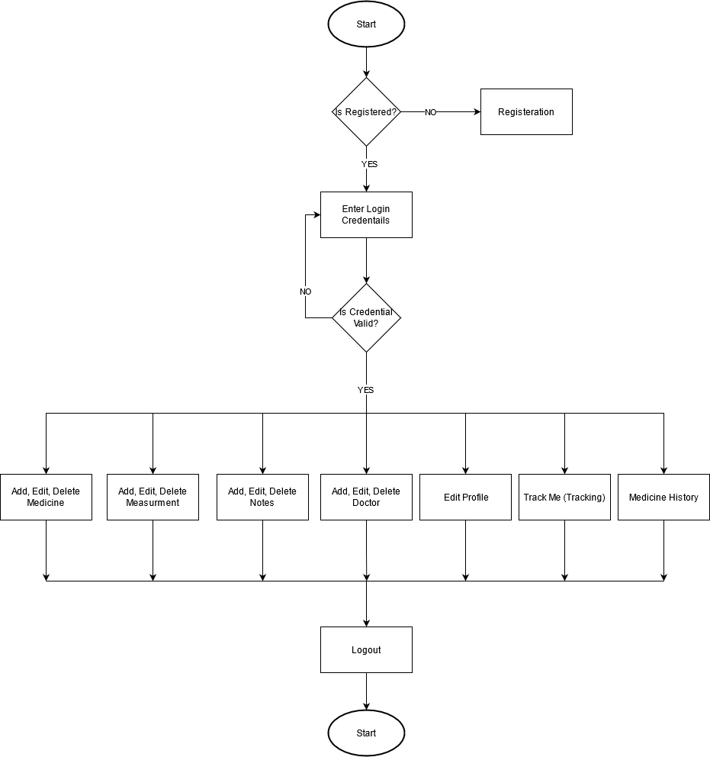

Figure System Flow Chart

### HIGH-LEVEL USE CASE DESCRIPTION.

1. **Register**

**Use case:** Register

**Actor:** User

**Description:**A new user needs to be registered to use the system properly. He/she needs to provide the required information to register into the system.

1. **Login**

**Use case:** Login

**Actor:** User

**Description:** A registered user can provide their login credentials to the application to access the application's services.

1. **Add medicine**

**Use case:** Add medicine

**Actor:** User

**Description:** A user can add the necessary medicines they use into the system and the other information required to remind them when they need to take medicine. They can also edit or delete the information relate to medicine.

1. **Add notes**

**Use case:** Add notes

**Actor:** User

**Description:** A user can add notes related to their health. They can also edit or delete the information relate to the note.

1. **Add measurements**

**Use case:** Add measurement

**Actor:** User

**Description:** A user can add various health-related measurements that they have taken into the system. They can also edit or delete the information relate to measurement.

1. **Add doctor**

**Use case:** Add doctor

**Actor:** User

**Description:** A user can add information related to their doctors into the system. They can also edit or delete the information relate to doctor.

1. **Enable tracking**

**Use case:** Enable tracking

**Actor:** User

**Description:** A user can enable tracking in the application, which retrieves their information every couple of minutes to see the user’s movement and if the user location remains the same even after a couple of minutes if asks the user if it is ok if the user does not respond it sends an SMS alert to the people close to the user informing about the user's current situation.

1. **Send medicine reminder**

**Use case:** Send report

**Actor:** System

**Description:** A reminder is sent to the user's phone, reminding them to take their medication at the user's provided time and when their stock is low or finished.

1. **Track user movement**

**Use case:** Track user movement

**Actor:** System

**Description:** It retrieves the user location every couple of minutes when the user enables tracking.

1. **Medicine History**

**Use case:** To keep history of all the medicine consumed

**Actor:** System

**Description:** A user can view the history of all the medicine he/she has taken.

### DATA FLOW DIAGRAMS

1. **Level 0 DFD diagram of the overall system**

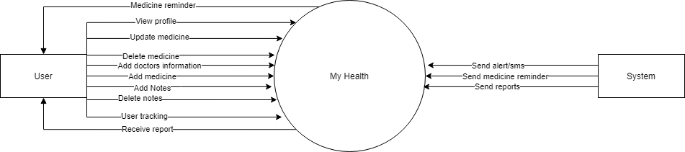

Figure Level 0 DFD of overall system

The Context Level or Level 0 DFD (Data Flow Diagram) consists of a primary process at the middle, which refers to the application named My Health, and two entities: the user and the system.

1. **DFD Register**
   1. **Level 0 DFD - Register**

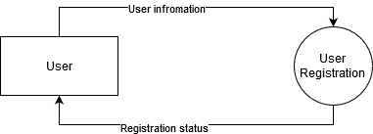

Figure Level 0 DFD - Register

The level 0 DFD in the above figure shows the registration process of a user in the application. The figure above represents a single external entity, the user, and a primary process known as user registration. In this process, the user provides necessary information for registration. After the completion of the process, the user again receives the registration status.

* 1. 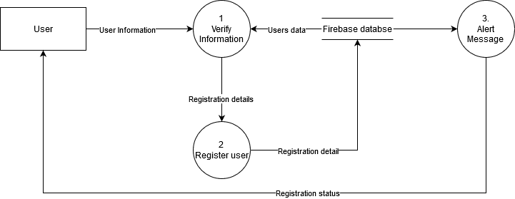**Level 1 DFD – Register**

Figure Register level 1 DFD

In level 0 DFD, the whole registration process is shown in a single process, whereas in the level 1 data flow diagram, the process is further broken down into many other processes.

Here in the level 1 DFD, the registration process clarifies that the user provides the required information. The system first verifies the information provided then the process of registration is done by saving the user-provided data in the database. After completion of the registration, the user is notified by the application about the registration status.

1. **Login**
   1. 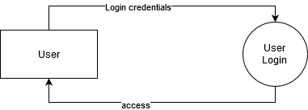**Level 0 DFD - Login**

Figure Login level 0 DFD

The level 0 DFD in the above figure shows the login process in the application. The whole login process consists of a single external entity, the user, and a user login process. In this process, the user provides login credentials to login into the application, after which the user is granted access into the system if the user is registered.

* 1. 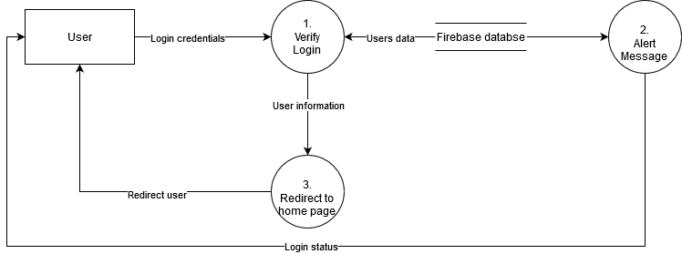**Level 1 DFD – Login**

Figure Login level 1 DFD

The above figure is the level 1 data flow diagram of the login process. The login process is further broken down into other processes in contrast to the level 0 DFD.

The user provides the login credentials, which are first verified with the data in the firebase database. If the user is registered into the system, then the user is given access to their homepage.

1. **Add medicine**
   1. 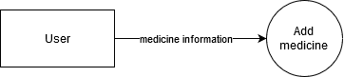**Level 0 DFD - Add medicine**

Figure Add medicine level 0 DFD

The level 0 DFD of add medicine is represented by the above diagram, consisting of a single entity user and the primary process known as add medicine. The user provides the necessary information regarding the medicine they need to take into the application.

* 1. **Level 1 DFD – Add medicine**

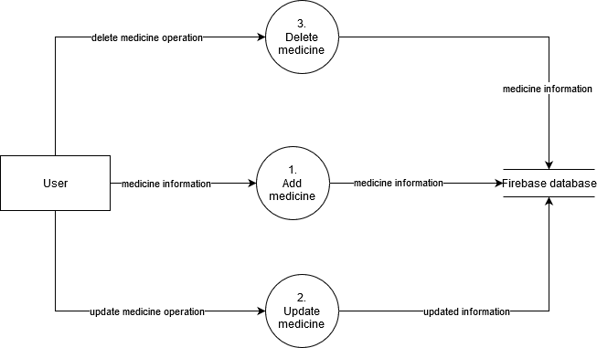

Figure Level 1 DFD - Add Medicine

In the above figure of level 1 DFD of add medicine, the process is further broken down in contrast to the level 0 DFD.

Here, the user's processes of adding the medicine, removing the unwanted medication, and updating the current medical information are shown. In the add medicine process, the user provides the information of medicine and their intake, which is then stored in the database; similarly, if they need to update the current medicine, they re-enter the new medicine information, and the information is updated in the database. Furthermore, if they need to delete a medicine, the information related to that medicine is deleted.

1. **Add doctor**
   1. 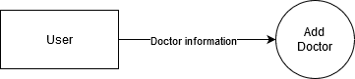**Level 0 DFD – Add doctor**

Figure Add doctor level 0 DFD

The above figure shows the level 0 DFD of the add doctor process, consisting of a single entity, the user, and a primary process known as add doctor. Here the user enters the doctor's information into the application, which is stored in the database.

* 1. 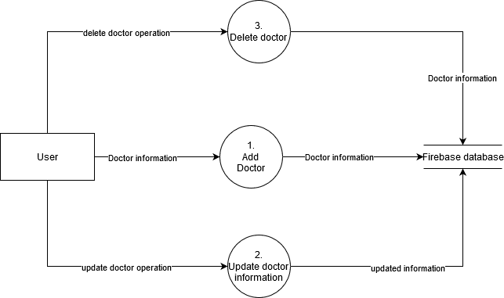**Level 1 DFD – Add doctor**

Figure Add doctor level 1 DFD

The above figure consists of the level 1 DFD of the add doctor process. This level is further broken down from level 0 DFD and consists of other functions such as adding a doctor, updating the doctor's information, and deleting a doctor's information.

To add a doctor, the user first inputs the necessary information related to the doctor into the system, which is then stored in the database. When updating a doctor's information, the new information related to the doctor is updated into the database, and when removing a doctor, the doctor's information is deleted from the database.

1. **Add notes**
   1. 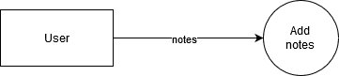**Level 0 – Add notes**

Figure Add notes level 0 DFD

The above figure shows the level 0 DFD of the add notes process, consisting of a single entity, the user, and a primary process known as add notes. Here the user takes a note, which is saved in the application and stored in the database.

* 1. 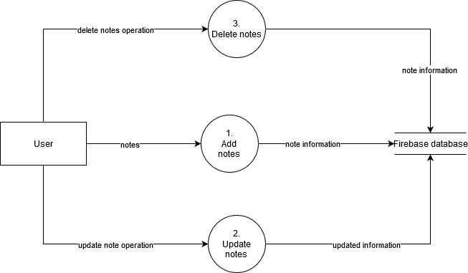**Level 1 – Add notes**

Figure Add notes level 1 DFD

The above figure shows that the add notes process is further broken down in contrast to level 0 DFD and represented as a level 1 DFD.

Here the user can add a note, update the existing note, and delete a note. To add a note, the user creates a new note that notes information is stored into the database when updating a note, the updated information is stored into the database, and when deleting a note, the information related to that note is deleted from the database and the entire system.

1. **Add measurement**

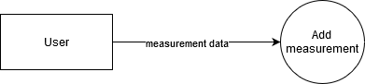**7.1. Level 0 DFD – Add measurement**

Figure Add measurement level 0 DFD

The above figure shows the level 0 DFD of the add measurement process, which consists of a single entity, the user, and a primary process known as add measurement. Here the user provides the measurement records into the system, which is then stored in the database.

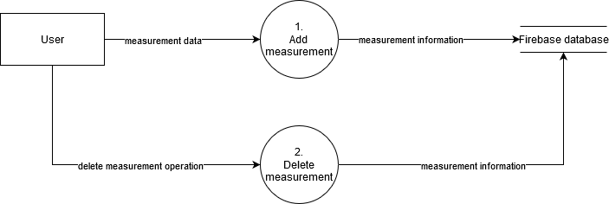**7.2. Level 1 DFD – Add measurement**

Figure Add measurement level 1 DFD

The above diagram shows the level 1 DFD of the adding measurement, which is further broken down from level 0 DFD.

Here, the process is broken down into adding the measurements and deleting the measurement data. The measurement data is added into the application to add measurement, which is stored in the system, and when deleting a measurement data, information related to that measurement is deleted from the database.

1. **Track Me**
   1. **Level 0 DFD – Track Me**

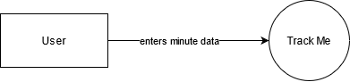

Figure Track Me Level 0 DFD

The level 0 DFD showed above shows the process of tracking. Here the user is the external entity. The user provides minute data to start the tracking process.

* 1. **Level 1 DFD – Track Me**

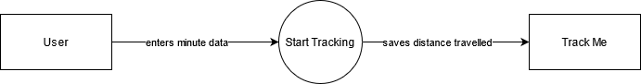

Figure Track Me Level 1 DFD

Here in level 1 of the track me DFD, the process is a bit expands in the context of level 0. The user first enters a minute field to start the tracking process, and a distance traveled value is saved by the tracking process within the time given by the user.

1. **Medicine History** 
   1. **Level 0 DFD – Medicine History**

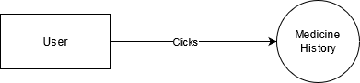

Figure Medicine history Level 0 DFD

The above figure represents the Level 0 DFD for Medicine history; here, the user is the single external entity that clicks the Medicine history in the application to start its processes.

* 1. **Level 1 DFD – Medicine History**

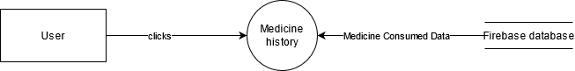

Figure Medicine History Level 1 DFD

The level 1 DFD for medicine history shows the process a bit clearer than that of level 0 DFD. The user clicks the medicine history, which then reads data of medicine consumed by the user from the database and shows it to the user.

### USE CASE

**Actor: User**

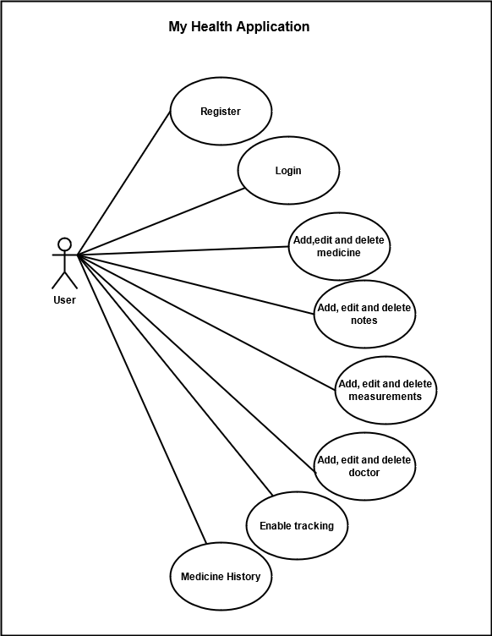

Figure User Use Case Diagram

**Actor: System**

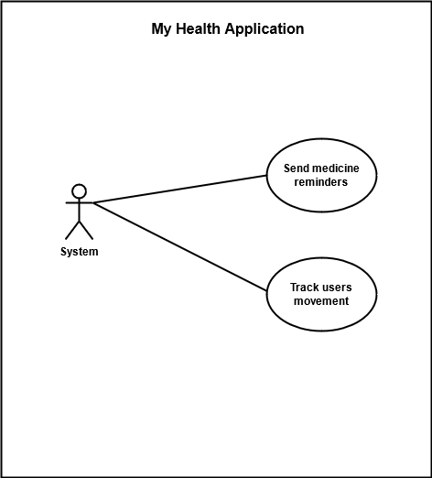

Figure System Use Case Diagram

### WIREFRAME

The wireframe was developed for the system initially before development.

Figure Register page

1. **Register**

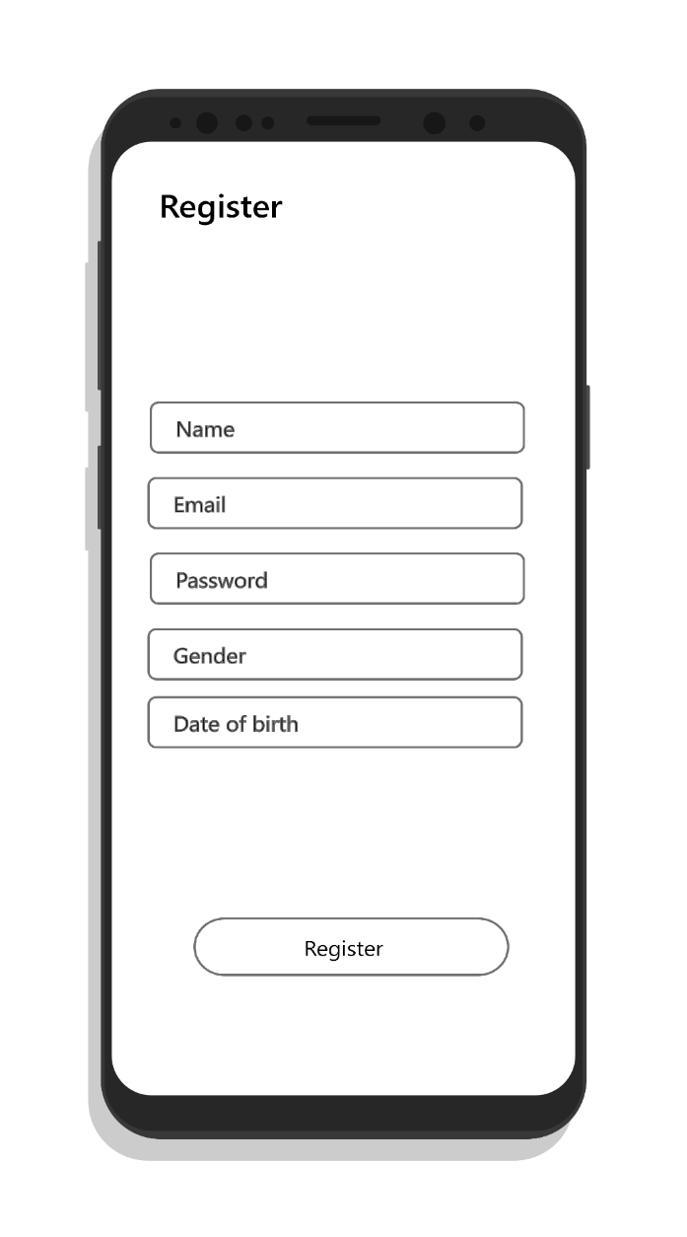

1. **Login**

Figure Login page

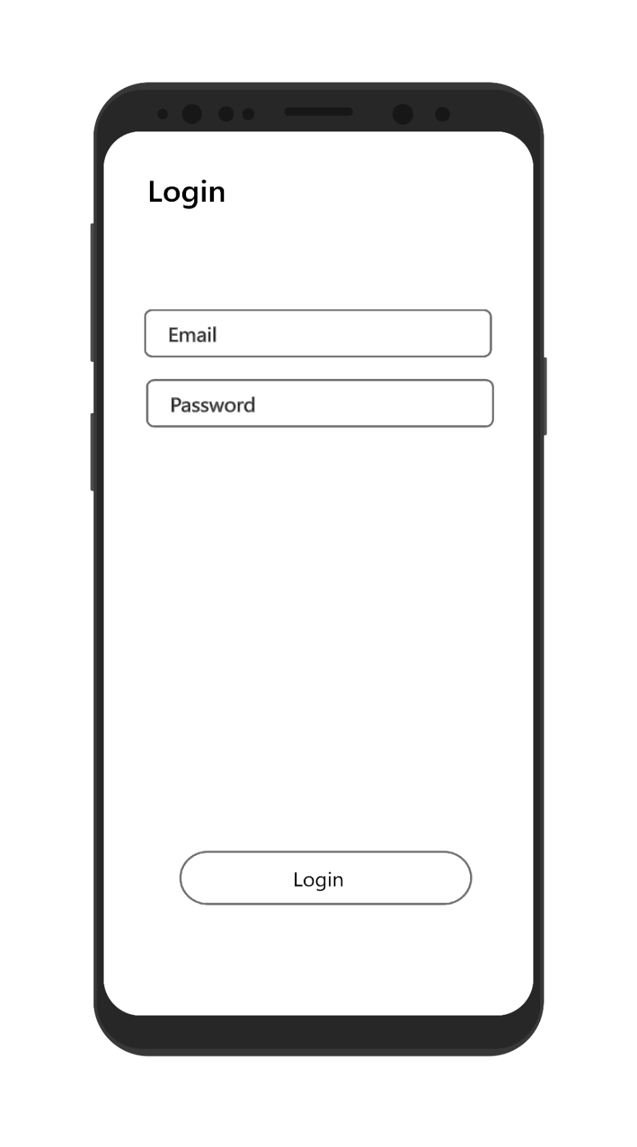

1. **Home page**

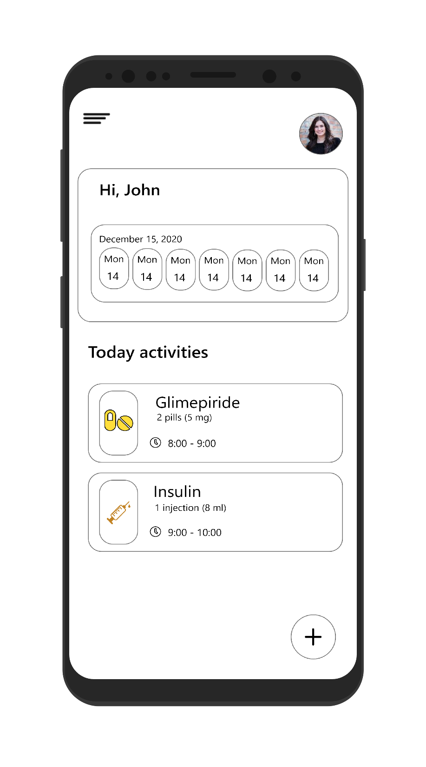

Figure Home page

1. **Medicine pages**

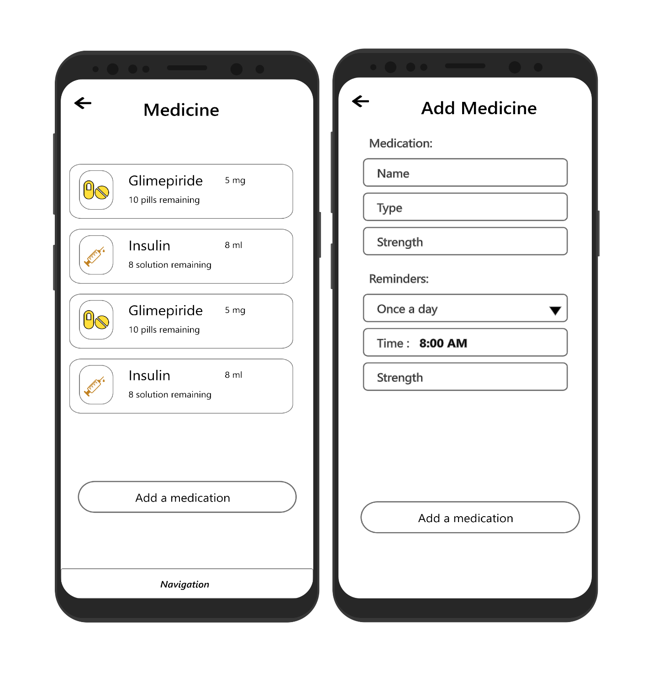

Figure Add Medicine pages

1. **Doctors page**

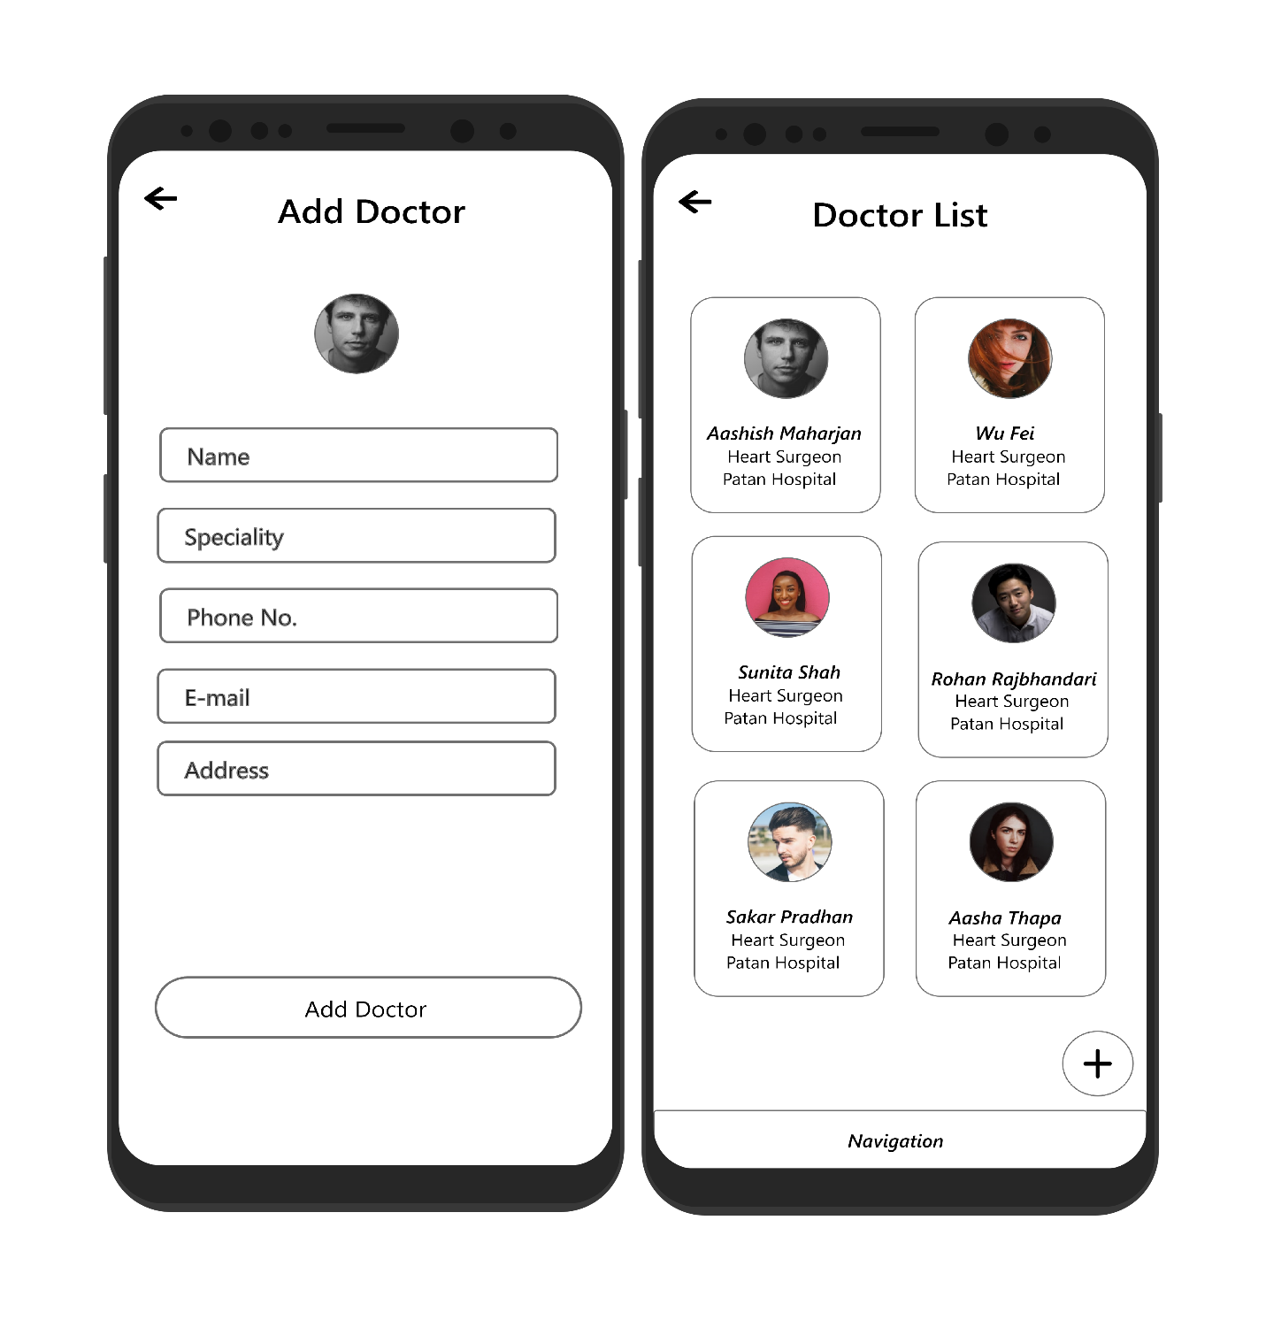

Figure Add doctors pages

1. **Notes page**

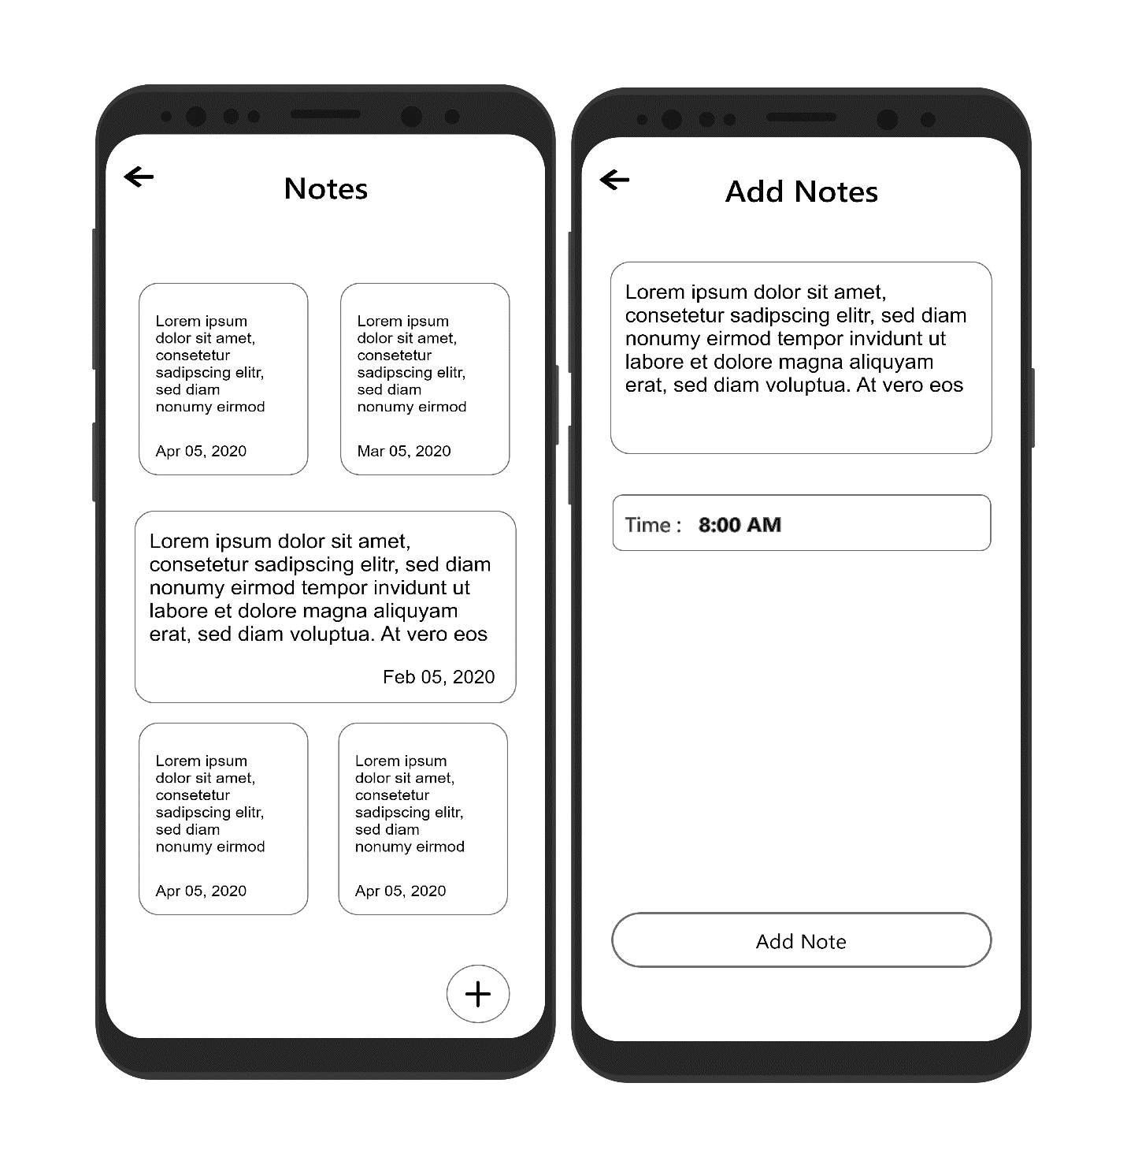

Figure Add notes pages

1. **Measurement Pages**

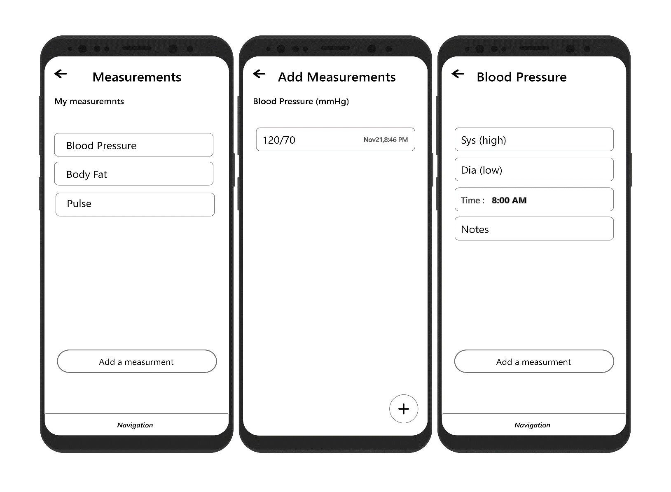

Figure Add measurements pages

1. **Enable tracking page**

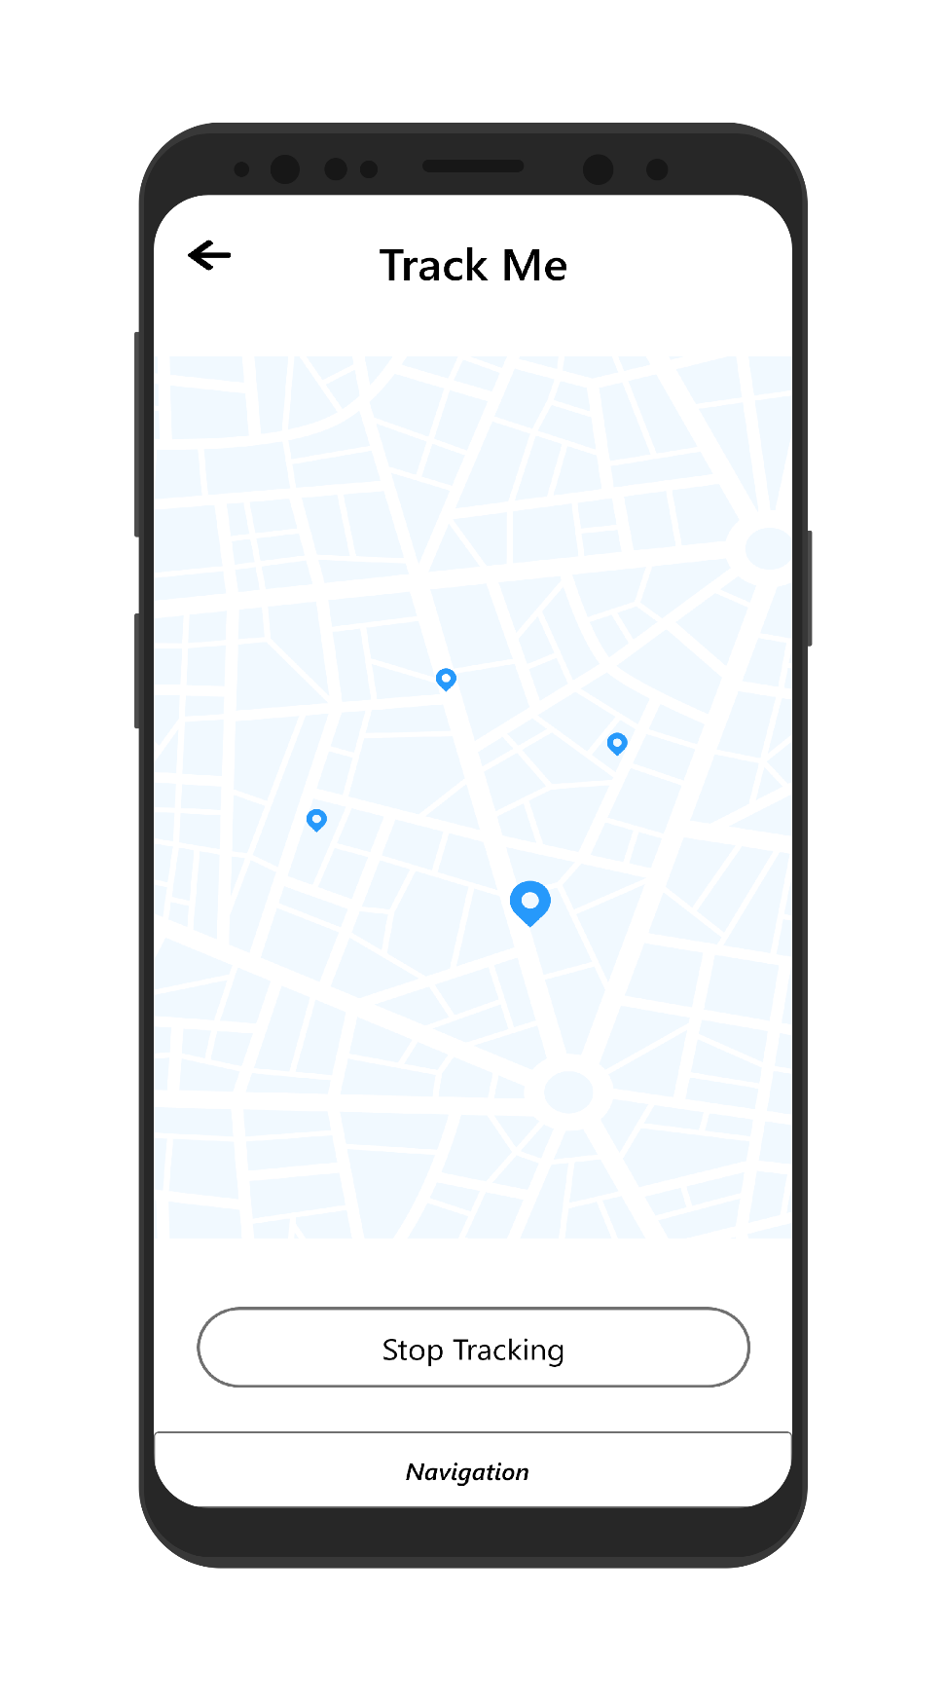

Figure Enable tracking page

## APPENDIX F: SCREENSHOT OF THE SYSTEM

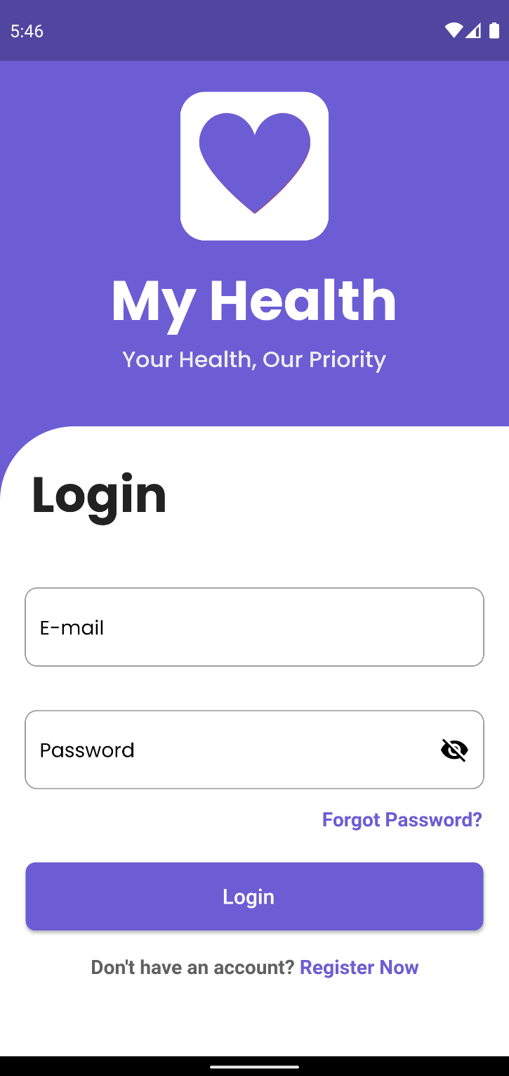

Figure Login Page

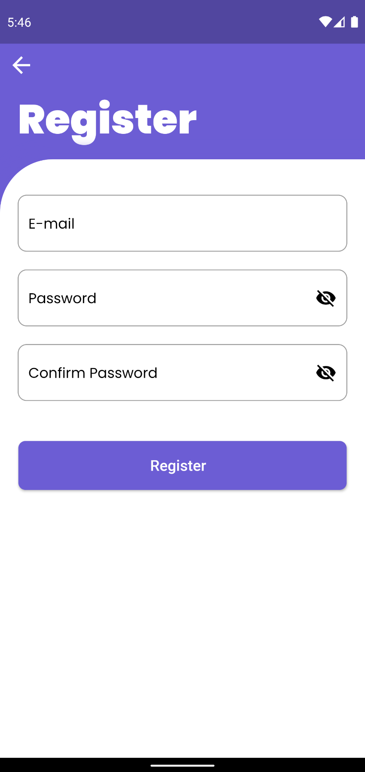

Figure Register Page

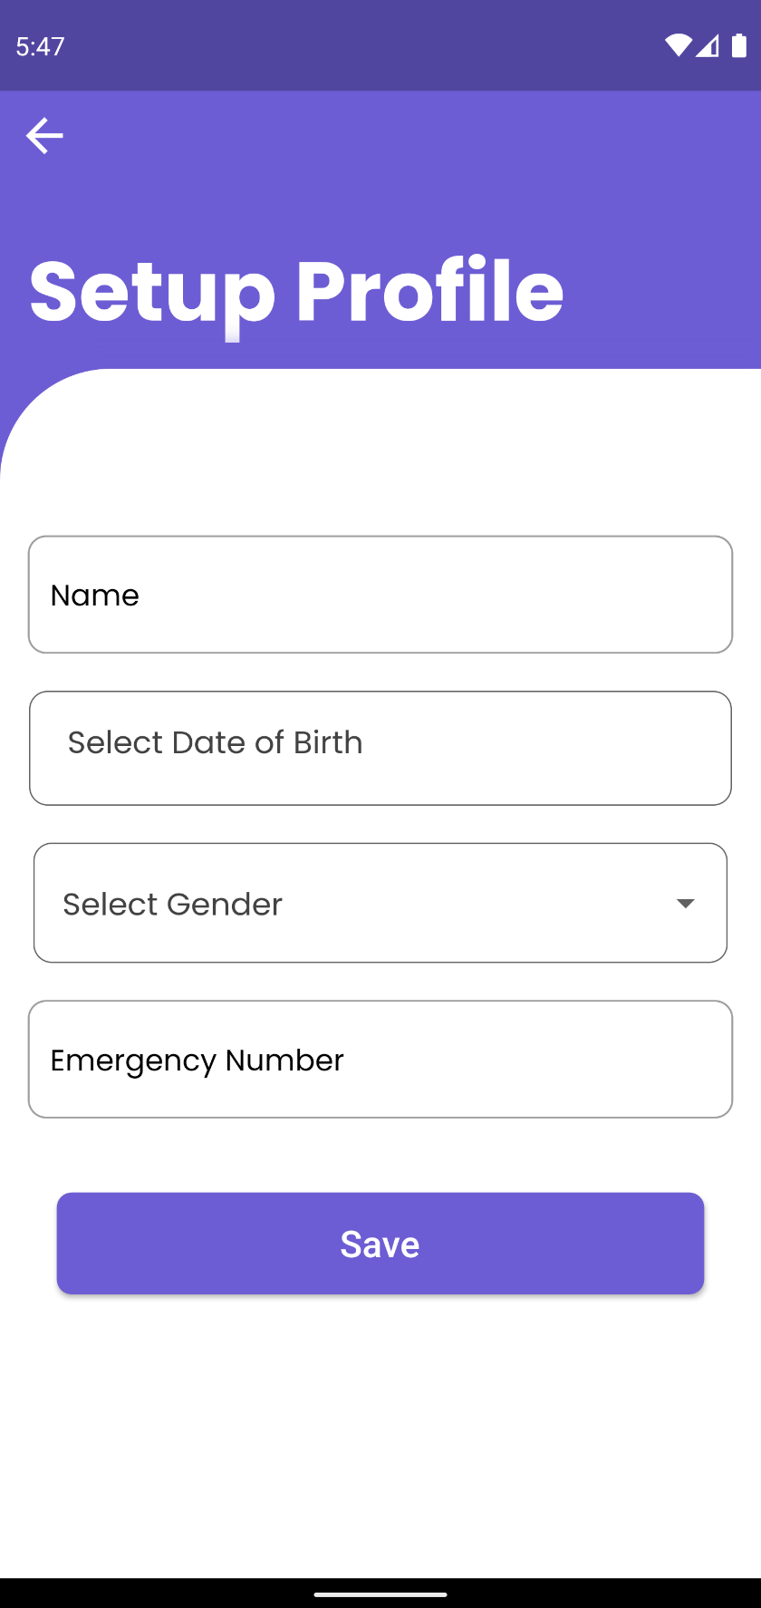

Figure Setup Profile Page

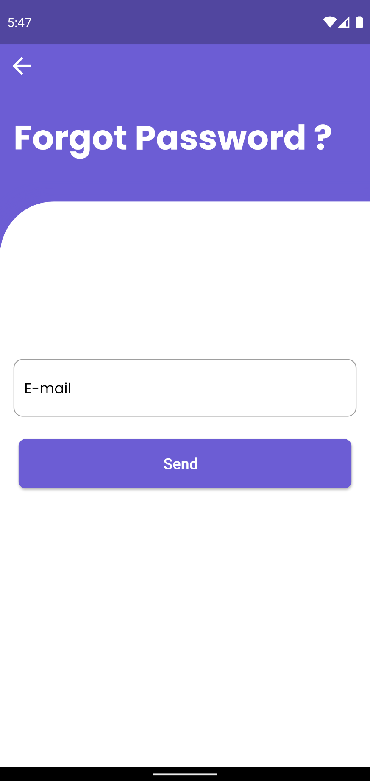

Figure Forgot Password Page

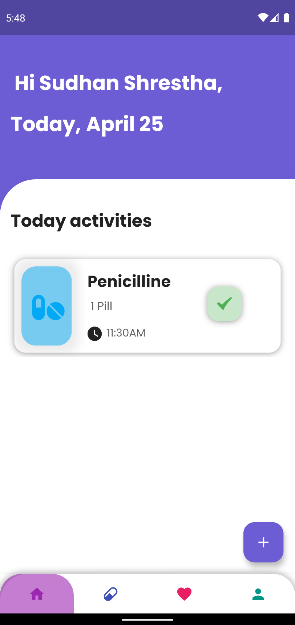

Figure Home Page

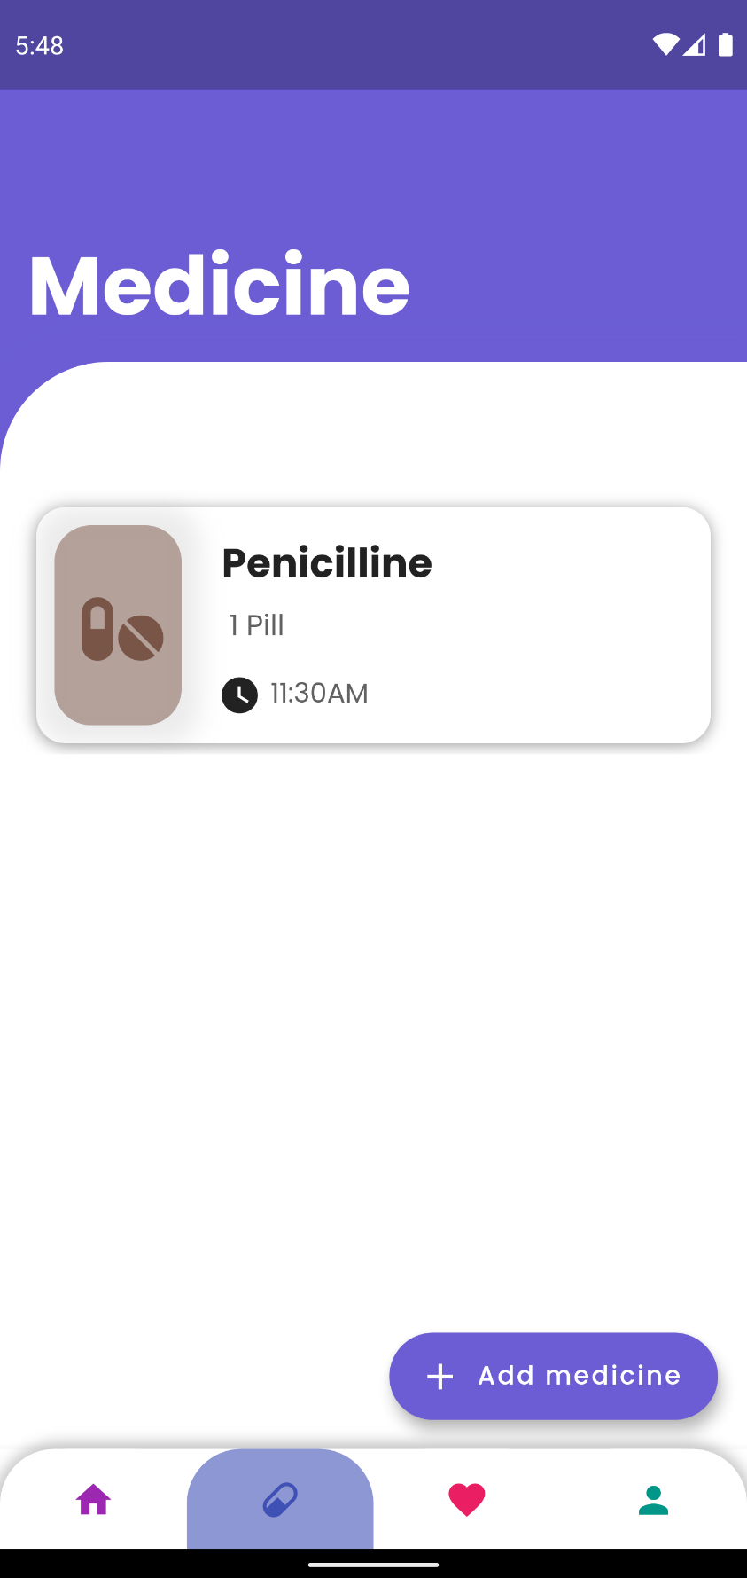

Figure Medicine Page

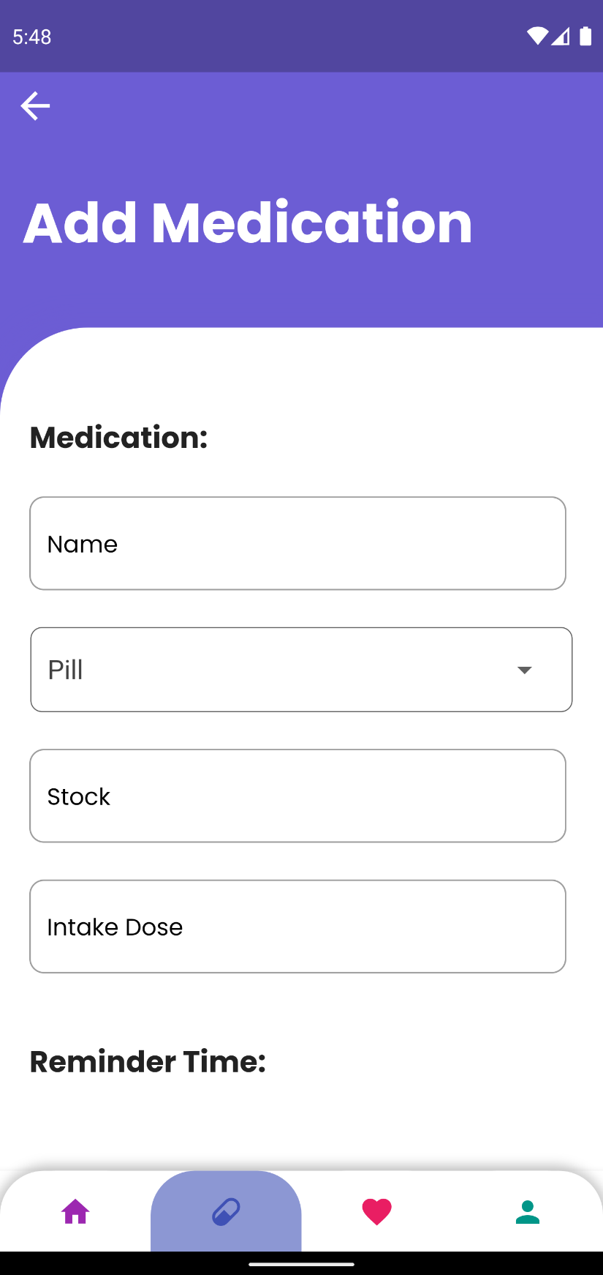

Figure Add Medicine Page

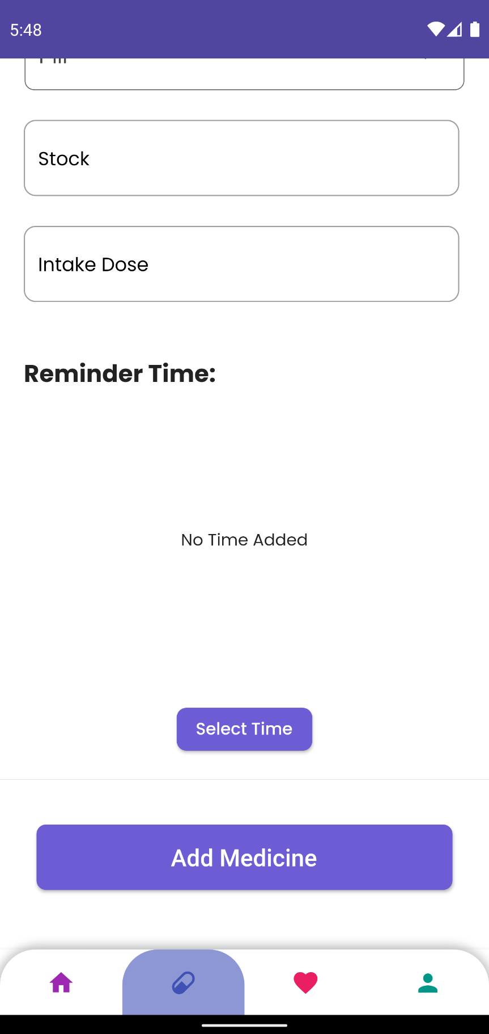

Figure Add Medicine Page

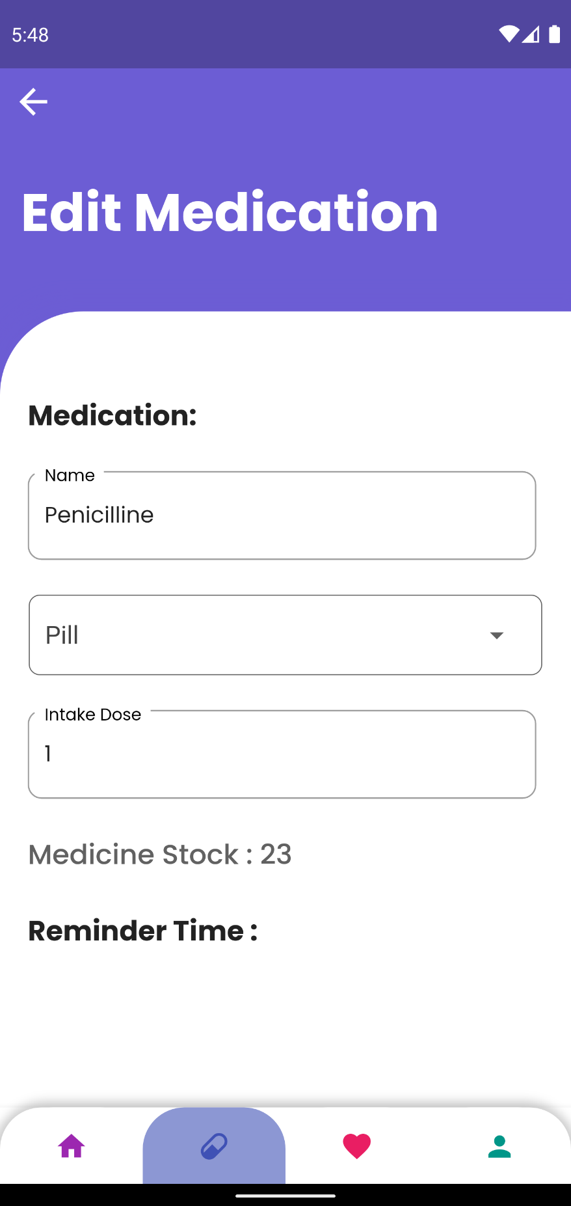

Figure Edit Medicine page

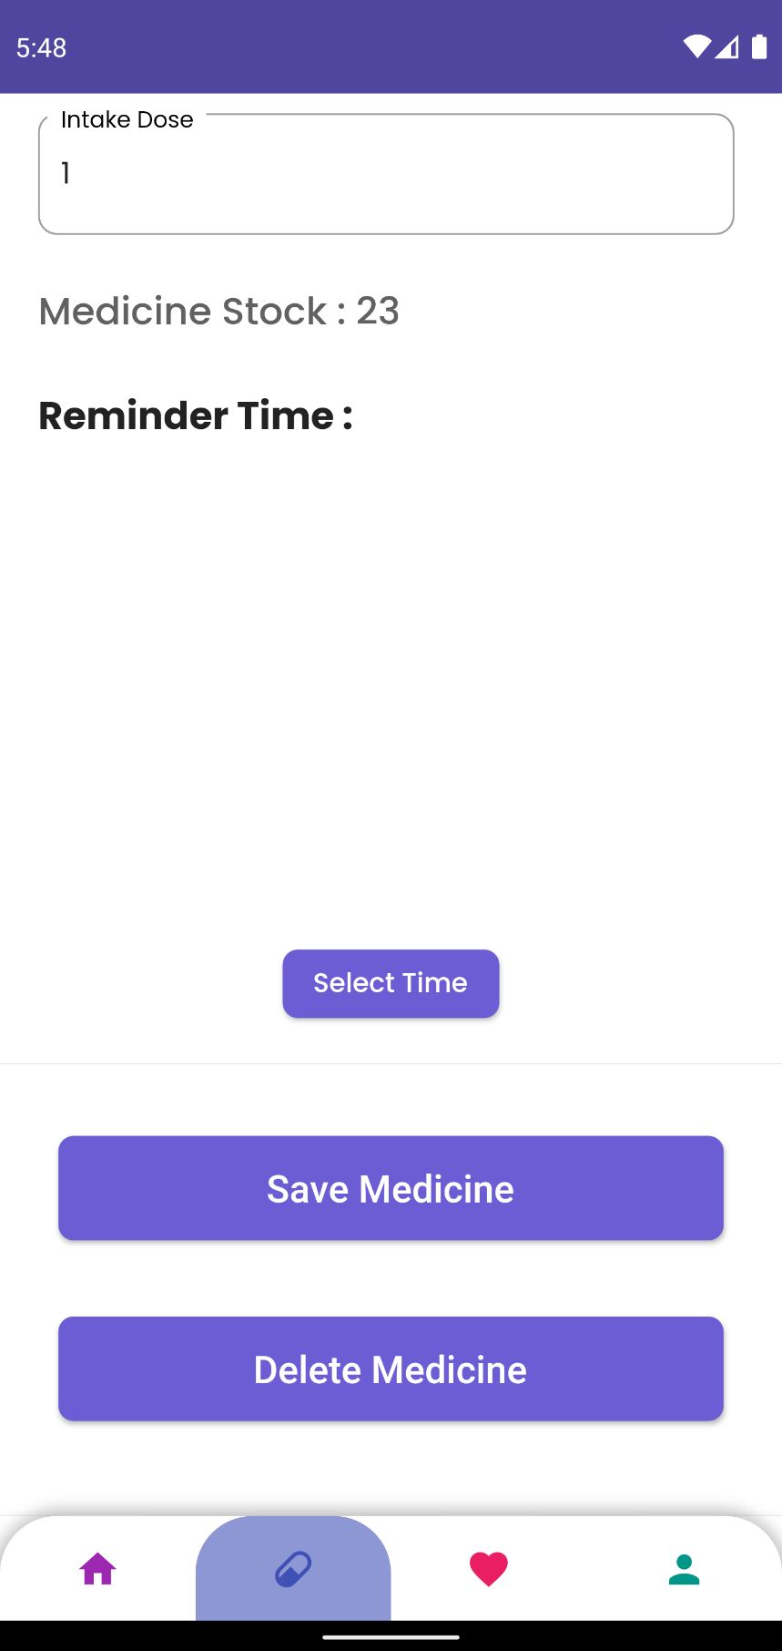

Figure Edit Medicine Page

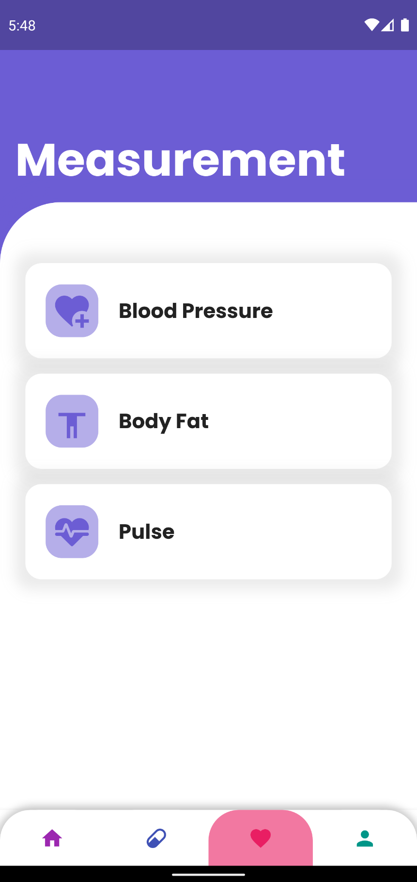

Figure Measurement Page

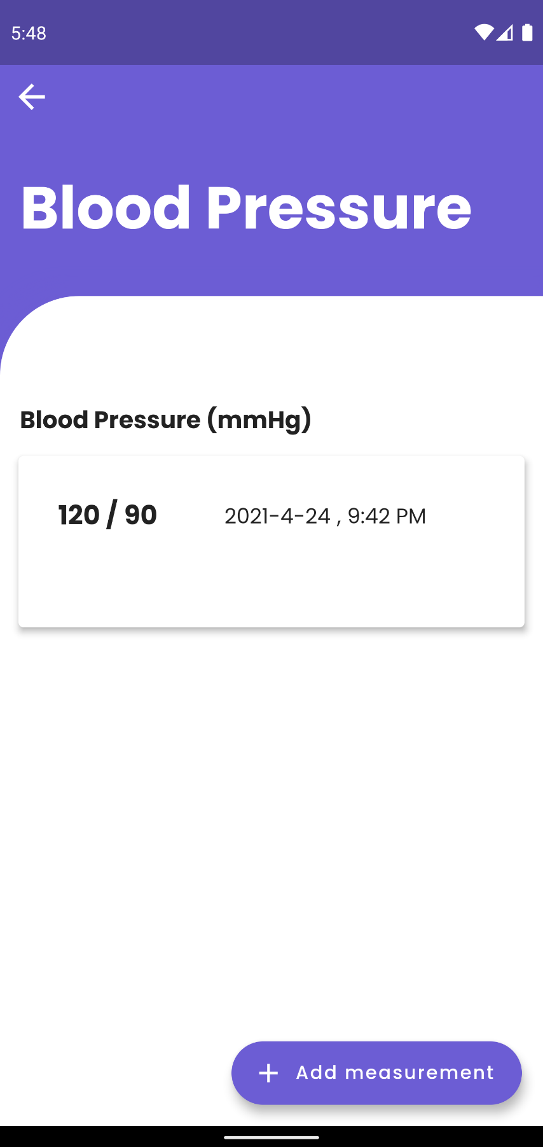

Figure Blood Pressure Page

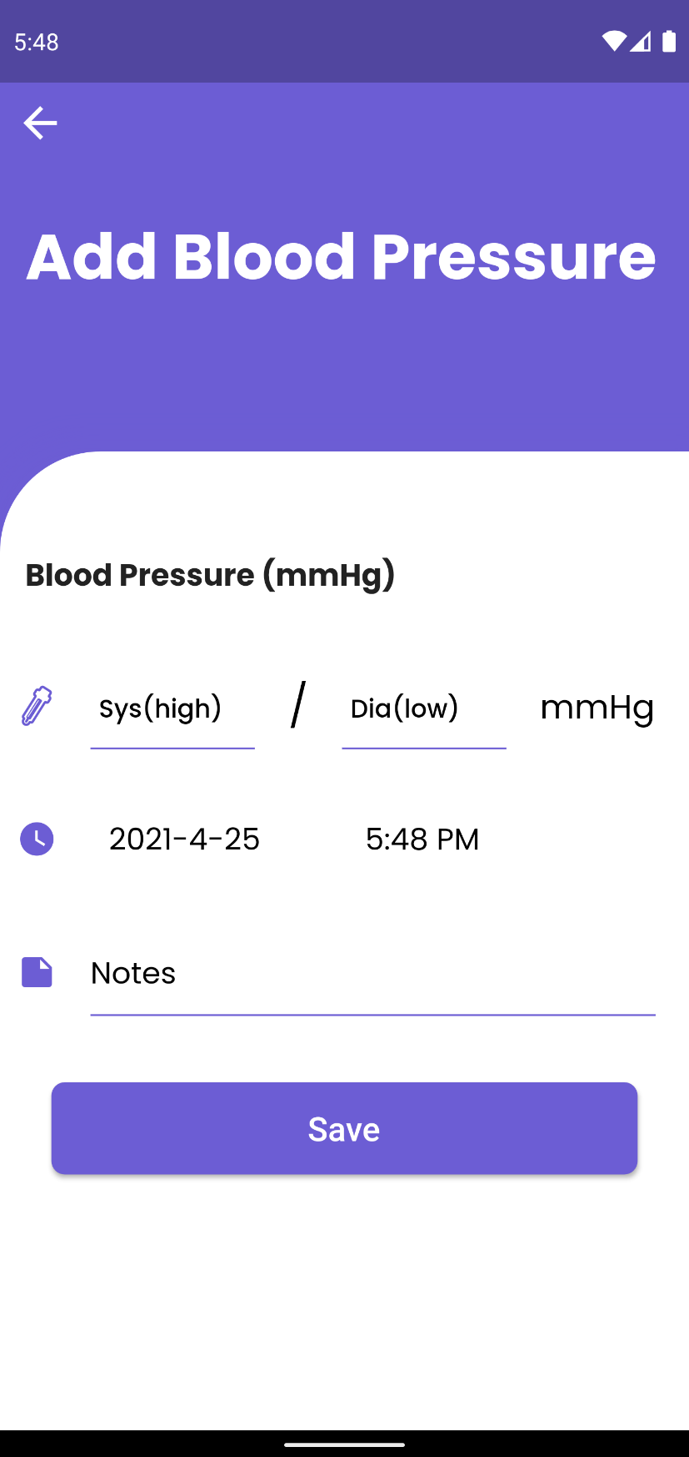

Figure Add Blood Pressure Page

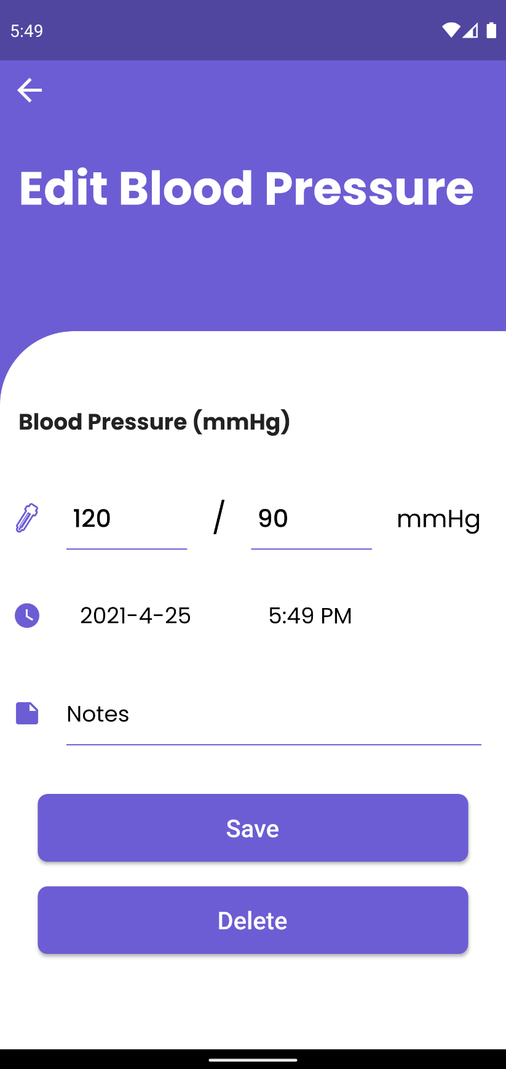

Figure Edit Blood Pressure Page

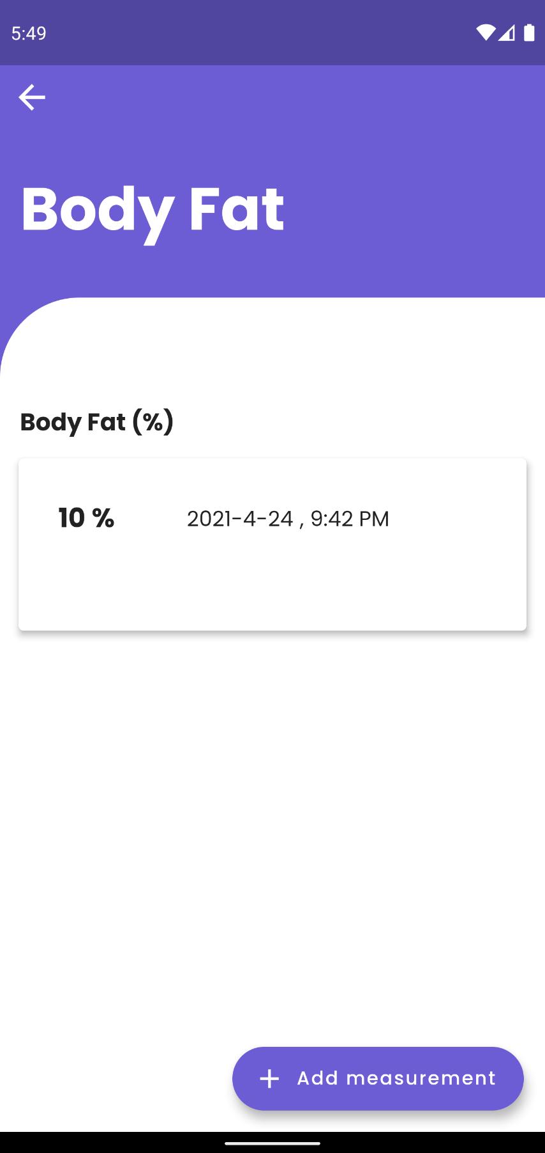

Figure Body Fat Page

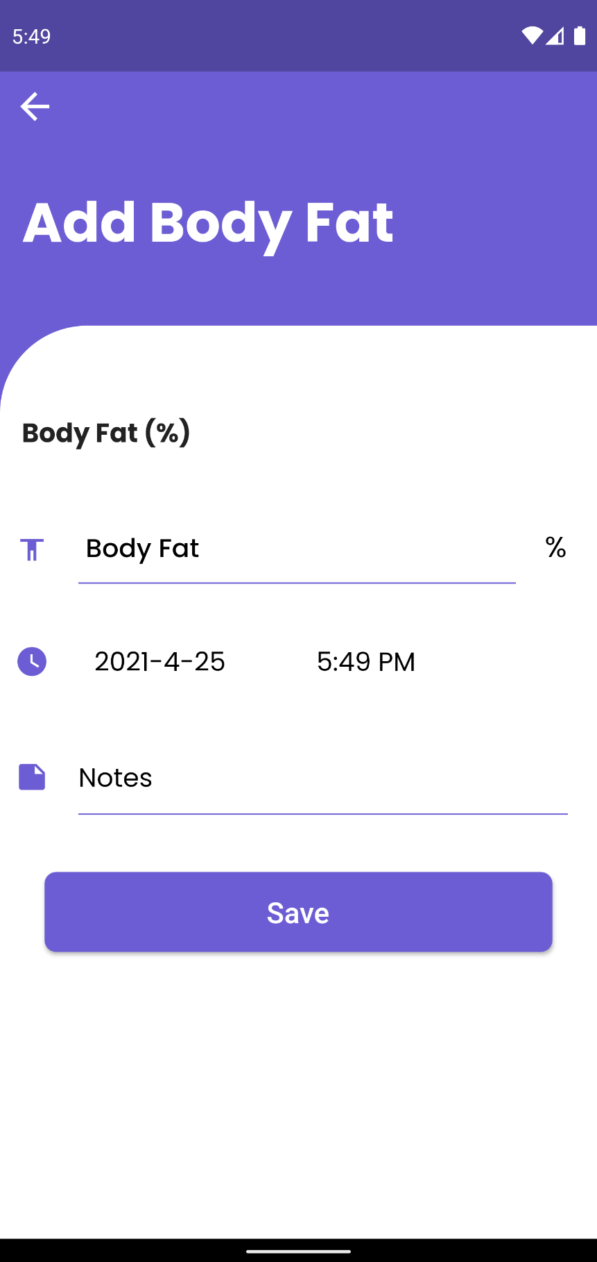

Figure Add Body Fat Page

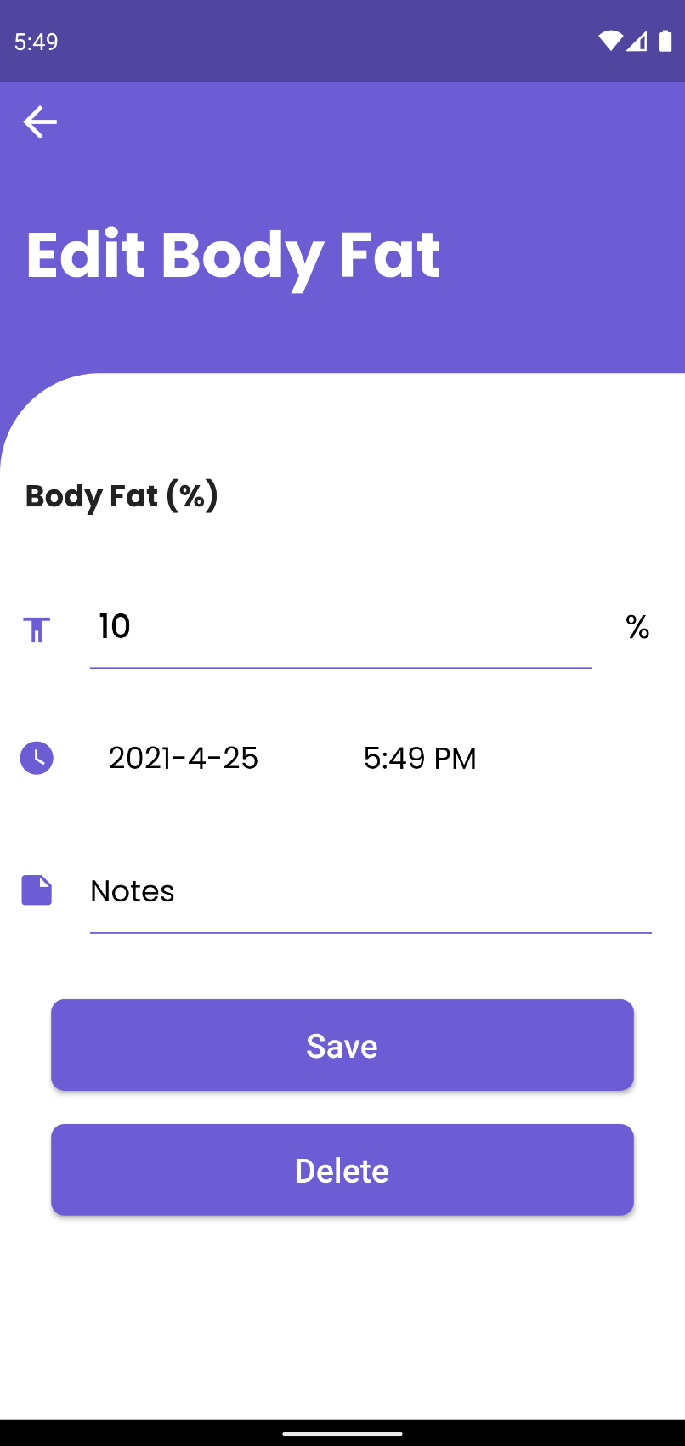

Figure Edit Body Fat Page

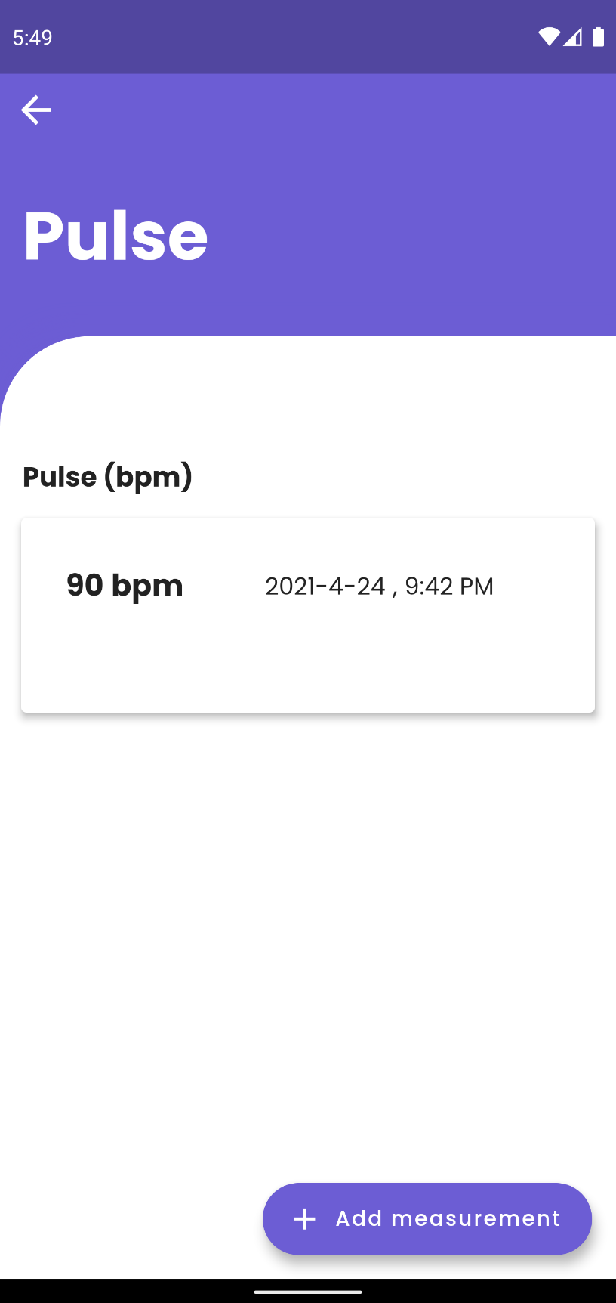

Figure Pulse Page

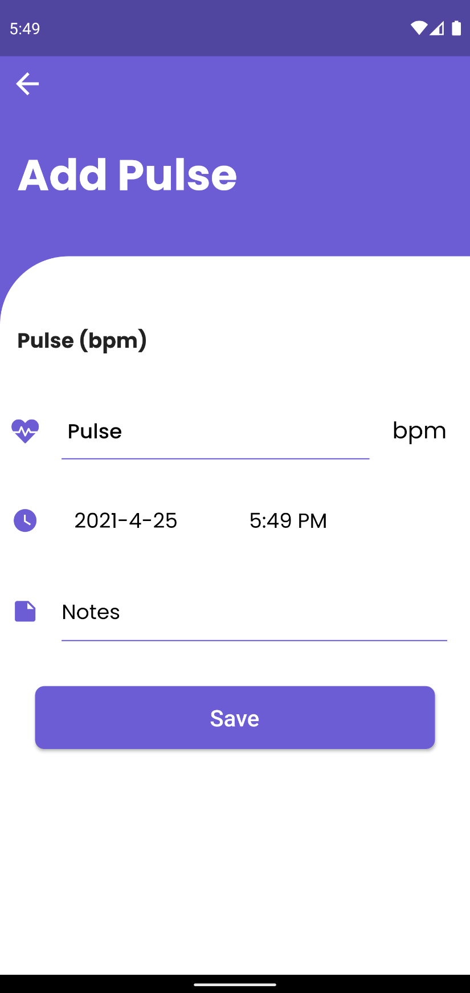

Figure Add Pulse Page

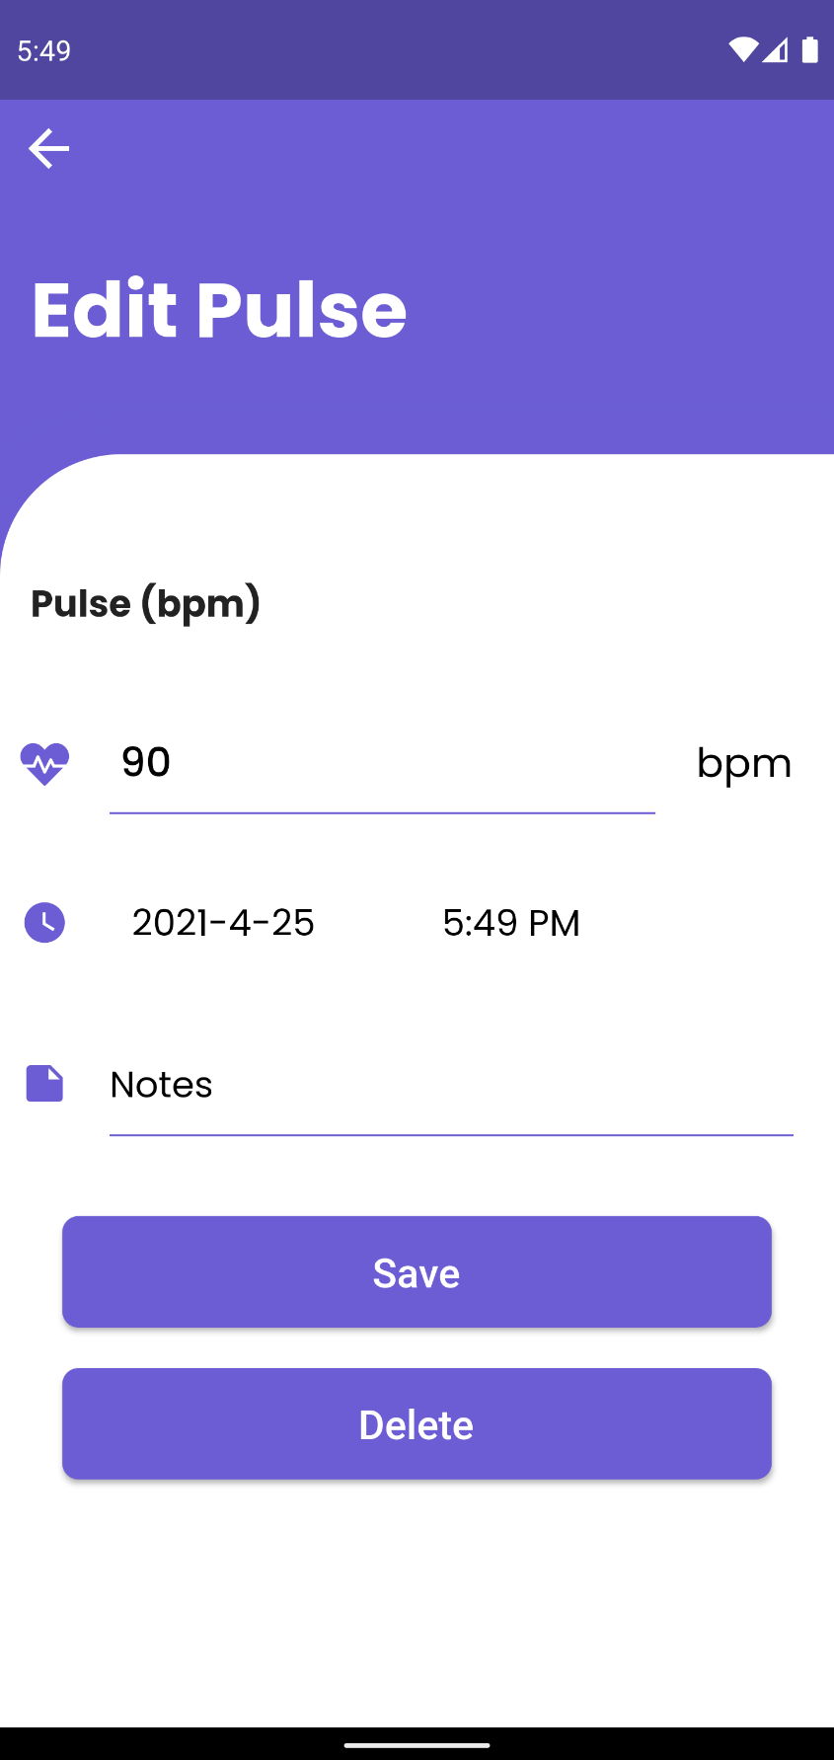

Figure Edit Pulse Page

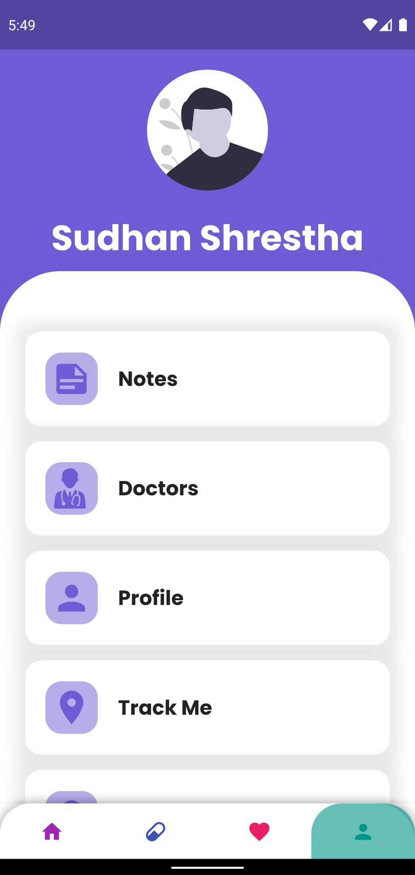

Figure Other/Menu Page

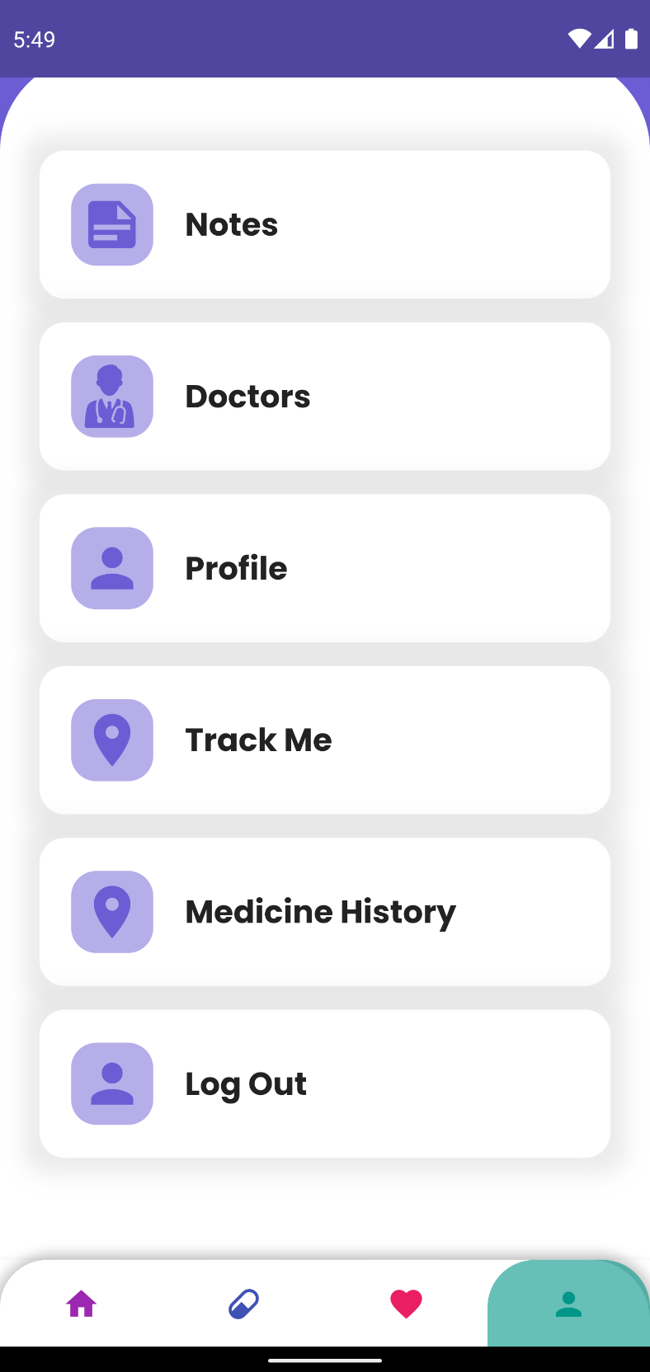

Figure Other/ Menu Page

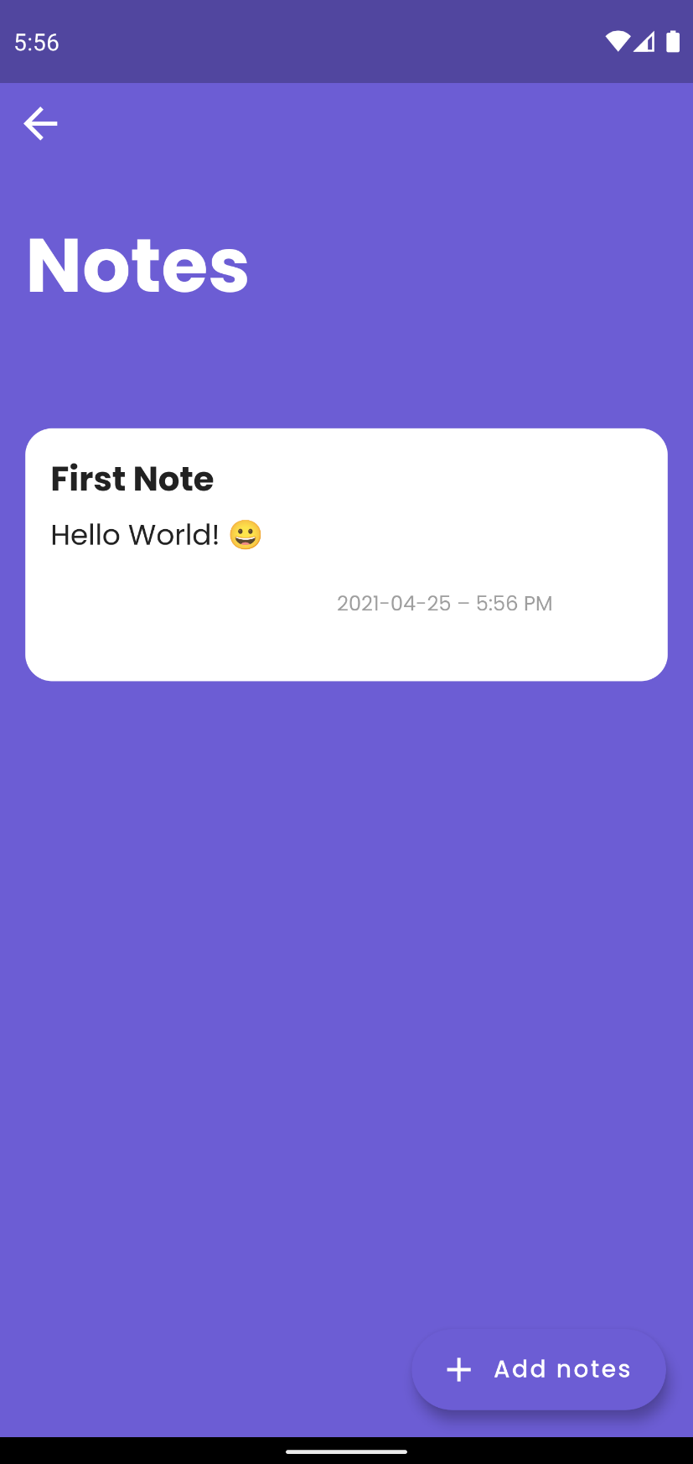

Figure Notes Page

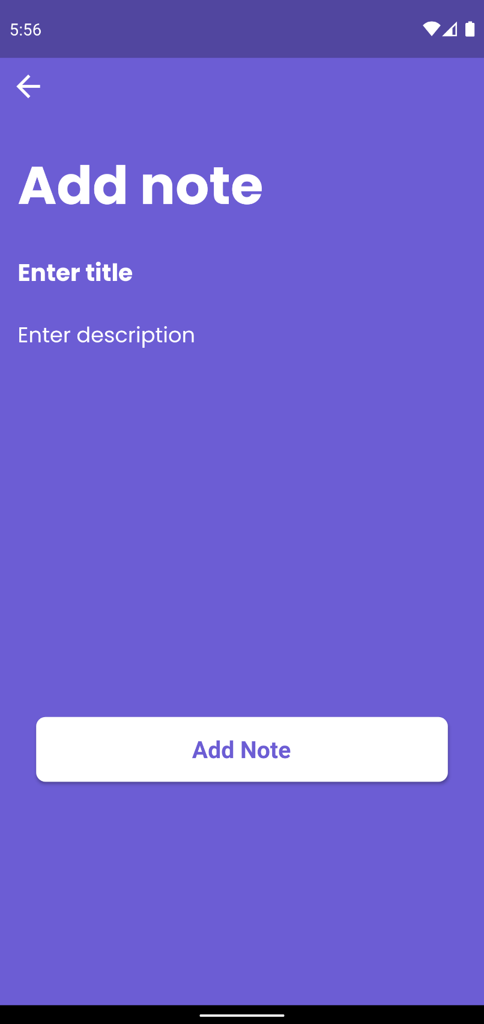

Figure Add Notes Page

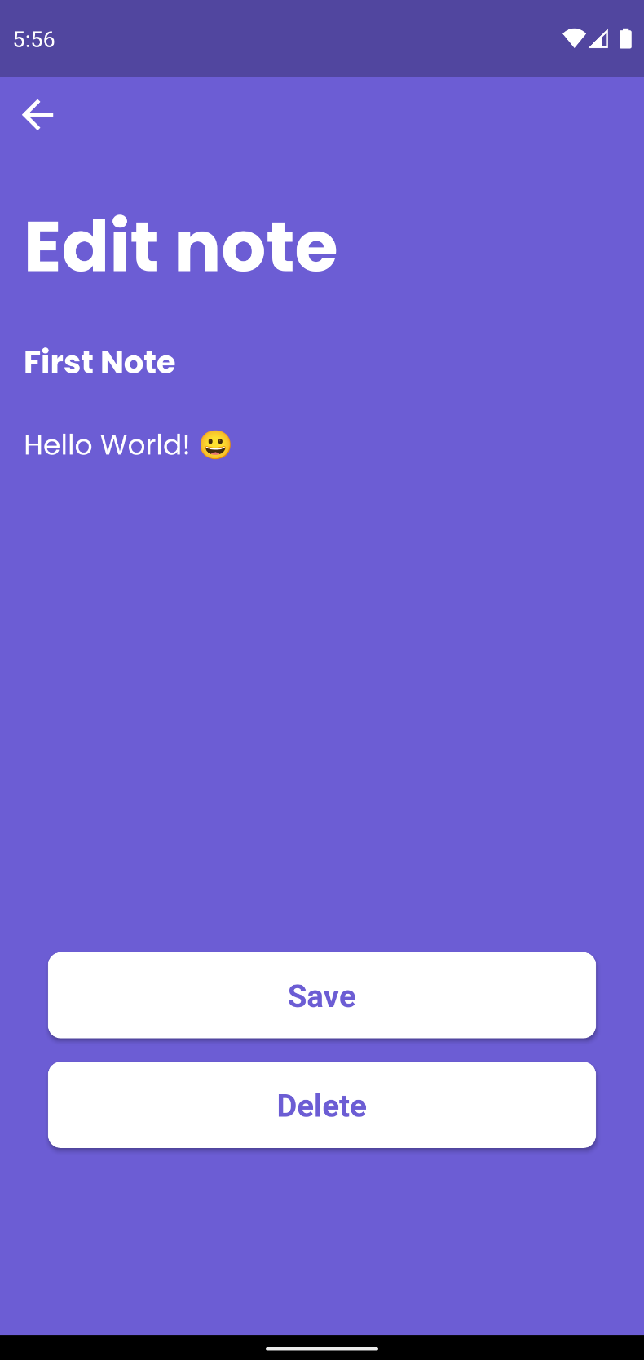

Figure Edit Note Page

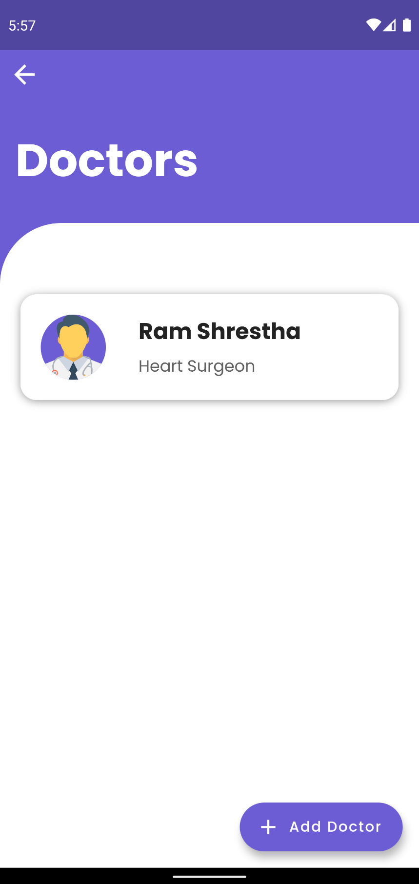

Figure Dcotors Page

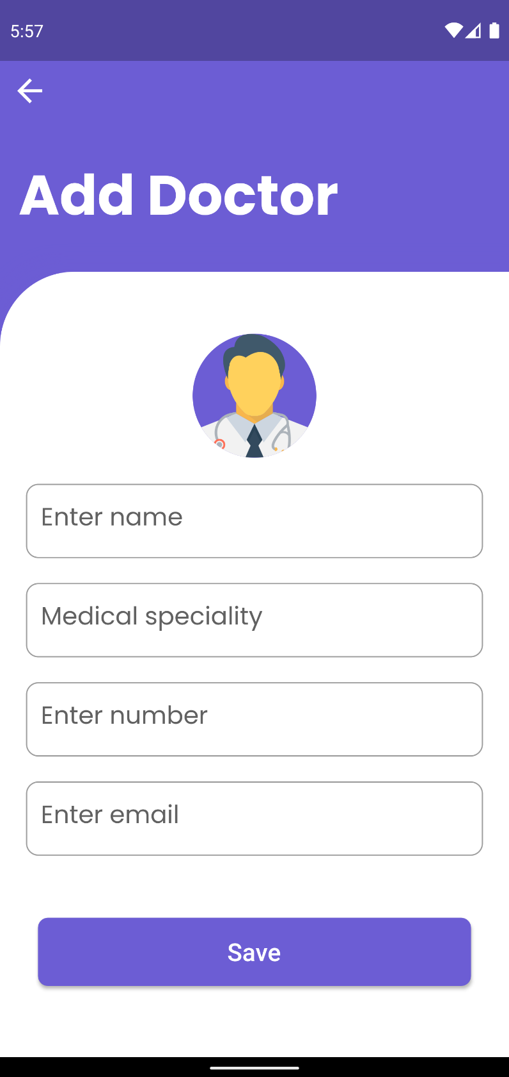

Figure Add Doctor Page

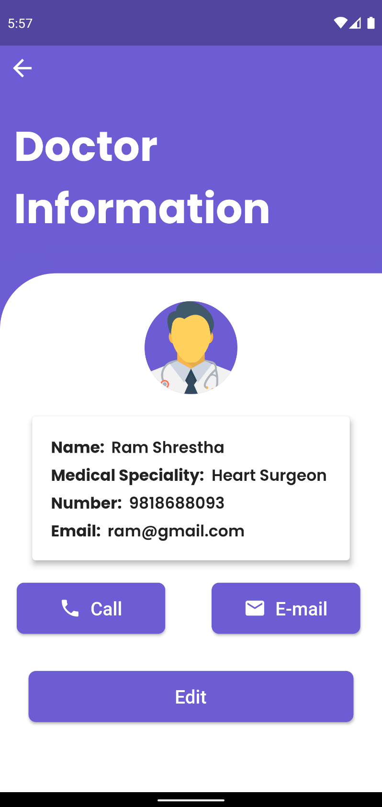

Figure Doctor Information Page

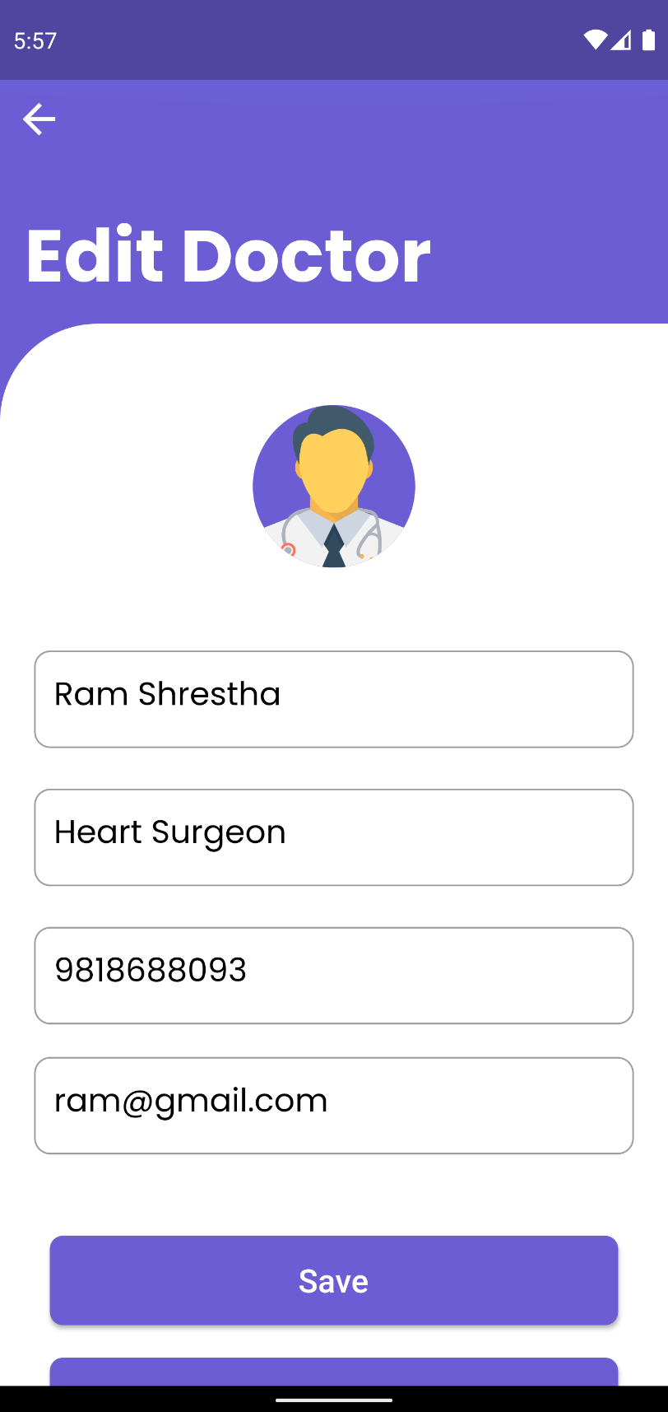

Figure Edit Doctor Page

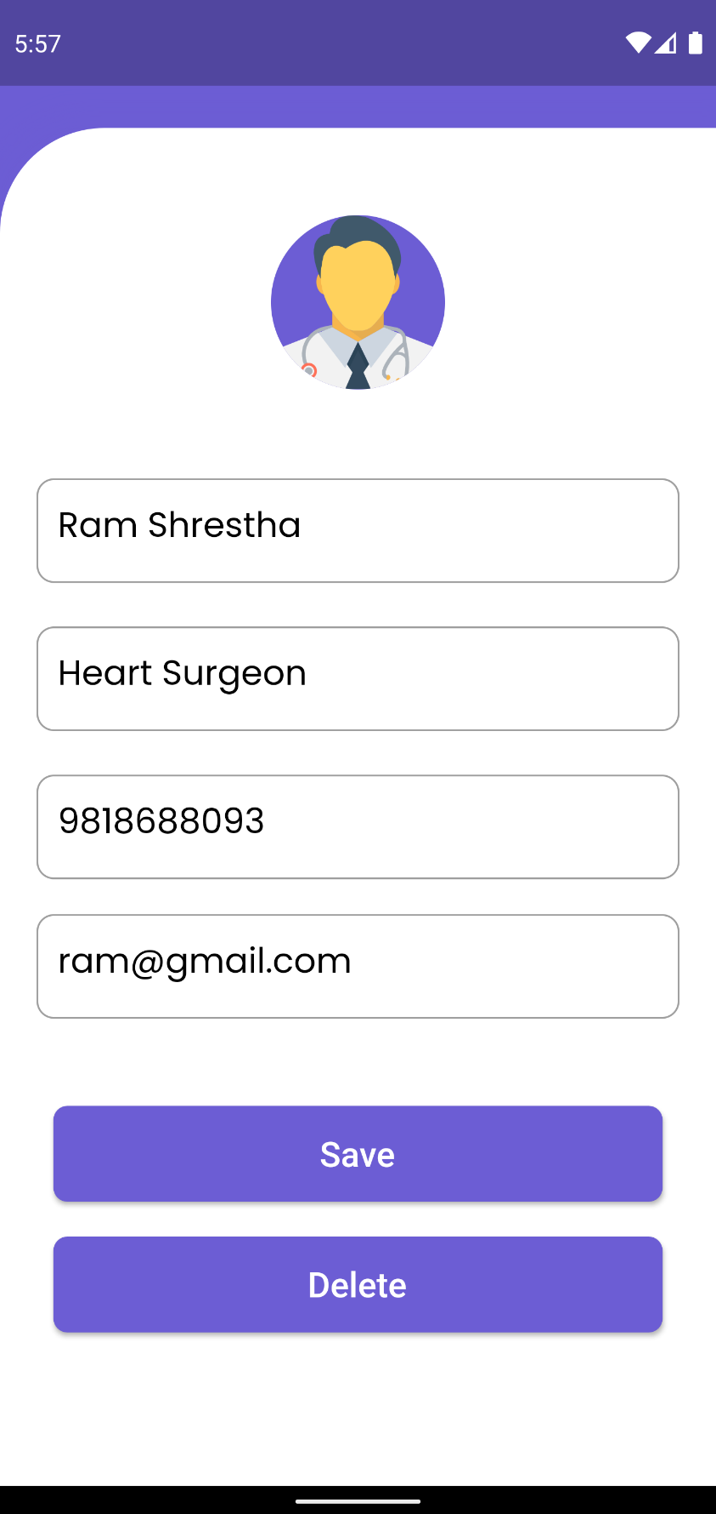

Figure Edit Doctor Page

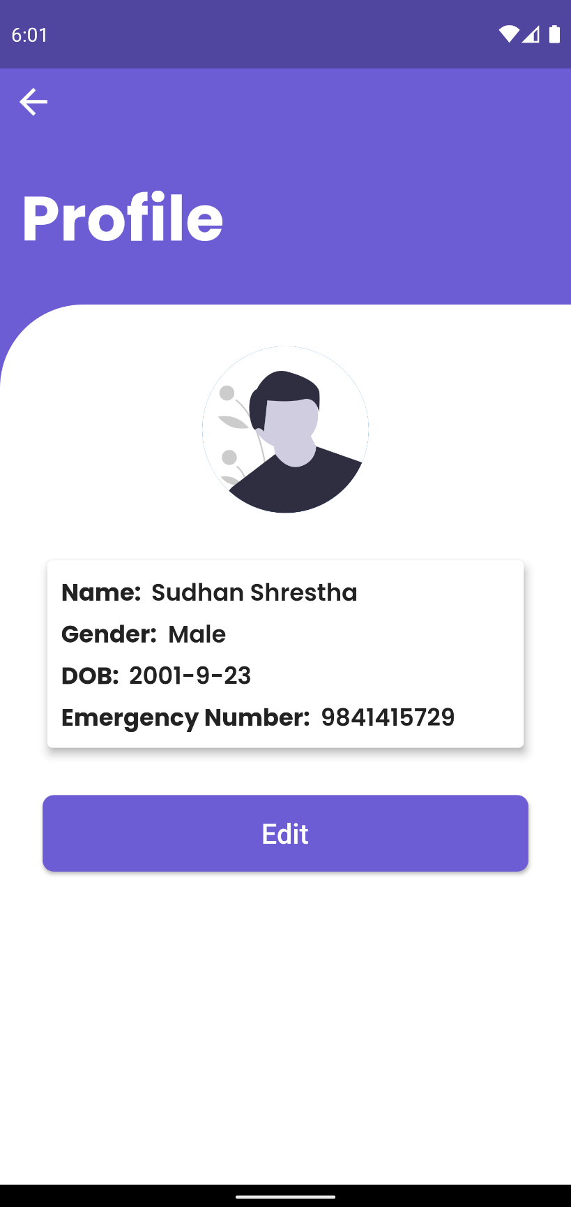

Figure Profile Page

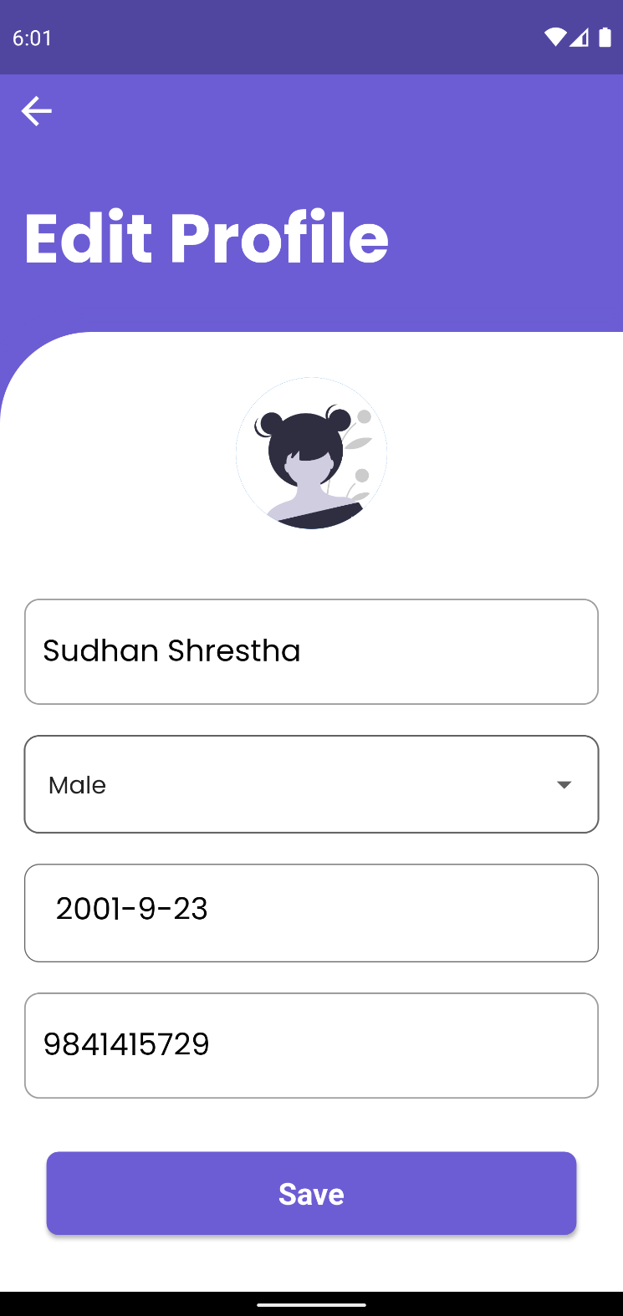

Figure Edit Profile Page

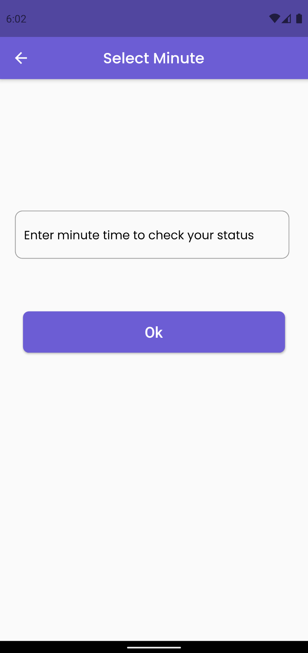

Figure Tracking Select Minute Page

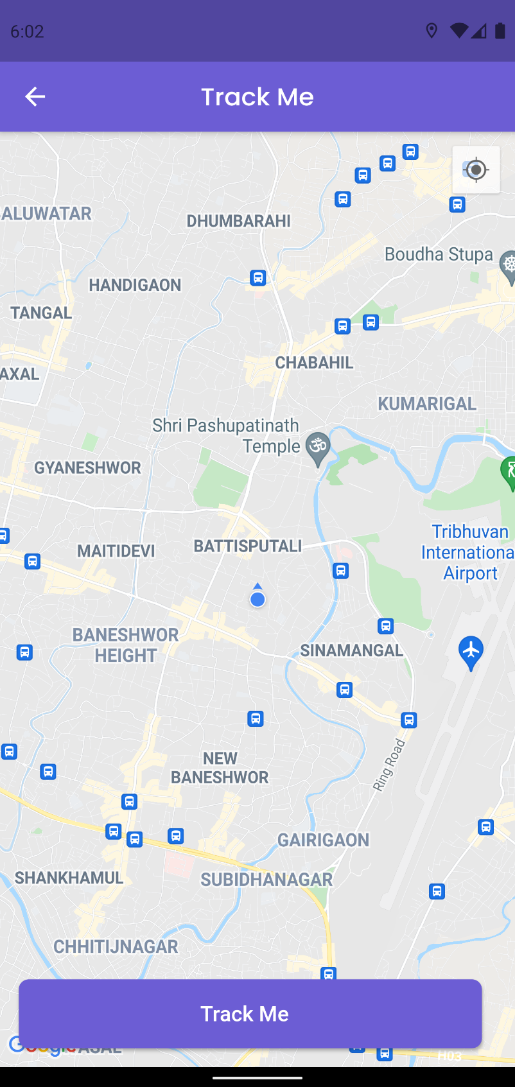

Figure Track Me Page

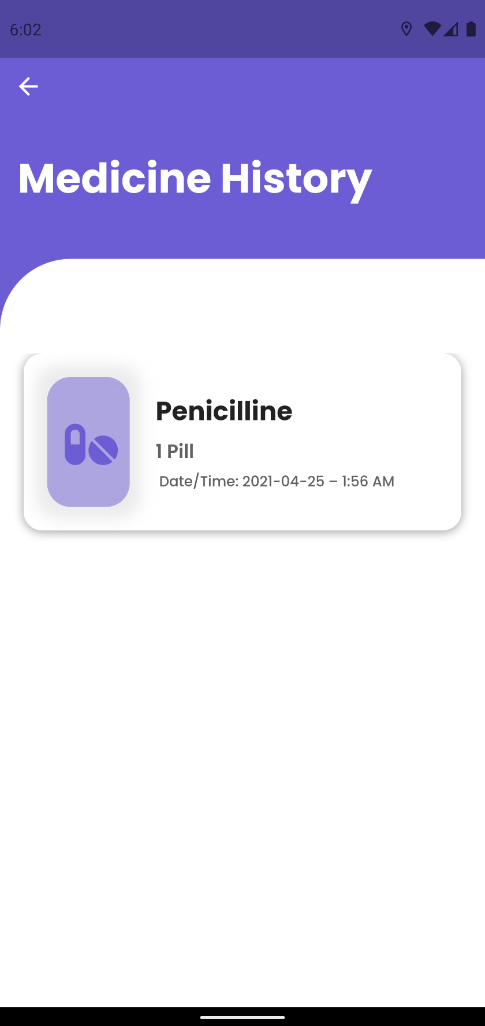

Figure Medicine History Page

## APPENDIX G: TESTING

### System Testing

The additional system testing left are as shown below:

1. **To Test CRUD operation for Doctors**

|  |  |
| --- | --- |
| **Objective** | To perform CRUD operation in Doctor and its related feature. |
| **Action** | To carry out CRUD operation in Doctor and its related features. |
| **Expected Result** | User will be able to Add Doctor, update their doctor’s information and delete doctor. |
| **Actual Result** | User can Add Doctor, update their doctor’s information and delete doctor. |
| **Conclusion** | Test Successful. |

Table System Testing to Test CRUD operation for Notes

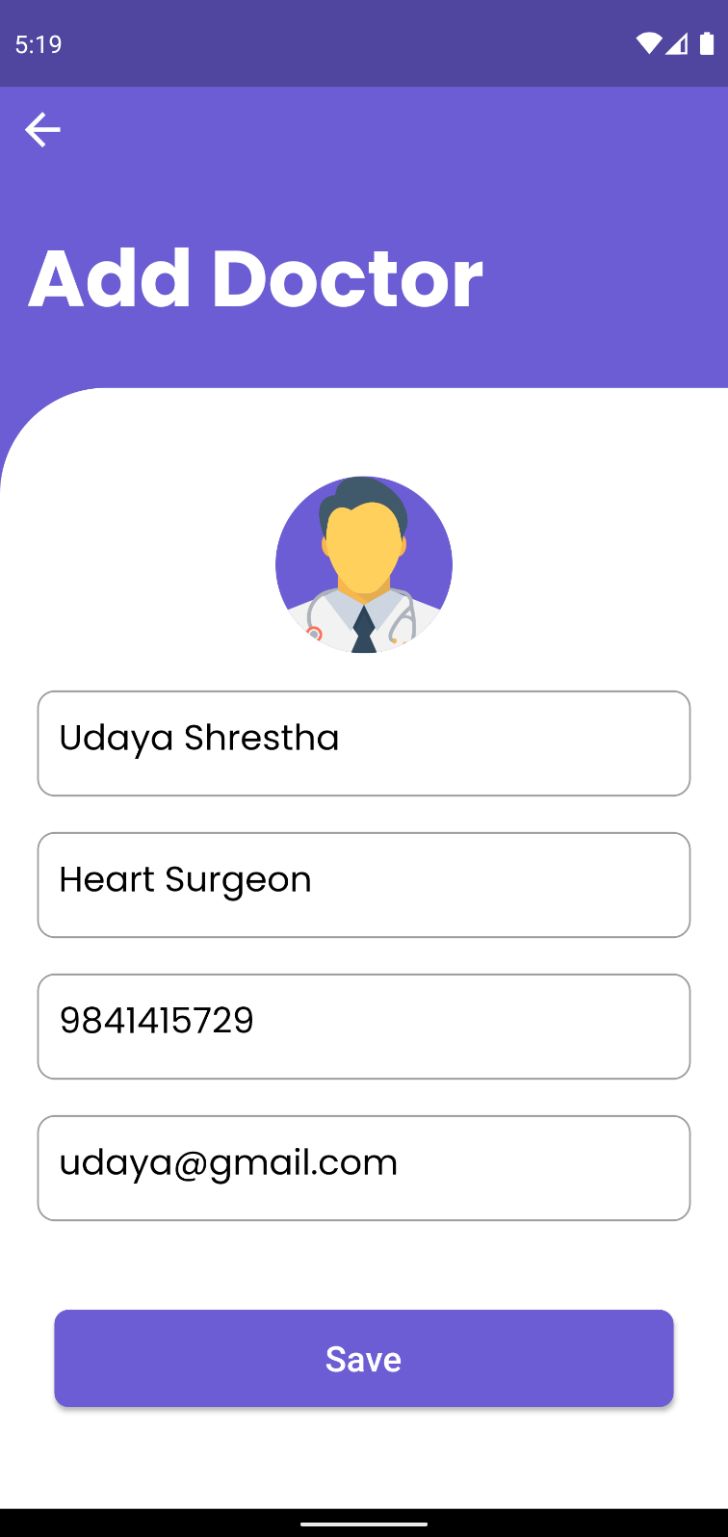

Figure A doctor being added

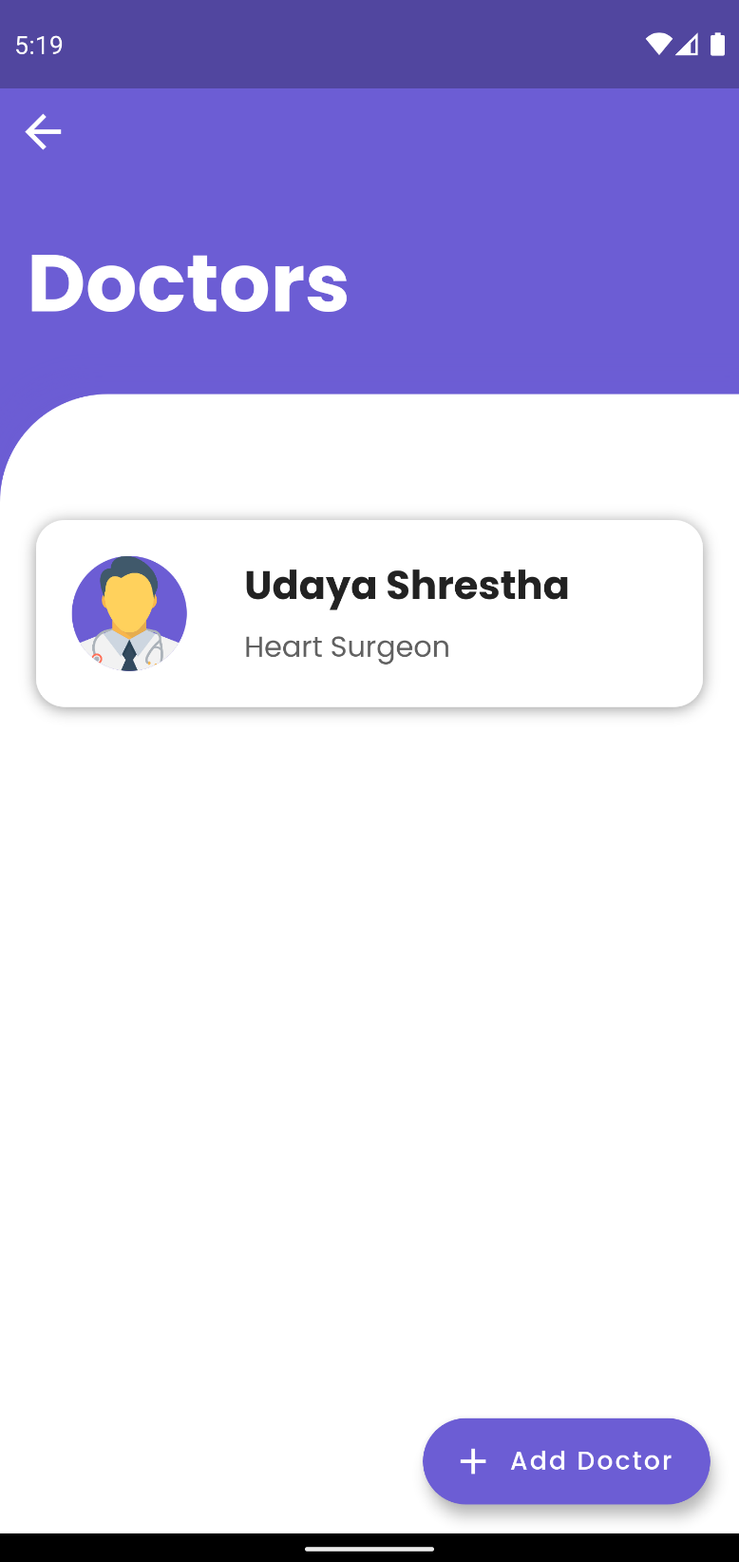

Figure Added doctor being displayed in the Doctors UI

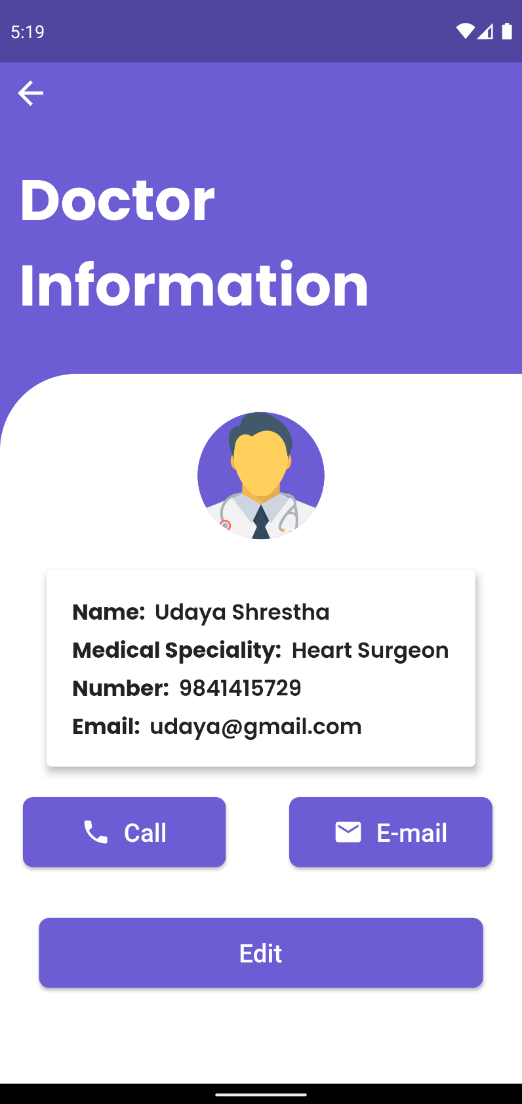

Figure Doctors full information being displayed when clicked on doctor

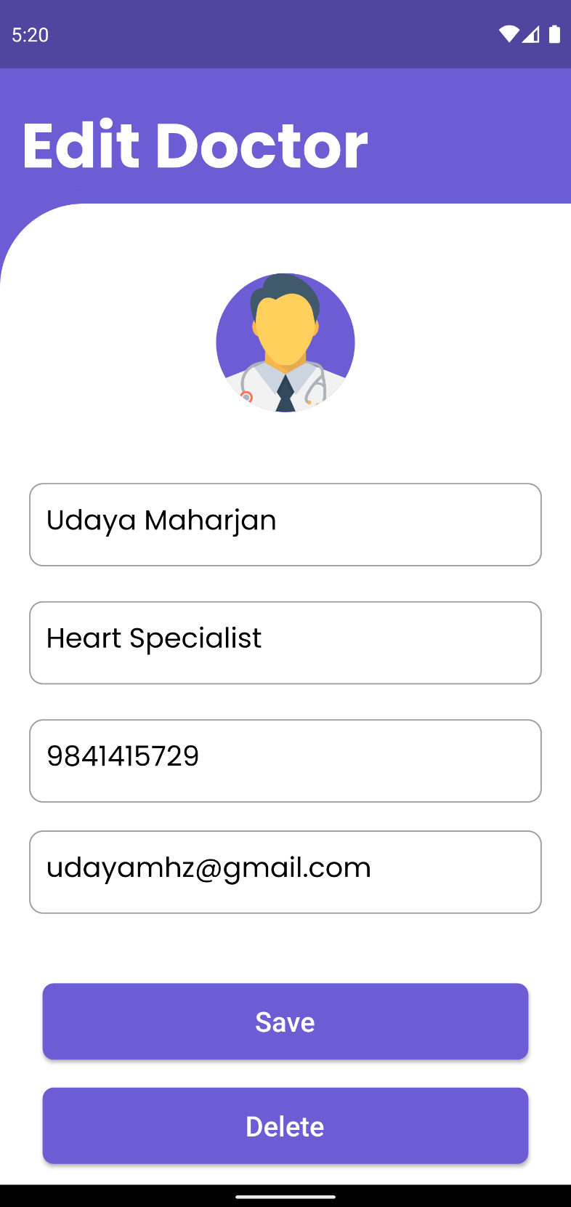

Figure Updating/Editing a Doctors Information

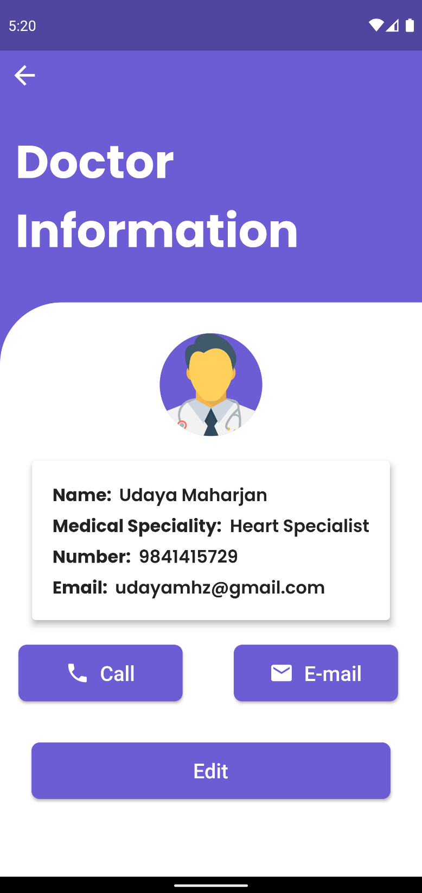

Figure Updated/Edited Doctors information being displayed

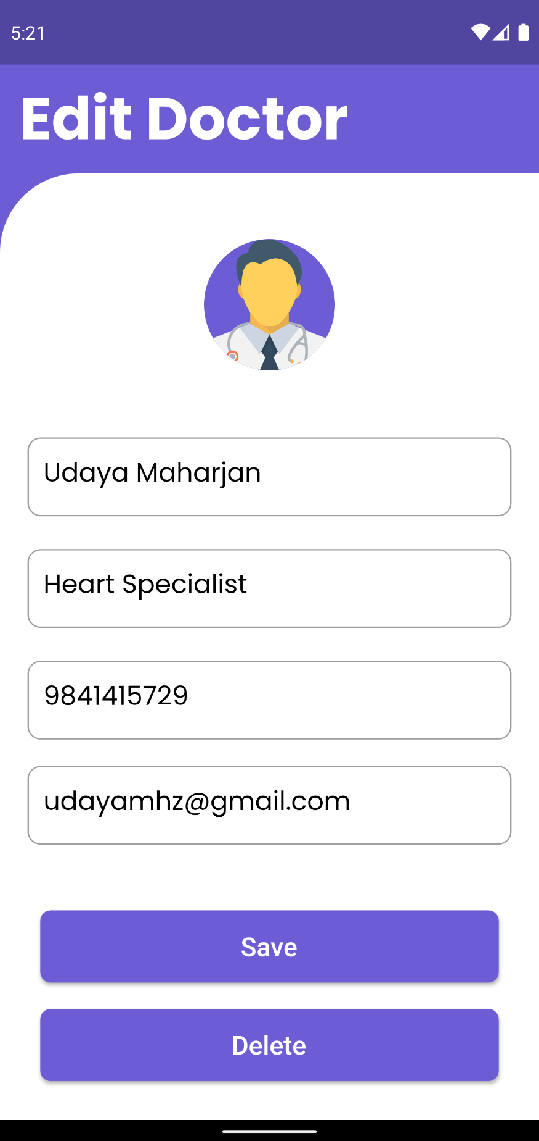

Figure Deleting a Doctor

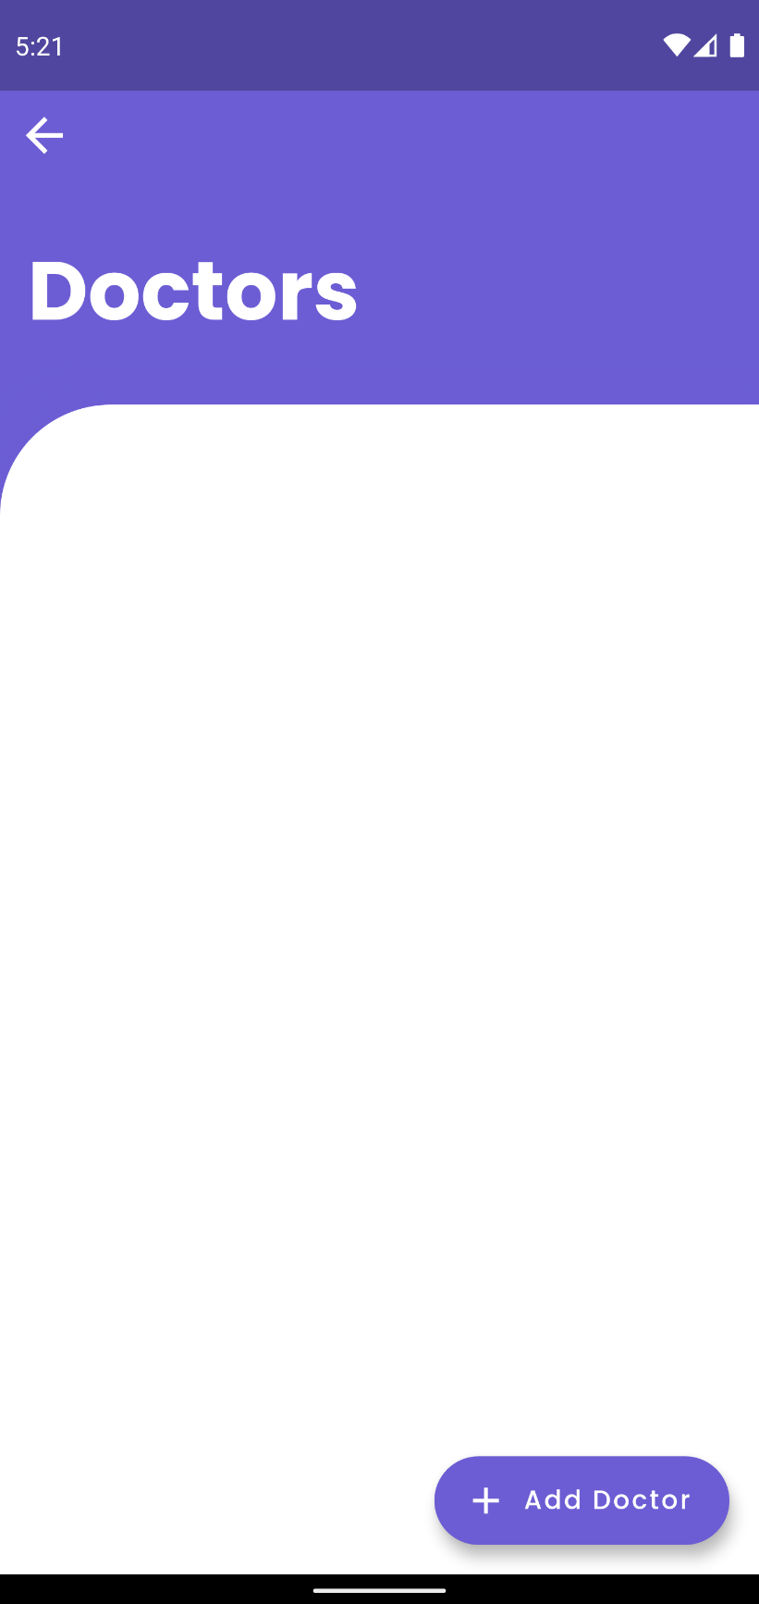

Figure Doctor information not being shown after deleting

1. **Doctor Input Validation.**

|  |  |
| --- | --- |
| **Objective** | To input invalid input in Doctor, relate input fields. |
| **Action** | To input invalid data into doctor input fields. |
| **Expected Result** | User will not be able to insert invalid data. |
| **Actual Result** | User were not able to insert invalid data. |
| **Conclusion** | Test Successful. |

Table System Testing Doctor Input Validation

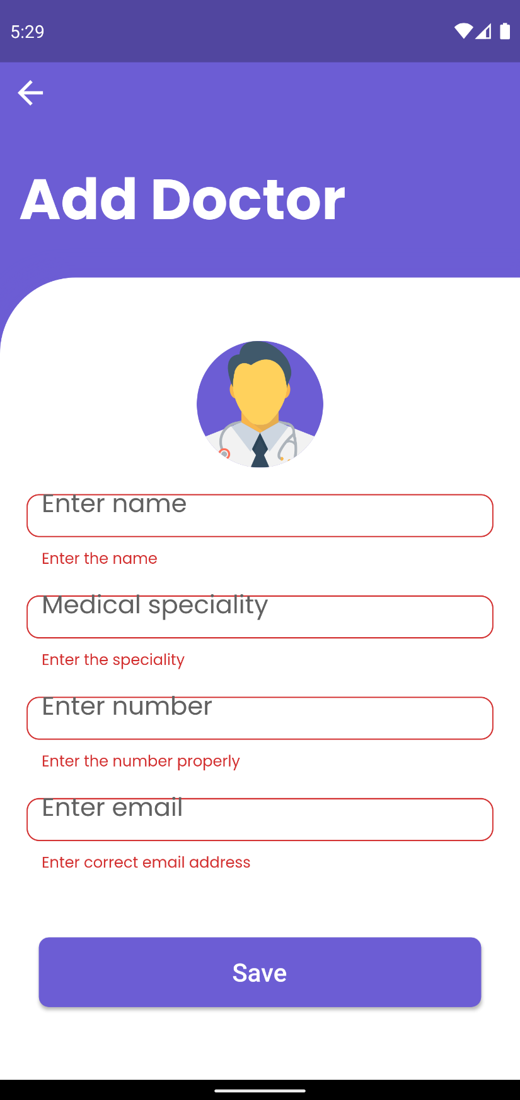

Figure Error message being displayed when empty data is entered into fields of Add Doctor

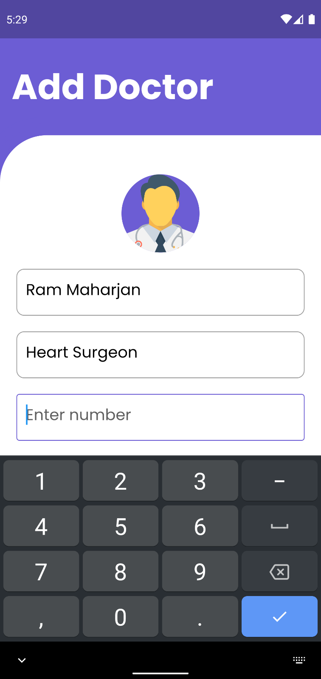

Figure Only Numbers being allowed to enter into Number field of Add Doctor

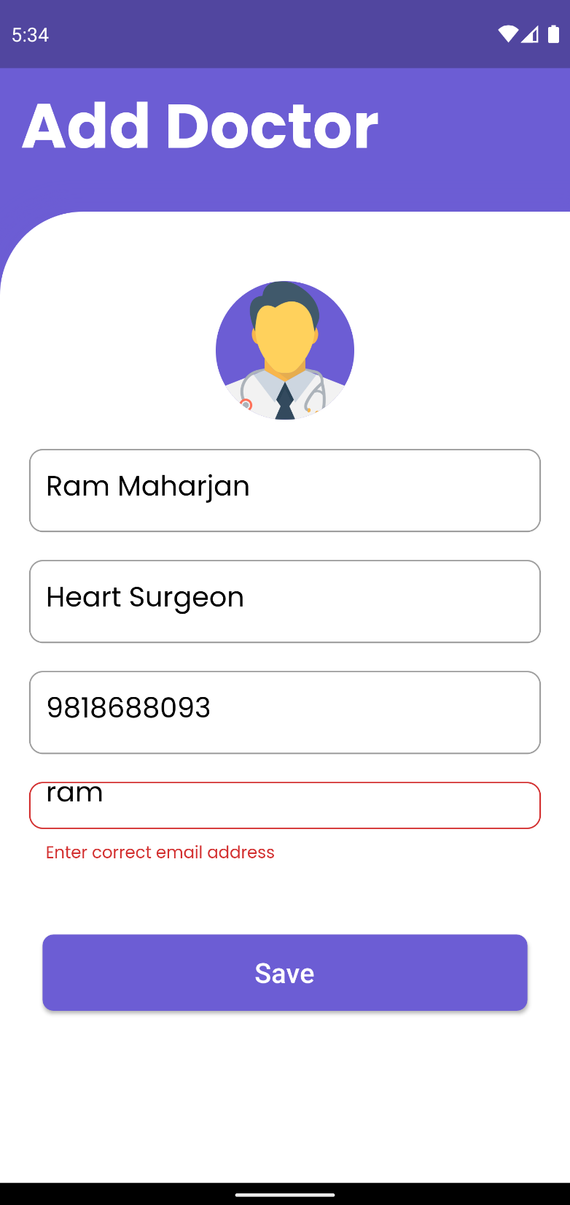

Figure Invalid Email Not being allowed to enter in email field of Add Doctor

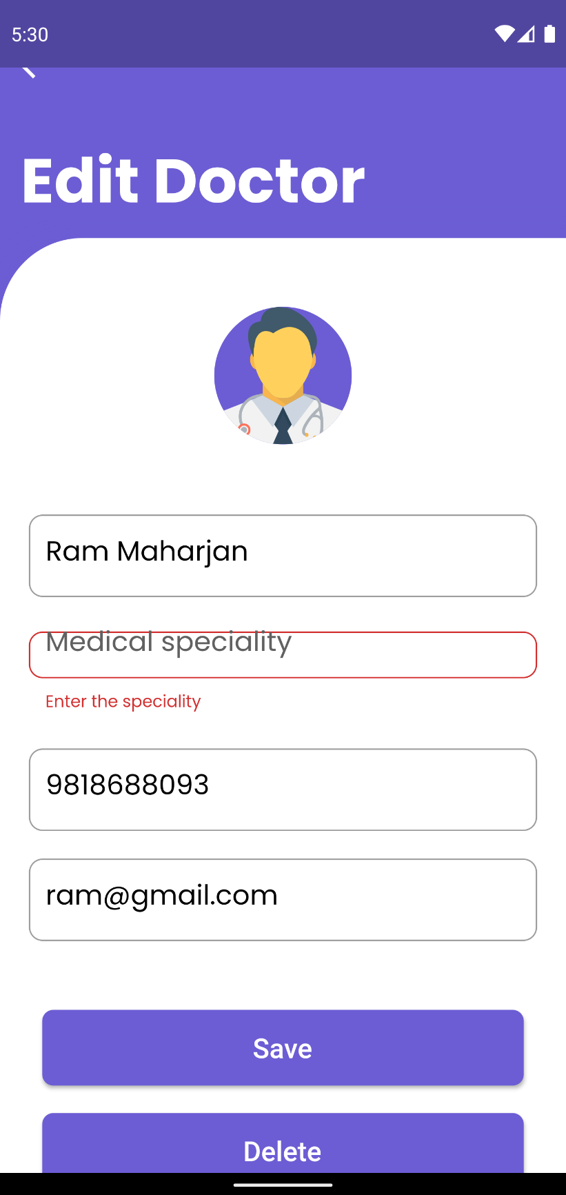

Figure Error message being displayed when empty data is entered into fields of Edit Doctor

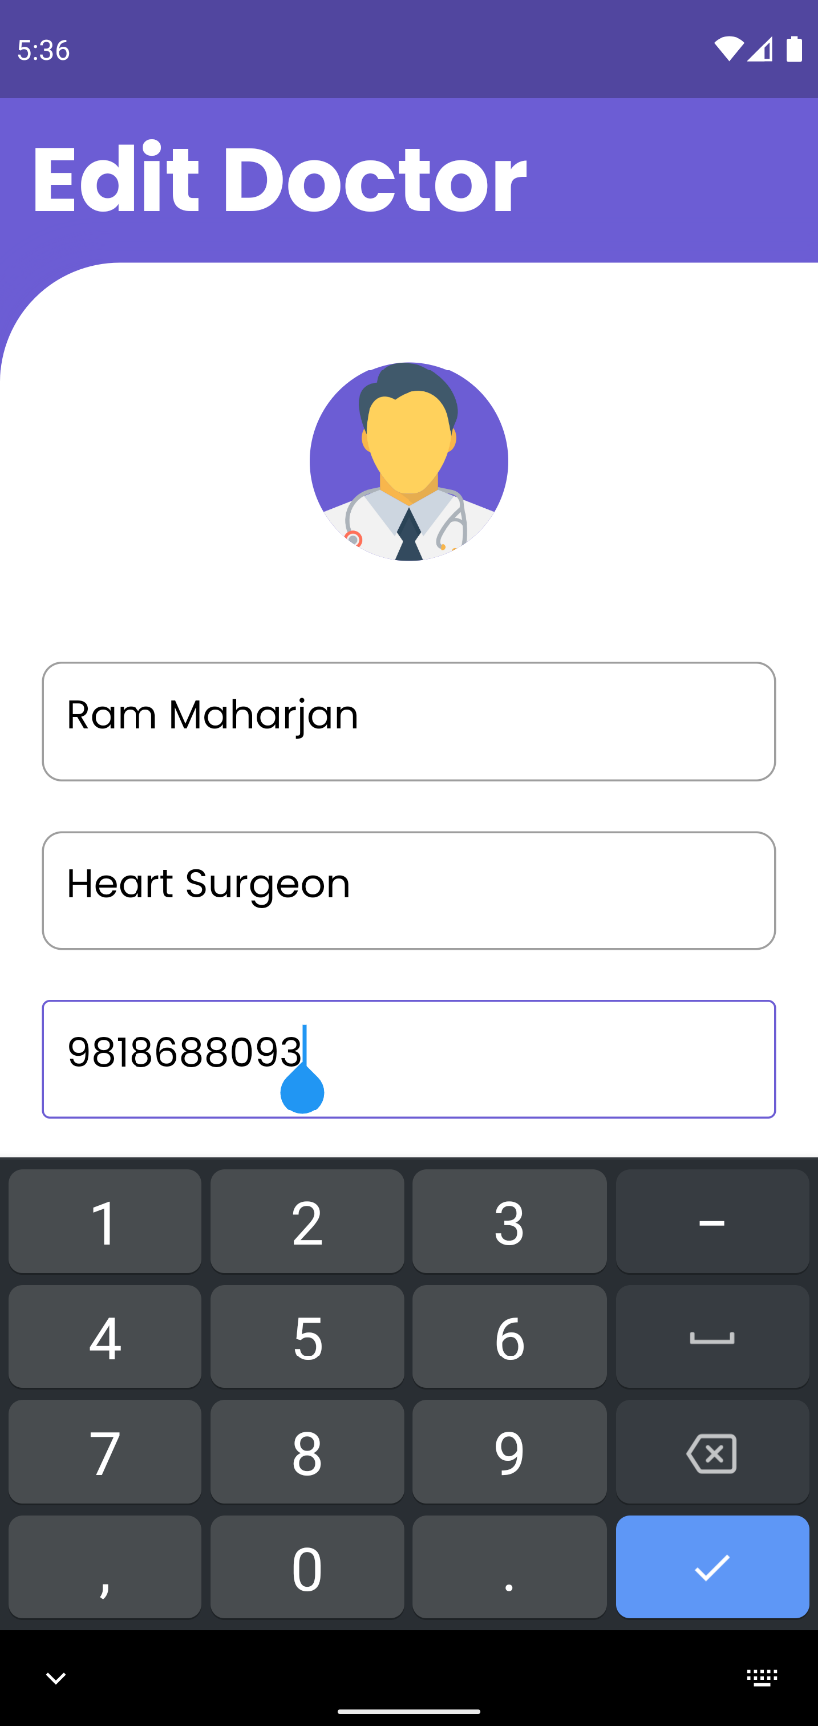

Figure Only Numbers being allowed to enter into Number field of Edit Doctor

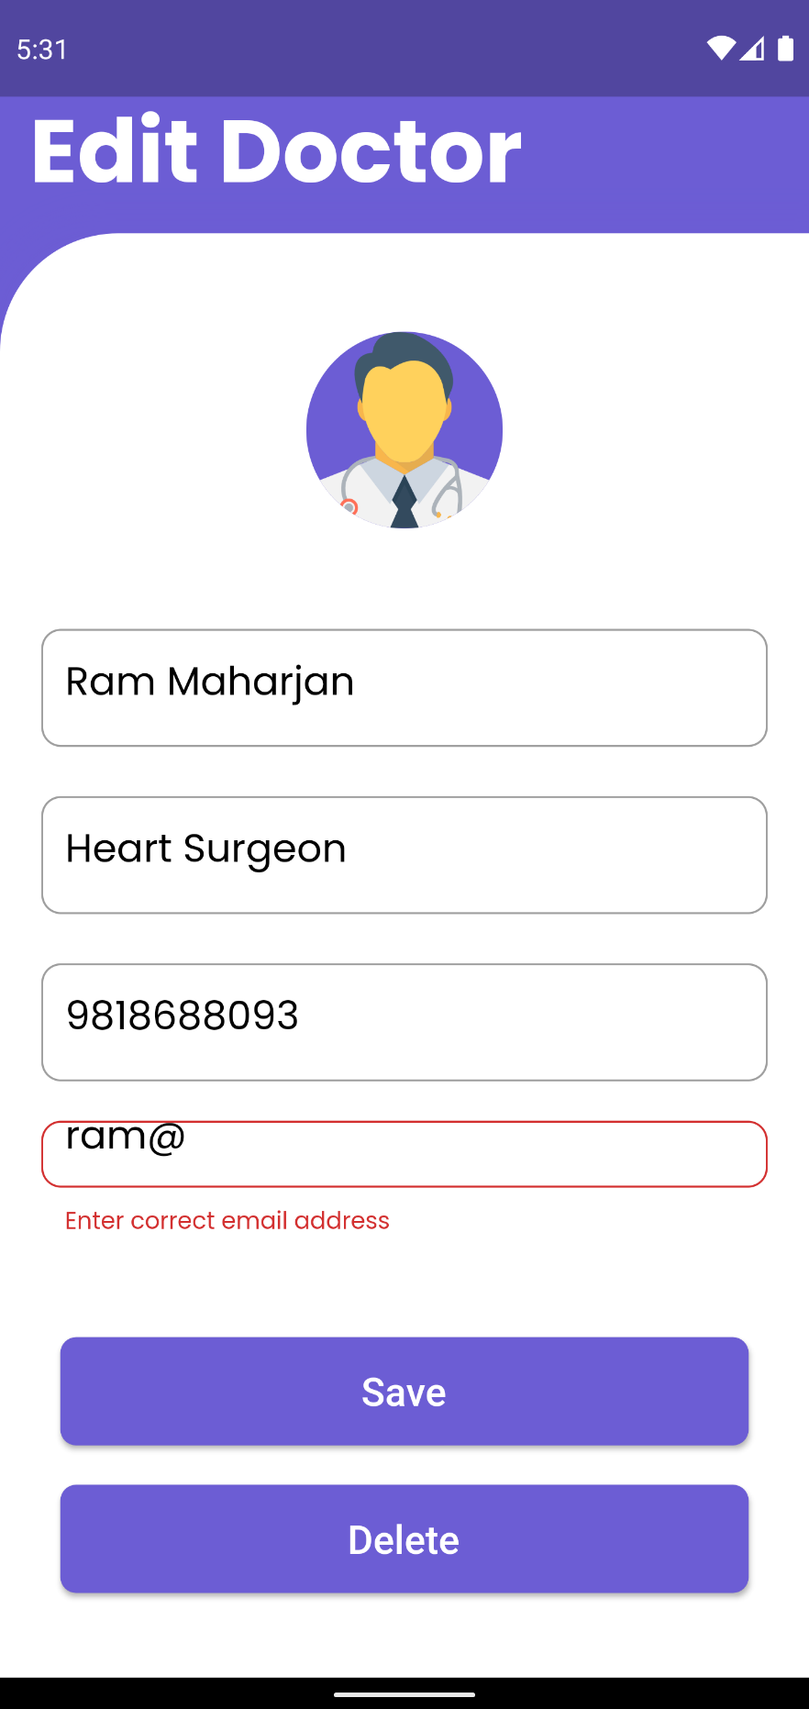

Figure Invalid Email Not being allowed to enter in email field of Edit Doctor

1. **Edit Profile**

|  |  |
| --- | --- |
| **Objective** | To edit user profile. |
| **Action** | To input valid data to edit profile of a user |
| **Expected Result** | User profile will be updated. |
| **Actual Result** | User profile was updated |
| **Conclusion** | Test Successful. |

Table System Testing Edit Profile

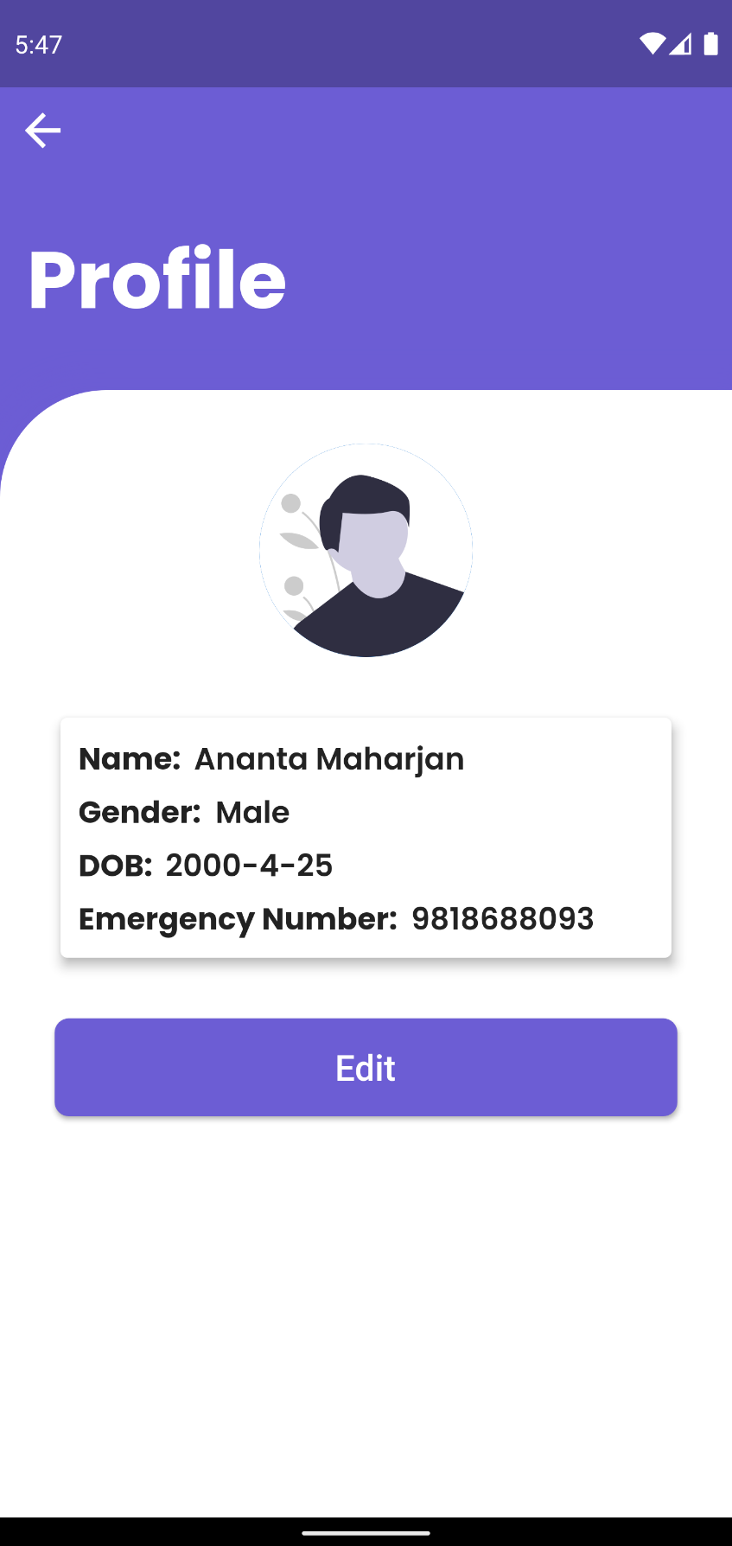

Figure Pressing Edit on Profile UI

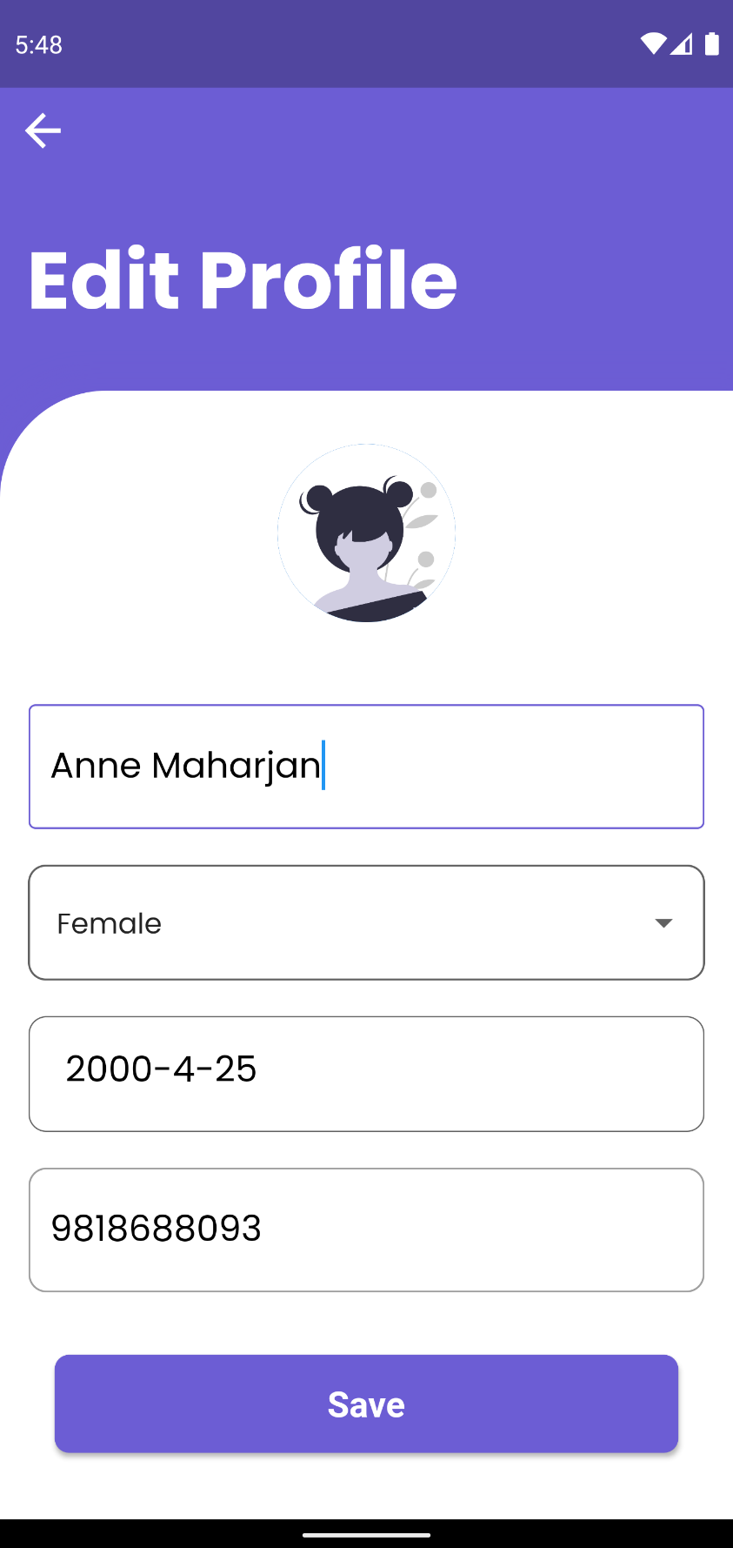

Figure Updating/Editing User profile

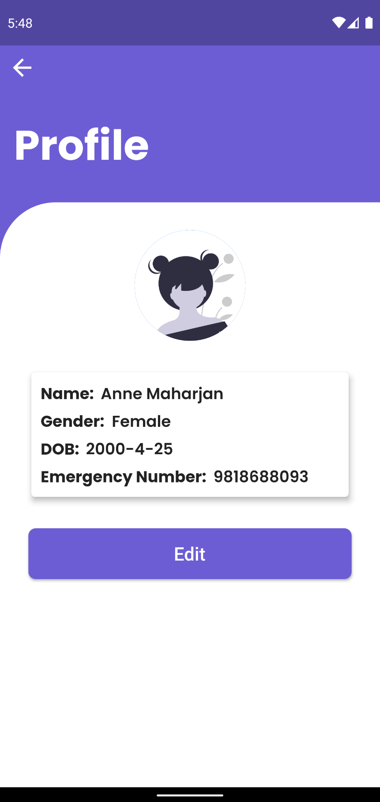

Figure Updated/Edited Profile data being displayed

1. **Edit Profile Validation**

|  |  |
| --- | --- |
| **Objective** | To input invalid input in Edit Profile |
| **Action** | To input invalid data into Edit Profile input fields. |
| **Expected Result** | User will not be able to insert invalid data. |
| **Actual Result** | User were not able to insert invalid data. |
| **Conclusion** | Test Successful. |

Table System Testing Edit Profile

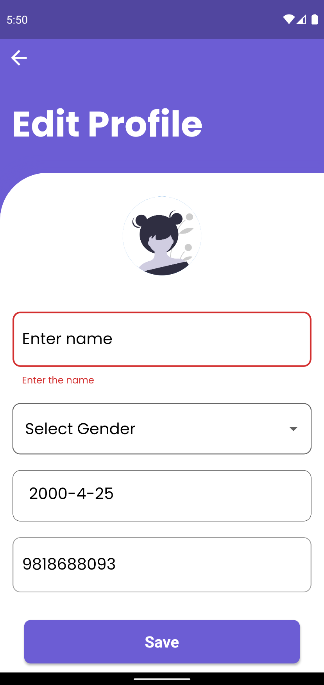

Figure Error Message being displayed when empty data is being entered into Edit profile field

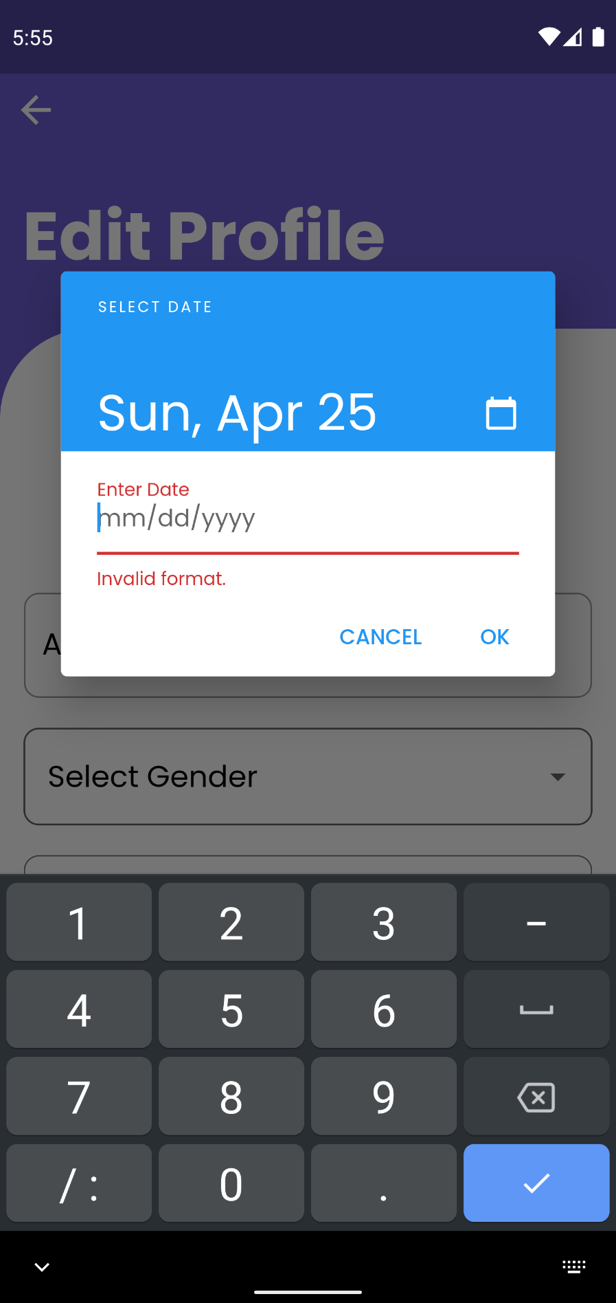

Figure Error Message being displayed when entering empty data in date field of edit profile

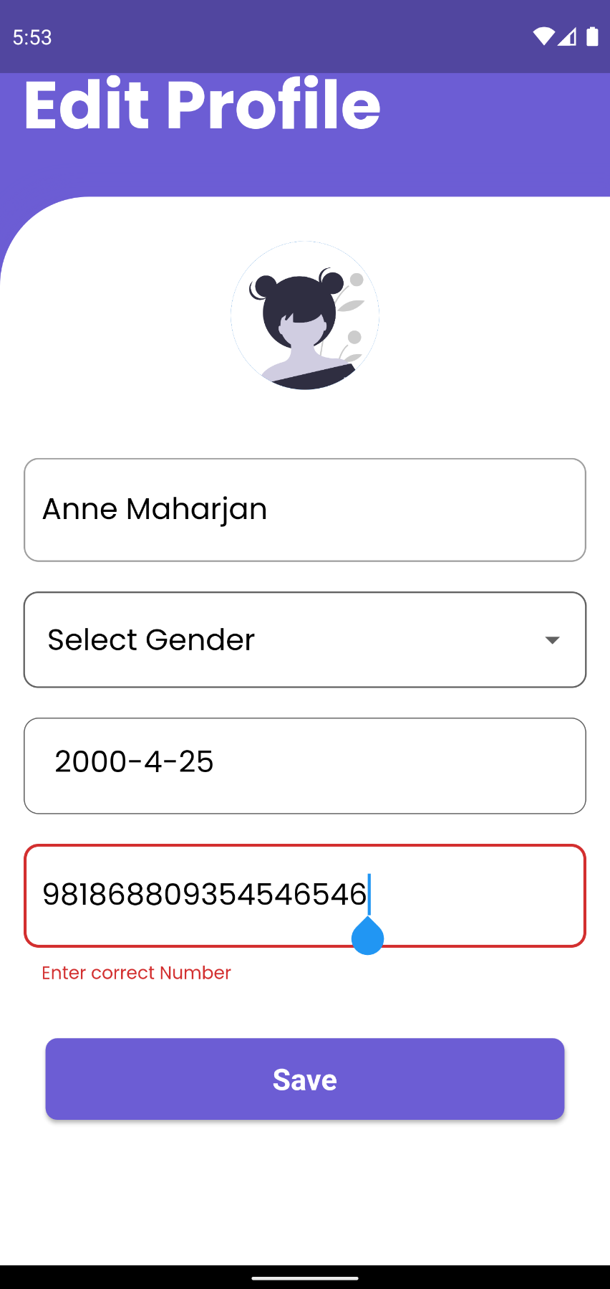

Figure Error message being displayed when entering an invalid phone number

1. **View Medicine History**

|  |  |
| --- | --- |
| **Objective** | To View the Medicine, Consume history. |
| **Action** | To click on medicine history. |
| **Expected Result** | User medicine consumption data should be displayed. |
| **Actual Result** | User medicine consumption data was displayed. |
| **Conclusion** | Test Successful. |

Table System Testing View Medicine History

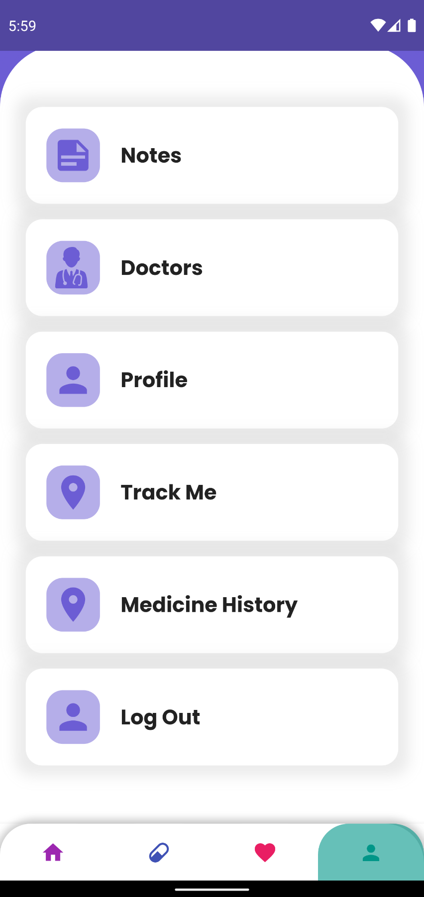

Figure Click Medicine History

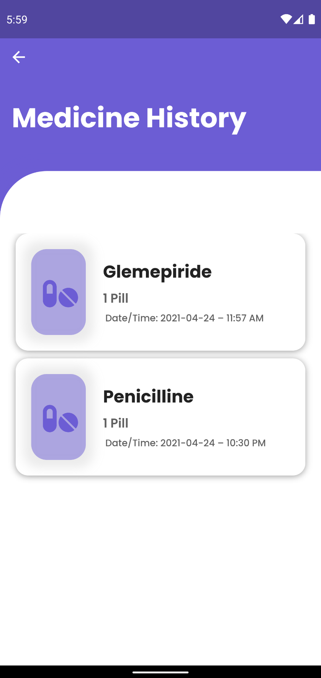

Figure Medicine History Being Displayed

1. **Logout User**

|  |  |
| --- | --- |
| **Objective** | To logout user. |
| **Action** | To click on logout. |
| **Expected Result** | The user will be logged out from the application and redirected to the login page. |
| **Actual Result** | The user was logged out from the application and redirected to the login page. |
| **Conclusion** | Test Successful. |

Table System Testing Logout User

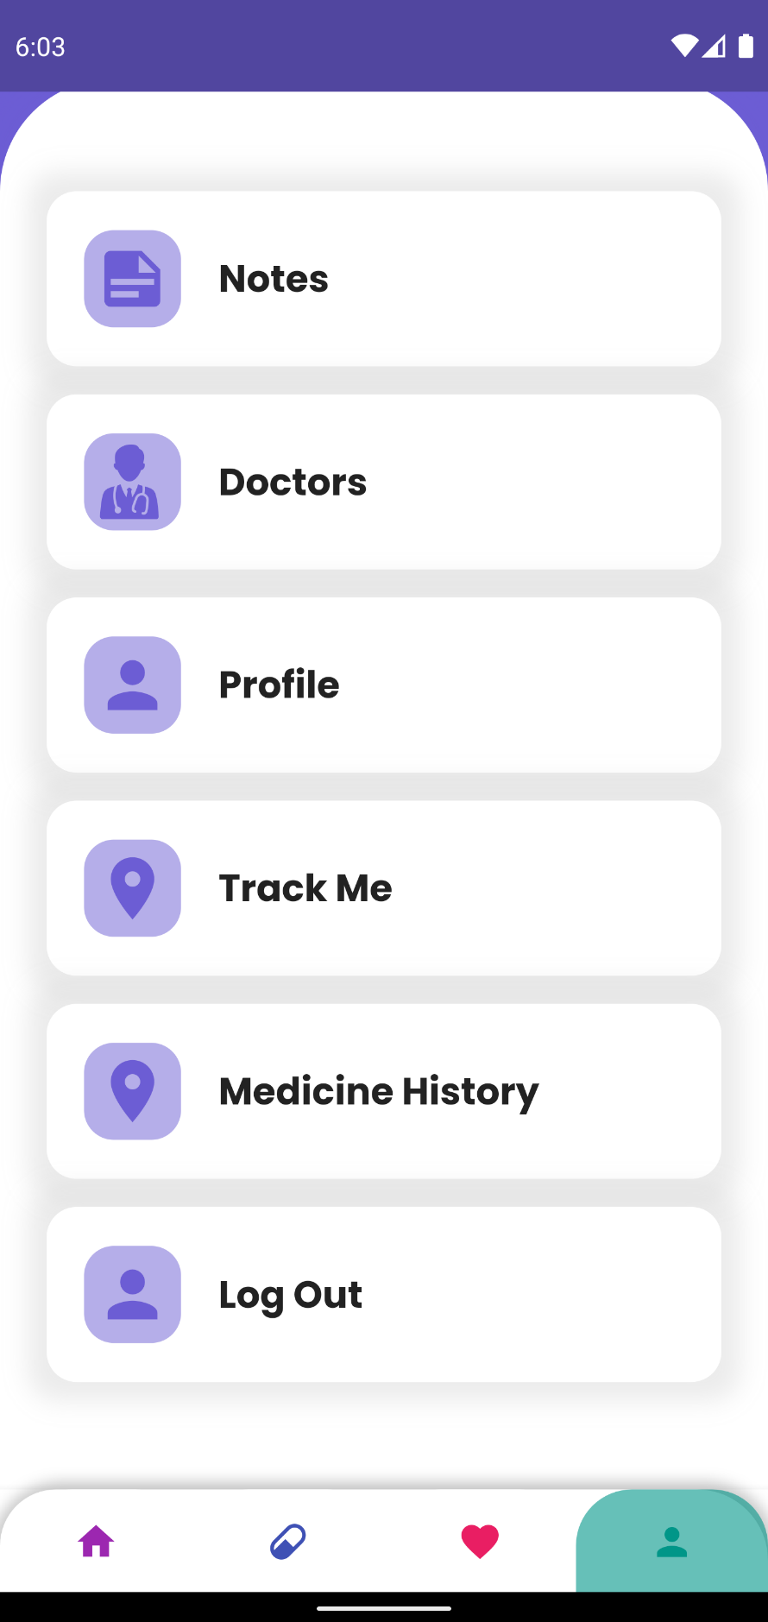

Figure Clicking logout button

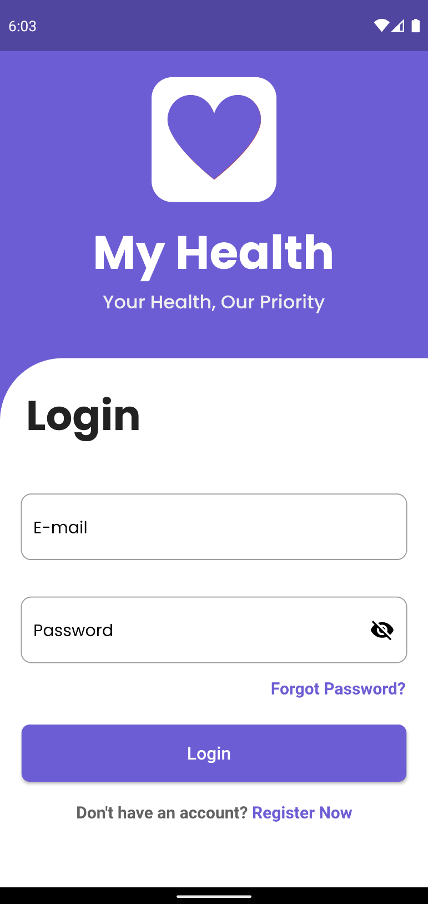

Figure User being logged out of the system and redirected to login page

1. **To Test Forgot Password**

|  |  |
| --- | --- |
| **Objective** | To check if mail is sent to the user to reset the password |
| **Action** | Click on forgot password, and enter the user email and send it. |
| **Expected Result** | The application will send an email to the user with a valid and registered email a link to the rest password. |
| **Actual Result** | The application sent an email to the user with a valid and registered email a link to the rest password. |
| **Conclusion** | Test Successful. |

Table System Testing to Test Forgot Password

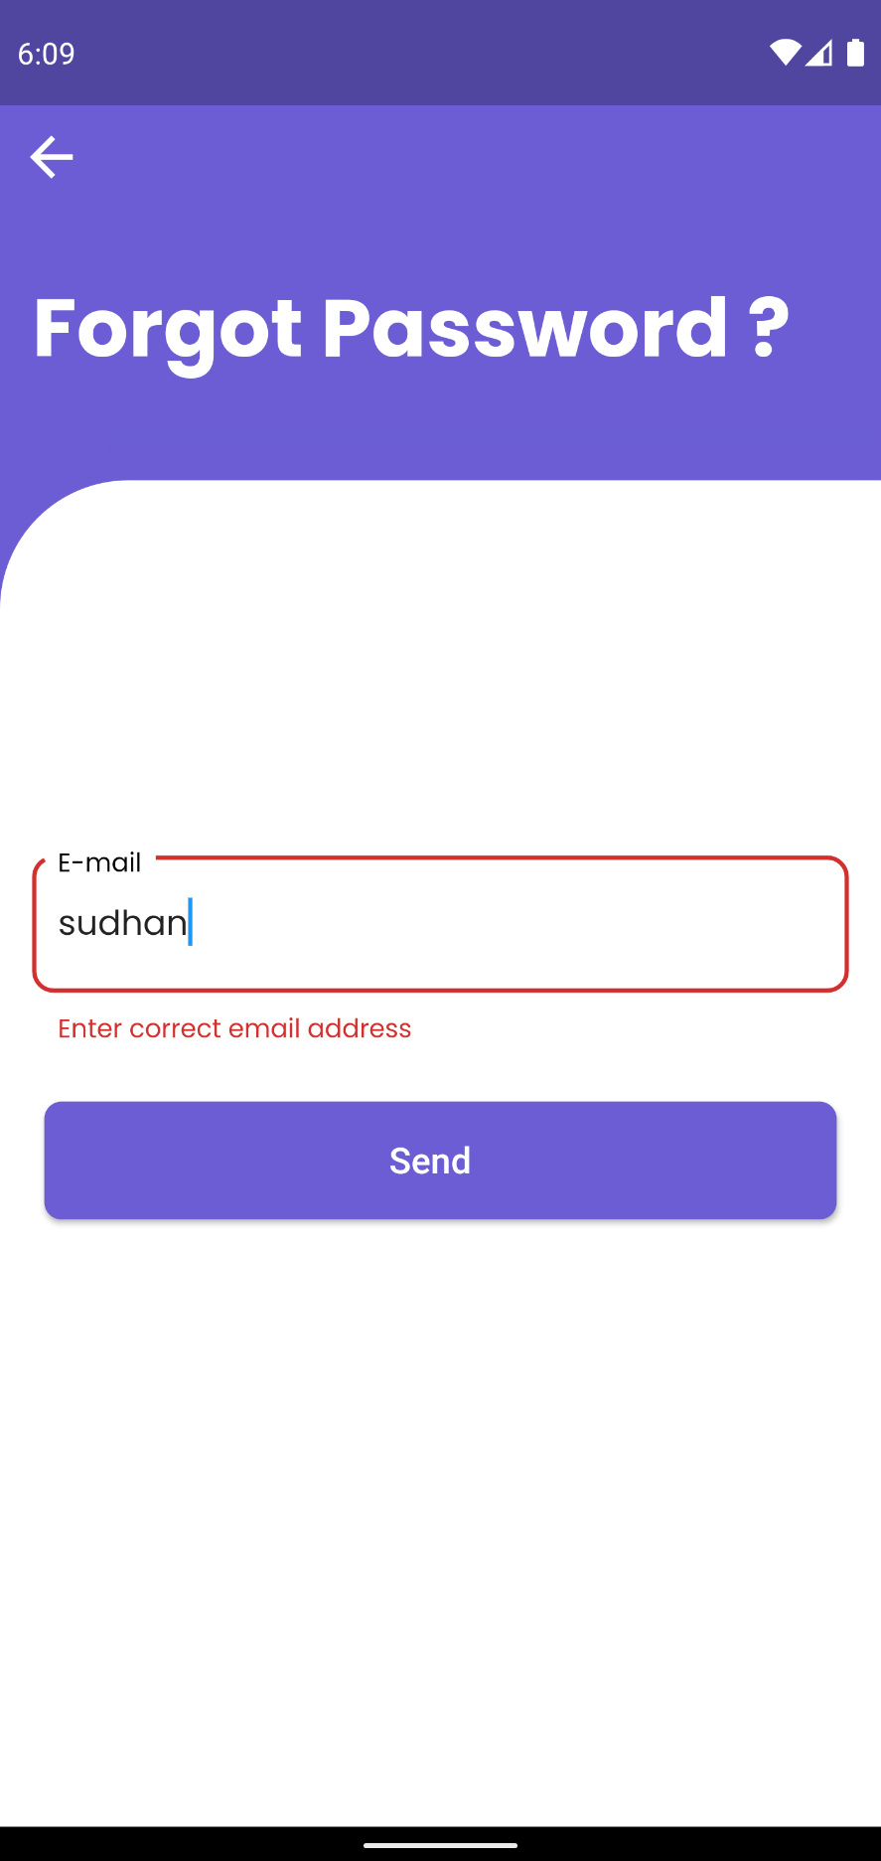

Figure Error message being displayed when invalid email address is entered in Forgot Password UI

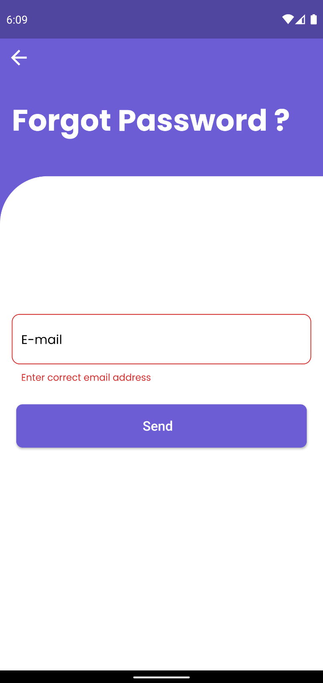

Figure Error message being displayed when empty data is entered in Forgot Password UI

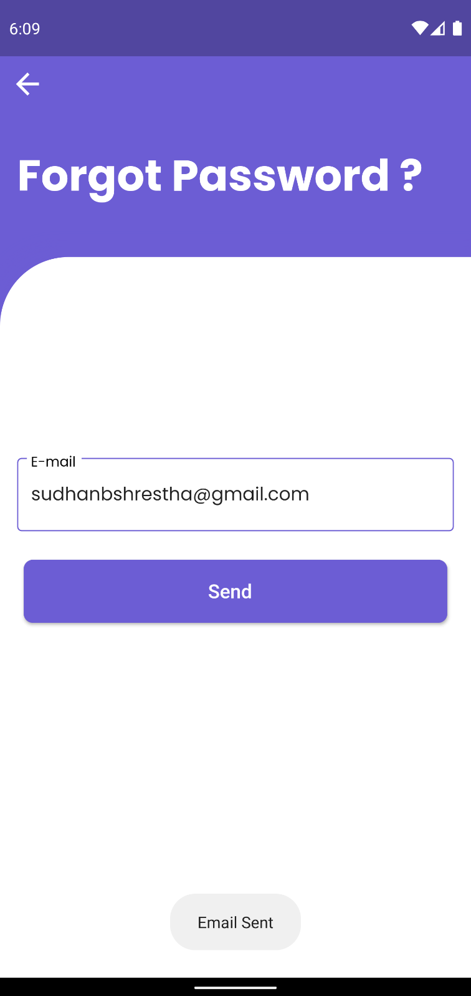

Figure Email being sent to the user to reset password

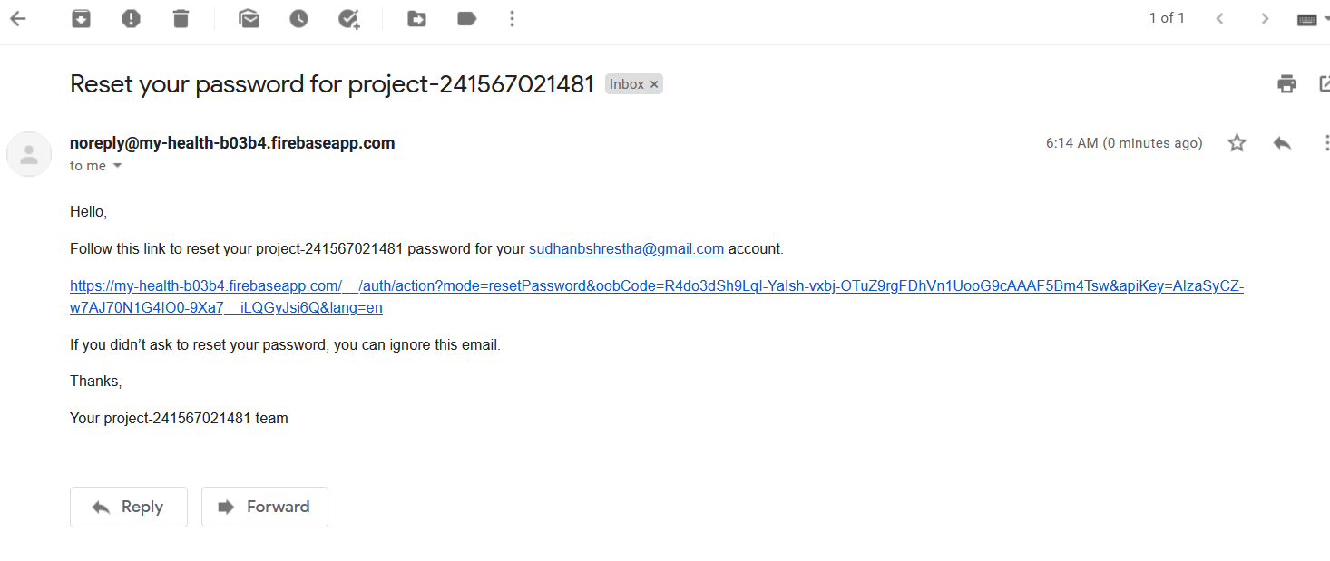

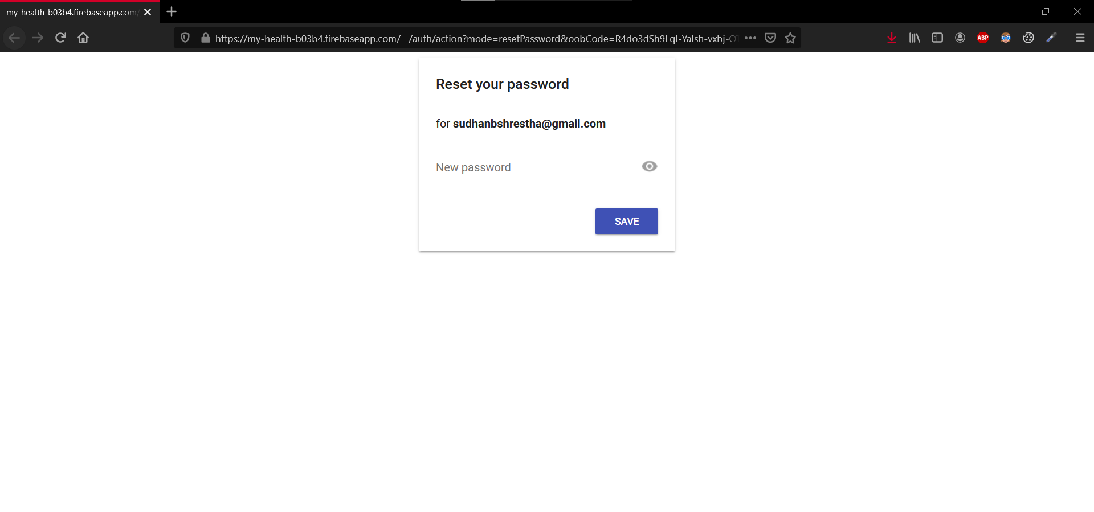

Figure Reset password Ui provide by Firebase

Figure Email to reset password being revived in the users email inbox

## APPENDIX H: USER FEEDBACK

### USER FEEDBACK

Feedback was asked to the people how used the application in the post-survey here are the result of the feedback by the participants.

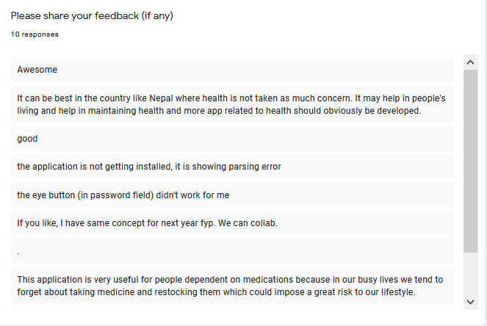

Figure Feedbacks of the participants

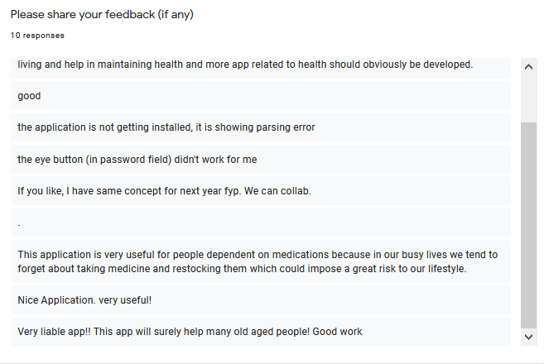

Figure Feedbacks of the participants

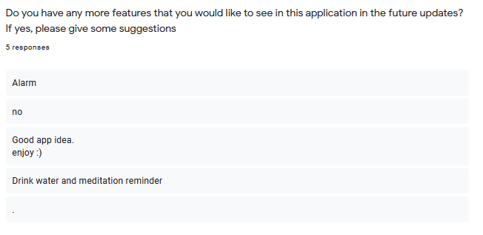

Figure Suggestion for future update of the participants